Supplementary Figures

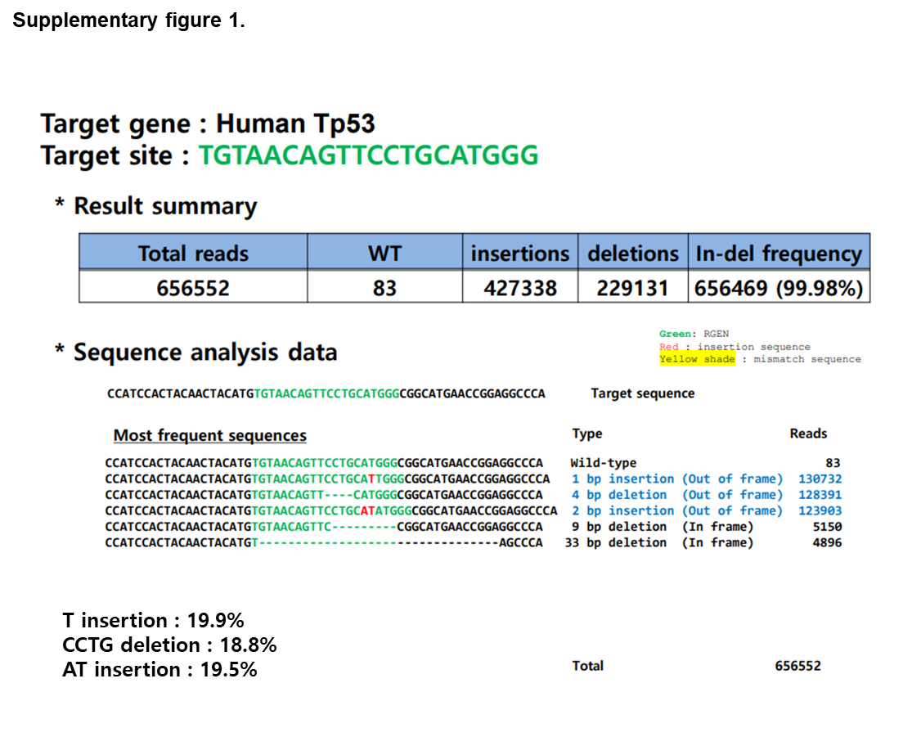

Supplementary figure 1. Using CRISPR-Cas9 system, a cell line with p53 gene deleted was manufactured in HepG2
We deleted the p53 gene in the p53+/+ HepG2 cell line using the CRISPR-Cas9 system. The target site of Human p53: TGTAACAGTTCCTGCATGGG was investigated by the NGS method. The insertion/deletion frequency was 99.98% (T insertion:19.9%, CCTG deletion:18.8%, AT insertion:19.5%).

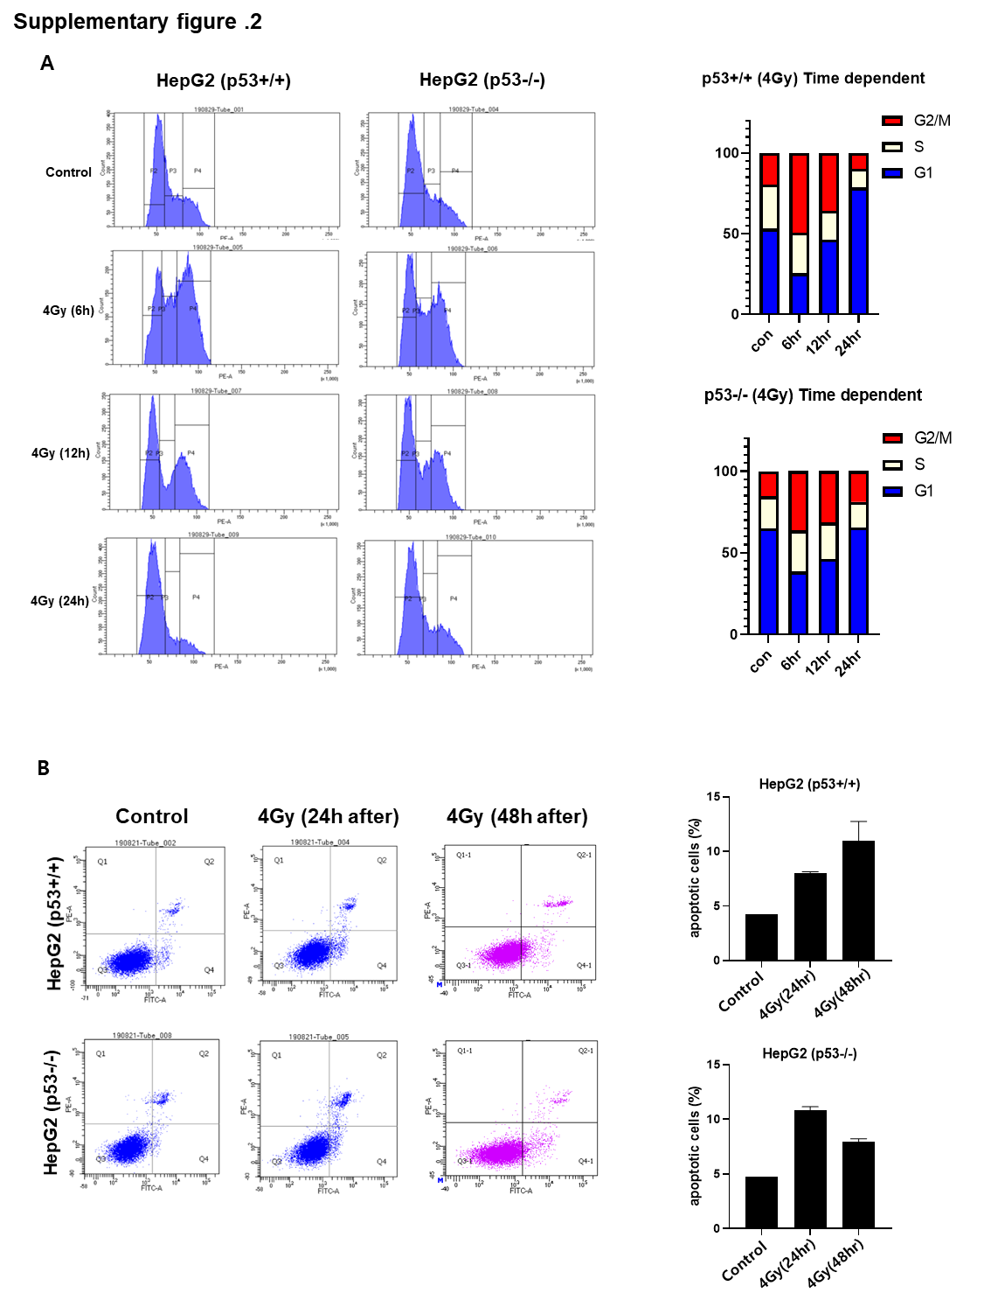

Supplementary figure 2. Measurement and identification of differences in cell cycle arrest and apoptosis effects according to the presence of the p53 gene in liver cancer cells by radiation irradiation.
Changes in cell cycle and apoptosis after irradiation using HepG2, a liver cancer cell line, were measured by FACS. This was done to confirm the radiation resistance effect of conventional p53. Using FACS equipment, it was confirmed that cell cycle arrest and apoptosis are induced in p53+/+, p53-/-cells by radiation treatment. In p53+/+cell, powerful cell cycle arrest in the G2/M phase was observed from 6 hours after irradiation and gradually switched to G1 phase cell cycle arrest as time passed. A similar cell cycle alteration was observed in p53-/-cell, but it was verified that the effect was smaller than that of p53+/+cell. Also, p53-/-cell had significantly less apoptosis 48 hours after irradiation than p53+/+cell. It showed stronger cell cycle arrest and apoptosis at p53+/+cell compared to p53-/-cell (A,B).

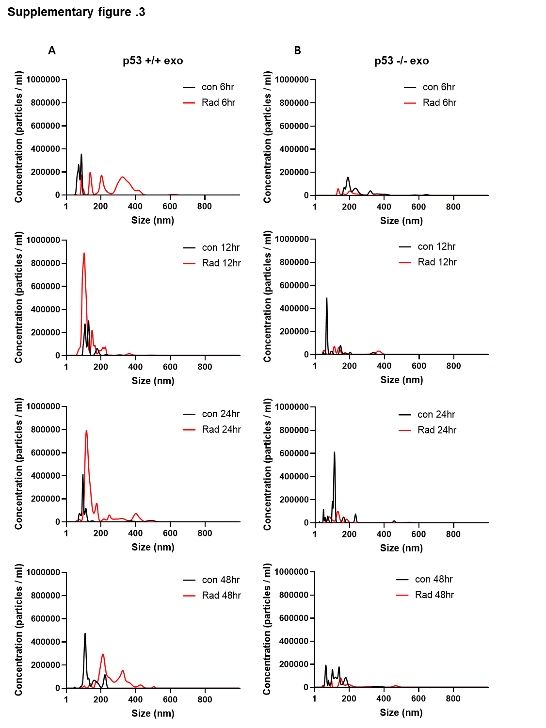

Supplementary figure 3. Measurement of exosome secretion induced by irradiation.
To quantitatively and qualitatively measure the amount of exosome released from HepG2 cells by irradiation, it was measured using the NANOSIGHT instrument using the Nanoparticle Tracking Analysis technique. (A,B)

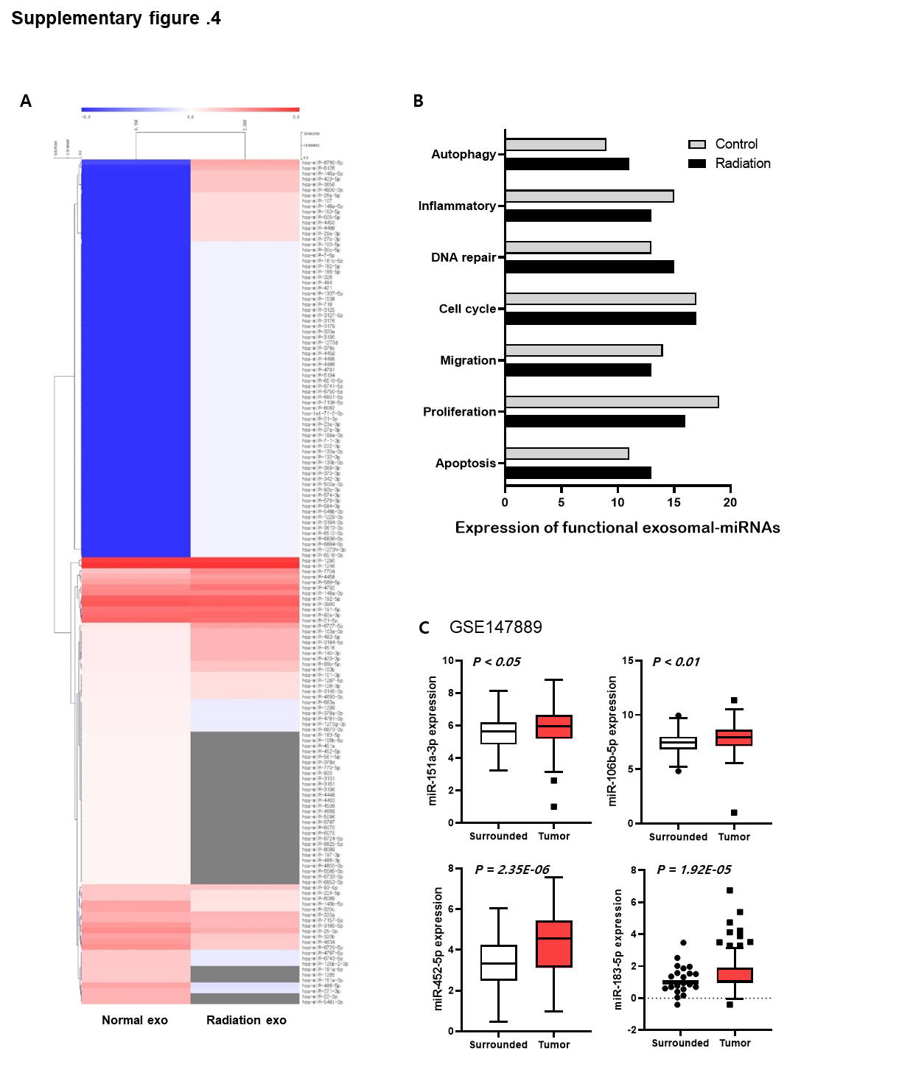

Supplementary figure 4. Measurement and verification of changes in microRNA composition inside the exosome due to irradiation.
Exosomal miRNAs changed after radiation exposure was analyzed through heatmap using the Mev software. (A) The exosomal miRNAs altered by radiation exposure were classified and investigated by intracellular function. (B) Using the previous study GEO database (GSE147889), the level of expression in the liver cancer tissues of the candidates we discovered was analyzed by comparing it with the surrounding tissues. (C)

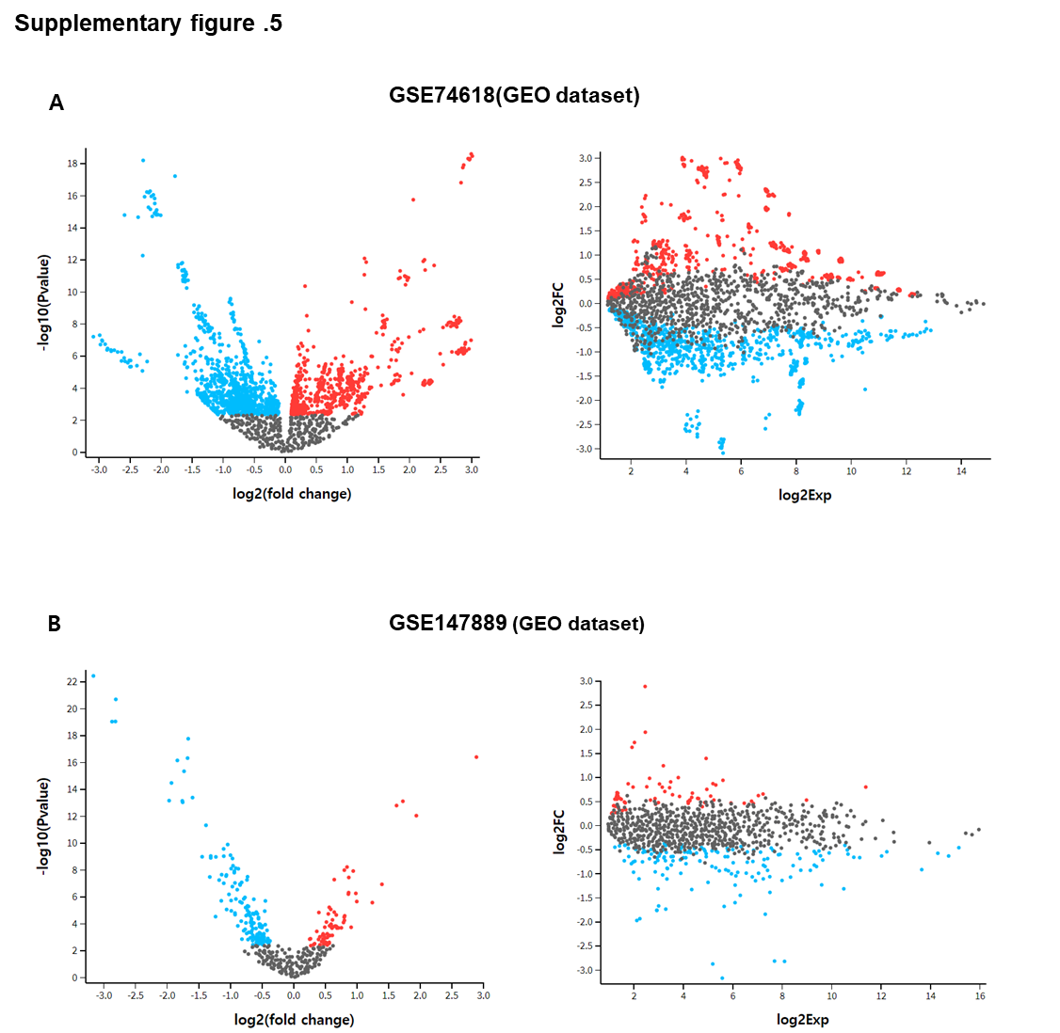

Supplementary figure 5. Bioinformatics analysis to explore for candidate groups in two databases of previous studies.
We analyzed the search for candidates with significant values using volcanic plots and mean-difference plots to investigate promising candidates from this study data and two previous study databases. Data with significant P-value and expression level were displayed in red for positive values and blue for negative values. (A,B)

