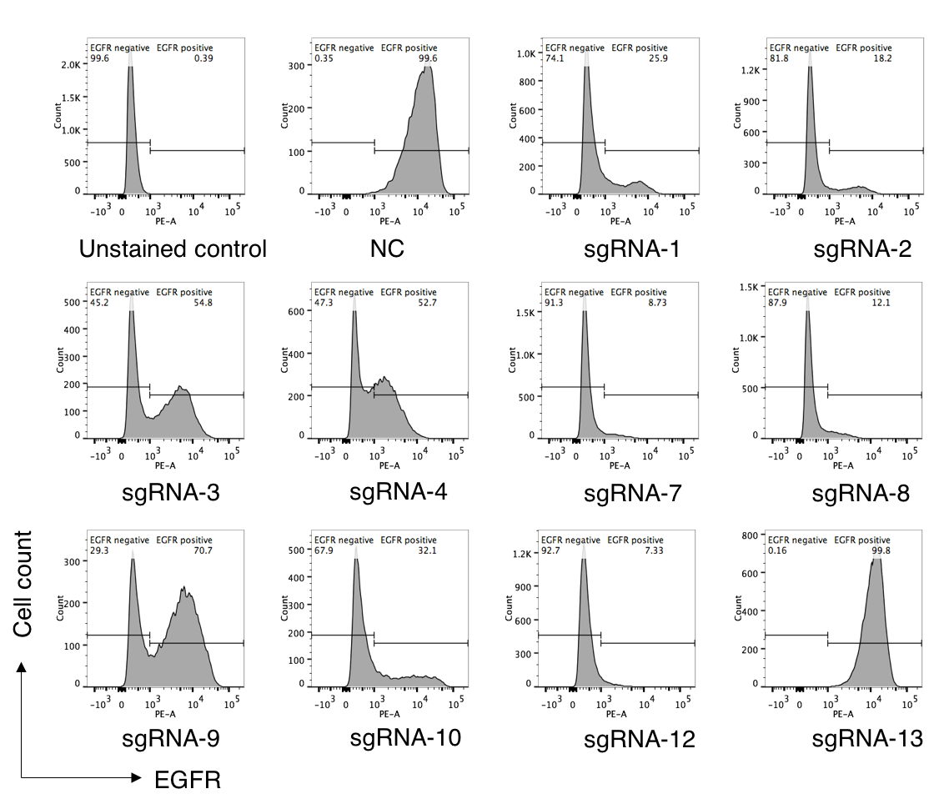
Figure S4. Deletion of endogenous EGFR were determined by Fluorescence-Activated Cell Sorting (FACS) analysis. The ten sgRNA lentiviruses were separately introduced into A549 cells and then selected with puromycin. Cells were harvested, immunostained with Anti-EGFR PE antibody (BioLegend) and subject to FACS analysis. All live cells were gated, and the proportion of EGFR (PE) positive cells was counted. NC stands for negative control.

