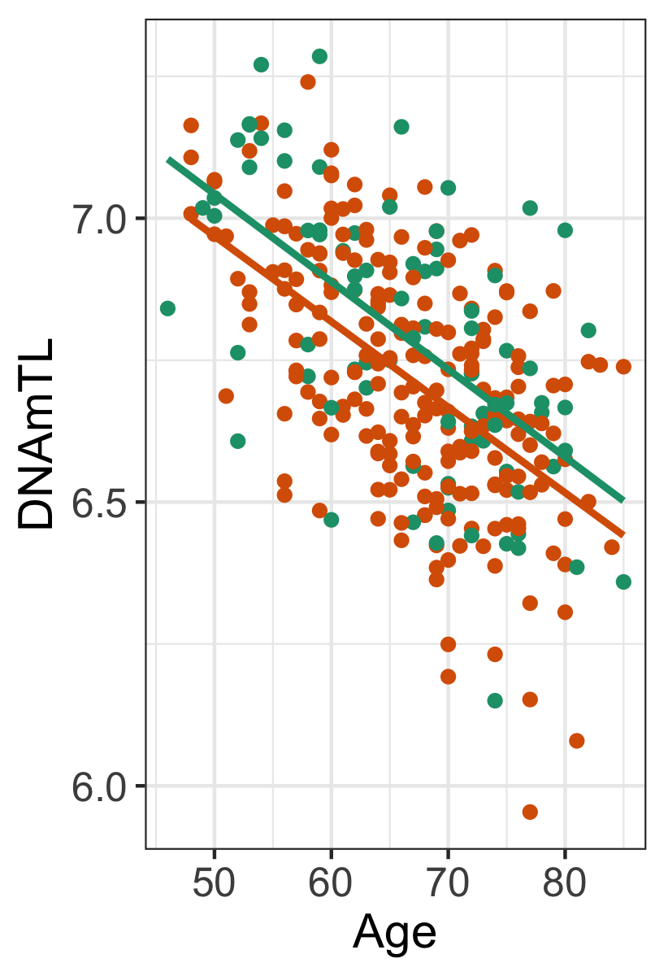
Figure S2. Linear relationship between DNAmTL (y-axis) and chronological age (x-axis). Green and orange colour represent non-exacerbators, and exacerbators, respectively.

