Supplemental Section for Methylprednisolone, Venous Thromboembolism, and Association with Heparin to 30 days in Hospital Survival in Severe COVID-19 Pneumonia
Ronaldo C. Go, Themba Nyirenda, Maryam Bojarian, Davood Karimi Housseini, Mehek Rahim, Kevin Kim, and Keith M. Rose

Table of Contents
Figure S1. Cohort Flow Chart 5
Table S1. Baseline Demographics Disease Characteristics on Unmatched Population 5
Figure S2. Bar plot of COVID-19 Hospitalizations in the 13 HMH Hospitals from March – June 2020 7
Figure S3. Spaghetti plot of inpatient COVID-19 patients in 13 HMH Hospitals between March to June 2020… 7
Table S2. Univariate and Multivariate Cox Regression Analyses of Propensity Score Matched Population 8
Figure S4. Boxplot of fraction of inspired oxygen (FiO2) reported on COVID-19 patients NMP, LD MP, and HD MP 9
Figure S5. Plot of differences Methylprednisolone – No Methylprednisolone in hospitalized COVID-19 patients 10
Figure S6. Comparison Boxplots of distributions of Logit of Propensity Scores for MP– NMP treated COVID-19 patients 11
Figure S7. Distributions of Logit of Propensity Scores for MP and NMP treated COVID-19 patients 12
Figure S8. A plot of log cumulative hazard function (-log (survival function)) by time for MP and NMP treated COVID-19 patients 13
Figure S9. A plot of log cumulative hazard function (-log (survival function)) by log(time) in MP and NMP treated COVID-19 patients 14
Figure S10. The plot of log cumulative hazard(-negative survival)) by days for the NMP , LD MP and HD MP treated COVID-19 patients 15
Figure S11. The plot of log cumulative hazard (-negative survival) by log (days) in NMP, LD MP, HD MP treated COVID-19 patients 16
Figure S12. Plot of observed standardized score process of methylprednisolone vs. 20 simulated realizations 17
Figure S13. Plot of observed standardized score process of methylprednisolone (MP) dose level (None, LD, HD) vs. 20 simulated realizations 18
Figure S14. Plot of observed standardized score process of FiO2 (%) vs. 20 simulated realizations 19
Table S3. Assessment of the Proportional Hazards Assumptions in Baseline Characteristics in COVID-19 Patients 20

Table S4. Assessment of the Proportional Hazards Assumptions for the Demographic and comorbidities 21
Table S5. Assessment of the Proportional Hazards Assumptions for the dichotomized lab values and respiratory rate 22
Table S6. Assessment of the Proportional Hazards Assumptions for therapy for COVID- 19 23
Table S7. Assessment of the Proportional Hazards Assumptions for clinical presentation parameters 24
Table S8. Assessment of the Proportional Hazards Assumptions for labs (continuous) form 25
Table S9. Assessment of the Proportional Hazards Assumptions for the inflammatory markers 26
Table S10. Assessment of the Proportional Hazards Assumptions for the vitals 27
Table S11. Univariate* Cox Regression Analysis of In-hospital Mortality in COVID-19 Patients 28
Table S12. Multivariable Risk of In-hospital mortality in COVID-19 patients with/without methylprednisolone 29
Table S13. Multivariable Risk of In-hospital mortality in COVID-19 patients with HD, LD and No methylprednisolone 30
Figure S17. Boxplots of fraction of inspired oxygen (FiO2) reported on admission in COVID-19 patients who were not treated with methylprednisolone and COVID-19 patients who received methylprednisolone 31
Figure S18. Boxplots of fraction of inspired oxygen (FiO2) reported on admission in COVID-19 patients who were not treated with methylprednisolone and COVID-19 patients who received LD methylprednisolone and HD methylprednisolone 32
Figure S19. Boxplot of Total Dose/Absolute Body Weight/Day in hospitalized COVID-19 patients who received Methylprednisolone (N=380) 33
Figure S20. Boxplot of Total Dose/Absolute Body Weight/Day in hospitalized COVID-19 patients who received LD Methylprednisolone (N=216) and HD Methylprednisolone (N=164) 34
Table S14. Level of Oxygen Support with Treatment 35
Table S15. Level of Oxygen Support and No methylprednisolone and Prophylactic anticoagulation 35

Table S16. Level of Oxygen Support for No Methylprednisolone and Therapeutic Anticoagulation 36
Table S17. Level of Oxygen Support and Methylprednisolone and Prophylactic Anticoagulation 36
Table S18.Level of Oxygen Support and Methylprednisolone and Therapeutic Anticoagulation 37

Figure S1. Cohort Flow Chart.
379 received no methylprednisolone
380 received no methylprednisolone
1121 patients where data abstracted but 759 included in propensity score matched sample

Excluded because: 3 < 18 years of age
71 pregnant
375 used other corticosteroids 92 not inpatient
2 duplicates
2041 patients ﬂagged in electronic health record in COVID -19

164 high dose
Methylprednisolone
215 low dose
Methylprednisolone

Table S1. Baseline Demographics Disease Characteristics on Unmatched Population

Variable | Unmatched No  methylprednisolone (N=645) | Unmatched Methylprednisolone (N=476) | P Value
Age in years | 64.00(53.00,79.00) | 64.00(56.00,73.00) | 0.6620
Male | 411(63.43) | 219(53.03) | 0.6079
Weight (kg) | 81.20(68.70,90.72) | 83.90(71.10,99.80) | 0.0040
BMI (kg/m²) | 28.18(24.83,31.65) | 29.48(25.94,34.30) | <.0001
Nursing Home | 125(19.38) | 43(10.26) | <.0001
Former/Current  smoker | 116(19.86) | 96(25.81) | 0.0377
Never smoker | 468(80.14) | 276(74.19) | 0.0377
SOB | 412(63.78) | 334(78.96) | <.0001
Cough | 417(64.75) | 301(71.16) | 0.0327
AMS | 109(17.33) | 46(11.11) | 0.0058
GI | 149(23.17) | 88(20.90) | 0.4077
Anosmia or Ageusia | 10(1.57) | 9(2.20) | 0.4834
Duration of Symptoms prior to  admission | 5.00(2.00,7.00) | 5.00(3.00,7.00) | 0.0165
Diabetes | 214(33.18) | 157(37.20) | 0.1888
COPD | 27(4.19) | 30(7.09) | 0.0506
Asthma | 40(6.22) | 40(9.48) | 0.0569
Cancer | 61(9.46) | 49(11.61) | 0.2594
CAD | 86(13.33) | 67(15.84) | 0.2839
CVA | 28(4.35) | 15(3.55) | 0.6336
CHF | 51(7.96) | 32(7.57) | 0.9071
Arrhythmia | 65(10.12) | 38(8.96) | 0.5967
Renal Failure | 40(6.23) | 33(7.78) | 0.3249
Rheumatologic  Disease | 15(2.33) | 22(5.20) | 0.0159

qSOFA 0 | 375(59.62) | 225(54.35) | 0.2544
qSOFA 1 | 199(31.64) | 156(37.68) | 0.2544
qSOFA 2 | 51(8.11) | 31(7.49) | 0.2544
qSOFA 3 | 4(0.64) | 2(0.48) | 0.2544
O2 sat < 94% | 305(48.41) | 225(57.25) | 0.0069
Temperature | 99.00(98.00,100.70) | 99.30(98.00,100.80) | 0.0476
Heart Rate | 95.00(82.00,108.00) | 95.00(82.00,108.00) | 0.0581
Respiratory Rate | 19.00(18.00,21.00) | 20.00(18.00,22.00) | 0.0097
Nasal Cannula | 227(82.85) | 137(66.50) | 0.0005
Venti mask | 4(1.46) | 3(1.46) | 0.0005
High Flow | 8(2.92) | 15(7.28) | 0.0005
CPAP | 1(0.36) | 2(0.97) | 0.0005
BPAP | 0(0.00) | 2(0.97) | 0.0005
Mechanical  Ventilation | 55(10.62) | 138(39.88) | <.0001
WBC | 6.50(5.00,9.10) | 6.50(5.10,9.50) | 0.5947
HGB | 13.40(12.00,14.50) | 13.50(12.20,14.80) | 0.2190
PLT | 200.00(158.00,251.00) | 186.00(147.00,251.0  0) | 0.0596
ALC | 0.90(0.60,1.20) | 0.79(0.60,1.10) | 0.0007
IL6 | 11.50(5.00,34.00) | 12.00(5.00,32.00) | 0.6607
CRP | 10.91(5.20,20.79) | 13.11(7.09,20.20) | 0.0444
D-Dimer | 1.01(0.64,2.11) | 0.98(0.61,1.89) | 0.7909
Ferritin | 641.89(320.65,1453.6  0 | 838.96(430.40,1569.  80) | 0.0044
Creatinine | 1.00(0.80,1.40) | 1.01(0.80,1.33) | 0.9379
Troponin | 0.03(0.01,0.30) | 0.02(0.01,0.09) | 0.0516
BNP | 103.70(29.85,701.30) | 88.80(26.20,362.00) | 0.1702
Hydroxychloroquin  e | 463(73.73) | 333(88.33) | <.0001
Azithromycin | 438(70.19) | 277(73.47) | 0.2793
Remdesivir | 4(0.65) | 63(16.80) | 0.0061
Tocilizumab | 31(5.01) | 11(2.94) | <.0001
Convalescent  Plasma | 0(0.00) | 4(28.57) | 0.0002
ECMO | 1(0.17) | 9(2.43) | 0.0011
Dialysis | 19(3.09) | 11(2.92) | 0.8748

HR = Hazard Ratio; CI = Confidence Interval; SOB = Shortness of Breath; AMS = Altered Mental Status; GI = Gastrointestinal Symptoms; PTA = Prior to admission; COPD = Chronic Obstructive Disease; CAD = Coronary Artery Disease; CVA = Cerebrovascular Accident; CHF = Congestive Heart Failure; LFTs = elevated liver function tests; qSOFA = Quick Sepsis Related Organ Failure Assessment; HCQ = Hydroxychloroquine; AZ = Azithromycin; MP = Methylprednisolone; HD MP = High Dose Methylprednisolone; LD MP = Low Dose Methylprednisolone; WBC= White Blood Cells; HGB = Hemoglobin; PLT = Platelet; ALC = Absolute Lymphocyte Count; ECMO = Extracorporeal Membrane Oxygenation

Figure S2. Bar plot of COVID-19 Hospitalizations in the 13 HMH Hospitals from March – June 2020. Hackensack University Medical Center (HUM) has 4 hospitals combined.

500
Hospital
BMC JFK OMC RBO RMC HUM JSU PMC RBP SOM

400

300
Maximum Daily IP Census

200

100

0
March

April

May

June

Hospitalization Month

Figure S3. Spaghetti plot of inpatient COVID-19 patients in 13 HMH Hospitals between March to June 2020.
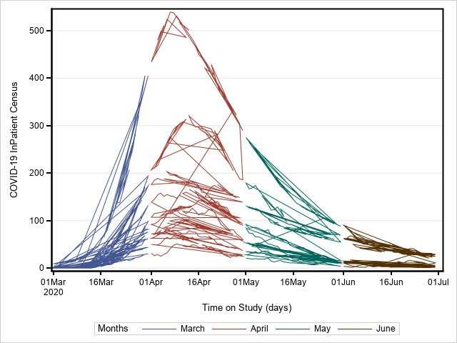

Table S2. Univariate and Multivariate Cox Regression Analyses of Propensity Score Matched Population

Univariate Cox Regression |  |  | Multivariate Cox Regression
Comparison | HR (95% CI) | P-Value |  | Comparison | HR (95% CI) | P-Value
Male vs Female | 1.20 (0.93, 1.56) | 0.1691 |  | Model 1: MP vs NMP
Age>60 vs <60 | 2.83 (2.05, 3.91) | <.0001 |  | MP vs NMP | 0.40(0.27,0.59) | <0.0001
Current vs Non Smoker | 0.62(0.29, 1.32) | 0.2154 |  | Nursing home vs Residential | 3.08(1.94,4.89) | >0.0001
Former vs Current Smoker | 1.21(0.91, 1.61) | 0.1934 |  | CAD vs None | 2.12(1.38,3.27) | 0.0006
Nursing Home vs Residential | 2.81(1.99, 3.96) | <.0001 |  | Invasive Mechanical Ventilation vs None | 2.87(1.64,5.02) | 0.0002
Symptoms |  |  |  | Non-Mechanical Ventilation Oxygen Support vs None | 1.11(0.60,2.05) | 0.7483
Fever vs None | 0.88 (0.67, 1.15) | 0.3445 |  | Model 2: Dose (LD or HD) vs NMP
SOB vs None | 1.18 (0.91, 1.53) | 0.2233 |  | HD MP vs NMP | 0.48(0.30,0.77) | 0.0025
Cough vs None | 0.79 (0.61, 1.01) | 0.0641 |  | LD MP vs NMP | 0.35(0.22,0.53) | <0.0001
AMS vs None | 3.14(2.32, 4.26) | <.0001 |  | Nursing Home vs Residential | 2.95(1.83,4.76) | <0.0001
GI vs None | 0.66(0.47, 0.93) | 0.0185 |  | CAD vs None | 2.22 (1.44,3.42) | 0.0003
Anosmia or Ageusia vs  None | NA | <.0001 |  | Invasive Mechanical Ventilation vs None | 2.77(1.58,4.86) | 0.0004
Duration of Symptoms PTA > 7 vs < 7 days | 0.61 (0.41, 0.91) | 0.0143 |  | Non-Mechanical Ventilation Oxygen Support vs None | 1.13(0.61,2.09) | 0.6992
Comorbidities
Diabetes vs None | 1.06 (0.82, 1.37) | 0.6503
COPD vs None | 2.44 (1.64, 3.63) | <.0001
Asthma vs None | 0.89 (0.56,1.41) | 0.6042
COPD/Asthma vs None | 1.49(1.07, 2.05) | 0.0169
Hypertension vs None | 2.12 (1.60, 2.81) | <.0001
Cancer vs None | 2.08 (1.46, 2.97) | <.0001
CAD vs None | 2.09 (1.56, 2.79) | <.0001
CVA vs None | 2.24 (1.44, 3.50) | 0.0004
CHF vs None | 2.12 (1.41, 3.21) | 0.0004
Arrhythmia vs None | 2.07 (1.43, 2.98) | 0.0001
Renal Failure vs None | 1.95 (1.37, 2.78) | 0.0002
Dialysis vs None | 0.74 (0.39, 1.43) | 0.3726
Elevated LFTS vs None | 1.03 (0.80, 1.33) | 0.8142
Oxygen Support
Low Oxygen Saturation vs None | 0.99 (0.77, 1.28) | 0.9307
Invasive Mechanical Ventilation vs None | 1.62 (1.16, 2.27) | 0.0051
Non-Mechanical Ventilation Oxygen Support Vs None | 0.98 (0.64, 1.50) | 0.9233
qSOFA
qSOFA 3 vs 0 | 10.23 (5.00, 20.96) | <.0001
qSOFA 2 vs 0 | 3.64 (2.41, 5.50) | <.0001
qSOFA 1 vs 0 | 1.42 (1.07, 1.90) | 0.0169
COVID-19 Treatment
Hydroxychloroquine vs None | 0.41 (0.30, 0.56) | <.0001
Azithromycin vs None | 0.64 (0.49, 0.84) | 0.0012
HCQ and Az vs None | 0.89 (0.19, 4.26) | 0.8860
Remdesivir vs None | 0.78 (0.34, 1.81) | 0.5637
Tocilizumab vs None | 0.68 (0.47, 0.98) | 0.0407
Convalescent Plasma vs None | 0.23 (0.03, 1.74) | 0.1558
Methylprednisolone
Dose
MP vs NMP | 0.44 (0.33, 0.60) | <.0001
HD MP vs NMP | 0.61 (0.44, 0.85) | 0.0033
LD MP vs NMP | 0.34 (0.24, 0.48) | <.0001

Figure S4. Boxplot of fraction of inspired oxygen (FiO2) reported on COVID-19 patients NMP, LD MP, and HD MP.
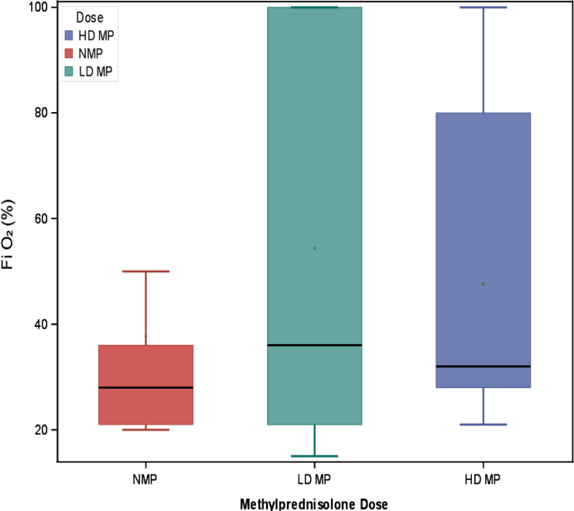

Figure S5. Plot of differences Methylprednisolone – No Methylprednisolone in hospitalized COVID-19 patients. The plot shows that the differences were very close to zero as were the Logit propensity scores.

Standardized Mean Differences

crpd1High

LowOxygen

renal_failure

respRate_high

cancer

hypertension

diabetes

sex

OlderAge

ObesityStatus

Logit Prop Score

-1.0 -0.5 0.0 0.5 1.0
Difference (Treated - Control)
All Obs Region Obs Matched Obs Negligible differences

Figure S6. Comparison Boxplots of distributions of Logit of Propensity Scores for MP– NMP treated COVID-19 patients. The boxplots show that the two distributions are well balanced for the MP-NMP matched observations.
Distribution of LPS

Matched
Treated (Methylpredn = Methylprednisolone) Control (Methylpredn = None) dnisolone)

Region
Observations

All

-2 -1 0 1
Logit of Propensity Score

Figure S7. LPS Cloud Plots showing Distributions of Logit of Propensity Scores for MP and NMP treated COVID-19 patients. The propensity matching procedure failed to match only 8 of the methylprednisolone patients with any of patients who did not receive methylprednisolone during their COVID-19 hospitalization.
Taken together, Table S1 and Table S2 and Figures S1-S3 show that that propensity matched sample of 384 pairs yielded reasonably well-balanced distributions to conduct subsequent analyses.

LPS Clouds

Treated
Observations

Control

-2 -1 0 1
Logit of Propensity Score
Outside Support Region Support Region (Not Matched) Matched Obs

Figure S8. A plot of log cumulative hazard function (-log (survival function)) by time for MP and NMP treated COVID-19 patients. The plot showed that cumulative hazard function made a sharp increase by day 40 and the no methylprednisolone cohort had a mild slowing rate around 30 days. This graph indicates that the methylprednisolone the proportional hazard assumption may not been satisfied.
Negative Log of Estimated Survivor Functions

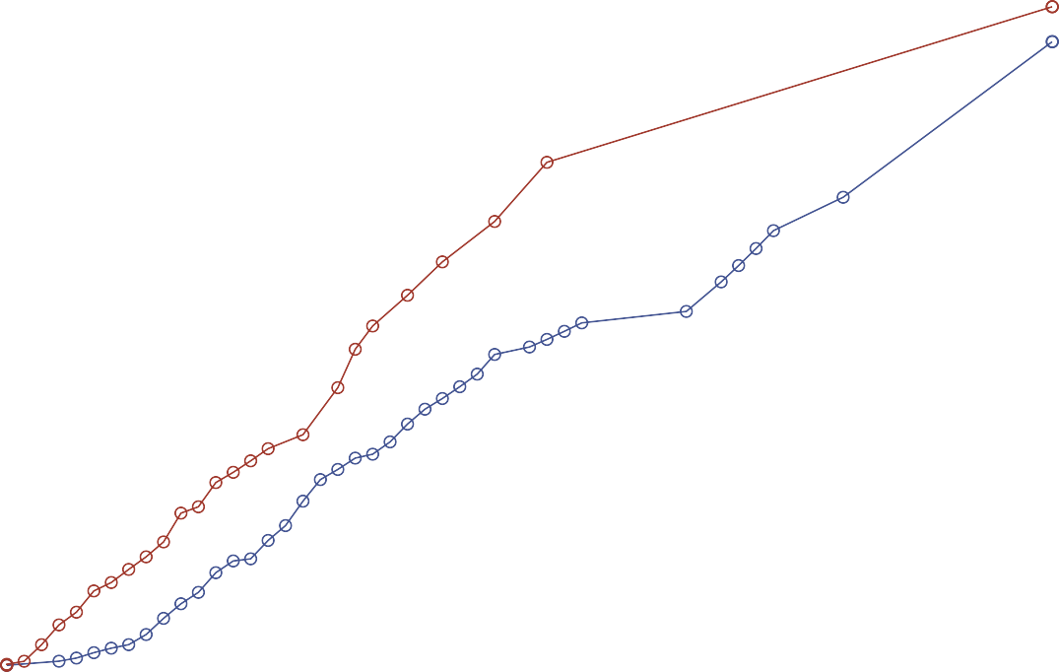1.5

1.0
-log(Survival Probability)

0.5

0.0
0 10 20 30 40 50 60
Days
Treatment MP NMP

Figure S9. A plot of log cumulative hazard function (-log (survival function)) by log(time) in MP and NMP treated COVID-19 patients. The shows that hazard in the methylprednisolone cohort were increasing more rapidly after 2 (log (Days)) indicating there was a possible interaction between methylprednisolone and days since admission.

Log of Negative Log of Estimated Survivor Functions

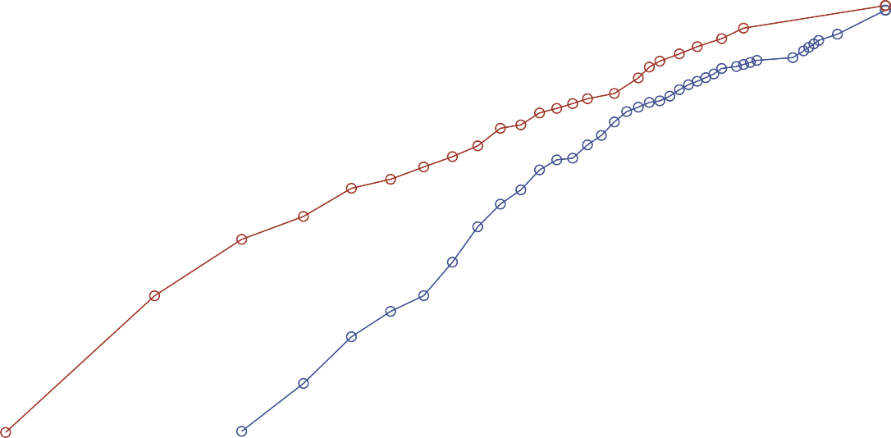0

-2
log[-log(Survival Probability)]

-4

-6
0 1 2 3 4
log(Days)
Treatment MP NMP

Figure S10. The plot of log(cumulative hazard)(-negative survival)) by days for the NMP , LD MP and HD MP treated COVID-19 patients. The graph show that cumulative hazard in HD and LD methylprednisolone were increase and in particular the HD MP was increasing much faster than LD after 40 days, this suggest that the proportional hazard assumption may not have been met.

Negative Log of Estimated Survivor Functions
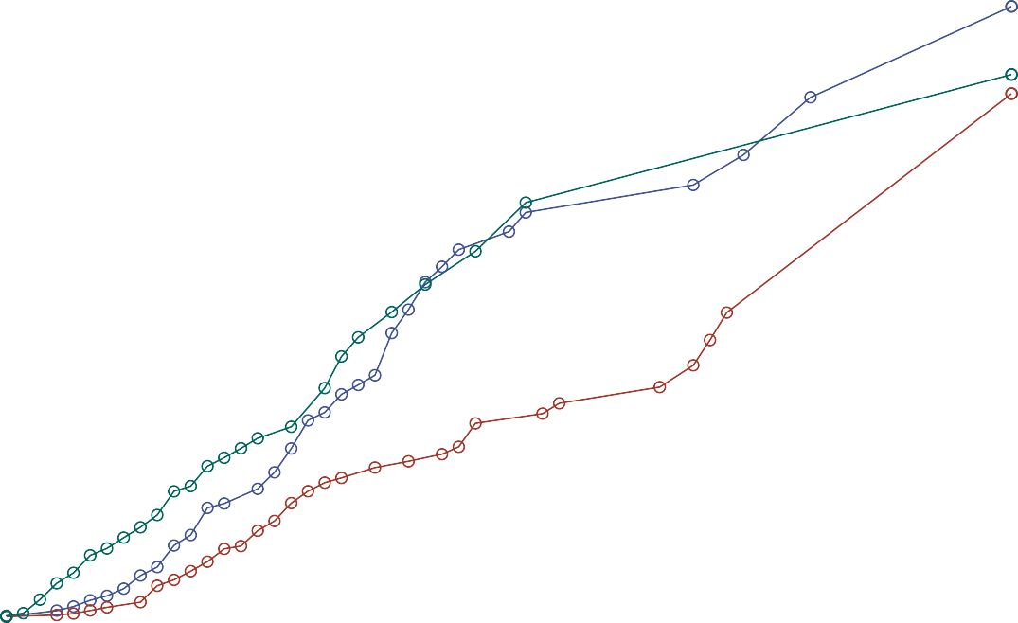2.0

1.5

1.0
-log(Survival Probability)

0.5

0.0
0 10 20 30 40 50 60
Days
Dose HD MP LD MP NMP

Figure S11. The plot of log cumulative hazard (-negative survival) by log (days) in NMP , LD MP , HD MP treated COVID-19 patients. show that cumulative hazard in HD and LD methylprednisolone were increase and in particular the HD MP was increasing much faster than LD after 2 log days, and by 3 log days, the HD MP and NMP are the same path while LD increased slowly before increasing faster before 4 log days. This suggest that the proportional hazard assumption may not have been met.

Log of Negative Log of Estimated Survivor Functions

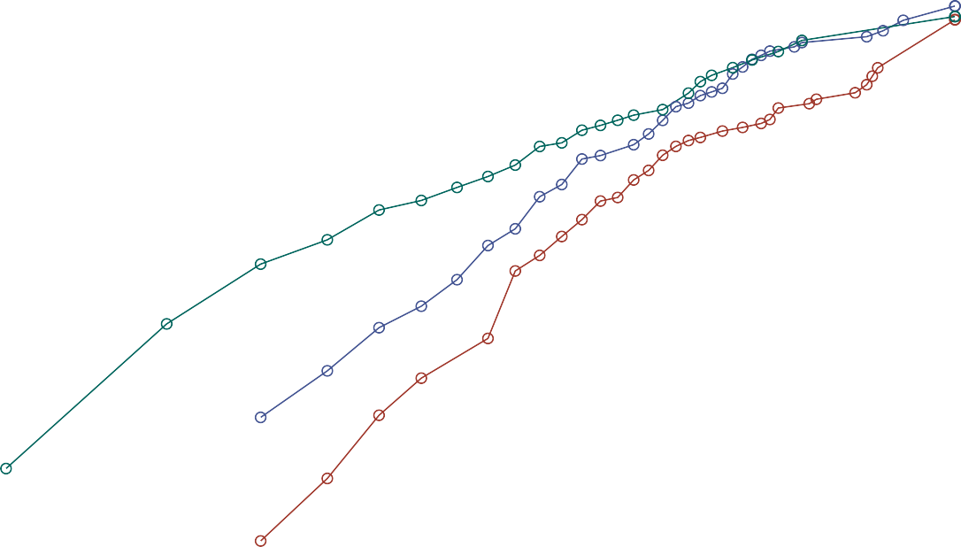0

-2
log[-log(Survival Probability)]

-4

-6
0 1 2 3 4
log(Days)
Dose HD MP LD MP NMP

In the following, we examined the proportional assumption using a formal test of Supremum test of proportionality, Lin, Wei, Ying (1993). Table S3 is a summary of all the covariates that were indicated to failed to satisfy the proportional based on the Supremum test. Tables S4 – S10 contain the results of the test for each variable included in the propensity matched cohort.

Figure S14. Plot of observed standardized score process of methylprednisolone vs. 20 simulated realizations. The plot shows that with the first 20 of 1,000 simulated realizations(depicted by thin dotted line) conducted here, the observed MP process (depicted by the thick solid line) exhibited significant deviation from the paths of simulations within the first 20 days since the COVID-19 admission and then thereafter the MP process was more typical with simulated realization. Over the 1000 simulated realization, the supremum test reported an absolute maximum value of 2.2103 with p-value of <0.0001. Thus, the test indicated that methylprednisolone administration significantly violated the proportional hazards assumption.

Checking Proportional Hazards Assumption for Methylprednisolone
Observed Path and First 20 Simulated Paths

1
Pr > MaxAbsVal: <.0001
(1000 Simulations)

0
Standardized Score Process

-1

-2

0 10 20 30 40 50 60
Days

Figure S15. Plot of observed standardized score process of methylprednisolone (MP) dose level (NMP, LD, HD) vs. 20 simulated realizations. The plot shows that with the first 20 of 1,000 simulated realizations(depicted by thin dotted line) conducted here, the observed MP dose process (depicted by the thick solid line) exhibited significant deviation from the paths of simulations within the first 20 days since the COVID-19 admission and then thereafter the MP dose process was more typical with simulated realizations. Over the 1000 simulated realization, the supremum test reported an absolute maximum value of 2.360 with p-value of <0.0001. Thus, the test indicated that methylprednisolone dose level significantly violated the proportional hazards assumption.

Checking Proportional Hazards Assumption for MethylprednisoloneDose
Observed Path and First 20 Simulated Paths

1
Pr > MaxAbsVal: <.0001
(1000 Simulations)

0
Standardized Score Process

-1

-2

0 10 20 30 40 50 60
Days

Figure S16. Plot of observed standardized score process of FiO2 (%) vs. 20 simulated realizations. The plot shows that with the first 20 of 1,000 simulated realizations(depicted by thin dotted line) conducted here, the observed FiO2 process (depicted by the thick solid line) exhibited significant deviation from the paths of simulations within the first 20 days since the COVID-19 admission and then thereafter the FiO2 process was more typical with simulated realizations.
Over the 1000 simulated realization, the supremum test reported an absolute maximum value of 2.4993 with p-value of <0.0001. Thus, the test indicated that FiO2 level significantly violated the proportional hazards assumption.

Checking Proportional Hazards Assumption for FiO2
Observed Path and First 20 Simulated Paths

2
Pr > MaxAbsVal: <.0001
(1000 Simulations)

1
Standardized Score Process

0

-1

0 10 20 30 40 50 60
Days

Table S3. Assessment of the Proportional Hazards Assumptions in Baseline Characteristics in COVID-19 Patients
Variable | Max Abs Value | Replications | Seed | P-Value
Nursing Home | 1.4886 | 1000 | 19 | 0.0110
Anosmia or Ageusia | 0.0030 | 1000 | 19 | <.0001
WBC lower | 2.3013 | 1000 | 19 | <.0001
Creatinine high | 1.2404 | 1000 | 19 | 0.0400
Respiratory Rate high | 1.3106 | 1000 | 19 | 0.0420
Hydroxychloroquine | 1.6164 | 1000 | 19 | 0.0020
Methylprednisolone | 2.2103 | 1000 | 19 | <.0001
HD/LD/No Methylprednisolone | 2.3601 | 1000 | 19 | <.0001
Fi02 | 2.4993 | 1000 | 19 | <.0001
qSOFA | 1.5330 | 1000 | 19 | 0.0200
Calcium | 1.3128 | 1000 | 19 | 0.0360
Initial BP (diastolic) | 1.4722 | 1000 | 19 | 0.0330
Supremum Test for Proportional Hazard Assumption. Any P<0.05 was Statistically Significant.

Table S4. Assessment of the Proportional Hazards Assumptions for the Demographic and comorbidities

Variable | Max Abs Value | Replications | Seed | P-Value
Sex | 0.8227 | 1000 | 19 | 0.3490
Older age | 1.0353 | 1000 | 19 | 0.1520
Obesity status | 1.1676 | 1000 | 19 | 0.0660
Form current Smoker | 0.6363 | 1000 | 19 | 0.6040
Is Smoker | 0.5641 | 1000 | 19 | 0.7890
Nursing Home | 1.4886 | 1000 | 19 | 0.0110
Fever | 0.3243 | 1000 | 19 | 0.9880
SOB | 1.0332 | 1000 | 19 | 0.1350
Cough | 0.9889 | 1000 | 19 | 0.1750
AMS Symptoms | 1.1986 | 1000 | 19 | 0.0530
GI | 0.6098 | 1000 | 19 | 0.6500
Anosmia or Ageusia | 0.0030 | 1000 | 19 | <.0001
Symptoms>7days | 0.5481 | 1000 | 19 | 0.7380
Duration symptom Cat | 0.8762 | 1000 | 19 | 0.2280
Diabetes | 0.6145 | 1000 | 19 | 0.6330
COPD_O2 | 0.6974 | 1000 | 19 | 0.4280
COPD | 0.2846 | 1000 | 19 | 0.9930
Asthma | 0.5324 | 1000 | 19 | 0.7420
COPD/asthma | 0.3837 | 1000 | 19 | 0.9530
Hypertension | 0.9271 | 1000 | 19 | 0.2310
Cancer | 1.0278 | 1000 | 19 | 0.1280
Coronary | 0.8326 | 1000 | 19 | 0.3160
Coronary Stroke | 1.1629 | 1000 | 19 | 0.0920
Coronary Heart | 0.9956 | 1000 | 19 | 0.1510
Coronary Arrhythmia | 0.8273 | 1000 | 19 | 0.2920

Variable | Max Abs Value | Replications | Seed | P-Value
Renal Failure | 0.5449 | 1000 | 19 | 0.7580
Renal Failure Dialysis | 0.6128 | 1000 | 19 | 0.5880
Rheumatic disease disorder | 0.6623 | 1000 | 19 | 0.5470
Supremum Test for Proportional Hazard Assumption. Any P<0.05 was Statistically Significant.

Table S5. Assessment of the Proportional Hazards Assumptions for the dichotomized lab values and respiratory rate

Variable | Max Abs Value | Replications | Seed | P-Value
WBC lower | 2.3013 | 1000 | 19 | <.0001
HBG lower norm | 1.1560 | 1000 | 19 | 0.0730
Platelet lower norm | 0.6383 | 1000 | 19 | 0.5980
Abs lymphocyte lower norm | 0.6654 | 1000 | 19 | 0.4550
IL-6 high | 1.1596 | 1000 | 19 | 0.0830
CRP d1 High | 0.9503 | 1000 | 19 | 0.2040
Ferritin high | 0.5388 | 1000 | 19 | 0.7860
D-dimer categ | 0.9539 | 1000 | 19 | 0.2180
Creatinine high | 1.2404 | 1000 | 19 | 0.0400
Respiratory Rate high | 1.3106 | 1000 | 19 | 0.0420
Supremum Test for proportional hazard assumption. Any p<0.05 was statistically significant.

Table S6. Assessment of the Proportional Hazards Assumptions for therapy for COVID-19

Variable | Max Abs Value | Replications | Seed | P-  Value
HCQ | 1.6164 | 1000 | 19 | 0.0020
Azithromycin | 0.8226 | 1000 | 19 | 0.3600
HCQ and AZ | 0.7439 | 1000 | 19 | 0.2570
Remdesivir | 0.7195 | 1000 | 19 | 0.4200
Tocilizumab | 0.7093 | 1000 | 19 | 0.4830
SAR | 0.8885 | 1000 | 19 | 0.2530
Convalescent Plasma | 0.4901 | 1000 | 19 | 0.3390
Methylprednisolone | 2.2103 | 1000 | 19 | <.0001
HD/LD/No Methylprednisolone | 2.3601 | 1000 | 19 | <.0001
Supremum Test for proportional hazard assumption. Any p<0.05 was statistically significant

Table S7. Assessment of the Proportional Hazards Assumptions for clinical presentation parameters

Variable | Max Abs Value | Replications | Seed | P-Value
Elevated LFTs | 0.8344 | 1000 | 19 | 0.3650
Low Oxygen | 0.9414 | 1000 | 19 | 0.2120
Supplemental Oxygen | 0.8402 | 1000 | 19 | 0.3030
FiO2 | 2.4993 | 1000 | 19 | <.0001
qSOFA | 1.5330 | 1000 | 19 | 0.0200
Fever Temp | 0.7363 | 1000 | 19 | 0.5400
Intubated | 1.0596 | 1000 | 19 | 0.1160
Mechanical ventilation | 0.5595 | 1000 | 19 | 0.5940
Supremum Test for proportional hazard assumption. Any p<0.05 was statistically significant.

Table S8. Assessment of the Proportional Hazards Assumptions for labs (continuous) form

Variable | Max Abs Value | Replications | Seed | P-  Value
White Blood Cells | 0.7495 | 1000 | 19 | 0.1300
Abs. neutrophil count | 0.9530 | 1000 | 19 | 0.2840
Abs. lymphocyte count | 0.9140 | 1000 | 19 | 0.2870
Abs. Neutrophil/Lymphocyte Ratio | 0.8075 | 1000 | 19 | 0.3350
Platelets | 0.8027 | 1000 | 19 | 0.4820
HGB | 1.0019 | 1000 | 19 | 0.3350
LDH | 0.5495 | 1000 | 19 | 0.8100
Ferritin | 0.9932 | 1000 | 19 | 0.1850
D-dimer | 0.4179 | 1000 | 19 | 0.8120
C-reactive Protein | 0.6009 | 1000 | 19 | 0.6370
Troponin | 0.6315 | 1000 | 19 | 0.3740
BNP | 0.8043 | 1000 | 19 | 0.0980
Creatinine | 0.8413 | 1000 | 19 | 0.1350
AST | 0.5009 | 1000 | 19 | 0.5200
ALT | 0.4692 | 1000 | 19 | 0.6730
Bilirubin | 0.1955 | 1000 | 19 | 0.5030
Supremum Test for proportional hazard assumption. Any p<0.05 was statistically significant.

Table S9. Assessment of the Proportional Hazards Assumptions for the inflammatory markers

Variable | Max Abs Value | Replications | Seed | P-  Value
IL-6 on Admission | 0.4438 | 1000 | 19 | 0.6970
IL-6 Recent | 0.4438 | 1000 | 19 | 0.6970
CK | 0.7009 | 1000 | 19 | 0.1930
La | 0.8184 | 1000 | 19 | 0.3190
Potassium | 0.8724 | 1000 | 19 | 0.2810
Magnesium | 0.6025 | 1000 | 19 | 0.5370
Phosphate | 0.4909 | 1000 | 19 | 0.3360
Calcium | 1.3128 | 1000 | 19 | 0.0360
Sodium | 0.3766 | 1000 | 19 | 0.8310
BUN | 0.4980 | 1000 | 19 | 0.5620
HCT | 0.7023 | 1000 | 19 | 0.6600
Glucose | 0.4796 | 1000 | 19 | 0.5520
Total bilirubin | 0.3156 | 1000 | 19 | 0.7450
Supremum Test for proportional hazard assumption. Any p<0.05 was statistically significant.

Table S10. Assessment of the Proportional Hazards Assumptions for the vitals

Variable | Max Abs Value | Replications | Seed | P-Value
Initial temperature | 0.5519 | 1000 | 19 | 0.7350
Initial Heart rate | 0.3960 | 1000 | 19 | 0.9890
Initial BP (Systolic) | 0.7093 | 1000 | 19 | 0.6500
Initial BP (diastolic) | 1.4722 | 1000 | 19 | 0.0330
Mean arterial pressure | 1.2078 | 1000 | 19 | 0.1220
Initial Respiratory Rate | 0.4505 | 1000 | 19 | 0.5730
Height (cm) | 0.5232 | 1000 | 19 | 0.7760
Weight(kg) | 0.9904 | 1000 | 19 | 0.1310
BMI kg/m² | 1.0447 | 1000 | 19 | 0.1000
Diagnosis age years | 1.3620 | 1000 | 19 | 0.0500
Supremum Test for proportional hazard assumption. Any p<0.05 was statistically significant.

Table S11. Univariate* Cox Regression Analysis of In-hospital Mortality in COVID-19 Patients
* univariate associations were reported for covariate that satisfied the proportional hazard assumption with since admission to COVID-19 hospitalization. Variables which demonstrated that the NPH assumption was violated were adjusted by inclusion of an interaction of FiO2 and time, and FiO2 in the model.

Comparison Effect | HR (95% CI) | P-Value
Male vs Female | 1.20 (0.93, 1.56) | 0.1691
Age>60 vs <60 | 2.83 (2.05, 3.91) | <.0001
Current vs Non-Smoker | 0.62(0.29, 1.32) | 0.2154
Former vs Current Smoker | 1.21(0.91, 1.61) | 0.1934
Nursing Home vs Home | 2.81(1.99, 3.96) | <.0001
Symptoms
Fever vs None | 0.88 (0.67, 1.15) | 0.3445
SOB vs None | 1.18 (0.91, 1.53) | 0.2233
Cough vs None | 0.79 (0.61, 1.01) | 0.0641
AMS vs None | 3.14(2.32, 4.26) | <.0001
GI vs None | 0.66(0.47, 0.93) | 0.0185
Anosmia or Ageusia vs None | NA | <.0001
Duration of Symptoms PTA > 7 vs < 7 days | 0.61 (0.41, 0.91) | 0.0143
Diabetes vs None | 1.06 (0.82, 1.37) | 0.6503
COPD vs None | 2.44 (1.64, 3.63) | <.0001
Asthma vs None | 0.89 (0.56,1.41) | 0.6042
COPD/Asthma vs None | 1.49(1.07, 2.05) | 0.0169
Hypertension vs None | 2.12 (1.60, 2.81) | <.0001
Cancer vs None | 2.08 (1.46, 2.97) | <.0001
CAD vs None | 2.09 (1.56, 2.79) | <.0001
CVA vs None | 2.24 (1.44, 3.50) | 0.0004
CHF vs None | 2.12 (1.41, 3.21) | 0.0004
Arrhythmia vs None | 2.07 (1.43, 2.98) | 0.0001
Renal Failure vs None | 1.95 (1.37, 2.78) | 0.0002
Dialysis vs None | 0.74 (0.39, 1.43) | 0.3726
Presentations Characteristics
Elevated LFTS vs None | 1.03 (0.80, 1.33) | 0.8142
Low Oxygen Saturation vs None | 0.99 (0.77, 1.28) | 0.9307
Mechanical Ventilation vs None | 1.62 (1.16, 2.27) | 0.0051
Non-Mechanical Ventilation Oxygen Support Vs None | 0.98 (0.64, 1.50) | 0.9233
qSOFA 3 vs 0 | 10.23 (5.00, 20.96) | <.0001
qSOFA 2 vs 0 | 3.64 (2.41, 5.50) | <.0001

Comparison Effect | HR (95% CI) | P-Value
qSOFA 1 vs 0 | 1.42 (1.07, 1.90) | 0.0169
Hydroxychloroquine vs None | 0.41 (0.30, 0.56) | <.0001
Azithromycin vs None | 0.64 (0.49, 0.84) | 0.0012
HCQ and Az vs None | 0.89 (0.19, 4.26) | 0.8860
Remdesivir vs None | 0.78 (0.34, 1.81) | 0.5637
Tocilizumab vs None | 0.68 (0.47, 0.98) | 0.0407
Convalescent Plasma vs None | 0.23 (0.03, 1.74) | 0.1558
Methylprednisolone
Dose
MP vs NMP | 0.44 (0.33, 0.60) | <.0001
HD MP vs NMP | 0.61 (0.44, 0.85) | 0.0033
LD MP vs NMP | 0.34 (0.24, 0.48) | <.0001
Level of Oxygen Support Vs MP Dose
No oxygen support in HD MP vs NMP | 0.96 (0.49, 1.86) | 0.8940
No oxygen support in LD MP vs NMP | 0.25 (0.10, 0.62) | 0.0028
Oxygen support in HD MP vs NMP | 0.50 (0.24, 1.06) | 0.0701
Oxygen support in LD MP vs NMP | 0.08 (0.02, 0.28) | <.0001
Mechanical Ventilation in HD MP vs NMP | 0.39 (0.23, 0.65) | 0.0003
Mechanical Ventilation in LD MP vs NMP | 0.34 (0.20, 0.57) | <.0001
HR = Hazard Ratio; CI = Confidence Interval; SOB = Shortness of Breath; AMS = Altered Mental Status; GI = Gastrointestinal Symptoms; PTA = Prior to admission; COPD = Chronic Obstructive Disease; CAD = Coronary Artery Disease; CVA = Cerebrovascular Accident; CHF
= Congestive Heart Failure; LFTs = elevated liver function tests; SOFA = Sequential Organ Failure Assessment; HCQ = Hydroxychloroquine; AZ = Azithromycin; MP = Methylprednisolone; HD MP = High Dose Methylprednisolone; LD MP = Low Dose Methylprednisolone

Table S12. Multivariable Risk of In-hospital mortality in COVID-19 patients with/without methylprednisolone Model 1 included interaction of FiO2 and time to adjust for interaction between time and risk factors including methylprednisolone, nursing home, coronary artery disease, supplemental oxygen in mechanical ventilation form vs none, supplemental oxygen in non-mechanical ventilation form vs none, hydroxychloroquine, and azithromycin.

Variable | Category | HR (95% CI) | P-Value
Methylprednisolone | Methylprednisolone vs None | 0.40 (0.27, 0.59) | <.0001
Nursing home | Yes vs. No | 3.08 (1.94, 4.89) | <.0001
Coronary Artery Disease | Yes vs. No | 2.12 (1.38, 3.27) | 0.0006
Supplemental Oxygen | Mechanical-Ventilation vs. None | 2.87 (1.64, 5.02) | 0.0002
Supplemental Oxygen | Non-mechanical Ventilation vs. None | 1.11 (0.60, 2.05) | 0.7483
Hydroxychloroquine | Yes vs. No | 0.67 (0.43,1.02) | 0.0644
Azithromycin | Yes vs. No | 0.64 (0.44, 0.93) | 0.0183
HR, Hazard Ratio; CI, confidence interval
Risk of in-hospital mortality by nonproportional hazard (NPH) Cox Regression model. Any p<0.05 was statistically significant.

Table S13. Multivariable Risk of In-hospital mortality in COVID-19 patients with HD, LD and No methylprednisolone. Model 2 included interaction of FiO2 and time to adjust for interaction between time and risk factors including methylprednisolone dose {High Dose(HD),Low Dose (LD), None}, nursing home, coronary artery disease, supplemental oxygen in mechanical ventilation form vs none, supplemental oxygen in non-mechanical ventilation form vs none, hydroxychloroquine, and azithromycin.

Variable | Category | HR (95% CI) | P-Value
Methylprednisolone Dose | HD Methylprednisolone vs. None | 0.48 (0.30, 0.77) | 0.0025
Methylprednisolone Dose | LD Methylprednisolone vs. None | 0.35 (0.22, 0.53) | <.0001
Nursing home | Yes vs. No | 2.95 (1.83, 4.76) | <.0001
Coronary Artery Disease | Yes vs. No | 2.22 (1.44, 3.42) | 0.0003
Supplemental Oxygen | Mechanical-Ventilation vs. None | 2.77(1.58, 4.86) | 0.0004
Supplemental Oxygen | Non-mechanical Ventilation vs. None | 1.13 (0.61, 2.09) | 0.6992
Hydroxychloroquine | Yes vs. No | 0.67 (0.44,1.02) | 0.0642
Azithromycin | Yes vs. No | 0.66 (0.45, 0.95) | 0.0262
HR, Hazard Ratio; CI, confidence interval. Risk of in-hospital mortality by nonproportional hazard (NPH) Cox Regression model. Any p<0.05 was statistically significant.

Figure S17. Boxplots of fraction of inspired oxygen (FiO2) reported on admission in COVID-19 patients who were not treated with methylprednisolone and COVID-19 patients who received methylprednisolone. In each boxplot, the horizontal line in the middle indicates the median, the bottom edge of the box is the 25th percentile and the top edge of the box is the 75th percentile of FiO2. The lower endpoints of the whiskers on each side of the box indicate the minimum and maximum value. The patients who did not receive methylprednisolone reported median FiO2 value of 28% (IQR: 21%- 36%) with a range of 20% to 100% from 368 of the 383 patients. The patients who received methylprednisolone reported median FiO2 value of 36% (IQR: 23% - 100%) with a range of 15% to 100% from 354 of the 380 patients. Analysis of FiO2 differences between matched patients indicated the median of 4.0% (IQR 0% to 35%) MP vs NMP was statistically significant (Wilcoxon signed rank test P<.0001).

100
MP Treatment
MP NMP

80

60
Fi O₂(%)

40

20

NMP MP
Methylprednisolone Treatment

Figure S18. Boxplots of fraction of inspired oxygen (FiO2) reported on admission in COVID-19 patients who were not treated with methylprednisolone (NMP) and COVID-19 patients who received LD methylprednisolone (LD MP) and HD methylprednisolone (HD MP). LD MP was defined as < 1.36 mg/kg/day and HD MP was defined as > 1.36 mg/kg/day. In each boxplot, the horizontal line in the middle indicates the median, the bottom edge of the box is the 25th percentile and the top edge of the box is the 75th percentile of FiO2. The lower endpoints of the whiskers on each side of the box indicate the minimum and maximum value. The patients who did not receive methylprednisolone reported median FiO2 value of 28% (IQR: 21%- 36%) with a range of 20% to 100% from 368 of the 383 patients. The patients who received LD MP reported median FiO2 value of 36% (IQR: 21% - 100%) with a range of 15% to 100% from 203 of the 380 patients. The patients who received HD MP reported median FiO2 value of 32% (IQR: 28%
- 80%) with a range of 21% to 100% from 151 of the 380 patients. Analysis of FiO2 differences between matched patients indicated the median of 4.0% (IQR 0% to 64%) LD MP vs NMP was statistically significant (Wilcoxon signed rank test P<.0001). Analysis of FiO2 differences between matched patients indicated the median of 7.0% (IQR 0% to 19%) HD MP vs NMP was statistically significant (Wilcoxon signed rank test P<.0001).

100
Dose HD MP NMP
LD MP

80

60
Fi O₂(%)

40

20

NMP LD MP HD MP
Methylprednisolone Dose

Figure S19. Boxplot of Total Dose/Absolute Body Weight/Day in hospitalized COVID-19 patients who received Methylprednisolone (N=380). In the box plot above, the horizontal line in the middle indicates the median, the bottom edge of the box is the 25th percentile and the top edge of the box is the 75th percentile of Total Dose/ABW/Day. The lower endpoints of the whiskers on each side of the box indicate the minimum and maximum value. The green dashed line at Total Dose/ABW/Day of 1.36 depicts the cut-off value that was determined by the Youden Index Method. The total dose/ABW/day in the all methylprednisolone treated patients had a median of 1.25 mg/kg/day (IQR: 0.93 – 1.72 mg/kg/day), range 0.27 – 7.98 mg/kg/day.The cut-off value of total dose/ABW/day of 1.36 mg/kg/day against the mortality event had an area under ROC curve of 56.8% (95% CI 51.7% to 62.0%), which is not very high. Further the cut-off value had a sensitivity of 51.8% and specificity of 62.0% in determining patients who are at higher risk for in-hospitality mortality than lower risk. Thus, while this cutoff value should not be used as a reference level since administration of methylprednisolone moderate-severe
COVID-19 was not employed as the main therapy in an clinically designed trial, but rescue therapy, it provides us with a measure of predictive capability that underpinned its prescription during new pandemic.

8
MP Dose
MP

6
Total Dose/ABW/Day (mg/kg/day)

4

2

0
MP
All Methylprednisolone-treated Patients

Figure S20. Boxplot of Total Dose/Absolute Body Weight/Day in hospitalized COVID-19 patients who received LD Methylprednisolone (N=216) and HD Methylprednisolone (N=164). In each boxplot, the horizontal line in the middle indicates the median, the bottom edge of the box is the 25th percentile and the top edge of the box is the 75th percentile of Total Dose/ABW/Day. The lower endpoints of the whiskers on each side of the box indicate the minimum and maximum value. The green dashed line at Total Dose/ABW/Day of 1.36 depicts the cut-off value that was determined by the Youden Index Method. The total dose/ABW/day in the LD methylprednisolone treated patients had a median of 0.98 mg/kg/day (IQR: 0.82 – 1.10 mg/kg/day), range 0.27 – 1.36 mg/kg/day. The total dose/ABW/day in the HD methylprednisolone treated patients had a median of 1.79 mg/kg/day (IQR: 1.55 – 2.14 mg/kg/day), range 1.37 – 7.98 mg/kg/day.

8
MP Dose
HD MP LD MP
TotalDoseByABWByDay

6
Total Dose/ABW/Day (mg/kg/day)

4

2

0
LD MP

Methylprednisolone Dose

HD MP

Table S14. Level of Oxygen Support with Treatment (Methylprednisolone and Anticoagulation)

 | MP + Anticoagulant (n=754)
Oxygen Support | Total (n=754) | NMP, NAc (n=106) | NMP, PAc (n=214) | NMP, TAc (n=58) | MP, NAc (n=24) | MP, PAc (n=178) | MP, TAc (n=174)
None | 256 | 44  41.51 | 87  40.65 | 24  41.38 | 12  50.00 | 60  33.71 | 29  16.67
Non-Invasive Oxygen Support | 282 | 54  50.94 | 108  50.47 | 20  34.48 | 9  37.50 | 69  38.76 | 22  12.64
Invasive Mechanical- Ventilation | 216 | 8  7.55 | 19  8.88 | 14  24.14 | 3  12.50 | 49  27.53 | 123  70.69
Abbreviations: NAc = No anticoagulation; Pac = Prophylactic anticoagulation; Tac = Therapeutic anticoagulation

Table S15. Level of Oxygen Support and No methylprednisolone and Prophylactic anticoagulation.
Out of 214 hospitalized patients, 42(19.6%) in the NMP+ PAc arm. The difference in in-hospital mortality between the levels of supplemental oxygen: None (16.1%) vs Non-invasive oxygen support (10.2%) vs invasive mechanical ventilation (89.5%%), was significant (p<0.0001)

No methylprednisolone + Prophylactic Anticoagulant (n=214)
 | Level of Oxygen Support
Expired | None (n=87) | Non-invasive oxygen  support  (n=108) | Invasive Mechanical-Ventilation (n=19) | P-value
Alive | 73 | 97 | 2
 | 83.91 | 89.81 | 10.53
Expired | 14 | 11 | 17 | <.0001
 | 16.09 | 10.19 | 89.47

Table S16. Level of Oxygen Support for No Methylprednisolone and Therapeutic Anticoagulation.
26 of 58 (44.8%) in the NMP+ Therapeutic Anticoagulant group. The difference in in-hospital mortality between the levels of supplemental oxygen: None (25.0%) vs non invasive oxygen support (45.0%) vs mechanical ventilation (78.6%) was significant(p=0.0059)

No Methylprednisolone and Therapeutic Anticoagulation
(N=58)
 | Level of Oxygen Support
Expired | None (N=24) | Non Invasive Oxygen Support  (N=20) | Invasive  Mechanical-Ventilation (N=14) | P-value
Alive | 18 | 11 | 3
 | 75.00 | 55.00 | 21.43
Expired | 6 | 9 | 11 | 0.0059
 | 25.00 | 45.00 | 78.57

Table S17. Level of Oxygen Support and Methylprednisolone and Prophylactic Anticoagulation.
46 of 178(25.8%) in the MP+ Prophylactic Anticoagulant group. The difference in in-hospital mortality between the levels of supplemental oxygen: None (16.7%) vs non invasive oxygen support(8.7%) vs invasive mechanical ventilation (61.2%) was significant(p<0.0001)

Methylprednisolone + Prophylactic Anticoagulant (n=178)
 | Supplemental Oxygen
Expired | None (n=60) | Non-invasive oxygen support (n=69) | Invasive Mechanical  Ventilation  (n=49) | P-value
Alive | 50 | 63 | 19
 | 83.33 | 91.30 | 38.78 | <.0001
Expired | 10 | 6 | 30
 | 16.67 | 8.70 | 61.22

Table S18. Level of Oxygen Support and Methylprednisolone and Therapeutic Anticoagulation
90 of the 174 (51.7%) who were treated with MP + therapeutic anticoagulants expired during the COVID-19 hospitalization. The difference in in-hospital mortality between the levels of supplemental oxygen: None (16.7%) vs. Non-mechanical ventilation (8.7%) vs. mechanical ventilation (61.2%) was significant (P<0.0001)

Methylprednisolone + Therapeutic Anticoagulant(n=174)
 | Supplemental Oxygen
Expired | None (n=29) | Non invasive oxygen support (n=22) | Invasive  Mechanical-Ventilation (n=123) | P-value
Alive | 22 | 18 | 44
 | 75.86 | 81.82 | 35.77 | <.0001
Expired | 7 | 4 | 79
 | 24.14 | 18.18 | 64.23

