General Synthesis of Ultrafine Metal Oxide/Reduced Graphene Oxide Nanocomposites for Ultrahigh-Flux Nanofiltration Membrane

Wanyu Zhangª, Hai Xuª, Fei Xieª, Xiaohua Maª, Bo Niu^{a*}, Mingqi Chenª, Hongyu Zhangª, Yayun Zhangª, Donghui Long^{a *}
ªState Key Laboratory of Chemical Engineering, East China University of Science and Technology, Shanghai 200237, China

∗ Corresponding author:

E-mail: longdh@ mail.ecust.edu.cn (Donghui Long).

niubo@ecust.edu.cn (Bo Niu)

Figures and Tables:
Fig. S1. Zeta potentials of GO, Zn (Ac)₂·2H₂O and GO-Zn (Ac)₂·2H₂O mixture.
Fig. S2. Illustration of one ZnO cell (Zn white, O red; highlighted atoms are inside unit cell).
Fig. S3. TEM images of various samples.
Fig. S4. High-resolution C 1s XPS spectrum curves of ZnO/rGO.
Fig. S5. HR-TEM images of (a) ZnO/rGO-90℃, (b) ZnO/rGO-120℃, (c) ZnO/rGO-150℃, (d) ZnO/rGO-30%, (e) ZnO/rGO and (e) ZnO/rGO-70%.
Fig. S6. Graph of the average particle size and particle number density over temperature.
Fig. S7. Thermogravimetric analysis (TGA) curves of samples prepared (a) at various temperature and (b) by various precursor concentration.
Fig. S8. (a-b) TEM images, (c) XRD pattern, and SEM image of ZnO.
Fig. S9. (a) TEM images of ZnO/rGO-H₂O.
Fig. S10. (a) TEM images of ZnO/rGO-EtOH.
Fig. S11. TEM images of various metal oxide/rGO nanocomposites at different magnifications.
Fig. S12. TEM images of various metal oxide/rGO nanocomposites at different magnifications.
Fig. S13. TEM images of various metal sulfide/rGO nanocomposites at different magnifications.
Fig. S14. (a) Cd 3d XPS pattern of CdO/rGO. (b) Co 2p XPS pattern of CoO/rGO. (c) Cu 2p XPS pattern of CuO/rGO. (d) Fe 2p XPS pattern of Fe₂O₃/rGO. (e) Mg 1s and (f) Mg 2p XPS patterns of MgO/rGO. (g) La 3d XPS pattern of La₂O₃/rGO. (h) Mo 3d XPS pattern of MoO₃/rGO. (i) Nb 3d XPS pattern of Nb₂O₅/rGO.
Fig. S15. Thermogravimetric analysis (TGA) curves of CdO/rGO, CoO/rGO, CuO/rGO, Fe₂O₃/rGO, La₂O₃/rGO, MgO/rGO, MoO₃/rGO, ZnO/rGO and Nb₂O₅/rGO under air atmosphere.
Fig. S16. (a) Digital photograph, (b) top-view SEM image and (c) cross-section SEM image of ZnO/rGO/nylon membranes.
Fig. S17. Contact angle of water on (a) GO/Nylon and (b) ZnO/rGO/Nylon.
Fig. S18. SEM images of (a-e) ZnO/rGO and (f) GO membranes.

Table S1. Adsorption Energy of Zn²⁺ on functional groups
Table S2. Gibbs free energy of various reaction on GO surface functional groups.
Table S3. Metal oxide contents of various composites.
Table S4. Chemical structures and sizes of five dye molecules used in this work.
Table S5. Nanofiltration performance comparation of GO-based membranes.

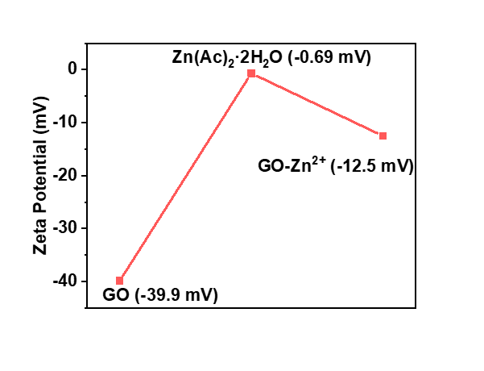
Fig. S1. Zeta potentials of GO, Zn (Ac)₂·2H₂O and GO-Zn (Ac)₂·2H₂O mixture.

Additional Analysis: As manifested in Fig. S1, the surface of graphene oxide (GO) is negatively charged (zeta potential=-40 mV), which originated from the oxygen functional groups located on nanosheets. After mixing GO and neutral Zn(Ac)₂·2H₂O (zeta potential=-0.69 mV) in ethylene glycol (EG) solution, the zeta potential shows a positive switch (-12.5 mV), suggesting the adsorption of [Zn(EG)₂]²⁺ on GO surface.

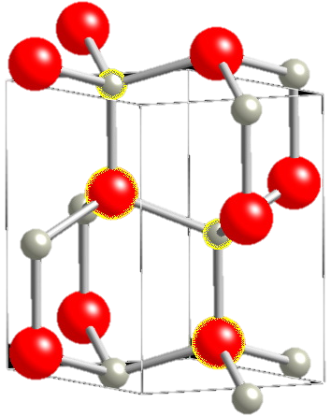
Fig. S2. Illustration of one ZnO cell (Zn white, O red; highlighted atoms are inside unit cell).

Additional analysis: The unit cell volume is approximately 47.6 Å³. Consequently, ZnO contains approximately 8.4×10²² atoms per cm³. The synthetically produced ZnO with the wurtzite structure may eventually exhibit a crystallographic arrangement different from the pattern established in the crystallographic records[1].

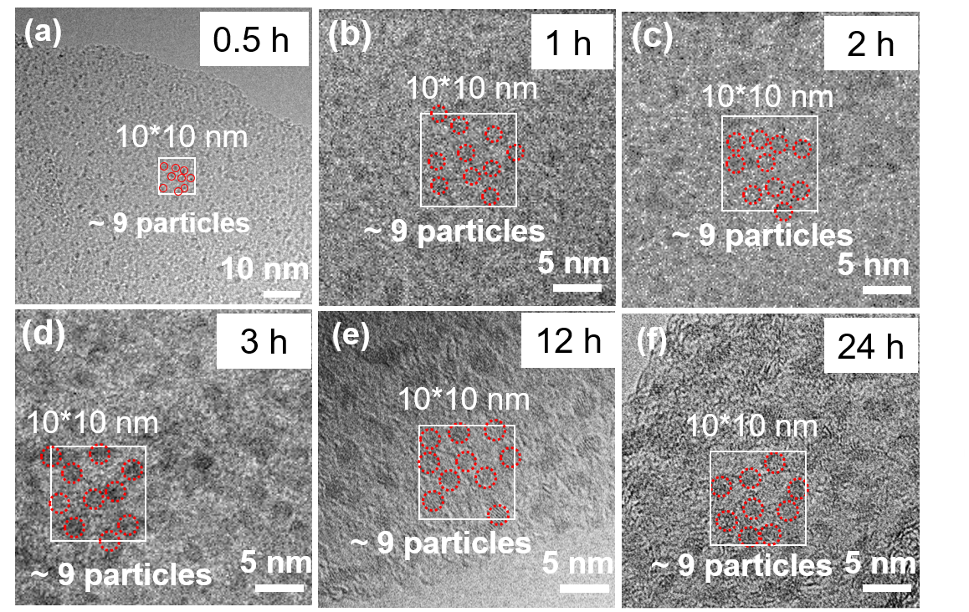
Fig. S3. TEM images of various samples synthesized at different time.

Additional analysis: The particle number density is almost the same of 9 per 10 nm×10 nm for all samples synthesized at different time, indicating that the nucleation occurs simultaneously at GO surface and no new nuclei form during growth process.

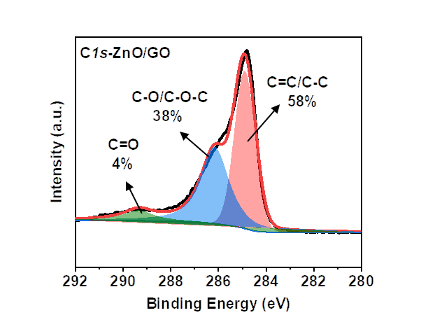
Fig. S4. High-resolution C 1s XPS spectrum curves of ZnO/rGO.

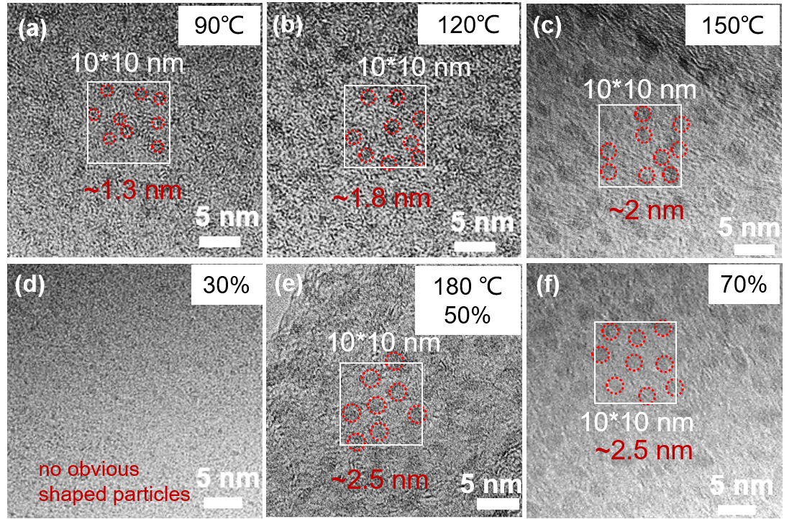
Fig. S5. HR-TEM images of (a) ZnO/rGO-90℃, (b) ZnO/rGO-120℃, (c) ZnO/rGO-150℃, (d) ZnO/rGO-30%, (e) ZnO/rGO and (e) ZnO/rGO-70%.

Additional Analysis: The samples synthesized at different temperature or with different precursor concentration show the same particle number density of 9 nanoparticles per 10 nm×10 nm.

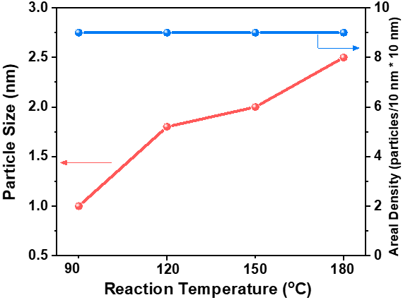
Fig. S6. Graph of the average particle size and particle number density over temperature.

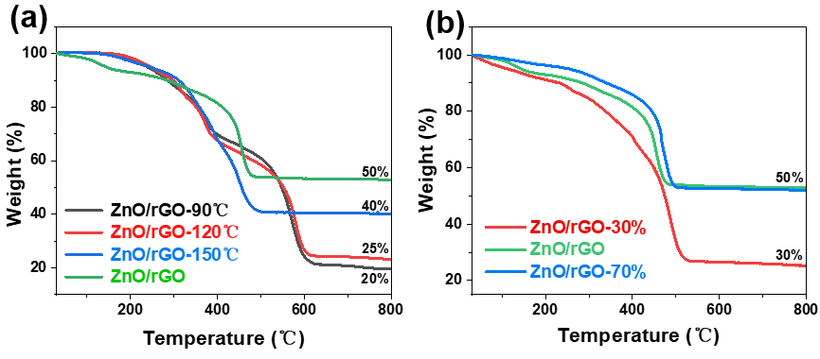
Fig. S7. Thermogravimetric analysis (TGA) curves of samples prepared (a) at various temperature and (b) by various precursor concentration.

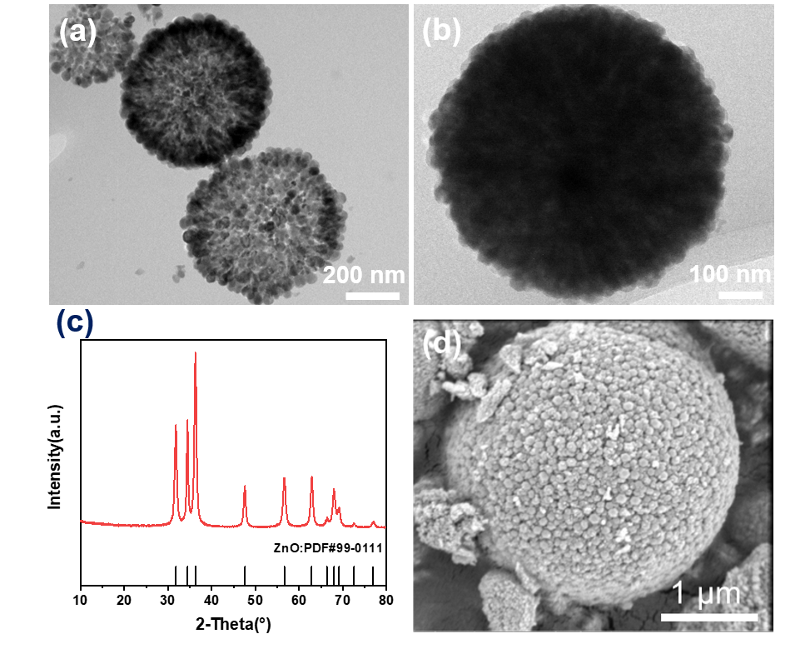
Fig. S8. (a-b) TEM images, (c) XRD pattern, and SEM image of ZnO.

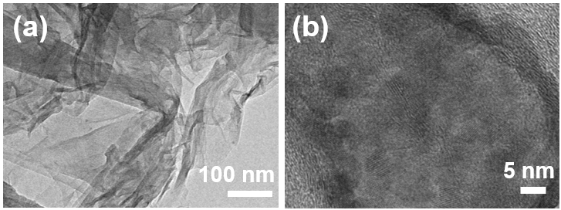
Fig. S9. (a) TEM images of ZnO/rGO-H₂O.

Additional Analysis: The sample ZnO/rGO-H₂O was synthesized using the same process as that of ultrafine ZnO/rGO nanocomposites, except that the solvent EG was changed to deionized water.

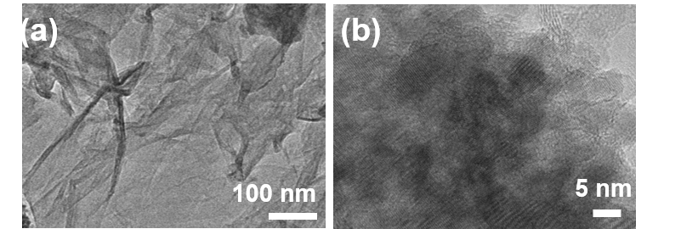
Fig. S10. (a) TEM images of ZnO/rGO-EtOH.

Additional Analysis: The sample ZnO/rGO-EtOH was synthesized using the same process as that of ultrafine ZnO/rGO nanocomposites, except that the solvent EG was changed to EtOH.

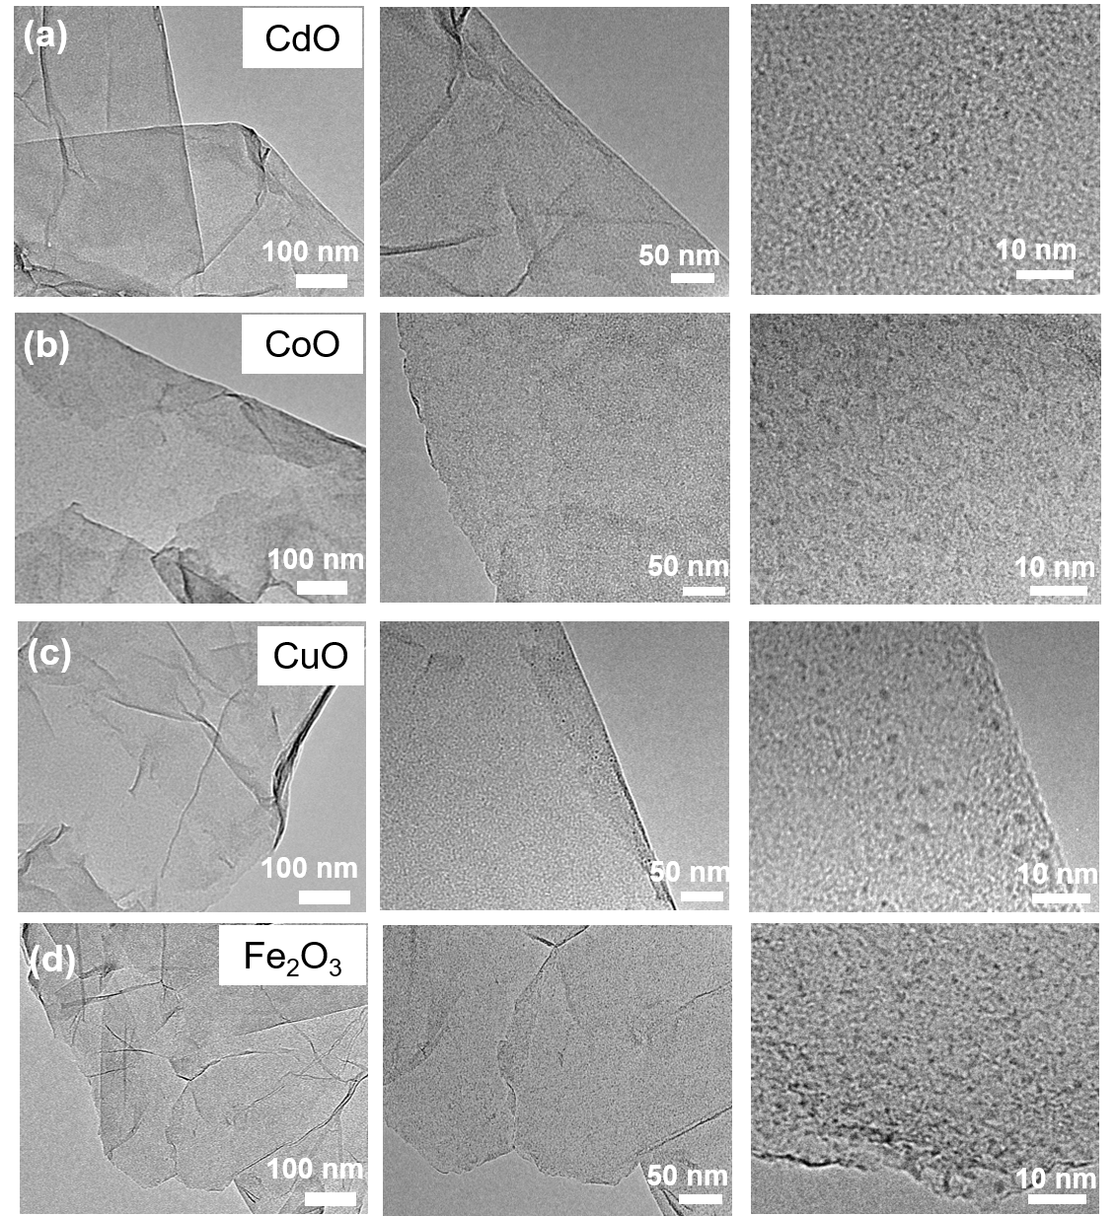
Fig. S11. TEM images of (a) CdO/rGO, (b) CoO/rGO, (c) CuO/rGO, (d) Fe₂O₃/rGO nanocomposites at different magnifications.

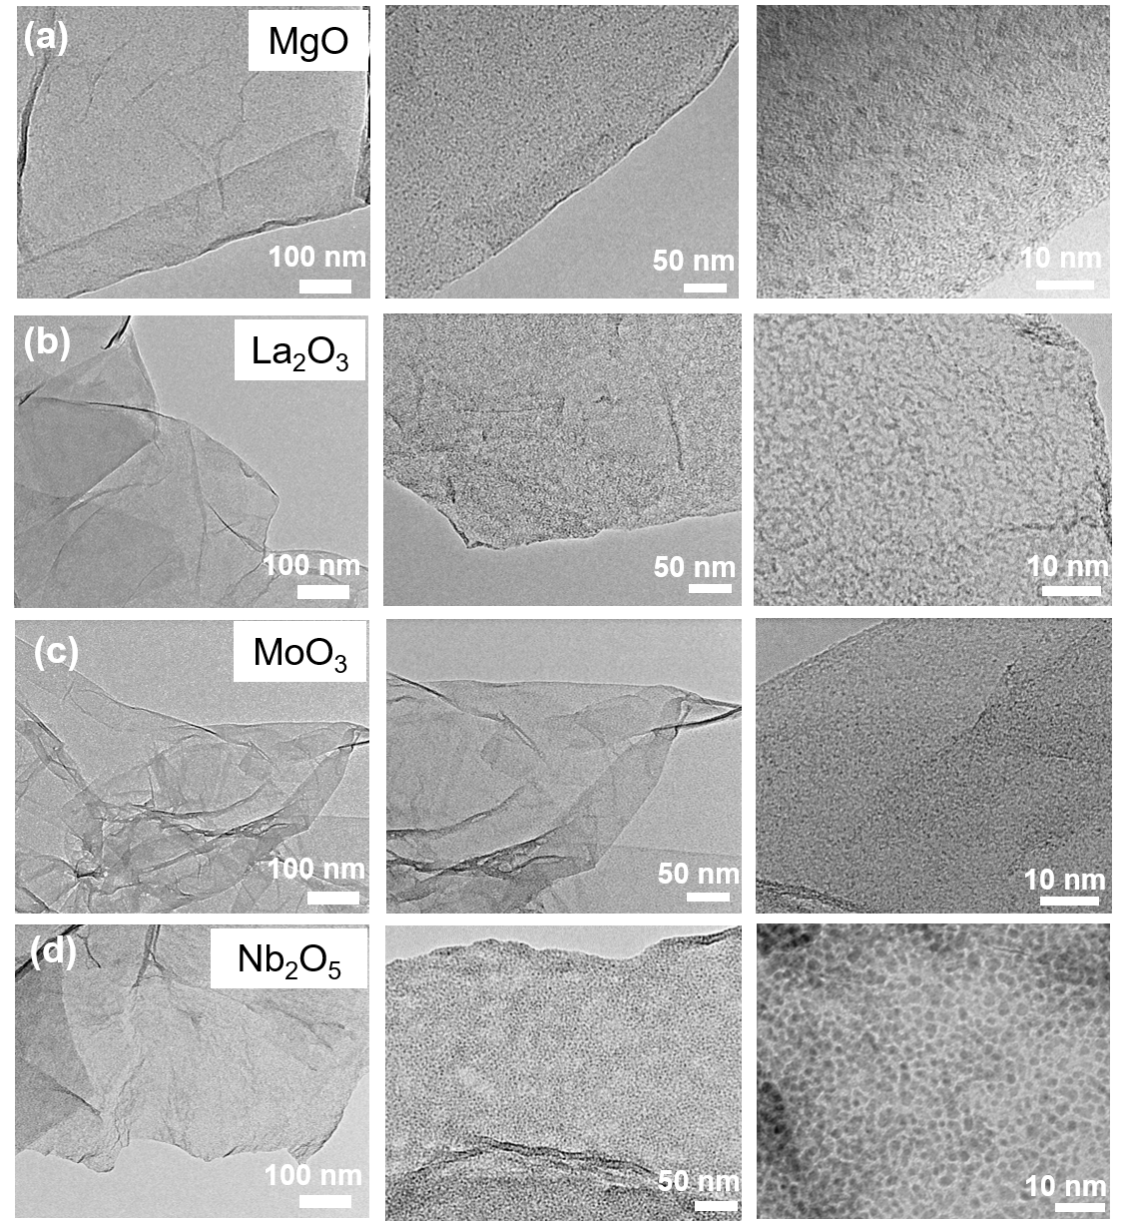
Fig. S12. TEM images of (a) MgO/rGO, (b) La₂O₃/rGO, (c) MoO₃/rGO, (d) Nb₂O₅/rGO nanocomposites at different magnifications.

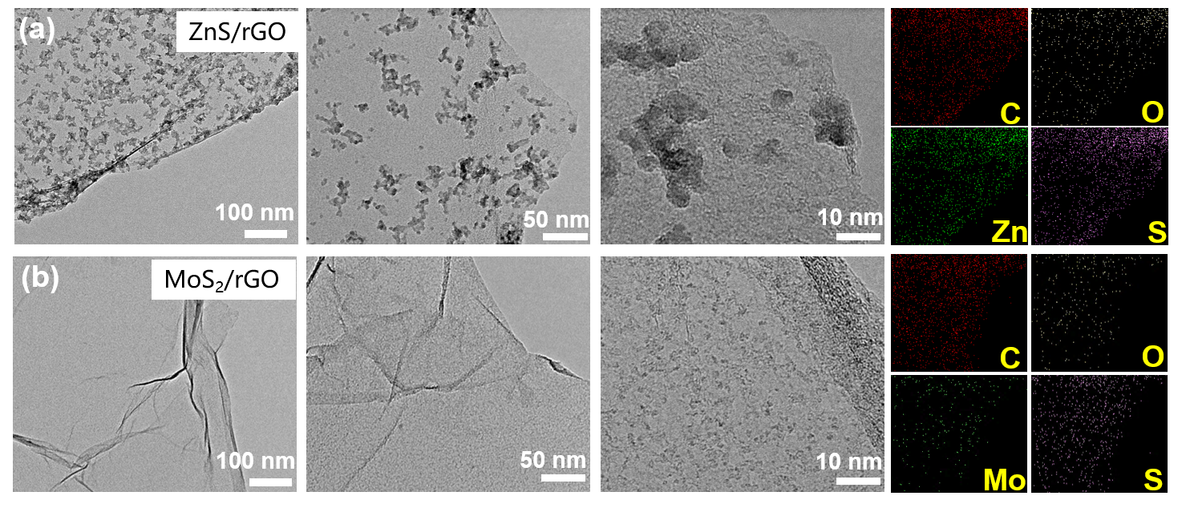Fig. S13. TEM images of (a) ZnS/rGO and (b) MoS₂/rGO nanocomposites at different magnifications.

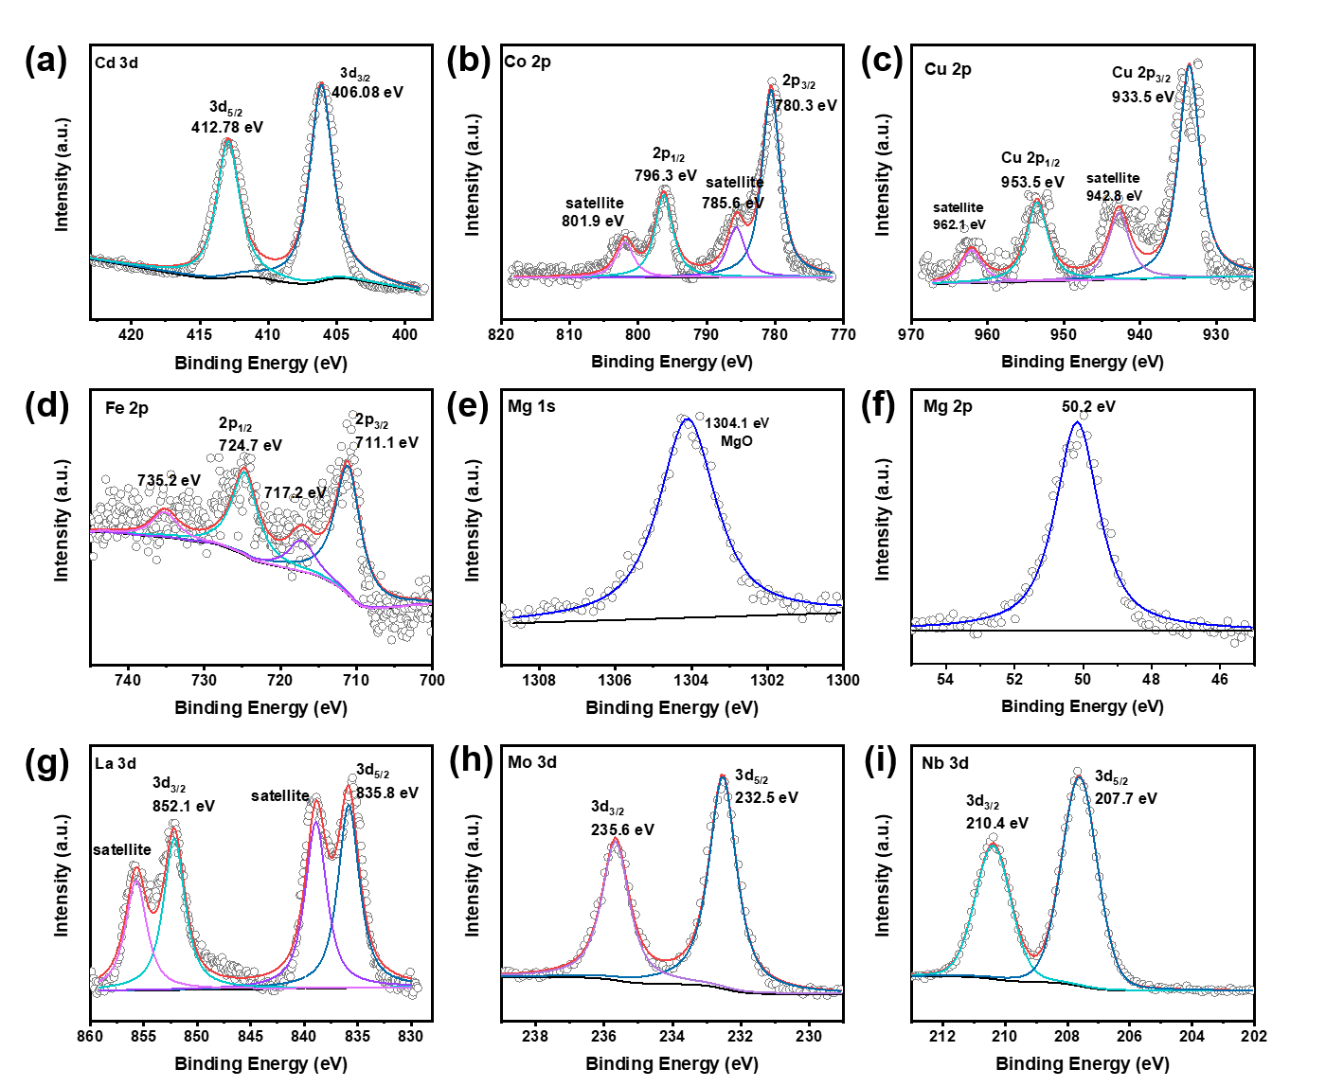
Fig. S14. (a) Cd 3d XPS pattern of CdO/rGO[2]. (b) Co 2p XPS pattern of CoO/rGO[3]. (c) Cu 2p XPS pattern of CuO/rGO[4]. (d) Fe 2p XPS pattern of Fe₂O₃/rGO[5]. (e) Mg 1s and (f) Mg 2p XPS patterns of MgO/rGO[6]. (g) La 3d XPS pattern of La₂O₃/rGO[7]. (h) Mo 3d XPS pattern of MoO₃/rGO[8]. (i) Nb 3d XPS pattern of Nb₂O₅/rGO[9].

Additional Analysis: The chemical compositions of metal oxide in nanocomposites were confirmed by XPS according to references.

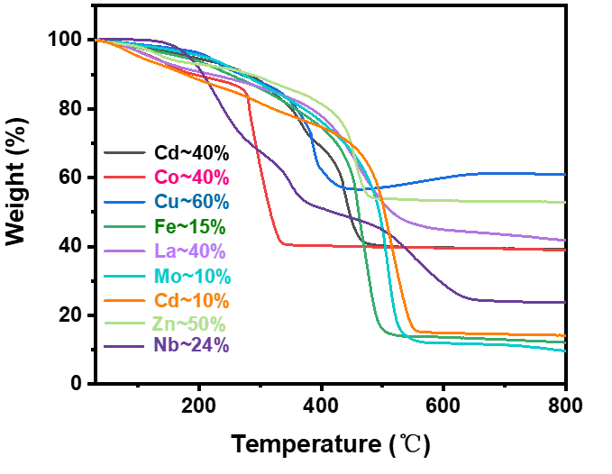

Fig. S15. Thermogravimetric analysis (TGA) curves of CdO/rGO, CoO/rGO, CuO/rGO, Fe₂O₃/rGO, La₂O₃/rGO, MgO/rGO, MoO₃/rGO, ZnO/rGO and Nb₂O₅/rGO under air atmosphere.

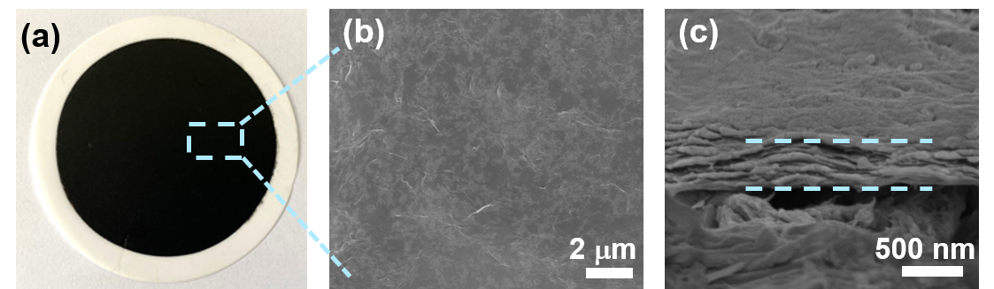
Fig. S16. (a) Digital photograph, (b) top-view SEM image and (c) cross-section SEM image of ZnO/rGO/nylon membranes.

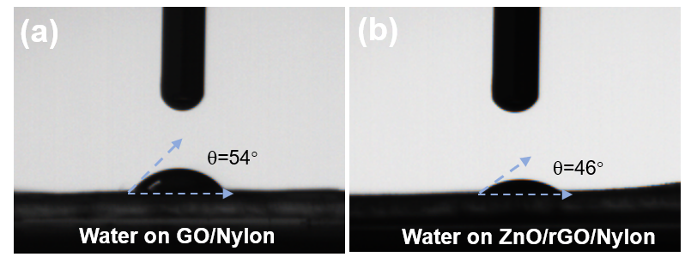
Fig. S17. Contact angle of water on (a) GO/Nylon and (b) ZnO/rGO/Nylon.

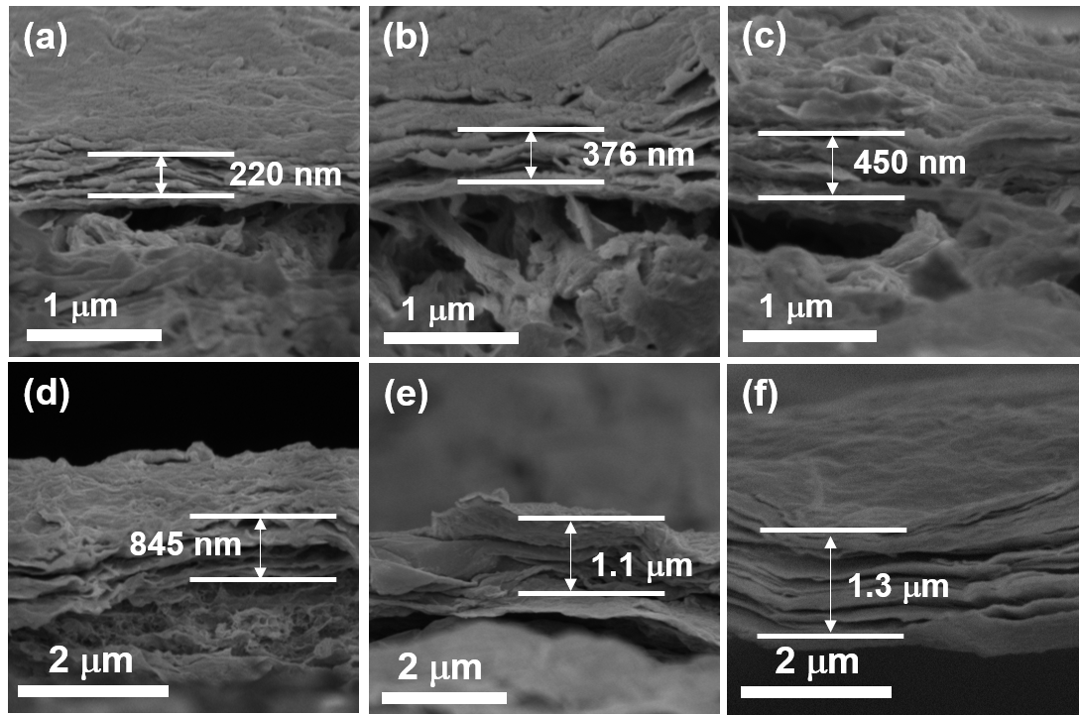
Fig. S18. SEM images of (a) 0.14 mg cm⁻², (b) 0.27 mg cm⁻², (c) 0.41 mg cm⁻², (d) 0.54 mg cm⁻², and (e) 0.68 mg cm⁻² ZnO/rGO loading amount on nylon membranes. (f) 0.54 mg cm⁻² loading amount of GO on nylon membrane.

Additional Analysis: From cross-section SEM image (Fig. S18), GO membrane presents a uniform laminar structure, while the layers in ZnO/rGO membranes were wrinkled with larger interlayer spacing.

Table S1. Gibbs free energy of various reaction on GO surface functional groups.
Functional groups | ΔG (I) /eV | ΔG (II) /eV | ΔG (III) /eV | ΔG_{total} /eV
-OH | -0.349 | -7.376 | 1.292 | -6.433
-COC | -1.089 | -6.868 | 0.958 | -6.999
-COOH | -1.036 | -7.282 | 1.710 | -6.6.08
-CO | -1.072 | -6.733 | 0.046 | -7.759
without GO |  | -0.678 | -6.412 | 1.539
*ΔG (I): Gibbs free energy of reaction adsorption of Zn²⁺ onto GO surface;
ΔG (II): Gibbs free energy of reaction Zn²⁺*→Zn(OH)₂*;
ΔG (III): Gibbs free energy of reaction Zn(OH)₂*→ZnO*;
ΔG_{total}: Gibbs free energy of the whole reaction.

Table S2. Nanofiltration performance comparation of GO-based membranes.
Membranes | Loading mass  (mg cm⁻²) | Thickness  (μm) | Pressure  (bar) | MB Rejection (%) | Water Permeance  (L m⁻² h⁻¹ bar⁻¹) | Ref
GO | 0.54 | 1.4 | 1 | 98.2 | 20 | This work
ZnO/rGO | 0.54 | 0.845 | 1 | 98.1 | 225 | This work
PEI-GO/PAA/PVA/GA |  |  | 5 | 99.3 | 0.87 | [10]
PDDA/GO |  | 0.01 | 5 | 99.2 | 6.42 | [11]
PAN/GO |  |  | 6 | 100 | 5.5 | [12]
GO/OCNTs |  |  | 3 | 99.3 | 7.24 | [13]
ZIF-8@GO |  | 0.105 | 1 | 100 | 49.81 | [14]
GO/g-C3N4 | 0.0247 |  | 1 | 100 | 76.6 | [15]
C-BCGO-Au-stc-M |  | 4 | 5 | 24.4 | 32.4 | [16]
GO/COF |  | 2.7 | 1 | 99.53 | 58.58 | [17]
DES/GO | 0.0035 |  | 3 | 96.7 | 21 | [18]
PVDF/SDS-GO/TiO₂ |  | 18.6 | 2 | 92.79 | 4.63 | [19]

Table S3. Chemical structures and sizes of five dye molecules used in this work[20].
Organic dye | Molecular weight  (g mol⁻¹) | Molecular size  (nm*nm) | Chemical structure
Methyl Orange (MO) | 327 | 1.13*0.42 | 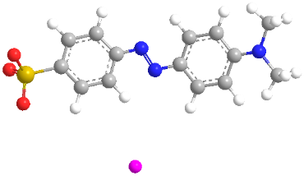
Eriochrome Black T  (EBT) | 461 | 1.55*0.88 | 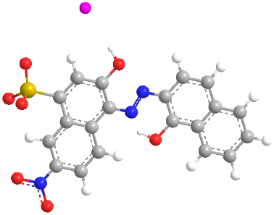
Congo Red (CR) | 696 | 2.56*0.73 | 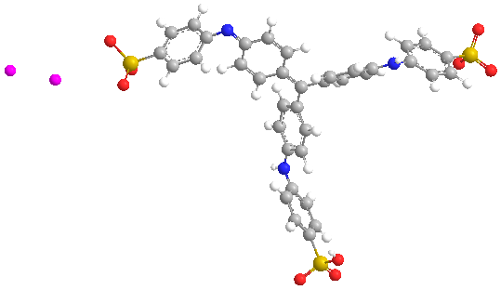
Methyl Blue (MB) | 799.8 | 2.36*1.74 | 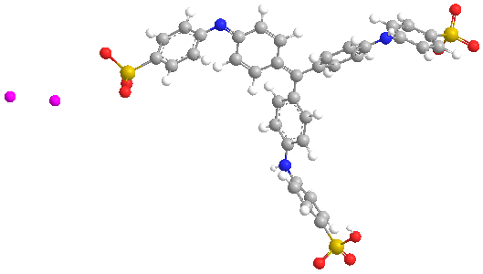
Evans Blue (EB) | 960 | 3.1*1.3 | 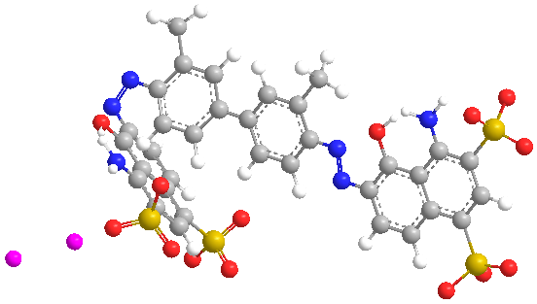
* C: grey balls; H: white balls; S: yellow balls; O: red balls; N: blue balls. The molecular sizes were calculated using ChemOffice2014.

Reference

1. CrystalMaker. Structure Type 014: ZnO (wurtzite). Available from: http://som.web.cmu.edu/structures/S014-ZnO.html.
2. Saravanan, R., et al., ZnO/Ag/CdO nanocomposite for visible light-induced photocatalytic degradation of industrial textile effluents. J Colloid Interface Sci, 2015. 452: p. 126-133.
3. Chang, L., et al., Hierarchical CoO microflower film with excellent electrochemical lithium/sodium storage performance. J. Mater. Chem. A, 2017. 5(39): p. 20892-20902.
4. Sun, L., et al., Nitrogen‐Doped Carbon‐Coated CuO‐In2O3 p–n Heterojunction for Remarkable Photocatalytic Hydrogen Evolution. Advanced Energy Materials, 2019. 9(48).
5. Wang, Q. and Y. Wang, Overcoming the Limiting Step of Fe2O3 Reduction via in Situ Sulfide Modification. ACS Appl Mater Interfaces, 2016. 8(16): p. 10334-42.
6. Ding, G., et al., Waste to Wealth: Exhausted Nitrogen-Doped Mesoporous Carbon/MgO Desulfurizers Turned to High-Sulfur-Loading Composite Cathodes for Li-S Batteries. ACS Appl Mater Interfaces, 2019. 11(21): p. 19096-19103.
7. Cheng, Z., et al., La2O3 modified silica-pillared clays supported PtOx nanocrystalline catalysts for catalytic combustion of benzene. Chemical Engineering Journal, 2020. 392.
8. Kawase, M., et al., Elucidation of the enhanced photoactivity of melon calcined with MoO3. Applied Catalysis B: Environmental, 2020. 273.
9. Huang, Q., et al., Rational cooperativity of nanospace confinement and rapid catalysis via hollow carbon nanospheres@ Nb-based inorganics for high-rate Li-S batteries. Chemical Engineering Journal, 2021. 411: p. 128504.
10. Wang, N., et al., Self-assembly of graphene oxide and polyelectrolyte complex nanohybrid membranes for nanofiltration and pervaporation. Chemical Engineering Journal, 2012. 213: p. 318-329.
11. Wang, L., et al., Layer-by-layer self-assembly of polycation/GO nanofiltration membrane with enhanced stability and fouling resistance. Separation and Purification Technology, 2016. 160: p. 123-131.
12. Qiu, Z., X. Ji, and C. He, Fabrication of a loose nanofiltration candidate from Polyacrylonitrile/Graphene oxide hybrid membrane via thermally induced phase separation. J Hazard Mater, 2018. 360: p. 122-131.
13. Kang, H., et al., Sandwich morphology and superior dye-removal performances for nanofiltration membranes self-assemblied via graphene oxide and carbon nanotubes. Applied Surface Science, 2018. 428: p. 990-999.
14. Zhang, W.H., et al., Graphene oxide membranes with stable porous structure for ultrafast water transport. Nat Nanotechnol, 2021. 16(3): p. 337-343.
15. Wu, Y., et al., 2D Heterostructured Nanofluidic Channels for Enhanced Desalination Performance of Graphene Oxide Membranes. ACS Nano, 2021. 15(4): p. 7586-7595.
16. Zhong, Y., et al., Graphene oxide modified membrane for highly efficient wastewater treatment by dynamic combination of nanofiltration and catalysis. J Hazard Mater, 2020. 397: p. 122774.
17. Chen, L., et al., High performance hierarchically nanostructured graphene oxide/covalent organic framework hybrid membranes for stable organic solvent nanofiltration. Applied Materials Today, 2020. 20.
18. Mehrabi, N., H. Lin, and N. Aich, Deep eutectic solvent functionalized graphene oxide nanofiltration membranes with superior water permeance and dye desalination performance. Chemical Engineering Journal, 2021. 412.
19. Suriani, A.B., et al., Incorporation of Electrochemically Exfoliated Graphene Oxide and TiO2 into Polyvinylidene Fluoride-Based Nanofiltration Membrane for Dye Rejection. Water, Air, & Soil Pollution, 2019. 230(8).
20. Fan, H., et al., High‐flux membranes based on the covalent organic framework COF‐LZU1 for selective dye separation by nanofiltration. Angewandte Chemie International Edition, 2018. 57(15): p. 4083-4087.

