Supplementary Materials for

In situ gene therapy rescues doxorubicin-induced ovarian damage via adenovirus mediated Sirt1 and Tgfbr2

Lingwei Ma, Huan Lu, Yanzhi Feng, Yan Li, Su Zhou, Meng Wu, Jinjin Zhang, Shixuan Wang

Correspondence to: shixuanwang@tjh.tjmu.edu.cn; jinjinzhang@tjh.tjmu.edu.cn

This PDF file includes:

Supplementary Text
Figures. S1 to S7
Tables S1

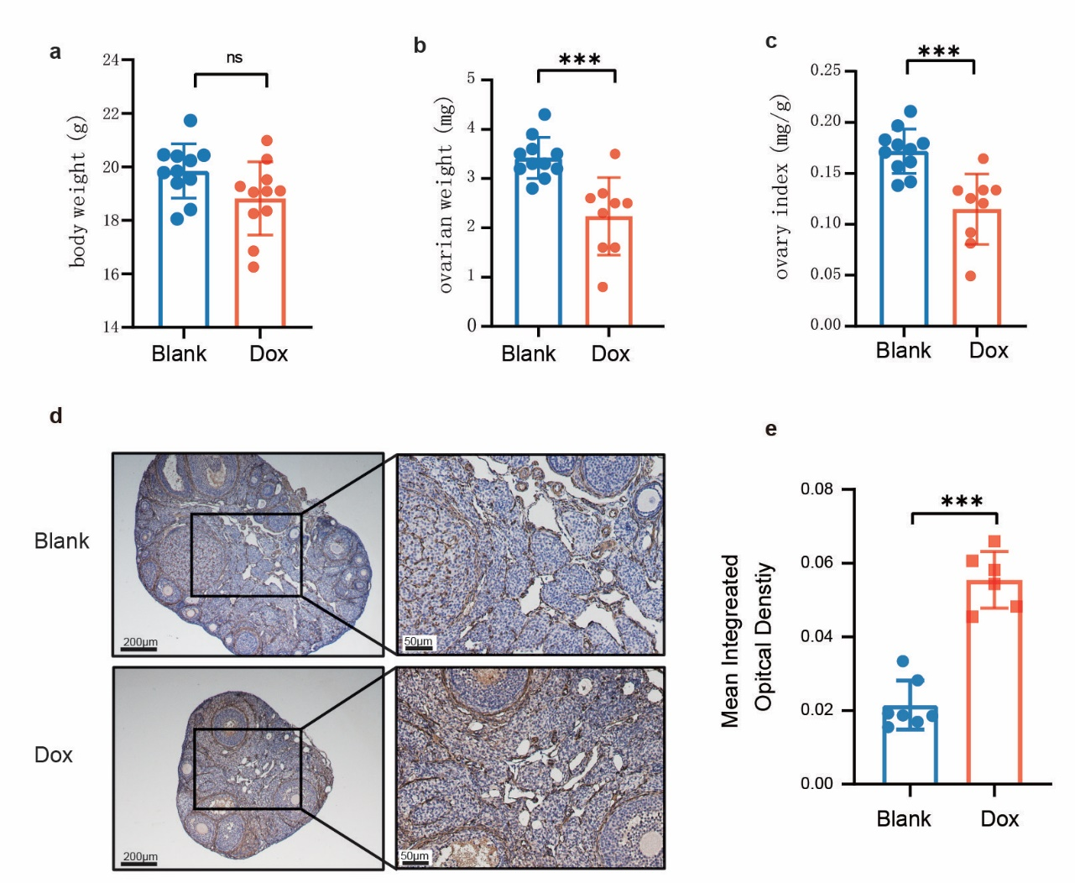

Figure. S1.
Doxorubicin impairs ovarian reserve function and induces ovarian fibrosis. a Body weight change of mice treated with normal saline (NS) or Dox (10 mg/kg). b Ovarian weight change of mice treated with NS or Dox. c Ovary index change of mice treated with NS or Dox. d Immunohistochemistry (IHC) of α-SMA expression in mice of con and Dox-treated groups. e mean IOD of α-SMA b. * P < 0.05, ** P < 0.01, *** P < 0.001.

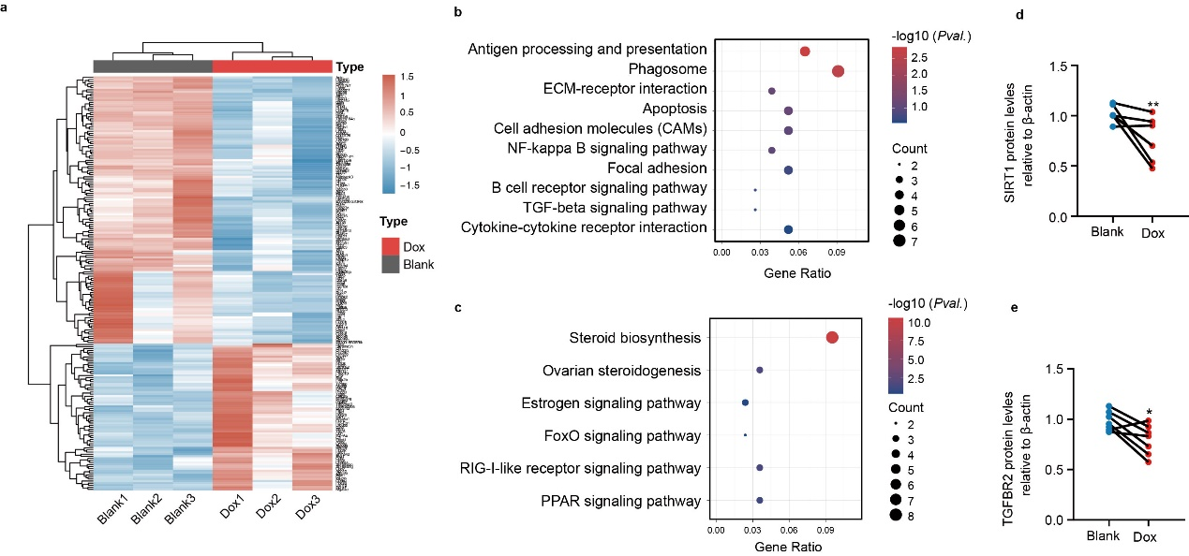

Figure. S2.
Identification of Sirt1 and Tgfbr2 as key genes whose expression is reduced in ovaries in response to Dox treatment through screening and validation. a Heatmap showing expression signatures of top 100 differentially expressed genes (DEGs). The gradient color change from red to blue indicates relative expression values changing from high to low. b KEGG pathway enrichment analysis of DEG of upregulated DEGs in Dox-induced ovarian damage. c KEGG pathway enrichment analysis of DEG of down-regulated DEGs in Dox-induced ovarian damage. (d and e) The relative protein expression level analysis of SIRT1 d and TGFBR2 e in human ovarian tissues detected by WB analysis. * P < 0.05, ** P < 0.01.

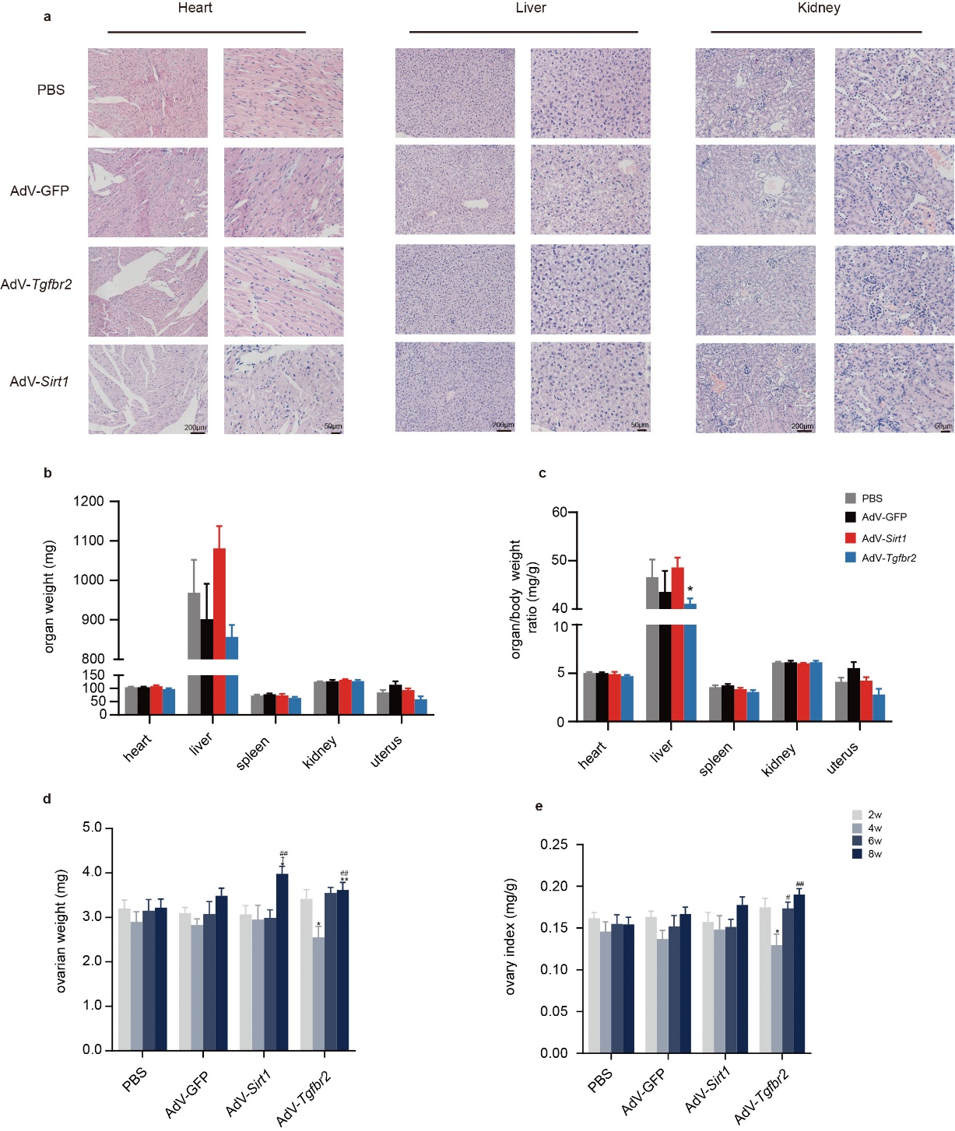

Figure. S3.
Ovarian in situ injection of AdV-Sirt1 and AdV-Tgfbr2 induces no obvious damage to major organs in mice. a H&E staining of the organ tissues in each group with heart, liver, and kidney as representatives at 8 weeks after ovarian in situ injection. b The organ weight in each group at 8 weeks. c The organ index in each group at 8 weeks. d Changes in ovarian weight in different groups. e Changes in ovary index in different groups (PBS，AdV-GFP, AdV-Sirt1 and AdV-Tgfbr2) over time (from 2 weeks to 8 weeks). (* Compared with the 2-week group, # Compared with the 4-week group, † Compared with the 6-week group. * P < 0.05, ** P < 0.01, # P < 0.05, ##P < 0.01, †P < 0.05).

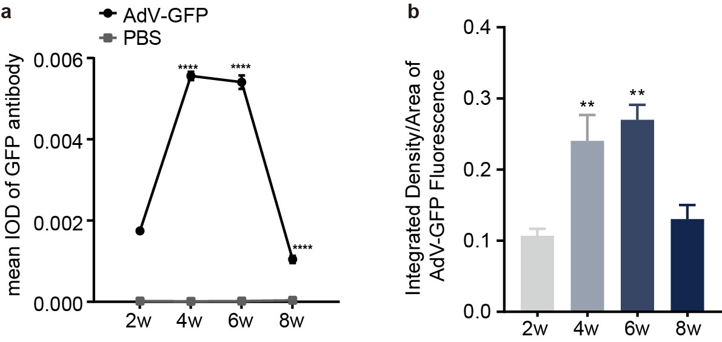

Figure. S4.
The relative expression analysis of GFP in ovarian IHC and frozen sections. a The relative expression analysis of GFP by IHC analysis. b The relative expression analysis of GFP intensity of frozen sections. ** P < 0.01, ****P < 0.0001.

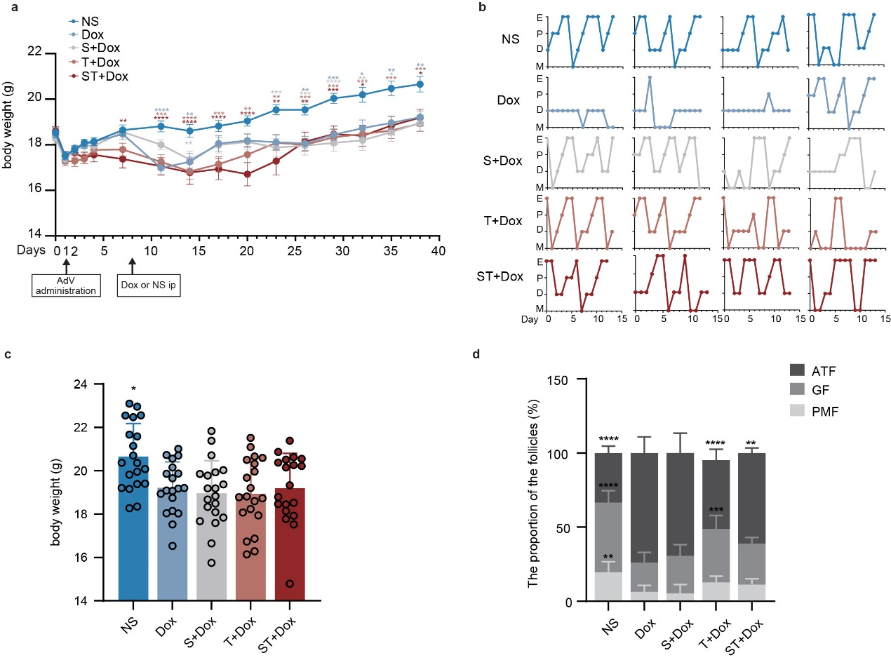

Figure. S5.
The changes of body weight, estrous cycle and the follicle proportion in each group. a Changes in body weight of each group over time. *Dox compared with N.S., * S+Dox compared with N.S., *T+Dox compared with N.S., * ST+Dox compared with NS. b Representative line chart of estrous cycle of each group. c The body weight of each group at the end of the experiment. d Ovarian follicle proportion based on ovarian sections in each group. * P < 0.05, ** P < 0.01, *** P < 0.001, ****P < 0.0001. ATF: atretic follicles, GF: growing follicles, PMF: primordial follicles.
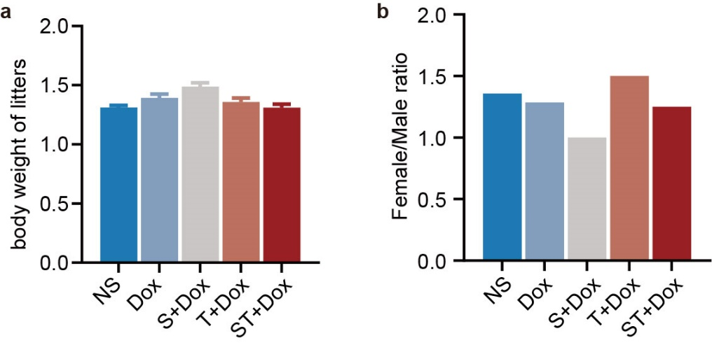

Figure. S6.
The average birth weight and the ratio of male to female of the offspring in each group. a Average birth weight of the offspring in each group. b The ratio of male to female of the offspring of each group.
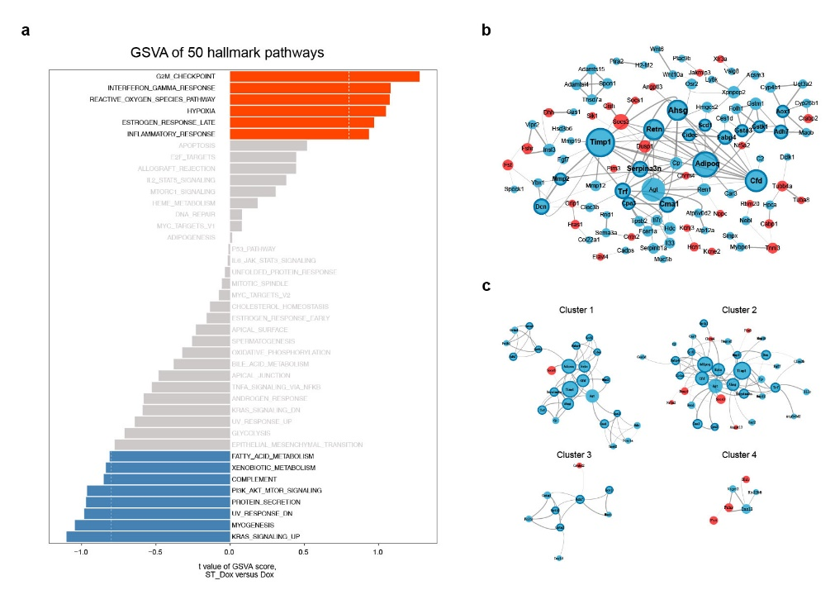

Figure. S7.
GSVA of the differentially expressed pathways and PPI network construction. a Gene set variation analysis and the differentially expressed analysis of pathways. b Construction of PPI network of DEGs. c Four highly connected clusters were identified. Blue nodes: down-regulated genes, red nodes: up-regulated gene. The node with the bold border line represents the hub gene. The area of the node represents the value of degree. The larger the area of the node, the greater the value of degree; the thickness of the connecting line between nodes represents the strength of interaction, and the thicker the stronger the effect.

Primers | Primer sequence（5’—3’）
Actb | (F) GGCTGTATTCCCCTCCATCG
 | (R) CCAGTTGGTAACAATGCCATGT
Sirt1 | (F) TGATTGGCACCGATCCTCG
 | (R) CCACAGCGTCATATCATCCAG
Tgfbr2 | (F) GACTGTCCACTTGCGACAAC
 | (R) GGCAAACCGTCTCCAGAGTAA
Tgfb1 | (F) CCACCTGCAAGACCATCGAC
 | (R) CTGGCGAGCCTTAGTTTGGAC
IL-1β | (F) GAAATGCCACCTTTTGACAGTG
 | (R) CTGGATGCTCTCATCAGGACA
Acta2 | (F) GTCCCAGACATCAGGGAGTAA
 | (R) TCGGATACTTCAGCGTCAGGA
Ccn2 | (F) GACCCAACTATGATGCGAGCC
 | (R) CCCATCCCACAGGTCTTAGAAC
Fn1 | (F) ATGTGGACCCCTCCTGATAGT
 | (R) GCCCAGTGATTTCAGCAAAGG
IL-6 | (F) CTGCAAGAGACTTCCATCCAG
 | (R) AGTGGTATAGACAGGTCTGTTGG
Mmp2 | (F) ACCTGAACACTTTCTATGGCTG
 | (R) CTTCCGCATGGTCTCGATG
Timp2 | (F) CGAGACCACCTTATACCAGCG
 | (R) ATGACTGGGGTGTAGGCGTA
Tnf-α | (F) CAGGCGGTGCCTATGTCTC
 | (R) CGATCACCCCGAAGTTCAGTAG
Ad5E4 | (F) TGTCTCAAAAGGAGGTAGACGATCC
 | (R) AGGTCTGTGAGGAACCTGAA

Table S1.
PCR primer list

