Title: Sustainable removal of soil arsenic by naturally-formed iron oxides on plastic tubes
Figure S1 Geographic map of the sampling sites. A total of 27 wetland soils were sampled from China. Inserts show overlapping sampling sites. Information of the sampling sites and basic soil characteristics can be found in Supplementary Dataset 1.

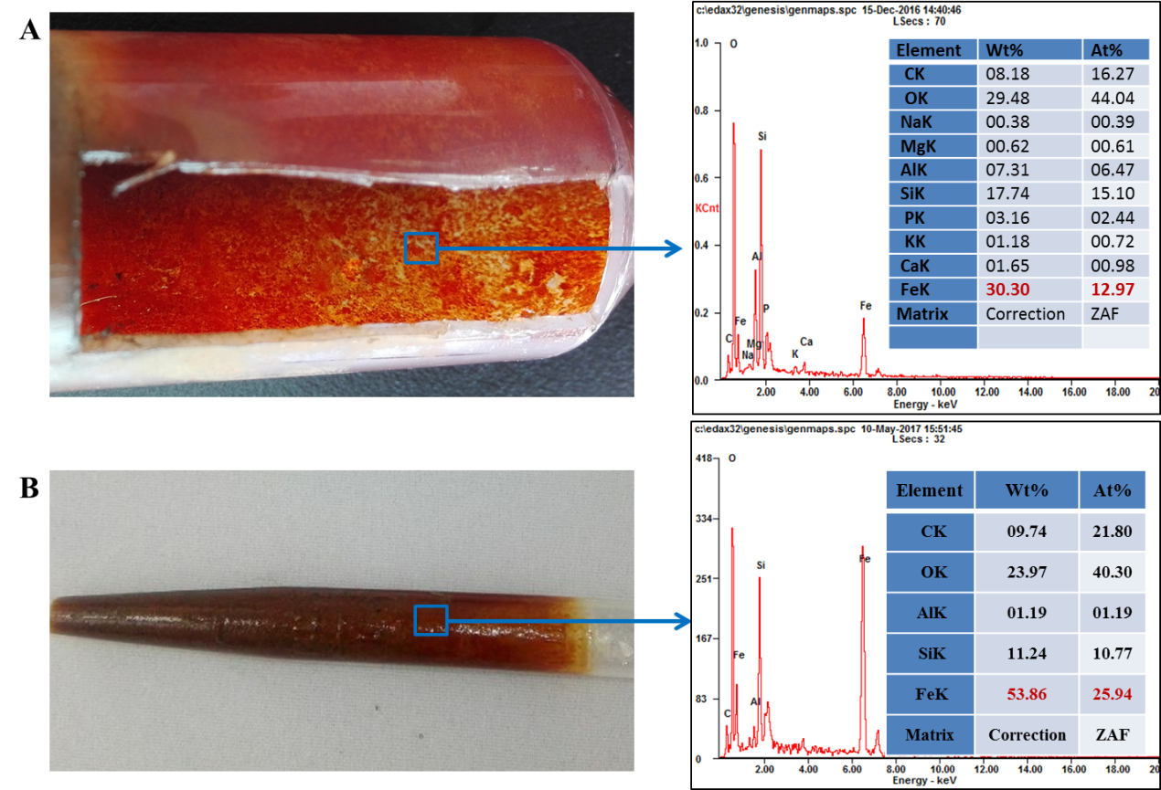
Figure S2 A close view of tube-wall iron (Fe) oxides. A) Tube-wall Fe oxides formed on PP tubes; B) Tube-wall Fe oxides formed on PP tubes. The blue frame plus arrow point elemental composition of the tube-wall Fe oxides.

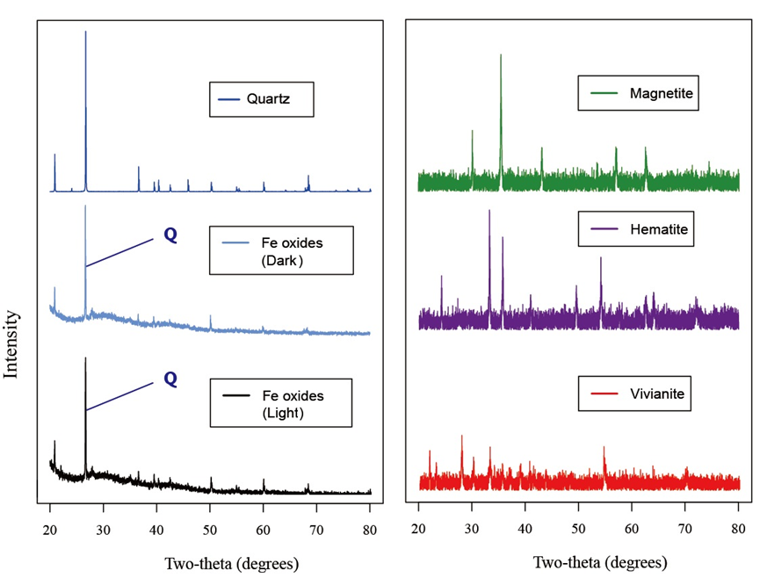
Figure S3 X-ray powder diffraction (XRD) images of tube-wall Fe oxides and Fe minerals. Fe oxides formed anaerobically under natural light and dark conditions (30 d) in saturated paddy soil incubation; data of Quartz, Magnetite, Hematite, and Viviantite were downloaded from RRUFF database (http://rruff.info/); Q means Quartz, V is Vivianite.

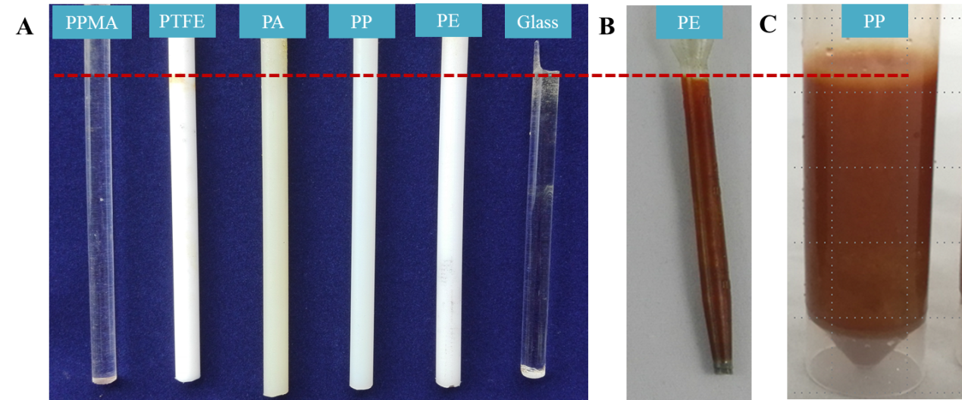
Figure S4 The influence of different materials on Fe oxides formation on the material surface. (A) columns; (B) tubes. Materials include PPMA, PTFE, PA, PP, PE, and Glass. The red dashed line means soil-water interface.

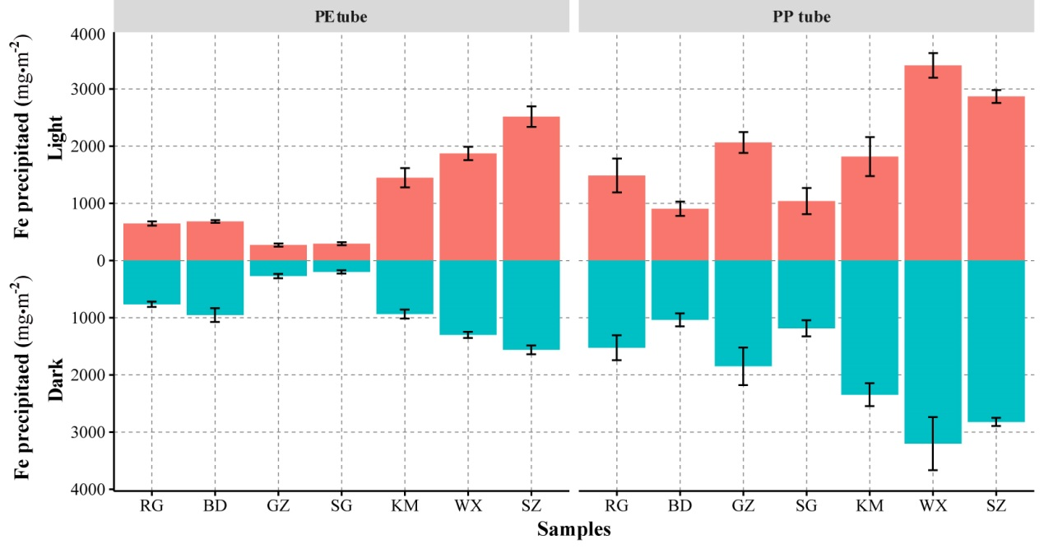
Figure S5 Fe oxides formed on PE and PP tubes at anaerobic under natural light and continuous dark conditions in different soils. The incubation was 30 days. The error bar is the standard deviation (n=3).

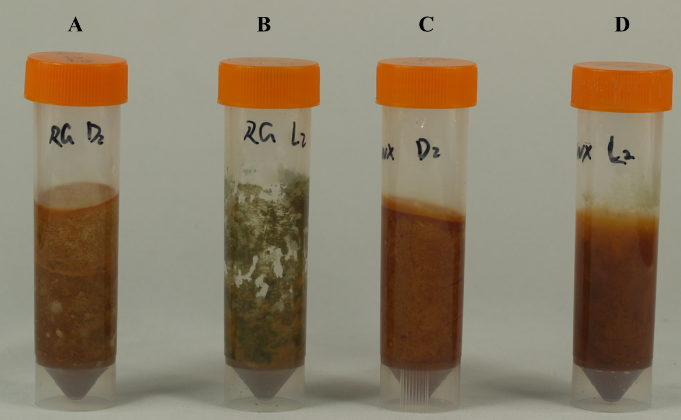
Figure S6 Tube-wall Fe oxides inhibited or enhanced by natural light. RG and WX are soils from Gugao and Wuxue city, China. D and L indicate the incubation condition under continuous dark or natural light, respectively.

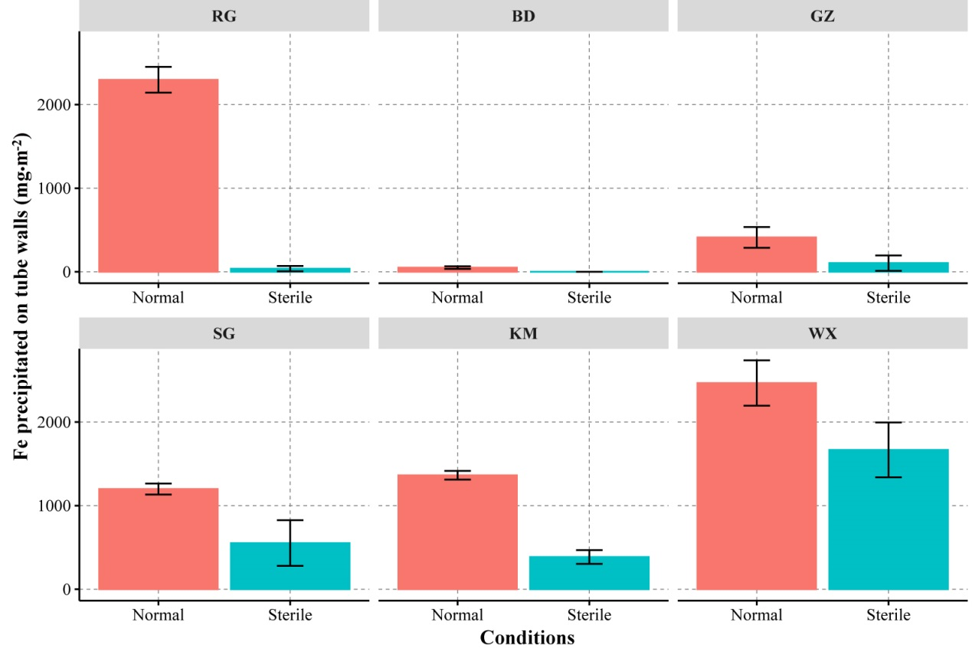
Figure S7 Tube-wall Fe oxides formed at anaerobic under normal and sterile conditions in different soils. Six soils were incubated under dark conditions, for 30 days. The error bar is the standard deviation (n=3).

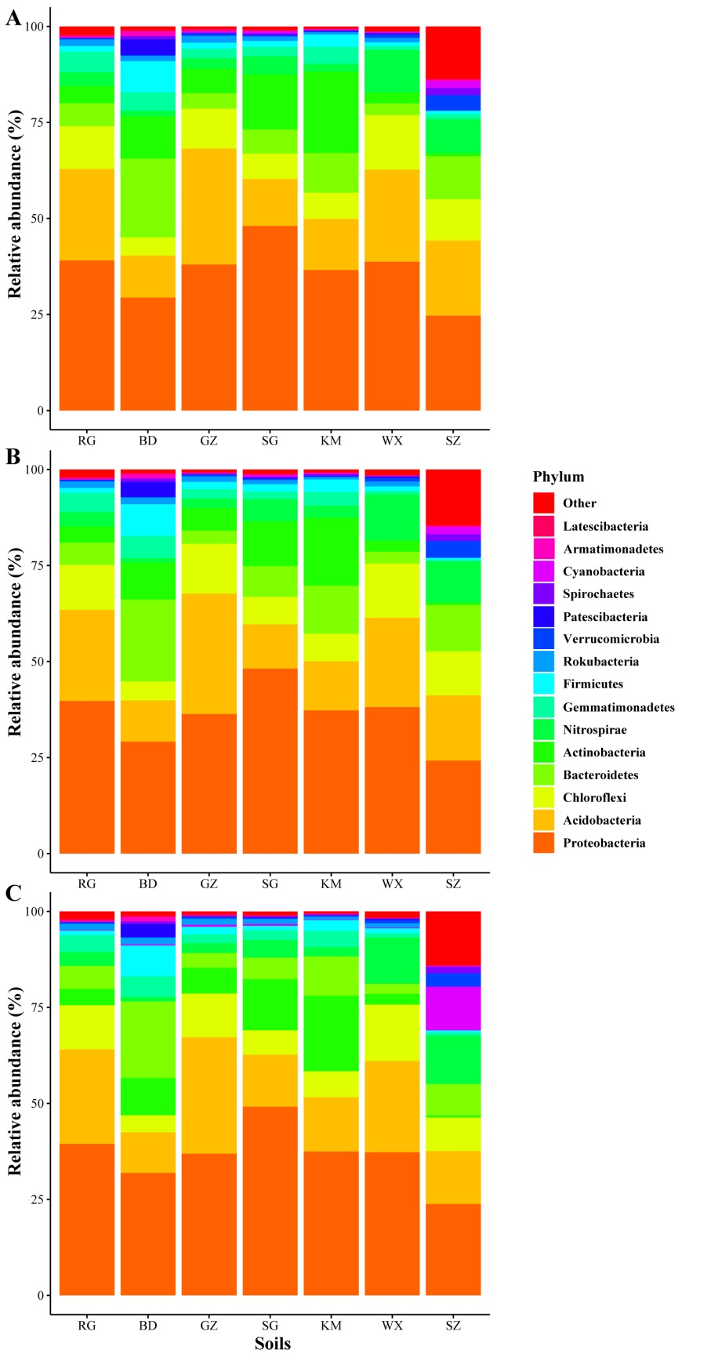
Figure S8 The relative abundance of the top 15 most phyla in soils. A) bulk soil; B) soil adjacent to tube-wall Fe oxides under continuous dark conditions; C) soil adjacent to tube-wall Fe oxides under natural light conditions.

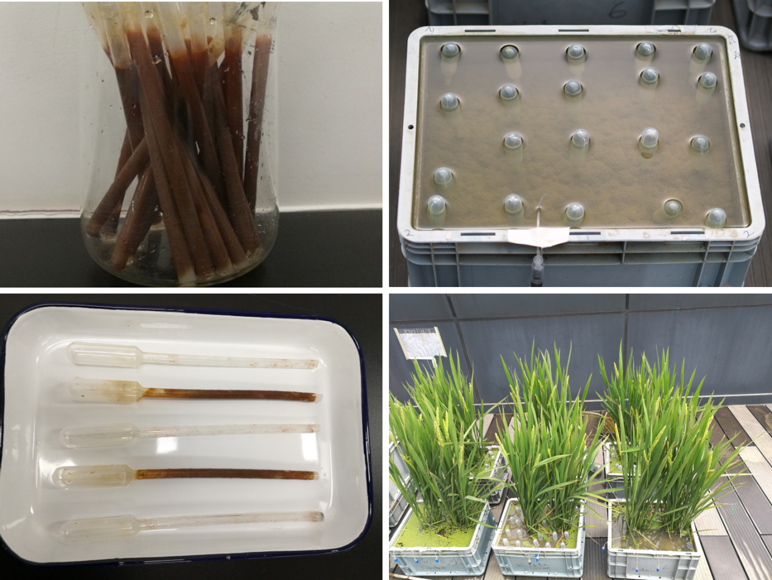
Figure S9 Remediate As contaminated paddy soils with the Fe hooks. PP tubes holding Fe hooks were taken out from saturated soils every 14 days. Fe hooks were rinsed by the overlying water and washed away by dishcloth. The PP tubes are recyclable after deployment.

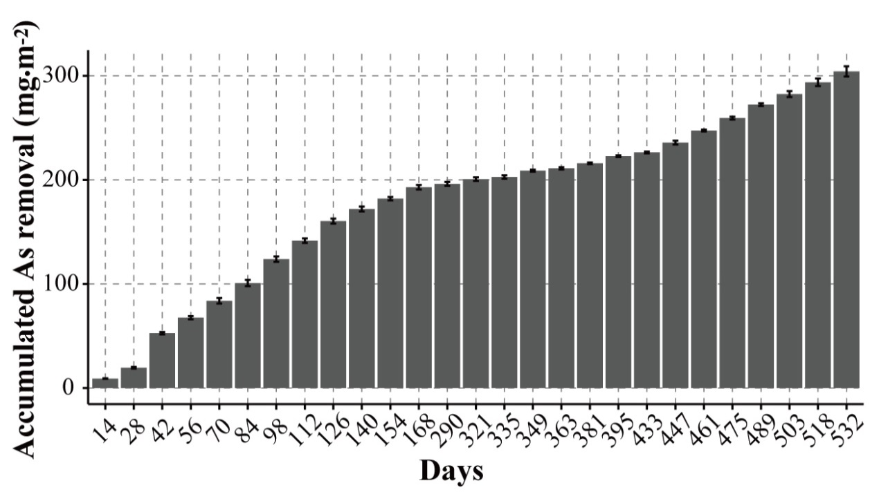
Figure S10 Accumulated As removal from soils during the two-year soil As remediation with Fe hooks. A real As-contaminated paddy soil (QY soil, 50.7 μg As kg⁻¹) was used. The error bar is the standard deviation (n=3).

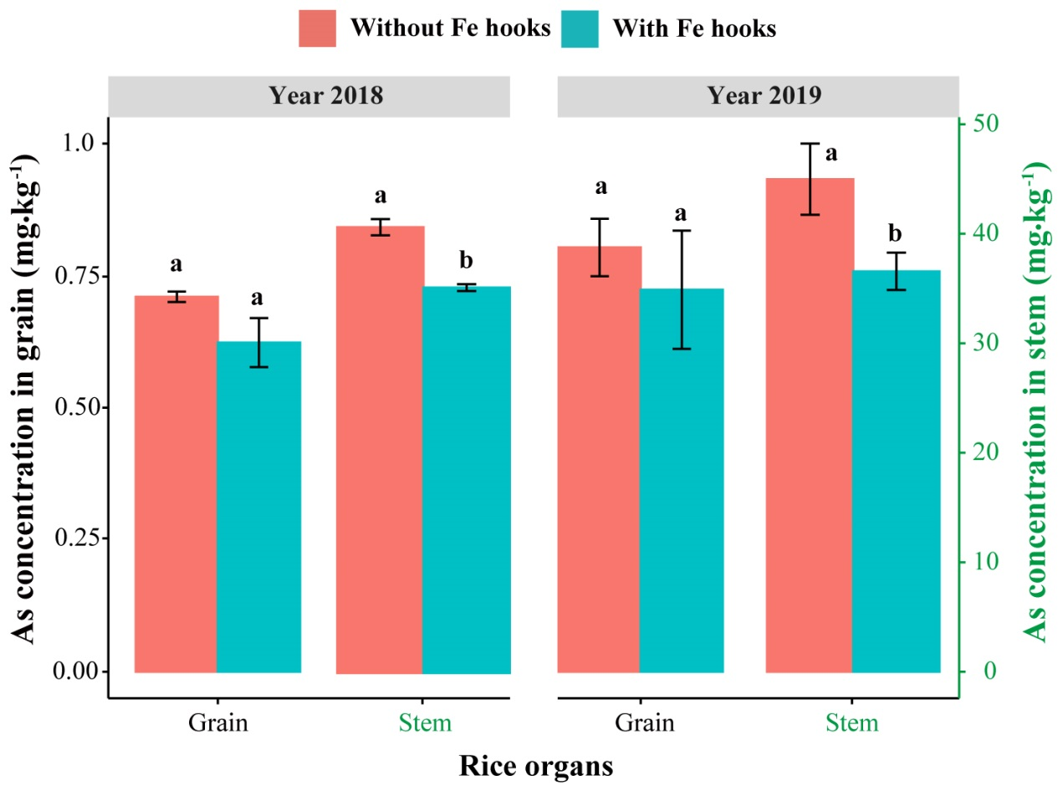
Figure S11 Arsenic concentration in rice organs during the two-year soil As remediation with Fe hooks. The lower-case letters “a” and “b” on the bars indicate significantly different (p < 0.05).

