1 Supplementary Figures

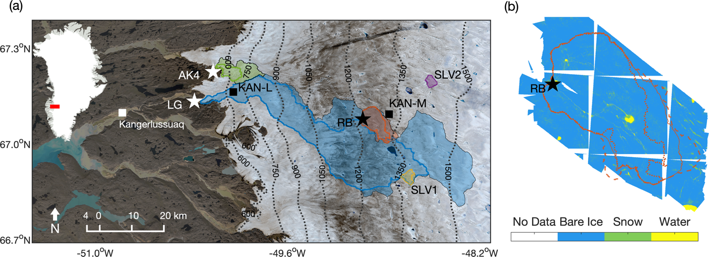
Figure S1: (a) Map of southwest Greenland study area showing the location of Rio Behar (RB) catchment (black star indicates discharge gage site location, outline is catchment boundary) (67.05ºN, -49.02ºW; 1215 m. a.s.l.) in relation to automatic weather stations KAN_M and KAN_L, discharge gage sites on the Akuliarusiarsuup Kuua River’s northern tributary (AK4) and the Leverett Glacier’s (LG) outlet, and two supraglacial lakes with satellite lake volume (SLV) estimates. (b) The 60.1 km² Rio Behar catchment was surveyed with an uncrewed aerial vehicle carrying an RGB camera during the 20–23 July 2015 and 6–13 July 2016 field experiments¹ (2016 values are shown here). These images were georefrenced, mosaiced, and georectified using Agisoft PhotoScan Pro stereophotogrammetry software. Catchment surface classification by a k-Nearest Neighbors algorithms yielded 3.1% snow cover, 1.2% water, and 95.7% bare ice during the 6–13 July 2016 field experiment (snow cover was 6.5% for the 2015 experiment)¹. Catchment delineations were obtained from WorldView-1 and WorldView-2 satellite imagery and associated high resolution stereo-photogrammetric digital elevation models following reference² (see Methods). The lower (dotted line), upper (dashed line) and “best guess” (solid line) catchment boundaries are shown here, with corresponding catchment surface areas of 51.2 km², 71.3 km², 60.1 km², respectively.

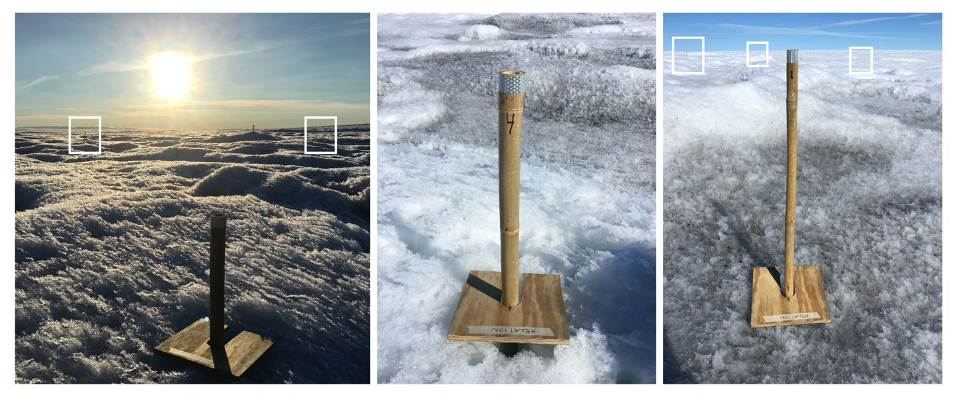
Figure S2: A network of twelve bamboo ablation stakes were randomly distributed within a ~0.5 km² area within the study catchment. The distance from an 8-inch square wooden ‘ablation board’ datum to the top of each stake was measured on a three-hourly schedule from 12:00 on 6 July 2016 to 21:00 on 12 July 2016. The board was oriented to true north and 2–4 measurements were made from a line printed on the board to the top of each stake to minimize local ablation rate variability in the vicinity of each stake. These distances were converted to cumulative surface lowering for comparison with simulated melt rates. Bright white ice (center image) contrasts with dark ice (right image). White boxes show stake locations visible in image background.

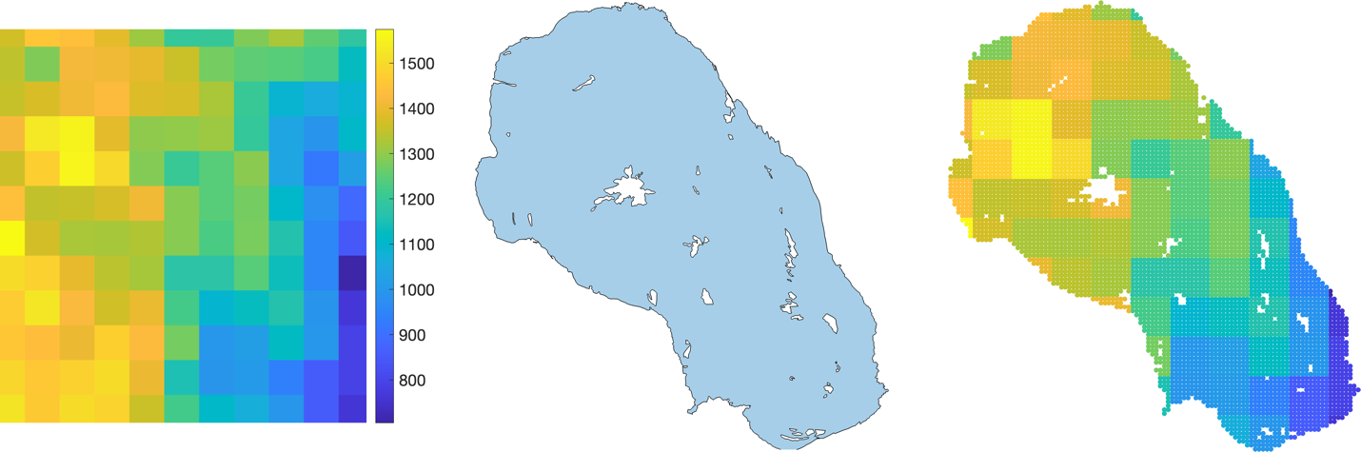
Figure S3: Example of processing stream applied to climate model output used in this study (RACMO2.3 data are shown here). (a) The native climate model output is provided at ~7.5 km grid spacing. (b) The catchment boundary contains areas drained by crevasse fields and internal moulins that are subtracted from the catchment contributing area. (c) The native climate model grid is projected onto the National Snow and Ice Data Center Equal-Area Scalable Earth (EASE) grid version 2.0³ and the climate model data is resampled at 100 m horizontal grid spacing using Delaunay triangulation and nearest neighbor interpolation. These 100 m gridded values are then intersected with the catchment boundary and converted to volumetric quantities using the catchment-scale area weighted average of the 100 m grid cells shown at right.

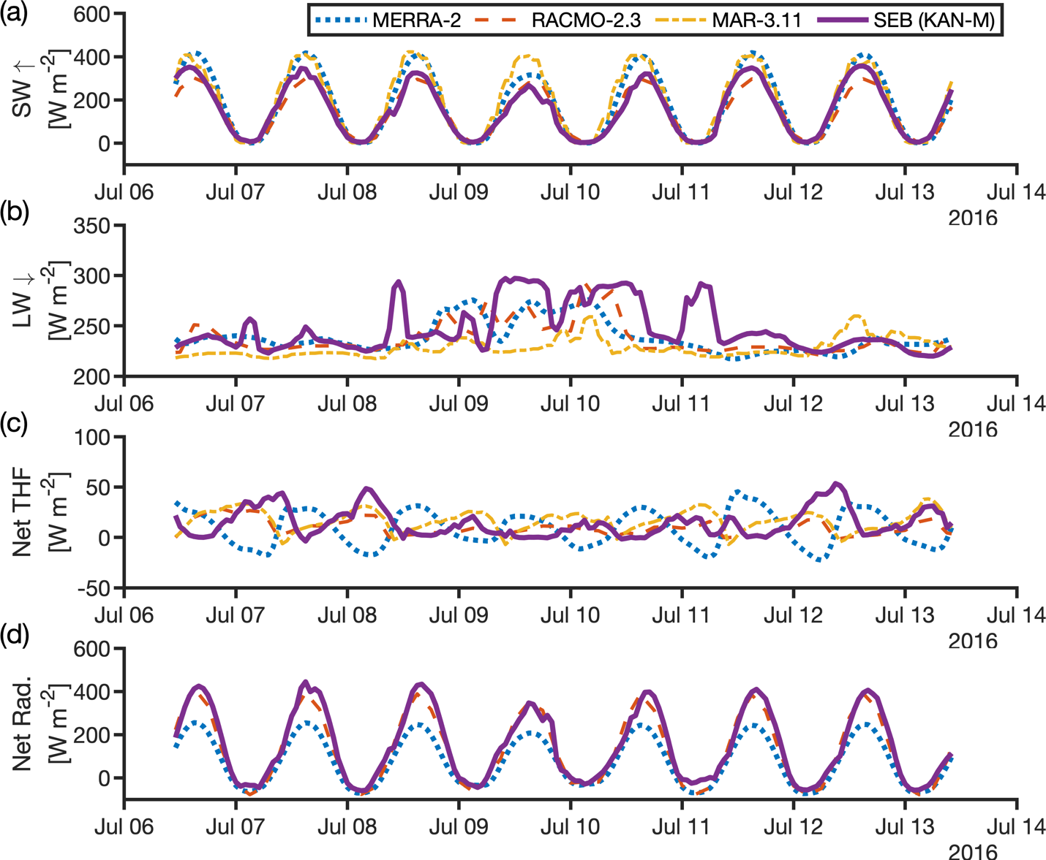
Figure S4: Hourly values of (a) reflected shortwave radiation, (b) incoming longwave radiation, (c) net turbulent heat flux, and (d) net radiation from MERRA-2, RACMO2.3, MAR3.10, and an independent offline surface energy balance (SEB) model⁴ forced with weather station observations during the 6–13 July 2016 field campaign. Among these models, RACMO2.3 most closely reproduces observed net radiation and SEB-modeled turbulent energy fluxes but overestimates meltwater runoff, consistent with the July 2015 field experiment¹ (see also Figure S5).

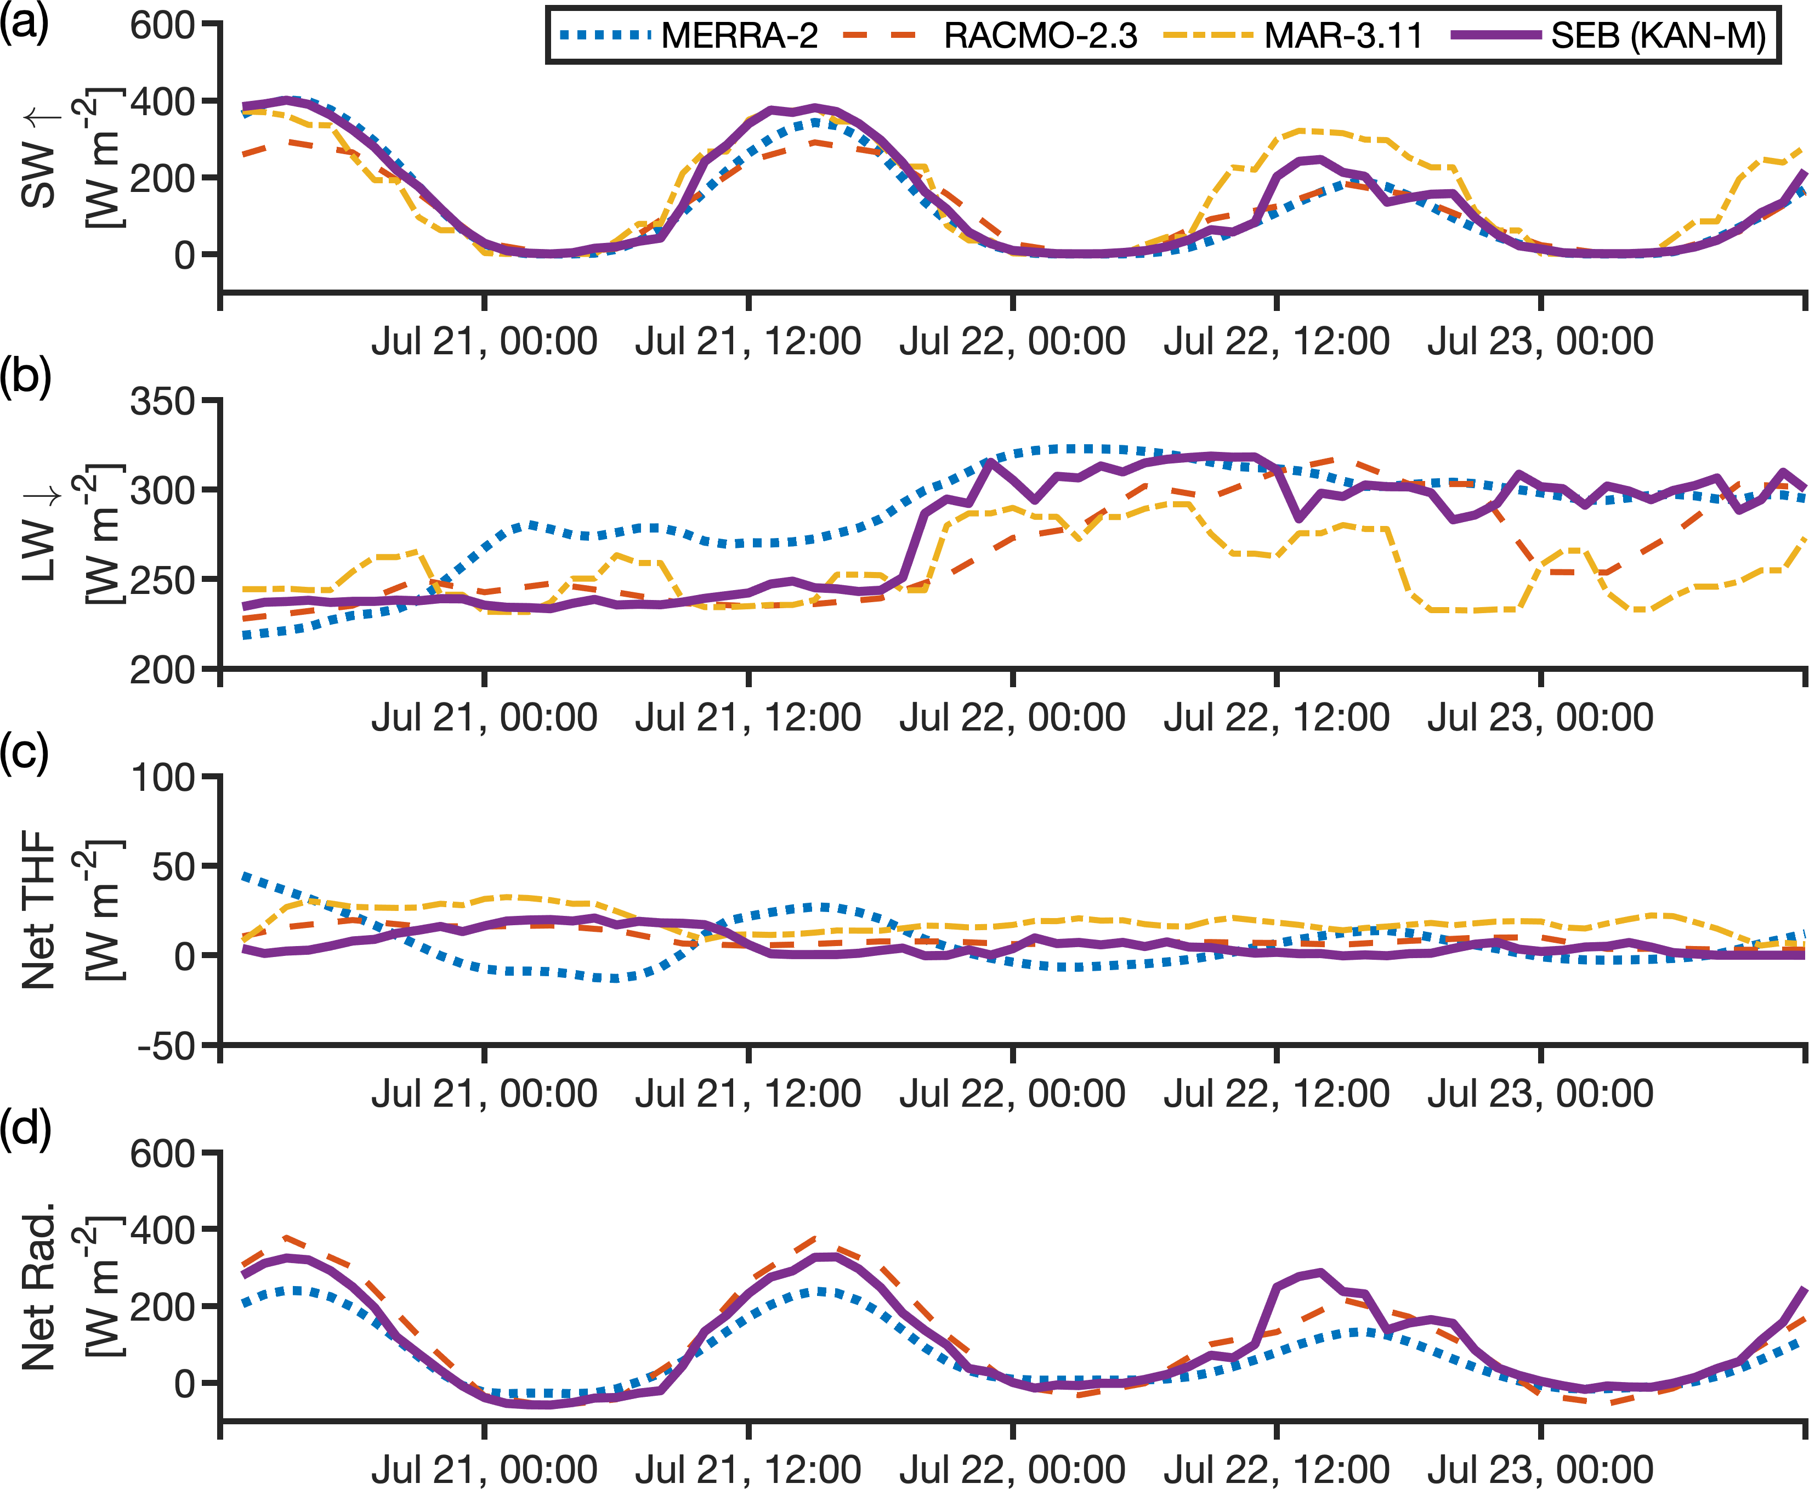
Figure S5: Hourly values of (a) reflected shortwave radiation, (b) incoming longwave radiation, (c) net turbulent heat flux, and (d) net radiation from MERRA-2, RACMO2.3, MAR3.10, and the SEB model forced with KAN-M automatic weather station observations during the 20–23 July 2015 field campaign. Among these models, RACMO2.3 most closely reproduces net radiation and turbulent energy fluxes but overestimates meltwater runoff.

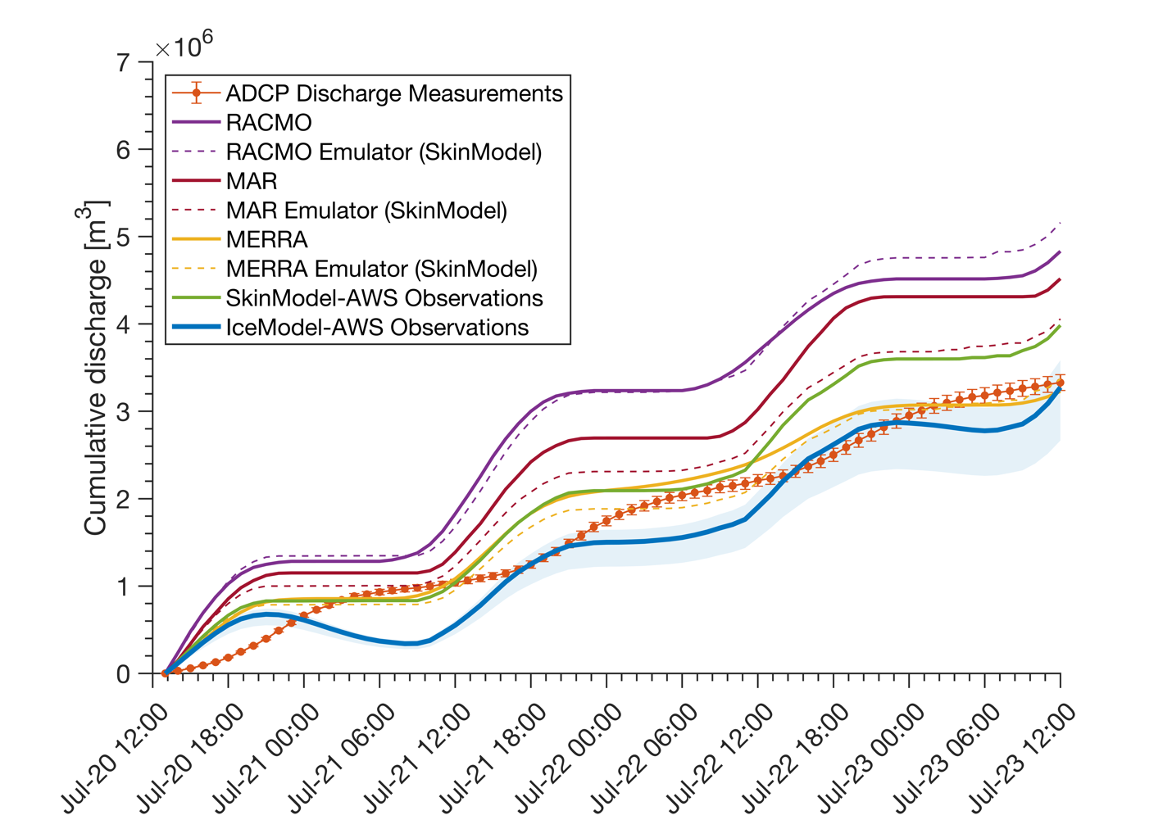
Figure S6: Model simulations of ice sheet surface meltwater runoff compared with direct discharge measurements collected during a 20–23 July 2015 field experiment¹. During this field experiment, heavy cloud cover was present during the final ~24 h. The radiative effect of cloud cover contributes to enhanced spread between climate model simulations and the climate model emulator “SkinModel” which is forced with hourly meteorological variables recorded at the KAN-M automatic weather station. Apart from these discrepancies, the climate-model emulator “SkinModel” closely reproduces climate model runoff, but overpredicts measured discharge when forced with weather station albedo measurements. In contrast, the one-dimensional ice column model IceModel reproduces observed discharge to within 1% cumulative, whereas two of three climate models overestimate runoff for this time and location. Consistent with our 2016 experimental findings, MERRA-2 simulates lower runoff due to its high albedo bias (Figure S7) and corresponding underestimation of net radiation (Figure S4 and Figure S5).

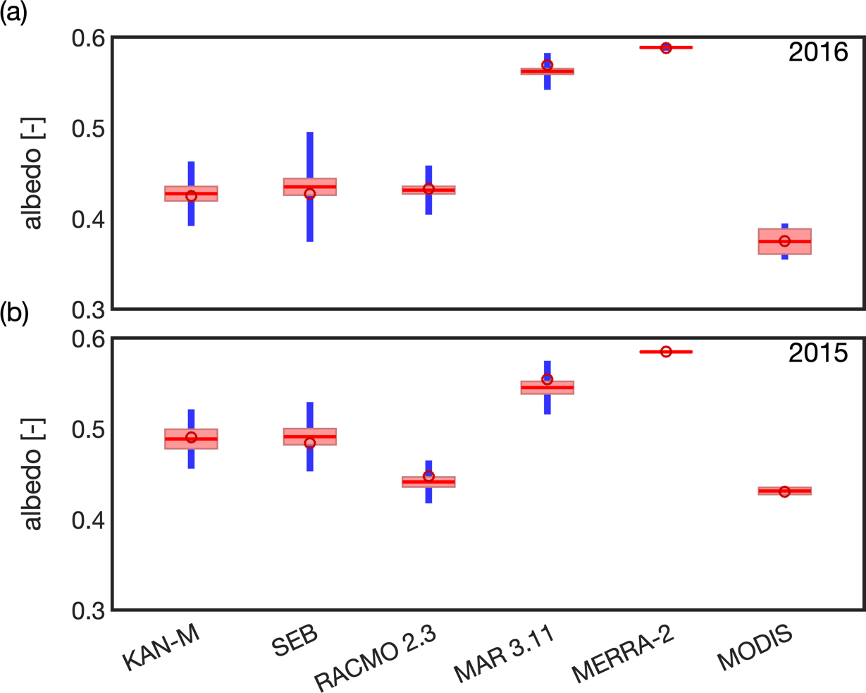
Figure S7: Comparison of observed hourly albedo from the KAN_M automatic weather station with albedo output from the offline ice surface energy balance model (SEB), two regional climate models (RACMO2.3 and MAR3.10), one global climate model (MERRA-2), and daily albedo from the MODIS satellite during the (a) 6–13 July 2016 field experiment, and (b) 20–23 July 2015 field experiment. Among the climate models examined, RACMO2.3 most closely reproduces observed albedo values. Consequently, RACMO2.3 most closely reproduces energy available for meltwater production, but overestimates meltwater runoff. The MODIS satellite time of overflight at this location is 10:30 for Terra and 13:30 for Aqua. Note that model simulations presented in this study labeled ‘AWS Observations’, and also the SEB model, are forced with KAN-M albedo observations.

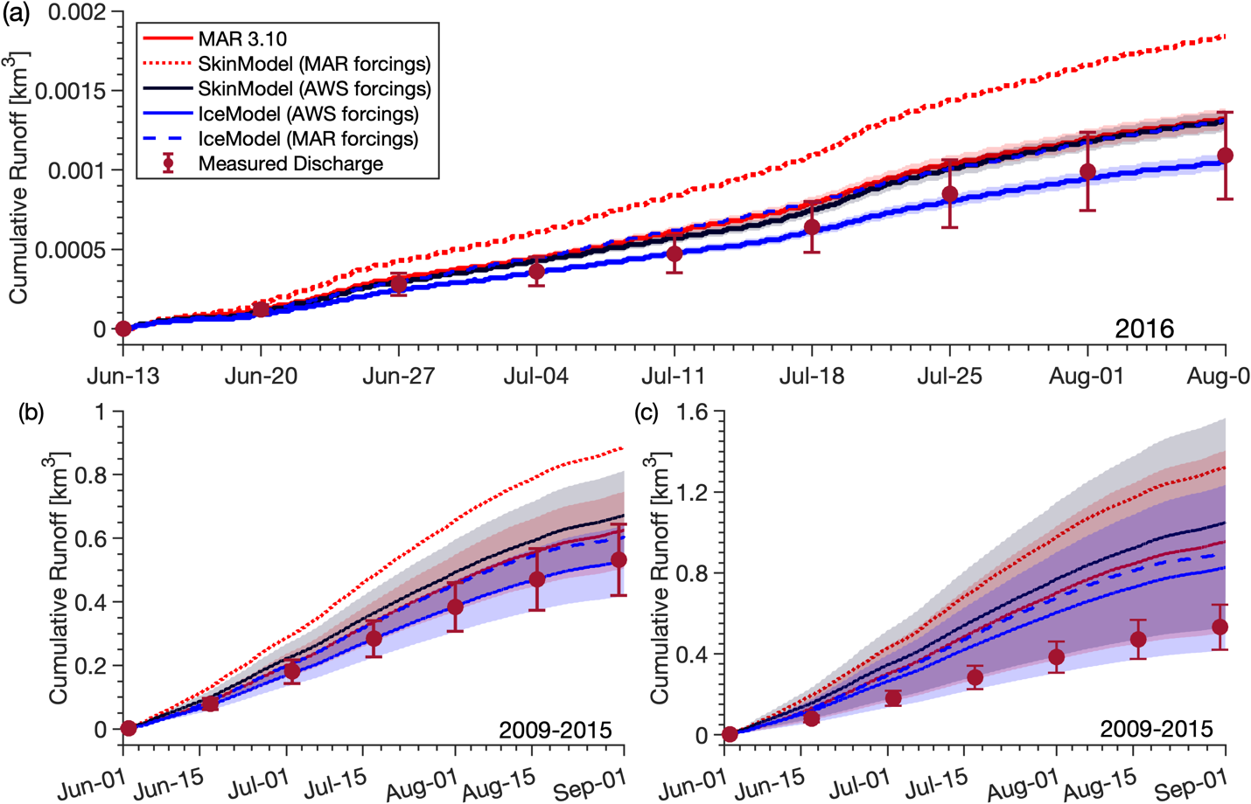
Figure S8: (a) Model simulations of cumulative ice sheet surface meltwater runoff compared with supraglacial discharge measured over two months⁵ in 2016 at a supraglacial catchment contained within the Akuliarusiarsuup Kuua River’s northern tributary (AK4) catchment. IceModel forced with meteorological observations from the nearby KAN-L automatic weather station (AWS) closely reproduces observed supraglacial discharge (compare solid blue line to red error bars proportional to $±$25% estimated discharge uncertainty at the 95% confidence level⁵). In contrast, all other models overestimate observed discharge. The supraglacial catchment contributing area was determined by direct mapping of topographic divides in the field which provides a field-validated constraint on meltwater runoff in this catchment. Modeled runoff uncertainty (shaded envelopes) is proportional to estimated $±$5% catchment area uncertainty⁵. (b-c) Same as (a) but for seven years (2009–2015) of cumulative proglacial discharge measured in the Akuliarusiarsuup Kuua River’s northern tributary (AK4)⁶. Runoff uncertainty (shaded envelopes) and central estimates (solid/dashed lines) are derived from catchment contributing area boundaries corresponding to upper, middle, and lower prescribed values of the flotation factor $k$, which accounts for evolving subglacial water pressure and hydraulic routing throughout the summer melt season⁷. In (b), upper and lower bounds are $k=1.0$ and $k=0.9$, respectively. In (c), upper and lower bounds are $k=1.1$ and $k=0.9$, respectively. Central estimates are the average of the upper and lower contributing areas. The close fit in (b) suggests that the AK4 contributing area is in the range of the lower and upper boundaries corresponding to $k=1.0$ and $k=0.9$, respectively.

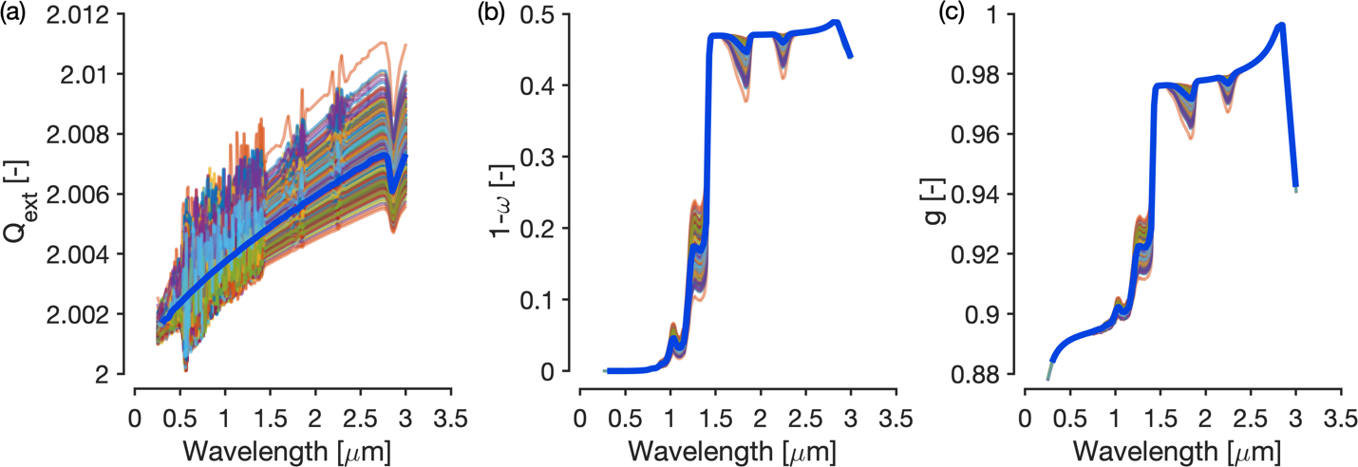
Figure S9: Values of (a) single-scattering extinction coefficient $Q_{ext}$, (b) single-scattering co-albedo $1-ω$, and (c) asymmetry parameter $g$, calculated with Mie scattering algorithms for an ensemble of grain sizes (N=1000) randomly drawn from a normal distribution with mean value 2.0 mm and standard deviation 0.3 mm. These single-scattering properties describe the extinction of shortwave radiation due to absorption and scattering by spherical ice grains. The mean values of each ensemble (thick blue lines) at 118 spectral bands that span the solar spectrum (here 0.3–3.03 $μ$m) are used to calculate spectral flux extinction coefficients (Eq. $13$), which describe the extinction by absorption and scattering of shortwave radiation by a volume of ice grains having a volume-to-surface-area ratio (effective optical radius) equivalent to the grain radius used for the Mie scattering calculations.

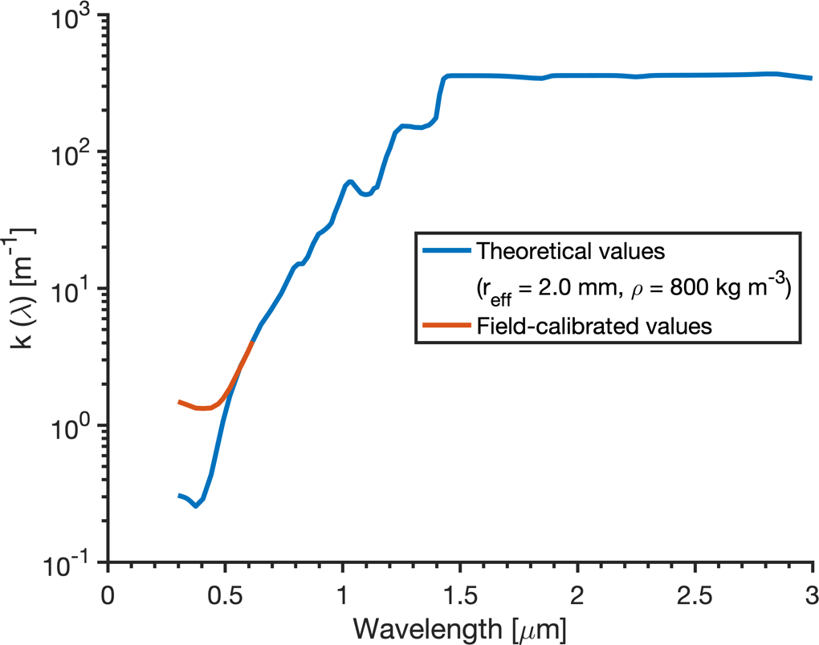
Figure S10: Values of spectral flux extinction coefficient, $k\left(λ\right)$, for an ice volume with effective optical grain radius $r_{eff}=2.0±0.3$ mm and bulk density $ρ=800 kg m^{-3}$, calculated with Eq. $13$ (theoretical values) using the single scattering properties in Figure S9, and field-calibrated values calculated with Eq. 14 using ice absorption coefficient values obtained from measurements of solar flux attenuation in glacier ice in the Greenland Ice Sheet ablation zone⁹. The higher values in the spectral region 0.3–0.7 $μ$m are caused by light absorbing impurities present within the ice column in the Greenland Ice Sheet ablation zone.

2 Supplementary Text

2.1 Supplementary Methods

2.1.1 Description of IceModel
Ice temperature, meltwater production, and refreezing are calculated using a one-dimensional coupled model of mass and heat transport. Following Liston et al.¹⁰:

$$\begin{aligned}C_{v}\frac{∂T_{i}}{∂t}-ρ_{i}L_{f}\frac{∂θ_{i}}{∂t}= \frac{∂}{∂z}\left[{(k}_{i}+k_{v})\frac{∂T_{i}}{∂z}\right]-\frac{∂q}{∂z}-v_{i}C_{p}\frac{∂T_{i}}{∂z} \#\left( SEQ Equation \backslash * ARABIC 1\right)\end{aligned}$$
where $ρ_{i}$ [kg m⁻³] is solid ice density, $C_{v}$ [J m⁻³ K⁻¹] is volumetric specific heat capacity, $T_{i}$ [K] is ice temperature, $L_{f}$ [J kg⁻¹] is the latent heat of fusion of ice, $θ_{i}$ [m³ m⁻³] is volumetric ice content, $z$ [m] is distance in the vertical dimension, $∂q/∂z$ [W m⁻³] is the net solar flux divergence, and $v_{i}$ [m s⁻¹] is the ice surface ablation rate. The model updates an earlier version¹⁰ with new values for the spectral absorption coefficient of ice¹¹ and the advection term $v_{i}$ following Jordan¹².
Changes in enthalpy associated with heat gained or lost by melting and refreezing of liquid water are governed by changes in ice content, where a decrease in ice content is equivalent to an increase in water content:

$$\begin{aligned}\frac{∂θ_{w}}{∂t}=-\frac{∂θ_{i}}{∂t}\#\left( SEQ Equation \backslash * ARABIC 2\right)\end{aligned}$$
and an increase in air content $θ_{a}$ [m³ m⁻³] is equivalent to a decrease in ice content scaled by volume expansion:

$$\begin{aligned}\frac{∂θ_{a}}{∂t}=-\frac{∂θ_{i}}{∂t}\frac{ρ_{w}}{ρ_{i}}.\#\left( SEQ Equation \backslash * ARABIC 3\right)\end{aligned}$$
The ice thermal conductivity, $k_{i}$ [W m⁻¹ K⁻¹], is from Calonne et al.¹³:

$$\begin{aligned}k_{i}=2.107+0.003618\left(ρ-ρ_{i}\right)\#\left( SEQ Equation \backslash * ARABIC 4\right)\end{aligned}$$
where the volumetric ice density $ρ$ and solid ice density $ρ_{i}$ are in units of kg m⁻³. The latent heat flux coefficient, $k_{v}$, accounts for water vapor diffusion within the ice matrix air passages, and is defined by:

$$\begin{aligned}k_{v}=\frac{D_{e}L_{s}}{R_{v}T_{i}}\frac{de_{si}}{dT_{i}}\#\left( SEQ Equation \backslash * ARABIC 5\right)\end{aligned}$$
where $L_{s}$ [J kg⁻¹] is the latent heat of sublimation, $R_{v}$ [J kg⁻¹ K⁻¹] is the gas constant for water vapor, the water vapor diffusivity, $D_{e}$ [m² s⁻¹] is given by Anderson¹⁴:

$$\begin{aligned}D_{e}=9.0×{10}^{-5}{\left(\frac{T_{i}}{273.16}\right)}^{14}\#\left( SEQ Equation \backslash * ARABIC 6\right)\end{aligned}$$
and the saturation vapor pressure over ice $e_{si}$ (Pa) is defined according to Murray¹⁵:

$$\begin{aligned}e_{si}=610.78\exp\left[\frac{21.875\left(T_{i}-273.16\right)}{T_{i}-7.66}\right]\#\left( SEQ Equation \backslash * ARABIC 7\right)\end{aligned}$$
where $T_{i}$ is in [K]. When meltwater is contained within the ice matrix, $k_{i}$ is replaced with $k_{iw}$:

$$\begin{aligned}k_{iw}=θ_{i}k_{i}+θ_{w}k_{w}\#\left( SEQ Equation \backslash * ARABIC 8\right)\end{aligned}$$
and $C_{v}=C_{s}/ρ_{s}$ is updated according to:

$$\begin{aligned}C_{s}=θ_{i}C_{i}+θ_{w}C_{w}+θ_{a}C_{a}\#\left( SEQ Equation \backslash * ARABIC 9\right)\end{aligned}$$
where $C_{i}$, $C_{w}$, and $C_{a}$ [J kg⁻¹ K⁻¹] are the specific heat capacities of pure ice, water, and air, respectively, and $ρ_{s}$ [kg m⁻³] is the ice matrix bulk density:

$$\begin{aligned}ρ_{s}=θ_{i}ρ_{i}+θ_{w}ρ_{w}+θ_{a}ρ_{a}.\#\left( SEQ Equation \backslash * ARABIC 10\right)\end{aligned}$$
The residual liquid water content of the ice matrix is set to 2% following Pettersson et. al.¹⁶.
2.1.2 Two-stream radiative transfer model
The solar radiation source term $∂q/∂z$ is evaluated with the two-stream radiative transfer model described by Schlatter¹⁷. Single-scattering extinction coefficient $Q_{ext}$, single-scattering co-albedo $1-ω$, and asymmetry parameter $g$, are computed as functions of grain size using Mie scattering algorithms provided as MATLAB code by Mätzler¹⁸ and the complex index of refraction of pure ice from Warren and Brandt¹¹. The Mie solutions at each wavelength are integrated over a Gaussian size distribution (N=1000) of scattering radii $N(μ=2.0±0.3 mm)$ to eliminate ripples associated with Bessel function solutions to the Mie equations¹⁹ (Figure S9).
The spectral flux extinction coefficients are applied to a downwelling solar irradiance profile for an Arctic mid-winter atmosphere. At the start of each model timestep, the two-stream model is solved using the observed broadband albedo as an upper boundary condition. The spectral flux extinction coefficients are combined with the modeled ice and liquid water fraction of each vertical layer to compute an effective bulk extinction coefficient:

$$\begin{aligned}K\left(z\right)=Θ_{m}\left(z\right)η\left(z\right)\#\left( SEQ Equation \backslash * ARABIC 11\right)\end{aligned}$$
where
$$\begin{aligned}Θ_{m}=θ_{w}+θ_{i}\frac{ρ_{i}}{ρ_{w}}\#\left(12\right)\end{aligned}$$
is the total equivalent liquid water content of the layer. The bulk extinction coefficient, $η(z)$, is calculated following Brandt and Warren²⁰:

$$\begin{aligned}η\left(z\right)=-\frac{1}{Δz}\ln\left[\frac{∫Q_{λ}^{↓}\exp\left[-k_{λ}\left(z+dz\right)\right]dλ}{∫Q_{λ}^{↓}\exp\left[-k_{λ}\left(z\right)\right]dλ}\right]\#\left( SEQ Equation \backslash * ARABIC 12\right)\end{aligned}$$
where $Q_{λ}^{↓}$ is incoming spectral irradiance at the ice surface, $k_{λ}$ is the spectral flux extinction coefficient for wavelength $λ$:

$$\begin{aligned}k\left(λ\right)=σ_{ext}\sqrt{\left(1-ω\left(λ\right)\right)\left(1-g\left(λ\right)ω\left(λ\right)\right)}\#\left( SEQ Equation \backslash * ARABIC 13\right)\end{aligned}$$
and:
$$σ_{ext}=\frac{3}{4}\frac{Q_{ext}\left(λ\right)}{r_{eff}}$$
is the single-scattering extinction coefficient.
An empirical constraint on $k\left(λ\right)$ is given by a user-defined absorption coefficient profile following Equation 15 of Warren et al.²¹:

$$\begin{aligned}k\left(λ\right)=k\left(λ_{0}\right)\sqrt{\frac{k_{abs}\left(λ\right)}{k_{abs}\left(λ_{0}\right)}}, 300<λ<700 \#\left( SEQ Equation \backslash * ARABIC 14\right)\end{aligned}$$
where $λ_{0}=600 nm$ is a reference wavelength. In this study, values for $k_{abs}\left(λ\right)$ used as input to Eq. $1$ are from measurements of flux attenuation within glacier ice in Greenland’s ablation zone⁹. Enhanced absorption of visible light due to impurities found on and within Greenland’s ablating ice surface including dust, black carbon, and microorganisms is demonstrated by the higher values of $k\left(λ\right)$ from 0.3–0.6 um (Figure S10).
2.1.3 Numerical implementation
Equation (1) is solved using one-dimensional finite volume discretization and fully implicit time stepping. The spectral model is discretized at 2 mm vertical grid spacing to 12 m depth. Values for $∂q/∂z$ at each 2 mm layer are obtained with a tri-diagonal matrix solver following Appendix 1 of Schlatter¹⁷. The thermal model is discretized at 2 cm vertical grid spacing to 20 m depth. Values for $∂T/∂t$ are obtained with a tri-diagonal matrix solver using the finite control volume method described by Patankar²².
At each timestep, the effective thermal conductivity ($k_{i}+k_{v}$; Equation $1$) and specific heat capacity ($C_{v}$; Equation $1$) are updated as functions of the evolving ice, air, and liquid water fractions following Equation 8 and Equation 9.
The upper boundary condition for Equation $1$ is the ice surface temperature $T_{sfc}$, which is initially unknown. To estimate it, a surface energy budget is cast in the following form:

$$\begin{aligned}χ\left(1-α\right)Q_{si}+Q_{li}-εσT_{sfc}^{4}+Q_{h}+Q_{e}+Q_{c}=Q_{m} \#\left(16\right)\end{aligned}$$
where $χ$ [-] allocates the incoming shortwave solar radiation $Q_{si}$ [W m⁻²] into a surface component allocated to the upper grid cell, and its subsurface component $∂q/∂z$, $α$ [-] is ice surface albedo, $Q_{li}$ [W m⁻²] is incoming longwave radiation, $εσT_{sfc}^{4}$ [W m⁻²] is longwave radiation emitted by the ice surface, $ε$ [-] is the ice surface emissivity, $σ$ [W m⁻² K⁻⁴] is the Stefan-Boltzmann constant, $T_{sfc}$ [K] is the ice surface temperature, $Q_{h}$ [W m⁻²] is the sensible heat flux, $Q_{e}$ [W m⁻²] is the latent heat flux, $Q_{c}$ [W m⁻²] is the conductive heat flux, and $Q_{m}$ [W m⁻²] is energy available for meltwater production. The methods used to obtain $Q_{h}$ and $Q_{e}$ are described in Liston et al.¹⁰.
The bottom boundary condition for Equation $1$ is:
$$\begin{aligned}{\left.\frac{dT_{i}}{dz}\right|}_{z_{max}}=0.0\#\left(17\right)\end{aligned}$$
where $z_{max}$ is 20.0 m and the model is initialized with $T_{i}\left(z_{max}\right)=-8.0°C$ based on observations of ice temperature in the western Greenland ablation zone²³.
For SkinModel simulations, if the resulting value for $T_{sfc}$ is greater than 0ºC, then its value is converted to melt energy and $T_{sfc}$ is set to 0ºC. If $T_{sfc}$ is less than 0ºC, then the energy deficit available to freeze liquid water is computed. For IceModel simulations, the value for $T_{sfc}$ is used as the upper boundary condition on Equation $1$, and a tri-diagonal matrix solver is used to obtain values for $T_{i}$ at each vertical node. If $T_{i}$ is less than 0ºC, then the energy deficit available to freeze liquid water is computed. If $T_{i}$ is greater than 0ºC, then its value is converted to melt energy and $T_{i}$ is set to 0ºC.
If the ice thickness of the topmost layer is less than 1 mm it is combined with the layer below. The two layers are combined by adding their ice and liquid water mass and updating the bulk density and thermodynamic properties using the combination formulas in Jordan et al.¹² (Equations 136–139).
Sequential solutions to the coupled radiative, thermodynamic, and hydrologic conservation equations are obtained with an operator splitting method²⁴. Within a timestep, the surface energy balance is computed, followed by the numerical spectral and thermodynamic equations. State variables are then updated, which include the ice, air, and liquid volumetric fractions, the enthalpy profile that accounts for release and consumption of latent heat, and the specific heat capacity, thermal conductivity, vapor diffusivity, and radiation extinction coefficient, which are used in the following time step.
The mass fraction of each individual control volume is composed of partial fractions of ice, liquid water, and air¹²:
$$\begin{aligned}γ_{k}=θ_{k}ρ_{k}\#(18) \end{aligned}$$
where $θ_{k}$ [m³ m⁻³], $γ_{k}$ [kg m⁻³] and $ρ_{k}$ [kg m⁻³] are respectively the partial volume fraction, partial density, and intrinsic density of constituent $k$.
The sum of the volume fractions is unity:
$$\begin{aligned}\sum_{k}{θ_{k}=1}\#(19)\end{aligned}$$
and the sum of the bulk densities is the total density:
$$\begin{aligned}ρ_{t}=\sum_{k}{θ_{k}ρ_{k}=\sum_{k}{γ_{k}}.}\#(20)\end{aligned}$$
The glacier ice density $ρ_{s}$ is the combined liquid water and ice bulk densities i.e. $ρ_{s}≅γ_{l}+γ_{i}$.
Porosity is the ratio of pore volume to total volume [m³ m⁻³]:
$$\begin{aligned}{ϕ=1-θ}_{i}=1-\frac{γ_{i}}{ρ_{i}}\#\left(21\right)\end{aligned}$$
The volume fractions are also expressed in terms of porosity and liquid saturation $s$, or the volume of liquid water per unit volume of voids [m³ m⁻³]:
$$\begin{aligned}θ_{i}=1-ϕ\#\left(22\right)\end{aligned}$$
$$θ_{l}=sϕ$$
$$θ_{a}=ϕ-sϕ$$
The liquid saturation $s$ is set to the residual liquid water holding capacity 2% following Pettersson et al.¹⁶. Liquid water that exceeds $ϕ$ is drained into the layer below, following²⁵. If a sub-freezing layer is encountered, the liquid water is instantaneously drained from the ice column.
References
1. Smith, L. C. et al. Direct measurements of meltwater runoff on the Greenland ice sheet surface. PNAS 114, E10622–E10631 (2017).
2. Yang, K., Smith, L. C., Chu, V. W., Gleason, C. J. & Li, M. A Caution on the Use of Surface Digital Elevation Models to Simulate Supraglacial Hydrology of the Greenland Ice Sheet. IEEE Journal of Selected Topics in Applied Earth Observations and Remote Sensing 8, 1–13 (2015).
3. Brodzik, M. J., Billingsley, B., Haran, T., Raup, B. & Savoie, M. H. EASE-Grid 2.0: Incremental but Significant Improvements for Earth-Gridded Data Sets. IJGI 1, 32–45 (2012).
4. van As, D. Warming, glacier melt and surface energy budget from weather station observations in the Melville Bay region of northwest Greenland. Journal of Glaciology 57, 208–220 (2011).
5. Muthyala, R. et al. Seasonal Variability in In-situ Supraglacial Streamflow and Drivers in Southwest Greenland in 2016. The Cryosphere Discussions 1–28 (2020) doi:10.5194/tc-2020-314.
6. Rennermalm, Å. K. et al. River discharge at station AK-004-001, 2008 - 2016, version 3.0. 1086494 data points (2017) doi:10.1594/PANGAEA.876357.
7. Mankoff, K. D. et al. Greenland liquid water discharge from 1958 through 2019. Earth System Science Data 12, 2811–2841 (2020).
8. Yang, K. et al. Surface meltwater runoff on the Greenland ice sheet estimated from remotely sensed supraglacial lake infilling rate. Remote Sensing of Environment 234, 111459 (2019).
9. Cooper, M. G. et al. First spectral measurements of light attenuation in Greenland Ice Sheet bare ice suggest shallower subsurface radiative heating and ICESat-2 penetration depth in the ablation zone. The Cryosphere Discussions (2020) doi:10.5194/tc-2020-53.
10. Liston, G. E., Winther, J.-G., Bruland, O., Elvehøy, H. & Sand, K. Below-surface ice melt on the coastal Antarctic ice sheet. Journal of Glaciology 45, 273–285 (1999).
11. Warren, S. G. & Brandt, R. E. Optical constants of ice from the ultraviolet to the microwave: A revised compilation. J. Geophys. Res. 113, D14220 (2008).
12. Jordan, R. A One-Dimensional Temperature Model For a Snowpack. http://hdl.handle.net/11681/11677 (1991).
13. Calonne, N. et al. Thermal Conductivity of Snow, Firn, and Porous Ice From 3‐D Image‐Based Computations. Geophys. Res. Lett. 46, 13079–13089 (2019).
14. Anderson, E. A. A point energy and mass balance model of a snow cover. (1976).
15. Murray, F. W. On the Computation of Saturation Vapor Pressure. Journal of Applied Meteorology 6, 203–204 (1967).
16. Pettersson, R., Jansson, P. & Blatter, H. Spatial variability in water content at the cold-temperate transition surface of the polythermal Storglaciären, Sweden. J. Geophys. Res. 109, F02009 (2004).
17. Schlatter, T. W. The Local Surface Energy Balance and Subsurface Temperature Regime in Antarctica. J. Appl. Meteor. 11, 1048–1062 (1972).
18. Mätzler, C. MATLAB Functions for Mie Scattering and Absorption, Version 2. 24 https://boris.unibe.ch/146550/ (2002) doi:10.7892/BORIS.146550.
19. Bohren, C. F. & Huffman, D. R. Absorption and Scattering of Light by Small Particles. (John Wiley & Sons, Ltd, 2007).
20. Brandt, R. E. & Warren, S. G. Solar-heating rates and temperature profiles in Antarctic snow and ice. Journal of Glaciology 39, 99–110 (1993).
21. Warren, S. G., Brandt, R. E. & Grenfell, T. C. Visible and near-ultraviolet absorption spectrum of ice from transmission of solar radiation into snow. Appl. Opt., AO 45, 5320–5334 (2006).
22. Patankar, S. V. Numerical Heat Transfer and Fluid Flow. (Hemisphere Publishing Corporation, 1980).
23. Hills, B. H. et al. Processes influencing heat transfer in the near-surface ice of Greenland’s ablation zone. The Cryosphere 12, 3215–3227 (2018).
24. Clark, M. et al. The structure for unifying multiple modeling alternatives (SUMMA), Version 1.0: Technical Description. 668 KB http://opensky.ucar.edu/islandora/object/technotes:526 (2015) doi:10.5065/D6WQ01TD.
25. Langen, P. L., Fausto, R. S., Vandecrux, B., Mottram, R. H. & Box, J. E. Liquid Water Flow and Retention on the Greenland Ice Sheet in the Regional Climate Model HIRHAM5: Local and Large-Scale Impacts. Front. Earth Sci. 4, (2017).

