Supplementary Information

Observation of roton-like dispersion relations in acoustic metamaterials
Zhenxiao Zhu^{1,#}, Zhen Gao^{1,# *}, Gui-Geng Liu^{2#}, Yong Ge³, Yin Wang³, Xiang Xi¹, Bei Yan¹, Fujia Chen⁴, Perry Ping Shum¹, Hongxiang Sun^{3,*}, Yihao Yang^{4,*}
¹Department of Electrical and Electronic Engineering, Southern University of Science and Technology, Shenzhen 518055, China.
²Division of Physics and Applied Physics, School of Physical and Mathematical Sciences, Nanyang Technological University, 21 Nanyang Link, Singapore 637371, Singapore.
³School of Physics and Electronic Engineering, Jiangsu University, Zhenjiang, 212013, China.
⁴Interdisciplinary Center for Quantum Information, State Key Laboratory of Modern Optical Instrumentation, ZJU-Hangzhou Global Science and Technology Innovation Center, Zhejiang University, Hangzhou 310027, China.
#These authors contributed equally to this work.
*E-mail: gaoz@sustech.edu.cn (Z.G.); jsdxshx@ujs.edu.cn (H.S); yangyihao@zju.edu.cn (Y.Y.);

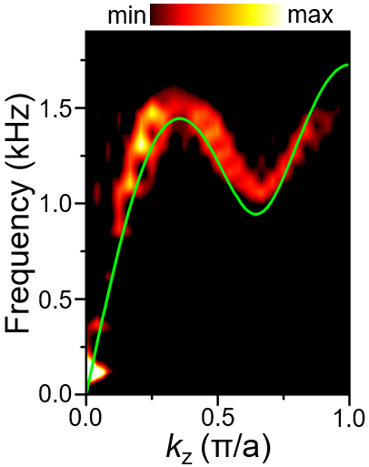
Supplementary Figure S1 The fitted curve (green line) of the measured dispersion (red colour) with third-nearest-neighbour interactions using the 1D toy model.

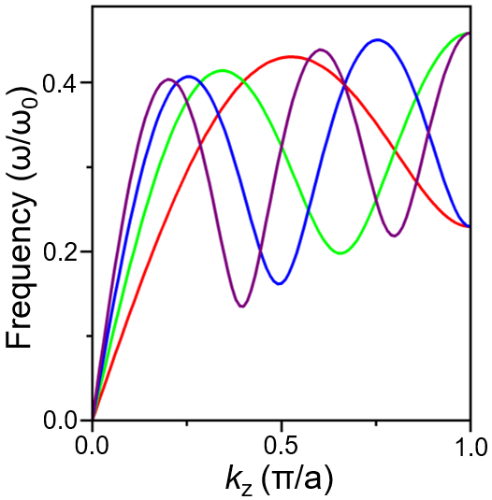
Supplementary Figure S2 Calculated roton-like dispersion relations for four 1D toy models with beyond-nearest-neighbour interactions. The dispersion relations for four 1D toy models with N = 2 (red curves), 3 (green curves), 4 (blue curves), 5 (purple curves), respectively. The parameters are K_{N}/K₁ = 3 with N = 2, 3, 4, 5 and , respectively.

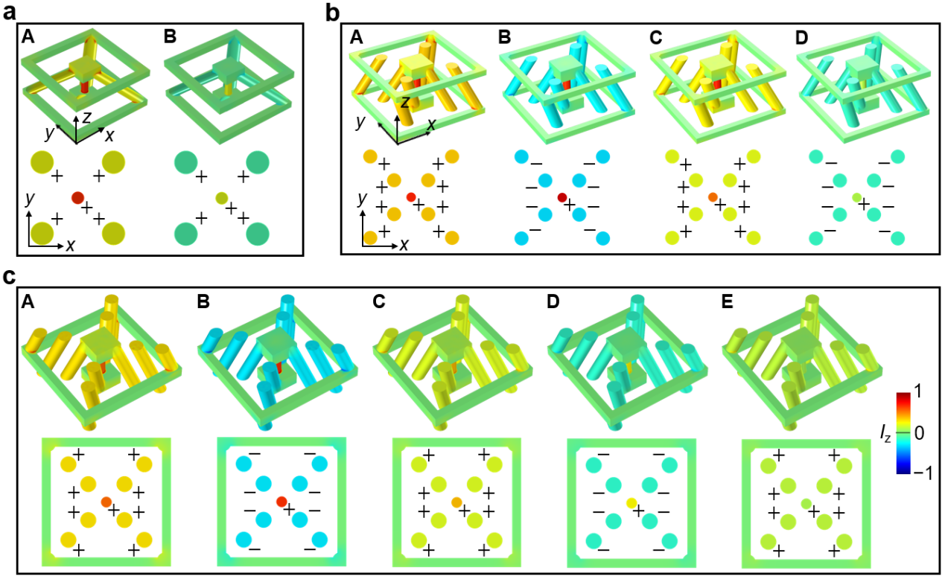
Supplementary Figure S3 The mean energy fluxes of different eigenmodes at the same frequency of 1.35 kHz for (a) N = 2, (b) N = 4 and (c) N = 5, respectively.

