Extended Data Fig. 1. Present forest type distribution in percent area in the West and Boreal regions.
Extended Data Fig. 2. Present forest type distribution in percent area in the East region.

Extended Data Fig. 3. a, Variable importance based on the Gini impurity for the ratio of forest migration velocity to tree species migration velocity. b, the distribution of tree species evenness. It is the average of past (1970-1999) and present (2000-2019). c, the distribution of climate change. It is an aggregated indicator of temporal changes in the top nine bioclimate variables in terms of variable importance (variables in red in a), normalized between 0 and 1. The predictor variable names correspond to Extended Data Table 1.
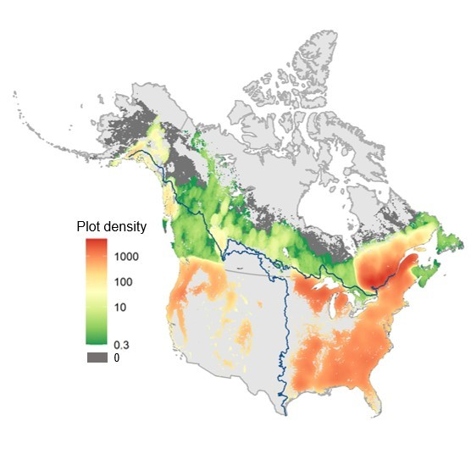
Extended Data Fig. 4. Forest inventory plot density for the present dataset (2000–2019). Plot density represents the number of sample plots per 0.1×0.1° grid (~100 km²). Thick line indicates the border between West, East, and Boreal categories.

Extended Data Fig. 5. Performance of two candidate machine learning models to map forest types. Kappa statistic and accuracy of random forests and support vector machine imputation models. Mean values from 20 repetitions and 95% CI are shown for each time period and region. Random forests outperformed support vector machine in all cases, and thus random forests were used to map forest types in this paper.
Extended Data Fig. 6. Variable importance and correlogram of all predictor variables used in this study. a, Variable importance based on classification accuracy of the random forests model. b, Correlation matrix of predictor variables for the present (2000-2019) dataset. See Extended Data Table 1 for detailed definition and description of each variable.

Extended Data Fig. 7. Average silhouette width with different number of clusters and number of dimensions obtained from autoencoder neural network. (a, b) West, (c, d) East, and (e, f) Boreal regions. Left column (a, c, e) is 2000-2019 dataset, and right column (b, d, f) is 1970-1999 dataset. Since silhouette width does not improve above number of dimensions = 15, we chose 15 as the number of dimensions for all models. Due to the data size, we used 90% of the East 2000-2019 dataset to conduct K-means cluster analysis and calculate silhouette width.
Extended Data Fig. 8. Confusion matrix of the random forests model trained using present (2000-2019) data for the West (a), East (b), and Boreal (c) region. The values are percent mean number of cases based on 20 repetitions.

Extended Data Fig. 9. Confusion matrix of the random forests model trained using past (1970-1999) data for the West (a), East (b), and Boreal (c) region. The values are percent mean number of cases based on 20 repetitions.

Extended Data Table 1. List of predictor variables used to map forest types.
Variable | Definition (unit) | 1970-1999 |  |  | 2000-2019
 |  | Data source | Reference year | Resolution | Data source | Reference year | Resolution
Climate covariates
C1 | Annual mean temperature (0.1 °C) | WorldClim v.2.1 (70) | 1970-2000 | 1 km² | CHELSA v.1.2 (71) | 1979-2013 | 1 km²
C2 | Mean diurnal range (°C) | WorldClim v.2.1 | 1970-2000 | 1 km² | CHELSA v.1.2 | 1979-2013 | 1 km²
C3 | Isothermality (unitless*100) | WorldClim v.2.1 | 1970-2000 | 1 km² | CHELSA v.1.2 | 1979-2013 | 1 km²
C4 | Temperature seasonality (standard deviation*100) | WorldClim v.2.1 | 1970-2000 | 1 km² | CHELSA v.1.2 | 1979-2013 | 1 km²
C5 | Temperature annual range (0.1 °C) | WorldClim v.2.1 | 1970-2000 | 1 km² | CHELSA v.1.2 | 1979-2013 | 1 km²
C6 | Mean temperature of wettest quarter (0.1 °C) | WorldClim v.2.1 | 1970-2000 | 1 km² | CHELSA v.1.2 | 1979-2013 | 1 km²
C7 | Mean temperature of driest quarter (0.1 °C) | WorldClim v.2.1 | 1970-2000 | 1 km² | CHELSA v.1.2 | 1979-2013 | 1 km²
C8 | Mean temperature of warmest quarter (0.1 °C) | WorldClim v.2.1 | 1970-2000 | 1 km² | CHELSA v.1.2 | 1979-2013 | 1 km²
C9 | Mean temperature of coldest quarter (0.1 °C) | WorldClim v.2.1 | 1970-2000 | 1 km² | CHELSA v.1.2 | 1979-2013 | 1 km²
C10 | Annual precipitation (mm) | WorldClim v.2.1 | 1970-2000 | 1 km² | CHELSA v.1.2 | 1979-2013 | 1 km²
C11 | Precipitation seasonality (coefficient of variation) | WorldClim v.2.1 | 1970-2000 | 1 km² | CHELSA v.1.2 | 1979-2013 | 1 km²
C12 | Precipitation of wettest quarter (mm) | WorldClim v.2.1 | 1970-2000 | 1 km² | CHELSA v.1.2 | 1979-2013 | 1 km²
C13 | Precipitation of driest quarter (mm) | WorldClim v.2.1 | 1970-2000 | 1 km² | CHELSA v.1.2 | 1979-2013 | 1 km²
C14 | Precipitation of warmest quarter (mm) | WorldClim v.2.1 | 1970-2000 | 1 km² | CHELSA v.1.2 | 1979-2013 | 1 km²
C15 | Precipitation of coldest quarter (mm) | WorldClim v.2.1 | 1970-2000 | 1 km² | CHELSA v.1.2 | 1979-2013 | 1 km²
C16 | Potential evapotranspiration (mm year⁻¹) | CGIAR-CSI v.2 (72) | 1970-2000 | 1 km² | CGIAR-CSI v.2 | 1970-2000 | 1 km²
C17 | Indexed annual aridity (unitless index*10⁻⁴) | CGIAR-CSI v.2 | 1970-2000 | 1 km² | CGIAR-CSI v.2 | 1970-2000 | 1 km²
Topographic covariates
T1 | Elevation (m) | EarthEnv (73) | 2010 | 1 km² | EarthEnv | 2010 | 1 km²
T2 | Roughness | EarthEnv | 2010 | 1 km² | EarthEnv | 2010 | 1 km²
T3 | Terrain ruggedness index | EarthEnv | 2010 | 1 km² | EarthEnv | 2010 | 1 km²
T4 | Topographic position index | EarthEnv | 2010 | 1 km² | EarthEnv | 2010 | 1 km²
T5 | Aspect cosine | EarthEnv | 2010 | 1 km² | EarthEnv | 2010 | 1 km²
T6 | Aspect sine | EarthEnv | 2010 | 1 km² | EarthEnv | 2010 | 1 km²
T7 | Slope | EarthEnv | 2010 | 1 km² | EarthEnv | 2010 | 1 km²
T8 | Profile curvature | EarthEnv | 2010 | 1 km² | EarthEnv | 2010 | 1 km²
T9 | Tangential curvature | EarthEnv | 2010 | 1 km² | EarthEnv | 2010 | 1 km²
T10 | First order partial derivative (E-W slope) | EarthEnv | 2010 | 1 km² | EarthEnv | 2010 | 1 km²
T11 | First order partial derivative (N-S slope) | EarthEnv | 2010 | 1 km² | EarthEnv | 2010 | 1 km²
T12 | Second order partial derivative (E-W slope) | EarthEnv | 2010 | 1 km² | EarthEnv | 2010 | 1 km²
T13 | Second order partial derivative (N-S slope) | EarthEnv | 2010 | 1 km² | EarthEnv | 2010 | 1 km²
Soil covariates
S1 | Bulk density (g cm⁻³) | WISE30sec v1.0 (74) | na | 1 km² | WISE30sec v1.0 | na | 1 km²
S2 | Percent clay (mass %) | WISE30sec v1.0 | na | 1 km² | WISE30sec v1.0 | na | 1 km²
S3 | Organic carbon content (g kg⁻¹) | WISE30sec v1.0 | na | 1 km² | WISE30sec v1.0 | na | 1 km²
S4 | pH measured in water | WISE30sec v1.0 | na | 1 km² | WISE30sec v1.0 | na | 1 km²
S5 | Electrical conductivity (dS m⁻¹) | WISE30sec v1.0 | na | 1 km² | WISE30sec v1.0 | na | 1 km²
S6 | C/N ratio | WISE30sec v1.0 | na | 1 km² | WISE30sec v1.0 | na | 1 km²
S7 | Total nitrogen (g kg⁻¹) | WISE30sec v1.0 | na | 1 km² | WISE30sec v1.0 | na | 1 km²
Anthropogenic impact
H | Human footprint | (75) | 1993 | 1 km² | (75) | 2009 | 1 km²

