Supplementary Information
Voltage-driven gigahertz frequency tuning of spin Hall nano-oscillators
Jong-Guk Choi^{1†}, Jaehyeon Park^{2†}, Min-Gu Kang¹, Doyoon Kim³, Jae-Sung Rieh³, Kyung-Jin Lee², Kab-Jin Kim^{2★} and Byong-Guk Park^{1★}
¹ Department of Materials Science and Engineering, KAIST, Daejeon 34141, Korea
² Department of Physics, KAIST, Daejeon 34141, Korea
³ School of Electrical Engineering, Korea University, Seoul 02841, Korea

- Contents -
Note 1. ST-FMR spectra for various frequencies
Note 2. Voltage-driven frequency modulation in Co/Ni sample with a different thickness
Note 3. Gate voltage effect on the current-induced SOT
Note 4. Threshold current for current-induced magnetization auto-oscillation

Note1. ST-FMR spectra for various frequencies
Figure S1a shows the schematic illustration of the ST-FMR measurement [S1, S2], of which details are discussed in the Method section of the main text. Figures S1b-S1d show the ST-FMR spectra of the Co/Ni sample with different $V_{g}$’s for various frequencies ranging from 10 to 21 GHz, measured while sweeping magnetic fields along the z-direction.
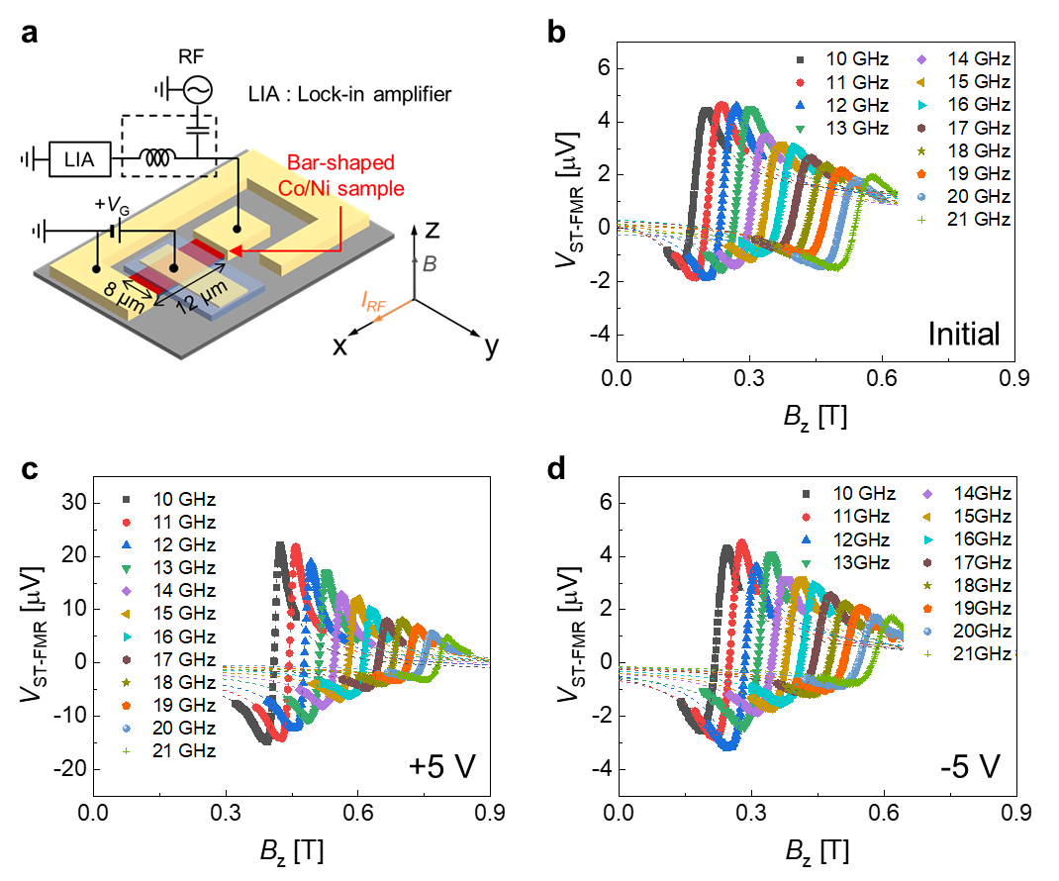
Figure S1. ST-FMR measurement of Co/Ni sample for various frequencies. a, Schematic diagram of the device structure of the ST-FMR measurement set-up. b-d, ST-FMR spectra of the Co/Ni sample for various frequencies ranging from 10 to 21 GHz with sequentially applied gate voltages $V_{g}$ = 0 V (initial) (b), $V_{g}$ = +5 V (c), and $V_{g}$ = -5 V (d). The dotted lines are the fitting curves based on Eq. (2) of the main text.
Note 2. Voltage-driven frequency modulation in Co/Ni sample with a different thickness
To show the reproducibility of the voltage-driven frequency modulation, we fabricated another Co/Ni device of Ta (3 nm)/Pt (5 nm)/[Co (0.4 nm)/Ni (0.6 nm)]₇/Co (0.4 nm)/AlO_{x} (2 nm), where a slightly thinner Co (0.4 nm) is used compared to the sample used in the main text has a [Ta (3 nm)/Pt (5 nm)/[Co (0.45 nm)/Ni (0.6 nm)]₇/Co (0.45 nm)/AlO_{x} (2 nm)]. We first check PMA of the sample using the ST-FMR measurement with the same procedure used in Fig. 2 of the main text. Figure S2 shows the resonance frequency ($f_{res,z}$) of ST-FMR spectra as a function of the resonance field ($B_{res,z}$) for two Co/Ni samples having different Co thicknesses. As the y-intercept indicates the PMA field ($B_{k}$) according to the Kittel formula $f_{res,z}=\frac{γ}{2π}(B_{res, z}+B_{k})$ [S3], demonstrating that the sample with a thinner Co has a stronger PMA.
We then fabricate an SHNO with a constriction width of 100 nm. The experimental procedure for the power spectral density (PSD) measurement is the same as used in Fig. 3 of the main text, except for a dc current ($I_{dc}$) of 1.8 mA used. Figures S3a-S3c show the color plots of PSD as a function of a magnetic field ($B$), where gate voltages of +5 V and -3V were sequentially applied. The auto-oscillation peak is clearly observed, and its frequency is increased by the positive voltage and restored by the subsequent negative voltage. Figure S3d shows the auto-oscillation spectra for a magnetic field of $B=0.9 T$ for different gate voltages, extracted from Figs. S3c-S3g. The frequency modulation of the sample with a thinner Co is about a few GHz, confirming the reproducibility of the voltage-driven frequency modulation of the SHNO.

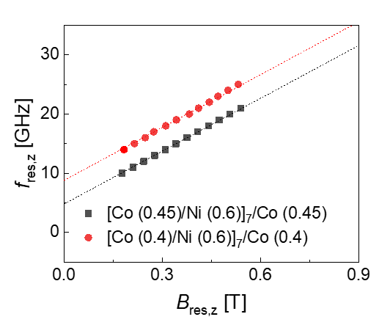
Figure S2. ST-FMR measurement. Resonance frequency ($f_{res,z}$) of ST-FMR spectra as a function of the resonance field ($B_{res,z}$) for the samples of Ta (3 nm)/Pt (5 nm)/[Co (0.45 nm)/Ni (0.6 nm)]₇/Co (0.45 nm)/AlO_{x} (2 nm) (black squares) and Ta (3 nm)/Pt (5 nm)/[Co (0.4 nm)/Ni (0.6 nm)]₇/Co (0.4 nm)/AlO_{x} (2 nm) structures (red circles).
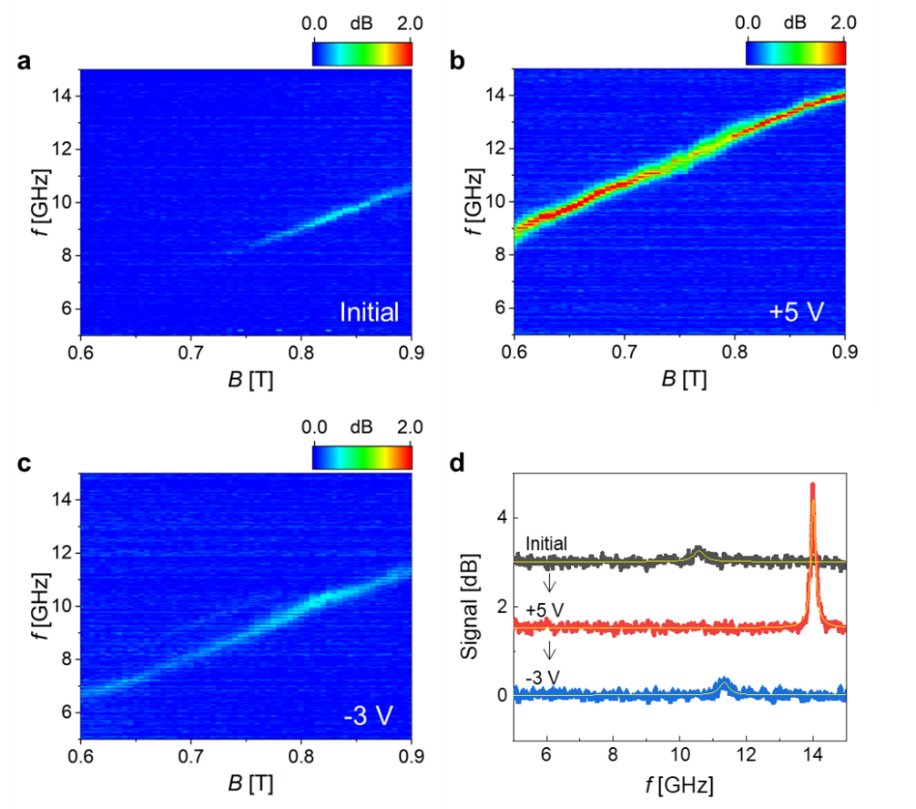
Figure S3. Voltage-driven frequency modulation in SHNO of Ta (3 nm)/Pt (5 nm)/[Co (0.4 nm)/Ni (0.6 nm)]₇/Co (0.4 nm)/AlO_{x} (2 nm). a-c, PSDs versus a magnetic field for sequentially applied gate voltages, $V_{g}$ = 0 V (initial state) (a), $V_{g}$ = +5 V (b), and $V_{g}$ = -3 V (c). $I_{dc}$= 1.8 mA. d, Auto-oscillation spectra for $B=0.9 T$ for different gate voltages, extracted from Figs. S3c-S3g. The yellow line is the Lorentz fit of the auto-oscillation spectra.
Note 3. Gate voltage effect on the current-induced SOT
We investigated the gate voltage effect on current-induced spin-orbit torque (SOT) using in-plane harmonic measurements. For the measurement, we fabricated a Hall bar device with a 10 μm × 10 μm cross using the Ta (3 nm)/Pt (5 nm)/[Co (0.45 nm)/Ni (0.6 nm)]₇/Co (0.45 nm)/AlOx (2 nm) film. The first and second harmonic Hall resistance ($R_{1ω}$ and $R_{2ω}$) were simultaneously measured with an a.c. current of 15 mA and a frequency of 11 Hz while rotating the sample (azimuthal angle φ) under an in-plane magnetic field ($B_{ext}$). The $B_{ext}$ ranges from 0.3 T to 4.0 T, which is larger than the perpendicular magnetic anisotropy field $(B_{k}$), so the magnetization is aligned in the magnetic field direction. The gate voltage was applied to the top electrode for 5 minutes at 150 ℃ before the measurement. Figure S4a shows the $R_{2ω}$ as a function of $φ$ under a magnetic field of 0.6 T for various gate voltages. The $R_{2ω}$ can be expressed as [S4, S5],
$R_{2ω}\left(φ\right)=\left(R_{AHE}\frac{B_{DLT}}{B_{eff}}+R_{∇T}\right)cosφ+2R_{PHE}\frac{B_{FLT}}{B_{ext}}\left(2\cos^{3}φ-cosφ\right)$, (2)
where $R_{AHE}$, $R_{PHE}$ and $R_{∇T}^{2ω}$ are the anomalous Hall resistance, planar Hall resistance and thermal effect contribution, respectively; $B_{DLT}$ and $B_{FLT}$ are the damping-like effective field and field-like effective field including Oersted field, respectively; $B_{eff}$ is the effective magnetic field ($B_{eff}=B_{ext}-B_{k})$. Figures S4b and S4c show the magnetic field-dependence of the $cosφ$ and ($2\cos^{3}φ-cosφ$) components of $R_{2ω}$, respectively. Figure S4d demonstrates that the extracted $B_{DLT}$ and $B_{FLT}$ values of the sample, which are not changed by the gate voltage.
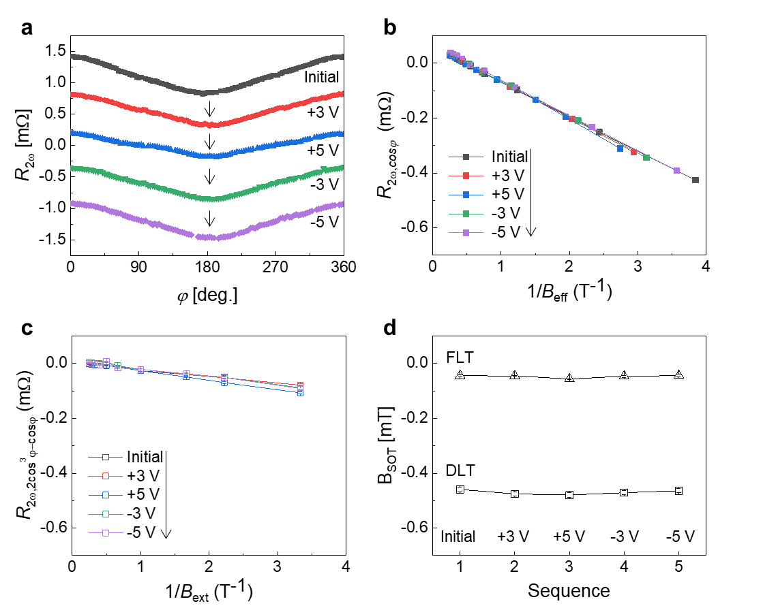
Figure S4. Gate voltage effect on current-induced SOT. a, Second-harmonic Hall resistance $R_{2ω}$ versus azimuthal angle $φ$ under an in-plane magnetic field of 0.6 T for sequentially applied gate voltages. b, $cosφ$ component of $R_{2ω}$ as a function of $1/B_{eff}$ for sequentially applied gate voltages. c, ($2\cos^{3}φ-cosφ$) component of $R_{2ω}$ as a function of $1/B_{ext}$ for sequentially applied gate voltages. The gate voltages were applied in the sequence indicated by the black arrows in Figs. S4a-S4c. d, The variation of the SOT-induced $B_{DLT}$ (black square) and $B_{FLT}$ (black triangle) values with sequentially applied gate voltages.

Note 4. Threshold current for current-induced magnetization auto-oscillation
We determine the threshold current ($I_{th}$) at which auto-oscillation begins to occur by a linear fit of the inverse of the PSD integral. Figures S5a-S5e show the (integral of PSD)⁻¹ versus current for sequentially applied gate voltages, where I_{th} is obtained by the x-intercept of the linear fit (solid red lines) [S6, S7]. Figure S4f displays the variation of $I_{th}$ with gate voltages, which is the same as Fig. 4f in the main text.
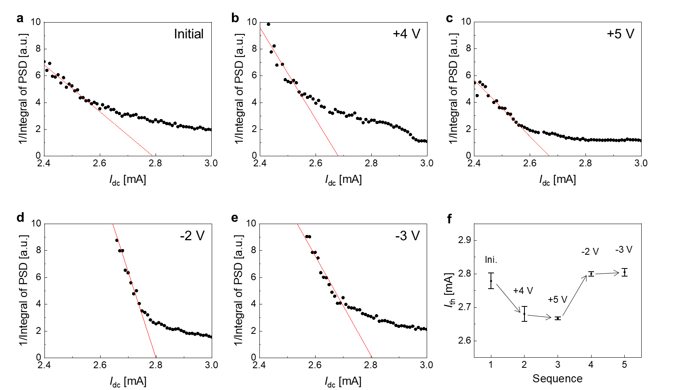
Figure S5. Threshold current for current-induced magnetization auto-oscillation. a-e, (integral of PSD)⁻¹ as a function of current for sequentially applied gate voltages, V_{g} = 0V (initial) (a), $V_{g}$ = +4 V (b), $V_{g}$ = +5 V (c), $V_{g}$ = -2 V (d), and $V_{g}$ = -3 V (e). $B=0.52 T$. f, $I_{th}$ according to the sequentially applied gate voltages, extracted from Figs. S5a-S5e.

References
- Liu, L., Moriyama, T., Ralph, D. C. & Buhrman, R. A. Spin-torque ferromagnetic resonance induced by the spin Hall effect. Phys. Rev. Lett. 106, 306601 (2011).
- Kim, J. H. et al. Spin-orbit torques associated with ferrimagnetic order in Pt/GdFeCo/MgO layers. Sci. Rep. 8, 6017 (2018).
- Beaujour, J.-M., Ravelosona, D., Tudosa, I., Fullerton, E. E. & Kent, A. D. Ferromagnetic resonance linewidth in ultrathin films with perpendicular magnetic anisotropy. Phys. Rev. B 80, 180415(R) (2009).
- Hayashi, M., Kim, J., Yamanouchi, M. & Ohno, H. Quantitative characterization of the spin-orbit torque using harmonic Hall voltage measurements. Phys. Rev. B 89, 144425 (2014).
- Avci, C. O. et al. Interplay of spin-orbit torque and thermoelectric effects in ferromagnet/normal-metal bilayers. Phys. Rev. B 90, 224427 (2014).
- Tiberkevich, V., Slavin, A. & Kim, J. Von. Microwave power generated by a spin-torque oscillator in the presence of noise. Appl. Phys. Lett. 91, 192506 (2007).
- Awad, A. A., Houshang, A., Zahedinejad, M., Khymyn, R. & Åkerman, J. Width dependent auto-oscillating properties of constriction based spin Hall nano-oscillators. Appl. Phys. Lett. 116, 232401 (2020).

