Supplementary Material of

"Eocene-Oligocene terrestrial cryospheric processes: bipolar glaciations and uplifted Tibet"

The supplementary information includes the following subsections;
1. Sedimentary background of ice-related structure bearing beds
2. Methods
2.1. Microscopic investigations
2.2. Elemental Analysis
2.3. Carbon and oxygen isotope analyses
2.4. Bulk mineralogy
2.5. Clay mineralogy
2.6. Zircon U-Pb dating
2.7. Palynological analysis
3. Mineralogy
4. Assessing diagenetic alteration of oxygen isotope values
5. Stratigraphic correlation and age determination
6. Paleogene silicate weathering intensity and paleoclimatic significance in the central Tibet
7. The Cenozoic elevation history of central Tibet
8. The photo credit of modern ice crystal marks and frost structures
9. Supplementary references
10. Supplementary figures

1. Stratigraphy and sedimentary background of ice-related structure bearing beds
Our study site located in the Lunpola Basin, which is a large Cenozoic continental basin in the central Tibet, southwestern China. It is situated in the Bangong-Nujiang suture zone formed by the Mesozoic collision of the Lhasa and Qiangtang blocks¹. The basin has an elongated rhombic shape of ~200 km × 15-20 km (~3600 km²) and surface elevations reach up to 4500–4600 m above sea level. The northern and southern sides of the basin are bordered by the Tanggula (Mts.) and Gangdese (Mts.), respectively, which have elevations estimated by 4800–5200 m, and its western border is connected to the Nyima Basin.
The Lunpola Basin contains one of the most relevant stratigraphic records for understanding the evolution of the Tibetan landscape with ulterior consequences on the global paleoclimate system, including the onset of the Asian monsoon²⁻⁴. The modern climate belongs to the Tibetan Plateau semiarid and sub-cold monsoon climate category, with a mean annual precipitation of 308 mm and a mean annual temperature of -1°C⁵.
Cenozoic fluvial to lacustrine deposits (>4000 m thick) rest unconformably on the Mesozoic basement, and are divided into the Paleocene to Eocene Niubao Formation and Oligocene to early Miocene Dingqinghu Formation⁶. The Niubao Fm. is mainly composed of reddish mudstones, sandstones, and gravels, representing fluvial to lacustrine environment⁷⁻⁹. Dolomite interlays with mudstone and siltstone usually occur in some intervals of the Niubao Fm. The overlying Dingqinghu Formation mainly consists of lacustrine deposits with grey mudstones, siltstones, and limestones⁹.
We discovered the ice-related structures in the middle unit of the Niubao Fm. in section 382 (32.034° N, 89.154° E; 4546 m of elevation) along the Zagya Zangbo River, located in the western part of the Lunpola Basin (Fig.1-B and Supplementary Fig. 1-A, B). The Niubao Fm. in section 382 consists of three informal stratigraphic units (Supplementary Fig. 1-A, B and Supplementary Fig.2):
(i) The lower unit (46 m thick) is characterized by 5 to 10 m thick, mottled, green to reddish, thick-bedded, matrix- or clast-supported pebble to boulder conglomerates with extremely poor sorting, angular-subangular gravels, disorganized and unstratified, and the matrix is mostly sandy (Supplementary Fig. 1-C), indicating an alluvial deposits accumulated along the basin margins.
(ii) The middle unit (144 m thick), where the ice-related structures have been recovered, consists of off-white to yellow, horizontal thin-bedded siltstones, dolomitic siltstone, and argillaceous dolomite and dolostone levels. Fine-grained sandstones occur as thin interlayers within the argillaceous rocks, commonly up to 5-20 cm in thickness. The same holds true for several layers of thin-bedded grayish-white lacustrine carbonate rocks (Supplementary Fig. 1-D). Most of these beds are structureless except for horizontal beddings. The contact between the siltstone beds and claystone layers is abrupt and non-erosive, suggesting deposition in dominantly low-energy hydrodynamic conditions. In addition, a large number of bird footprint and trace fossils produced in parallel layers can also be found (Supplementary Fig. 1-E, F), indicating an exposure or shallow-water environment in a marginal lacustrine ecosystem. Remarkably, the ice-related structures are recovered mostly from the off-white dolostone and argillaceous dolostone compared to rare occurrences in dolomitic siltstone and sandstone layers (Supplementary Fig. 2).
(iii) The upper unit (> 20 m thick) is composed of red and gray fine- to medium-grained sandstones with bedding mudstone. At the top of the section, there is a layer of conglomerate with a thickness of 4 m with good roundness. Fossils of plant leaves (Supplementary Fig. 1-G) and fishes (Supplementary Fig. 1-H) are common in this unit of the Niubao Formation revealing deposition in a braided river or fan delta.

2. Methods
2.1. Microscopic investigations
Petrographic thin sections prepared for petrographic observations of the ice-related structures on an optical microscope (NIKON ECLIPSE LV100N). A scanning electron microscopy–SEM (HITACHI FE-SU8010) was used to obtain detailed observations of mineral composition and microstructure in which they occur. The samples analyzed in SEM were dried for 24 h (~60 °C) and covered by 40 ηm of Au.
2.2. Elemental Analysis
The sample preparation and measurement of bulk rock major element analysis was made by Melting Method at the Wuhan Sample Solution Analytical Technology Co., Ltd., Wuhan, China. The flux is a mixture of lithium tetraborate, lithium metaborate and lithium fluoride (45:10:5). Ammonium nitrate and lithium bromide were used as oxidant and release agents, respectively. The melting temperature was 1050 ºC for a period of 15 min. Bulk rock major elements measured using a Zsx Primus II wavelength dispersive X-ray fluorescence spectrometer (XRF) produced by RIGAKU, Japan. The X-ray tube is a 4.0 Kw end window Rh target. The test conditions are 50 kV at 60 mA. All major element analysis lines are kα. The standard curve uses the national rock standard sample of GBW07101-14. The data were corrected by theoretical α coefficient method. The relative standard deviation is less than 2%.
Trace element analysis of bulk rock was conducted on Agilent 7700e ICP-MS at the Wuhan Sample Solution Analytical Technology Co., Ltd., Wuhan, China. The detailed sample-digesting procedure was as follows: (1) Approximately 5 g of bulk rock sample was pulverized into 200 mesh and placed in an oven at 105 ºC for 12 hours to dry; (2) An aliquot of 50 mg of each sample was accurately weighed and placed in a Teflon bomb; (3) Chemical treatment with 1 ml HNO₃ and 1 ml HF were added into the Teflon bomb; (4) Teflon bomb was putted in a stainless steel pressure jacket and heated to 190 ºC in an oven for ~24 hours; (5) After cooling, the Teflon bomb was opened and placed on a hotplate at 140 ºC and evaporated to incipient dryness, and then 1 ml HNO₃ was added and evaporated to dry again; (6) 1 ml of HNO₃, 1 ml of MQ water and 1 ml internal standard solution of 1 ppm were added, and the Teflon bomb was resealed and placed in an oven temperature of 190 ºC for >12 hours; (7) The final solution was then placed in a polyethylene bottle and diluted to 100 g by the addition of 2% HNO₃. Concentrations of all elements were normalized to the weight of the bulk sample. Corrections were made for blank concentrations of the elements in the solvent acid. Replicate analyses of samples showed relative standard deviations is less than 5%.
2.3. Carbon and oxygen isotope analyses
To prepare rock samples for carbon and oxygen isotope measurements, micro-drilled rock powder (100 μg) was loaded on a Kiel IV equipment and allowed to react with anhydrous H₃PO₄ for 220 seconds. CO₂ evolved from this reaction was analyzed on a Thermo-Finnigan MAT-253 mass spectrometer at Nanjing Institute of Geology and Palaeontology, Chinese Academy of Sciences, to determine the isotopic compositions of bulk carbonate carbon and oxygen isotopes. Isotopic results are expressed in the standard δ notation as per mil (‰) deviation from Vienna Pee Dee Belemnite. Standard GBW-04405 (with δ¹³C of 0.58+0.03‰ and δ¹⁸O of -8.49+0.05‰) were analyzed four times every 60–70 samples. Duplicate analyses indicate that the analytical uncertainties were better than 0.1‰ (1σ) for both carbon and oxygen isotope compositions. The long-term analytical precision of the stable isotope lab at NIGPAS for δ¹³C_{carb} and δ¹⁸O_{carb} is 0.04‰ and 0.08‰, respectively.
2.4. Bulk mineralogy
Based on fieldwork observations and petrographic analysis, 67 samples (Supplementary Fig. 2) were synchronously selected for clay and bulk minerals XRD analysis to determine and quantify the mineral composition of off-white ice-related structure bearing beds and intercalated argillaceous rock layers. The analysis was conducted using an X-ray diffractometer (Rigaku Ultima IV, Cu, Kα, 1.5406 Å, 40 kV, 40 mA, step 0.02° from 3° to 30°) at the Chengdu Land Microstructure Quality Testing Technology Service Co., Ltd, China.
Bulk minerals were identified based on peaks of each mineral, including 4.26 Å for quartz, 3.18 Å for feldspars, 3.03 Å for calcite, 2.88 Å for dolomite, 5.61 Å for analcite, 6.49 Å for potash feldspar, and 6.39 Å for plagioclase. In case of coarse fractions, mineral abundances were determined using peak heights. Given that the intensity of the diffraction pattern (generally expressed as peak height or peak area) of a mineral in a mixture is proportional to its concentration, the relative proportions (semi-quantitatively in nature expressed as vol%) of the identified minerals can be roughly determined using their peak intensities. This can be conducted by measuring the heights of the main reflections with MacDiff software¹⁰. The detection limit for quartz and feldspars are 1%, for calcite is 3% and for other minerals around 5%.
2.5. Clay mineralogy
Bulk samples were ground to < 45 μm and clay mineral fractions (< 2 μm) were isolated from decarbonated bulk samples. Approximately 50 g of each sample were disaggregated in deionized water and treated with 10% H₂O₂ and 1 mol/L HAC to remove organic materials and carbonate, respectively. The decarbonated suspensions were washed successively with deionized water to remove excess ions and to assist in the deflocculation of clays with the occasional addition of 1-2 ml NH₃.H₂O. Two slides were prepared for each sample, air-dried and then analyzed by X-ray diffraction (XRD). One slide was oven dried and measured directly as a natural sample. The same slide was used also after a 12 h solvation with ethylene-glycol. After measurements, the glycolated sample was again heated at 450 °C for 2 h and measured as a heated sample.
Semi-quantitative calculations of each peak’s parameters were carried out on the glycolated curve using Jade 6 software. Identifications of clay minerals were primarily made according to a comprehensive comparison of three multiple X-ray diffractograms obtained under different measurement conditions, as described in detail by¹¹. Briefly, the basal 001 reflection of glycolated chlorite is 14 Å and the 001 and 002 reflections of kaolinite are 7.16 Å and 3.57 Å, respectively. Chlorite is identified by the 3.52 Å peak of the 004 reflection and kaolinite is identified by the 3.57 Å peak of its 002 reflection. Illite and palygorskite were identified using 10 Å and 10.5 Å reflections, respectively. Illite/smectite mixed layers (I/S) have the basal 001 reflections of 12 to 15.5 Å on air-dried samples and were further identified on the glycolated samples on which the (001) peak of I-S will migrate to 16.9~17.1 Å (typically referred to as 17 Å). The percentages of smectite layers in I/S were estimated following conventional methods^{11,12}. A rate between saddle and peak was calculated in the (001) peak of I/S (~17.1 Å) on glycolated curve. Additionally, the ratio of illite and illite-smectite (I/S) mixed-layers contents was acquired based on following equation:
I/(I/S) = I1.0nm (EG)/(I1.0nm (H) - I1.0nm (EG)).
Here, I1.0nm (EG) and I1.0nm (H) refer to the peak area of 1.0 nm in glycolated and heated diffractograms, respectively. Finally, percentages of smectite layers in I/S can be read on the calibration curve according to the rate between saddle and peak in ~17 Å and the ratio of I/(I/S) with an error of ±5%.
2.6. Zircon U-Pb dating
One sample (ZP-01) of ca. 2 kg was collected from meter 30 in the study section (Supplementary Fig. 2). Detrital zircon grains were first separated by using the standard heavy liquid, followed by the magnetic separation. Two hundred and eight grains were picked manually at the binocular microscope from the ZP-01, and then mounted in an epoxy resin. The mount was sectioned and polished approximately in half so that interior parts of gains are exposed. The zircon separation and mount preparation were carried out at the Langfang Sincerity Geological Service Co., Ltd (Hebei, China). To evaluate the internal textures of zircons, transmitted and reflected light images photographed with an optical microscope, and cathodoluminescence (CL) images were obtained using a JSM-IT100 electron microscope connected to a Gatan MiniCL system at the Wuhan Sample Solution Analytical Technology Co., Ltd., Wuhan. Detailed analytical procedures and data reduction are the same as description by¹³. Zircon samples were analyzed using GeolasPro laser ablation system equipped with an ATL 193 nm ArF excimer laser (wavelength of 193 nm and maximum energy of 200 mJ) and a MicroLas optical system. An Agilent 7700e ICP-MS instrument was used to acquire ion-signal intensities. The in-situ U-Pb dating of zircons was carried out at the Wuhan Sample Solution Analytical Technology Co., Ltd., Wuhan. The spot size was 32 μm in diameter, and the laser energy was 80 mJ, with pulse frequency of 5 Hz. Reference material NIST610 glass and zircon 91500 were used for data reduction, and standards GJ-1 and Plešovice were measured as reference samples to check the calibration. The reference standards were analyzed sequentially with every 6 unknown samples. The data reduction, age calculation and uncertainty propagation were performed using an Excel-based software ICPMSDataCal¹⁴. Weighted mean calculations and U-Pb concordia plots were exported by using Isoplot/Ex_ver3¹⁵. Uncertainties for individual analyses were quoted at 1σ levels, whereas errors for weighted mean ages were given at 2σ level and 95% confidence intervals.
2.7. Palynological analysis
Following the standard method of SY/T 5522-2018 in the Experimental Technology Centre of NIGPAS, 14 bulk rock samples (Supplementary Fig. 2) were used for palynological analysis. Sedimentary rock was grinded into small particles of 5 mm. At least, 50 g of sediments for each sample were used in order to acquire recovered palynomorphs. This was followed by chemical treatment with HCl (10%) to remove the carbonates. Each sample was washed until neutral and dried, and then treated with HF (70%) to remove the silicates. Afterwards, the sample was washed until neutral, and sieved with 15 μm sieve. A total of 300 ml residue was poured into centrifuge tube and dried. Then, 150 ml of concentrated HCl was added and boiled for ca. 2 h until the sample was floated or clean, followed by a heavy liquid separation technique and sieving method to obtain the final residue. Slides were prepared by mounting residue in glycerin jelly, and then counted under a microscope using 20×20 magnifications. Pollen identifications were performed using the pollen flora of China. Palynological analyses was conducted at Nanjing Institute of Geology and Palaeonotology, Chinese Academy of Science, China.

3. Mineralogy
Bulk sample analysis indicates that non-clay minerals of off-white ice-related structure bearing beds and intercalated argillaceous rock layers are mainly dolomite, quartz, feldspar, and a small amount of calcite and analcite (Supplementary Fig. 3, Supplementary Table 1). Dolomite are the main carbonate minerals and their concentrations vary from 3.5 to 92.8 vol.%. Feldspar and quartz were detected in all studied samples with the concentration of < 1–63.5 vol.% and < 1–16.7 vol.%, respectively. The clay concentration (e.g., illite, chlorite and semctite) varies from 3.2 to 64.6 vol.% with a median of 21.8 vol.% (Supplementary Fig. 4., Supplementary Table 2). Of note, field-work survey showed that all reported sedimentary structures related to glaciation and cold waters-related authigenic minerals are largely restricted to the gray dolomite and argillaceous dolomite strata, of which dolomite mineral content is mostly between 59.8% and 84.3% (average 68.3%), only three samples contained less than 50%, which were 27.0%, 45.3%, and 49.0% respectively (Supplementary Fig. 2, Supplementary Table 1).
The clay-sized fraction minerals (< 2 μm) in the off-white ice-related structure bearing beds and intercalated argillaceous rock layers are mainly composed of two clay minerals (illite, I/S(R = 0)), with little kaolinite, chlorite and rare smectite (Supplementary Table 2). Illite has a relatively rich abundance (5.1–94.9%) with a median of 49.7%. I/S are variable (<1–84%) with an average of 41.9%. Chlorite and kaolinite have lesser abundances with concentrations vary from <1–5.0 vol.% and <1 to 27.7 vol.%, respectively. Smectite is the scarce clay mineral with a common content of 1 vol.% in most samples, except for four samples in the upper part of the succession, where it reached to ~80-90%.

4. Assessing diagenetic alteration of oxygen isotope values
Many factors may alter the stable oxygen-isotope composition in a terrestrial lake, e.g. temperature of water column, terrestrial/riverine discharge, atmospheric precipitation, groundwater and hydrological balance of the lake^{16,17}. The oxygen-isotope composition of the riverine water is consistent with the average values of which from rainwater, and the δ¹⁸O values of the lake water are relatively stable and can be used as a proxy for estimating lake-surface-water temperature¹⁶. Generally, the lake water δ¹⁸O values are inversely correlated with the water temperature, and the carbonate content, whereby the δ¹⁸O values in the lake sediments considerably decreased with the relative increase of the water temperature¹⁸.
In terrestrial lake environments, the δ¹⁸O value may reflect the hydrological balance of the lake, which is the change of evaporation versus precipitation/injection that is more obvious in a closed lake system. Overall, evaporation triggers a considerable accretion of the lake water δ¹⁸O. This is because the lighter oxygen isotope (δ¹⁶O) molecules preferentially escape from the lake surface water and transform into water vapor, resulting in the corresponding heavier oxygen isotope (δ¹⁸O) of calcite precipitated in lake waters¹⁶. In the open lake environment with humid climate, precipitation is much larger than evaporation and the lake water quality is characterized by low δ¹⁸O value, which is close to the isotopic composition of precipitation^{16,18-19}.
The lack of correlation between δ¹³C and δ¹⁸O values (R² = 0.00676, Supplementary Table 3) suggests that diagenetic alteration overprint is minimum. One factor, in particular, needs highlighting, although the bulk rock samples analyzed in this study are not pure carbonate minerals and contain quartz and feldspar, phosphoric acid reacts weakly with quartz and feldspar at room temperature. According to²⁰, the carbon and oxygen isotopic compositions of the mixture of the national standard sample GBW04406 for carbon and oxygen isotope of bulk carbonate and different proportions of clastic sediments show that the difference of carbonate content in the bulk rock does not affect the analysis results of carbon and oxygen isotopic compositions. On the other hand, the observation of thin section and scanning electron microscope shows that the carbonate mineral grains of 382 section lacustrine carbonate rock sample are fine-grained, and the grain size is generally less than 10 μm (Supplementary Fig.5). Therefore, no obvious recrystallization was found, which indicates that the diagenetic strength of the sample is very weak. Thus, the isotopic compositions of our samples are considered to reflect the primary signals of the ancient lake system. However, caution should be taken as dolomite drives the δ¹⁸O compositions towards higher values¹⁶.

5. Stratigraphic correlation and age determination
Age determination of the studied interval of the Niubao Fm. has been carried out based on U-Pb dating of detrital zircons, palynological investigations of terrestrial palynomorphs, magnetostratigraphy, biostratigraphy, and regional lithostratigraphic correlation (Supplementary Fig. 6). The seven youngest age of zircon have discordances < 10% and their mean age is centered at 37.8 ± 0.59 Ma (2σ) (Supplementary Fig. 7, Supplementary Table 4). The mean age of the youngest population of zircons (n>3) that overlap in age at 2σ can be a statistically robust measure for a maximum depositional age of sediments²¹. This approach has been widely implemented to infer a single age in several cases²². We thus propose that the stratum from the bottom of 382-Bridge section (ca. 35 meter in thickness) is 37.84 ±0.59 Ma, or younger. Additionally, Han et al. (2019) used four youngest detrital zircons to constrain the maximum depositional ages (35.31 ±0.93 Ma) of the fine sandstone bed at the upper part of this section⁶ (Supplementary Fig. 2 and Supplementary Fig. 6). Therefore, the U-Pb age from the lacustrine Niubao Fm. yielded an age of 37.84 ±0.59 Ma and 35.31 ±0.93 Ma at 32 m and 165 from the base of the stratigraphic section, respectively^{6,23}.
Although only 7 samples contained a moderate abundance of terrestrially-derived palynomorphs, the recorded sporomorphs from the lower interval of the Niubao Fm. (Supplementary Fig. 2) indicate a late Eocene to early Oligocene age, which is consistent with the adjoining study areas in the central and northern Tibet²⁴⁻²⁹. The most common recovered sporomorphs encompass Abietineaepollenites sp., Pinuspollenites sp., Taxodiaceaepollenites hiatus, Ephedripites (Distachyapites) tertiarius, Ephedripites (Distachyapites) fusiformis, Quercoidites asper, Quercoidites microhenrici, Rutaceoipollis ovatus, Triporopollenites sp., Betulaceoipollenites bituitus, Juglanspollenites verus, Ulmipollenites minor, Chenopodipollis sp. (Supplementary Fig. 8)
The lithostratigraphic correlation between section 382 and the Dayu section in the Lunpola Basin is characterized by the predominance of comparable marker beds (the last set of marl at the top and a thick conglomerate at the bottom, see Supplementary Fig. 6). Additionally, the U-Pb geochronology and biostratigraphy of the Niubao Fm. in section 382 observed a regional synchronous correlation with the Niubao Fm. in the Dayu section. Tropical fish debris (e.g., Cyprinid), insect (water striders, Aquarius lunpolaensis), algae and plant leaf fossils from adjacent hinterlands were preserved in the sedimentary record of section 382 (Supplementary Fig. 1 and Supplementary Fig. 6), are also identified in the middle unit of Dayu section (⁹and references therein), revealing an analogous depositional history for both sites.
Based on the latest systematic magnetostratigraphic studies and radiometric dating of the Dayu section from central Lunpola Basin, Fang et al.⁹ established a relatively accurate geochronological pattern for the Niubao and Dingqinghu formations. They showed that the depositional age of the lacustrine sediments (188-28 m) in the 382-Bridge section was estimated by ~37.8 to 31.0 Ma, where the appearance of ice-related structures occurred probably between ~37.8 and 32.5 Ma (Fig. 3 and Supplementary Fig. 6). Here, we followed the recently published age model of³⁰, whereby an age estimate of ca. 33.6 Ma based on our U-Pb geochronology coincides with the Oi-1 event and is further emphasized by a strong negative oxygen isotope excursion (ca. 8.6‰) (Fig. 3 and Supplementary Fig. 9), reinforcing the credibility of our proposed time framework.

6. Paleogene silicate weathering intensity and paleoclimatic significance in the central Tibet
The chemical index of alteration (CIA, the molar ratio of Al₂O₃ to Al₂O₃ + CaO + Na₂O + K₂O) is a significant chemical weathering proxy³¹. Here, the CaO* is the amount of CaO incorporated in the silicate fraction of the rock^{31,32}. During the late Bartonian-Pariabonian, the CIA in the 382 section was low that followed directly by significant fluctuations between low and moderate values with lowest records at the EOT-1 and Oi-1 (Fig. 3, Supplementary Table 5). By carefully comparing the CIA of argillaceous dolostones, dolostones and dolomitic siltstone throughout the studied interval, it is clearly observed that the CIA of dolomitic siltstone is significantly larger than that of dolostones and argillaceous dolostones. This indicates that the earlier was formed in a warmer and semi-humid climate as opposed to the later that was deposited in a cooler and semi-arid climate. These settings indicate that all reported IISS related to glaciation and cold waters-related authigenic minerals are largely restricted to the gray dolomite and argillaceous dolomite strata. However, there has been no little record of the ice-related structures in the middle dolomitic siltstone facies.
Furthermore, it can be observed that the CIA value at the bottom (40-37.8 Ma) is relatively large (73.73-65.21), where both dolomite and argillaceous rock samples show high values. During the early Pariabonian (37.6-33.6 Ma), the CIA was low (55.34-70.50) with an average of 63.0 that followed directly by significant fluctuations between low and moderate values with lowest records during the EOT period (55.34). Subsequently, a sudden increase in the CIA was reported after Oi-1 that reached up to 73.63, revealing a major shift towards a slightly high weathering intensity. This was followed by successive oscillations from cool to slightly warm settings in the central Tibet during 32.5-31 Ma, whereby the CIA observed a cyclic pattern that is consistent with the proposed climatic variability. Finally, a long-term negative trend of decreased CIA values after 31 Ma that are estimated by 53.36-61.60, with an average of 57.51, which is consistent with other climate proxy data, such as δ¹⁸O curve and ratio of (smectite + I/S)/illite (Fig. 3).
Notably, the clay mineralogy also represent an invaluable archive to record the past catchment continental weathering intensity. Generally, chlorite and illite are predominant under low weathering, cool and/or arid climate, whereas smectite, I/S, and kaolinite commonly increase during periods of enhanced weathering intensity under temperate-humid climates³³. However, clay minerals are linked to continental crust weathering processes characterized by the disappearance of primary silicate minerals with a loss of base ions and concomitant formation of clay minerals³¹. In that case, the protolith can have an impact on the mineralogy of clays produced by weathering³¹.
The immobile elements La and Th are more abundant in felsic rocks than in mafic rocks, and the opposite is true for Sc. Therefore, the Th/Sc ratio is a useful indicator of the provenance of felsic/mafic rock contributions³⁴⁻³⁵. However, La/Th and Th/Sc in the clay fractions of 382 section show very limited variability (Supplementary Fig. 10; Supplementary Table 2), indicating that the source rock was well mixed by riverine transport prior to deposition, and suggesting a negligible provenance control.
In 382 section, the smectite content was scarce and reached to zero in most samples, except for four samples in the upper part of the succession, where it averages ∼80-90% (Supplementary Fig. 10, Supplementary Table 2). Therefore, the kaolinite content has been excluded as an index for weathering intensity. I/S is mostly a transitional product³⁶, and we used the ratio of (smectite + I/S)/illite to trace the continental weathering intensity at the scale of the drainage basins. Here, we noticed that the whole trend of this ratio is completely consistent with the CIA (Fig 3).
More importantly, the Oi-1 event in the Lunpola lacustrine basin, the strongest cooling process in the EOT period, is perfectly reflected in the δ¹⁸O records (ca. ~+8.6 ‰), which is consistent with counterparts from the marine records (Fig.3). Here, the measured δ¹⁸O values show a significantly negative pattern (-8.45 to -11.15‰) within the purplish-red coarse-grained siliciclastics at the lower part of the succession (<37.8 Ma, Supplementary Fig. 9, Supplementary Table 3). This was followed directly by an increase in the δ¹⁸O profile during the Pariabonian (from 37.8 to 34.5 Ma) with a positive shift ranged between -3.13 and -6‰, with an average of -5.06‰ (Supplementary Fig. 3 and Supplementary Fig. 9). In the interval from 33.4 to 32.5 Ma, although there are many records of frozen sedimentary structures, the δ¹⁸O values observed rather negative pattern (-5.98 to -9.33‰, with an average of -7.58‰, Supplementary Fig. 3 and Supplementary Fig. 9), which may be attributed to significant release of light δ¹⁶O and/or enhanced river water in-charge into the Lunpola lake basin under humid climate conditions. Our hypothesis is, therefore, reinforced by the relatively high CIA values and ratios of the (smectite+ I/S)/illite. Within the upper part of the succession, the δ¹⁸O profile fluctuated towards slightly positive values with an average of -4‰, likely related to the aforementioned clues. However, there was a clear-cut positive migration (-5.95‰) at about 32.2 Ma, which was related to the hydrological interactions of the Lunpola lake basin at this time. Correlation between the C and O isotopes at 32.5 Ma observed a significant change in the hydrological equilibrium state from a relatively open to a closed lake system (Supplementary Fig. 9).
These findings are compatible with the globally recognized EOT-1 and Oi-1 cooling event (Fig.3), which are further consistent with the positive excursion of the δ¹⁸O isotope profile at this time. This was followed by a long-term negative trend of the δ¹⁸O curve consistent with increased CIA values, indicating a sharp termination of this episodic glaciation at ~32.5 Ma and a major shift towards warm greenhouse state, and strong weathering intensity and precipitation during deposition in the Lunpola Basin. Therefore, the studied succession well-substantiated records of local cold or near freezing conditions during latest Eocene-earliest Oligocene in the central Tibetan Plateau and a global cooling across the EOT, where the latter is also recorded in the Qinghai Tibet Plateau and its surrounding areas^{2,24,37-39}.

7. The Cenozoic elevation history of central Tibet
In terms of the Paleogene Lunpola-Nyima sediment depocenters, the central Tibet was located between the paleo-Gangdese and the paleo-Qiangtang (Tangulha) mountains⁷. Since the Cretaceous, the Qiangtang Block become an intracontinental setting⁴⁰, whereas the Gangdese Mountain maintained high elevations since at least the Paleocene⁴¹. Therefore, the paleogeomorphic scenario of both mountains suggested an elevation of >4000 m⁴¹⁻⁴⁴. However, to date, the Cenozoic elevation history of Lunpola-Nyima sediment depocenters remains controversial.
Previously, the Lunpola/Nyima Basins palaeolatitude has been estimated based on pedogenic carbonate δ¹⁸O, indicating that it was elevated to ~4.5 km by the late Eocene-Oligocene⁴⁵. Subsequent studies have shown that the central Tibet was at an elevation of ca. 3 km, where paleoaltimetric data supports the occurrence of an old Paleogene proto-Tibetan plateau between 45 and 30 Ma^{42,46}. A recent study found that the Lunpola Basin was in a humid subtropical “Shangri-La”–like ecosystem with a ~1,500 m elevation about middle Eocene (~47 Mya)⁴⁷. However, some paleoelevations based on paleobotany and paleontology indicated a lower elevation estimates of the same region of 1-3 km until the late Oligocene⁴⁸⁻⁴⁹. It is noteworthy that Latest systematic revised-magnetostratigraphic studies in the Dayu section and the paleontological data of the Lunpola Basin pointed out that the discrepancy has arisen simply from poor age control, implying that a basin floor at <2.3 km above mean sea-level bounded by high mountain systems (>4 km) at ~39.5-37 Ma⁹. Meanwhile, the paleosol carbonate δ¹⁸O data showed that the upper Niubao Fm. of the Dayu section was at an elevation of ~4.5 km from 35 to ~26.5-23 Ma¹⁰. This result is consistent with the late Oligocene to Miocene paleo-elevation estimates (~3-4.5 km) of the Lunpola/Nyima Basins (Fig. 4, ref.^{7,50-53}).

8. The photo credit of modern ice crystal marks and frost structures
The modern ice crystal marks in Fig2. c is by ref.⁵⁴.
The modern ice crystal marks in Fig2. d is by ref.⁵⁵.
The modern frost structures in Fig2. e is by ref.⁵⁶.

9. Supplementary references
1. Kapp, P., Yin, A., Harrison, T. & Ding, L. Cretaceous-Tertiary shortening, basin development, and volcanism in central Tibet. Geol. Soc. Am. Bull. 117, 865-878 (2005).
2. Ao, H. et al. Orbital climate variability on the northeastern Tibetan Plateau across the Eocene–Oligocene transition. Nat. Commun. 11, 5249 (2020).
3. Dupont-Nivet, G. et al. Tibetan plateau aridification linked to global cooling at the Eocene–Oligocene transition. Nature 445, 635-638 (2007).
4. Licht, A. et al. Asian monsoons in a late Eocene greenhouse world. Nature 513, 501-506 (2014).
5. Mao, Z. Q. et al. Recognition of tuffs in the middle-upper Dingqinghu Fm., Lunpola Basin, central Tibetan Plateau: Constraints on stratigraphic age and implications for paleoclimate. Palaeogeogr. Palaeoclimatol. Palaeoecol. 525, 44-56 (2019).
6. Han, Z. P. et al. Internal Drainage Has Sustained Low‐Relief Tibetan Landscapes Since the Early Miocene. Geophys. Res. Lett. 46, 8741-8752 (2019).
7. DeCelles, P. G. et al. High and dry in central Tibet during the Late Oligocene. Earth Planet. Sc. Lett. 253, 389-401 (2007).
8. Kapp, P., DeCelles, P. G., Gehrels, G. E., Heizler, M. & Ding, L. Geological records of the Lhasa-Qiangtang and Indo-Asian collisions in the Nima area of central Tibet. Geol. Soc. Am. Bull. 119, 917-933 (2007).
9. Fang, X. M. et al. Revised chronology of central Tibet uplift (Lunpola Basin). Sci. Adv. 6, 1-10 (2020).
10. Petschick, R. MacDiff 4.2. 2 [online]. 2000 [cited 2001-1-12]Available from: http://servermac.geologie.un-frankfurt.de/Rainer.html.
11. Reynolds, R. C. Interstratified clay minerals. Crystal Structures of Clay Minerals and Their X-Ray Identification, 249-303 (1980).
12. Reynolds, R. C. & Hower, J. The Nature of Interlayering in Mixed-Layer Illite-Montmorillonites. Clay Clay Miner. 18, 25-36 (1970).
13. Zong, K. Q. et al. The assembly of Rodinia: The correlation of early Neoproterozoic (ca. 900Ma) high-grade metamorphism and continental arc formation in the southern Beishan Orogen, southern Central Asian Orogenic Belt (CAOB). Precambrian Res. 290, 32-48 (2017).
14. Liu, Y. S. et al. Continental and Oceanic Crust Recycling-induced Melt–Peridotite Interactions in the Trans-North China Orogen: U–Pb Dating, Hf Isotopes and Trace Elements in Zircons from Mantle Xenoliths. J. Petrol. 51, 537-571 (2010).
15. Ludwig, K. R. Isoplot, rev. 3.75. A geochronological toolkit for microsoft excel. Berkeley Geochronology Center Special Publication 5, 1-75 (2003).
16. McCormack, J., Nehrke, G., Jöns, N., Immenhauser, A. & Kwiecien, O. Refining the interpretation of lacustrine carbonate isotope records: Implications of a mineralogy-specific Lake Van case study. Chem. Geol. 513, 167-183 (2019).
17. Talbot, M. R. A review of the palaeohydrological interpretation of carbon and oxygen isotopic ratios in primary lacustrine carbonates. Chemical Geology: Isotope Geoscience section 80, 261-279 (1990).
18. Drummond, C. N., Patterson, W. P. & Walker, J. C. G. Climatic forcing of carbon-oxygen isotopic covariance in temperate-region marl lakes. Geology 23, 1031-1034 (1995).
19. Kelts, K. & Talbot, M. in Large Lakes: Ecological Structure and Function (eds.Tilzer, M. M. & Serruya, C.) 288-315 (Berlin, Heidelberg: Springer Berlin Heidelberg, 1990).
20. Deng, W. F., Wei, G. J. & Li, X. Online analysis of carbon and oxygen isotopic composition of impure carbonate. Geochemica 34, 495-500 (2005).
21. Dickinson, W. R. & Gehrels, G. E. Use of U–Pb ages of detrital zircons to infer maximum depositional ages of strata: A test against a Colorado Plateau Mesozoic database. Earth Planet. Sc. Lett. 288, 115-125 (2009).
22. Langer, M. C., Ramezani, J. & Da Rosa, Á. A. S. U-Pb age constraints on dinosaur rise from south Brazil. Gondwana Res. 57, 133-140 (2018).
23. Finzel, E. & Rosenblume, J. Dating lacustrine carbonate strata with detrital zircon U-Pb geochronology. Geology 49, (2020).
24. Dupont-Nivet, G., Hoorn, C. & Konert, M. Tibetan uplift prior to the Eocene-Oligocene climate transition: Evidence from pollen analysis of the Xining Basin. Geology 36, 987-990 (2008).
25. Miao, Y. F. et al. Late Eocene pollen records and palaeoenvironmental changes in northern Tibetan Plateau. Science in China Series D: Earth Sciences 51, 1089-1098 (2008).
26. Hoorn, C. et al. A late Eocene palynological record of climate change and Tibetan Plateau uplift (Xining Basin, China). Palaeogeogr. Palaeoclimatol. Palaeoeco. 344-345, 16-38 (2012).
27. Miao, Y. F. et al. Late Cenozoic pollen concentration in the western Qaidam Basin, northern Tibetan Plateau, and its significance for paleoclimate and tectonics. Rev. Palaeobot. Palyno. 231, 14-22 (2016).
28. Yuan, Q. et al. A late Eocene palynological record from the Nangqian Basin, Tibetan Plateau: Implications for stratigraphy and paleoclimate. Palaeoworld 26, 369-379 (2017).
29. Yuan, Q. et al. Aridification signatures from fossil pollen indicate a drying climate in east-central Tibet during the late Eocene. Clim. Past 16, 2255-2273 (2020).
30. Gradstein, F. M. & Ogg, J. G. in Geologic Time Scale 2020 (eds.Gradstein, F. M., Ogg, J. G., Schmitz, M. D. & Ogg, G. M.) 21-32 (Elsevier, 2020).
31. Nesbitt, H. W. & Young, G. M. Early Proterozoic climates and plate motions inferred from major element chemistry of lutites. Nature 299, 715-717 (1982).
32. McLennan, S. M., Hemming, S., McDaniel, D. K. & Hanson, G. N. Vol. 284 (eds.Johnsson, M. J. & Basu, A.) 295–303 (Geological Society of America, 1993).
33. Chamley, H. in Clay Sedimentology (ed.Chamley, H.) 21-50 (Berlin, Heidelberg: Springer Berlin Heidelberg, 1989).
34. Taylor, S. R. & McLennan, S. M. The Continental Crust: Its Composition and Evolution, vol. 94, 1985).
35. Cullers, R. L., Basu, A. & Suttner, L. J. Geochemical signature of provenance in sand-size material in soils and stream sediments near the Tobacco Root batholith, Montana, U.S.A. Chem. Geol. 70, 335-348 (1988).
36. Weaver, C. E. Clays, muds, and shales. Elsevier, (1989).
37. Tripati, A. & Darby, D. Evidence for ephemeral middle Eocene to early Oligocene Greenland glacial ice and pan-Arctic sea ice. Nat. Commun. 9, 1038 (2018).
38. Barbolini, N. et al. Cenozoic evolution of the steppe-desert biome in Central Asia. Sci. Adv. 6, b8227 (2020).
39. Page, M. et al. Synchronous cooling and decline in monsoonal rainfall in northeastern Tibet during the fall into the Oligocene icehouse. Geology 47, 203-206 (2019).
40. Yin, A. & Harrison, T. M. Geologic Evolution of the Himalayan-Tibetan Orogen. Annu. Rev. Earth Pl. Sc. 28, 211-280 (2000).
41. Ding, L. et al. The Andean-type Gangdese Mountains: Paleoelevation record from the Paleocene–Eocene Linzhou Basin. Earth Planet. Sc. Lett. 392, 250-264 (2014).
42. Wang, C. S. et al. Constraints on the early uplift history of the Tibetan Plateau. Proc. Natl Acad. Sci. USA 105, 4987 (2008).
43. Xu, Q. et al. Paleogene high elevations in the Qiangtang Terrane, central Tibetan Plateau. Earth Planet. Sc. Lett. 362, 31-42 (2013).
44. Lin, J. et al. Late Eocene–Oligocene High Relief Paleotopography in the North Central Tibetan Plateau: Insights From Detrital Zircon U–Pb Geochronology and Leaf Wax Hydrogen Isotope Studies. Tectonics 39, e2019T-e5815T (2020).
45. Rowley, D. B. & Currie, B. S. Palaeo-altimetry of the late Eocene to Miocene Lunpola basin, central Tibet. Nature 439, 677-681 (2006).
46. Spicer, R. A. Tibet, the Himalaya, Asian monsoons and biodiversity – In what ways are they related? Plant Diversity 39, 233-244 (2017).
47. Su, T. et al. A Middle Eocene lowland humid subtropical “Shangri-La” ecosystem in central Tibet. Proceedings of the National Academy of Sciences 117, 32989 (2020).
48. Wu, F. X., Miao, D. S., Chang, M., Shi, G. L. & Wang, N. Fossil climbing perch and associated plant megafossils indicate a warm and wet central Tibet during the late Oligocene. Sci. Rep.-UK 7, 878 (2017).
49. Su, T. et al. No high Tibetan Plateau until the Neogene. Science Advances 5, v2189 (2019).
50. Polissar, P. J., Freeman, K. H., Rowley, D. B., McInerney, F. A. & Currie, B. S. Paleoaltimetry of the Tibetan Plateau from D/H ratios of lipid biomarkers. Earth Planet. Sc. Lett. 287, 64-76 (2009).
51. Sun, J. et al. Palynological evidence for the latest Oligocene−early Miocene paleoelevation estimate in the Lunpola Basin, central Tibet. Palaeogeogr. Palaeoclimatol. Palaeoeco. 399, 21-30 (2014).
52. Jia, G. D., Bai, Y., Ma, Y. J., Sun, J. M. & Peng, P. A. Paleoelevation of Tibetan Lunpola basin in the Oligocene–Miocene transition estimated from leaf wax lipid dual isotopes. Glob. Planet. Chang. 126, 14-22 (2015).
53. Deng, L. H. & Jia, G. D. High-relief topography of the Nima basin in central Tibetan Plateau during the mid-Cenozoic time. Chem. Geol. 493, 199-209 (2018).
54. West, L. This is a picture of the frost this morning on the roof of my car. figshare https://www.flickr.com/photos/calliope/22777290474 (2015).
55. Roe, K. Frost on the car. figshare https://www.flickr.com/photos/karen_roe/26396824552 (2016).
56. Kleschinsky, J. H. Christmas Frost. figshare https://www.flickr.com/photos/ johnhenryk / 31750580022 (2016).

10. Supplementary figures

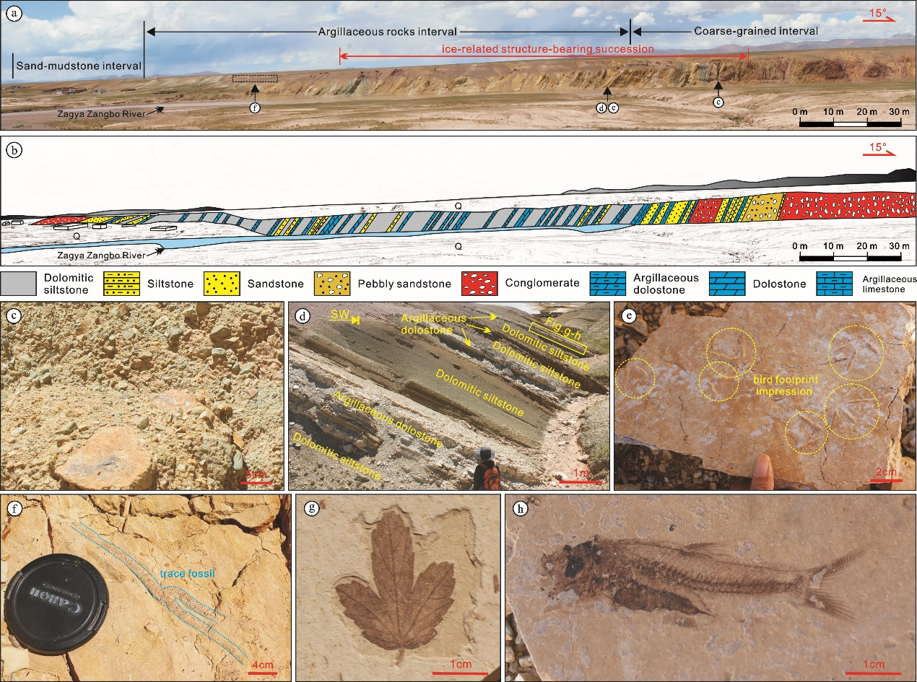
Fig. 1. Cross section and field photographs of the 382 section showing the stratigraphic interval of the middle Niubao Formation. a-b, Cross section of the 382 section showing lithofacies assemblage units and recovered ice-related sedimentary structures. c, Matrix-supported conglomerate from the bottom of the section, 5m; d, Distant view field photograph of grayish white lacustrine carbonate rocks interbedded with mudstone in the upper part of the section; (e) Bird footprint impression and (f) trace fossil in light gray fine-grained argillaceous rocks; (g) Plant leaf fossil and (h) Cyprinid fish fossil in gray laminated carbonate. Photo credit: Guoqing Xia, CDUT

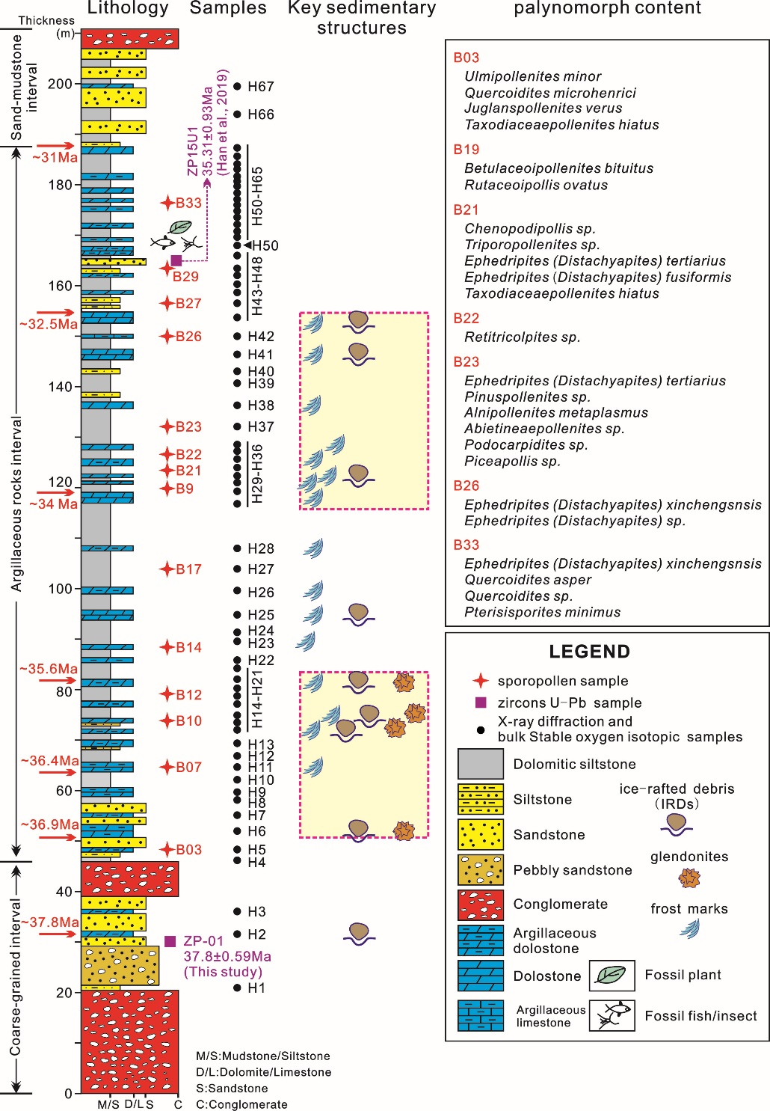
Fig. 2. Lithostratigraphy and palynomorph content of the 382 section from the Niubao Formation, Lunpola Basin. The zircon U-Pb age of 35.31 ±0.93 Ma is from⁶.

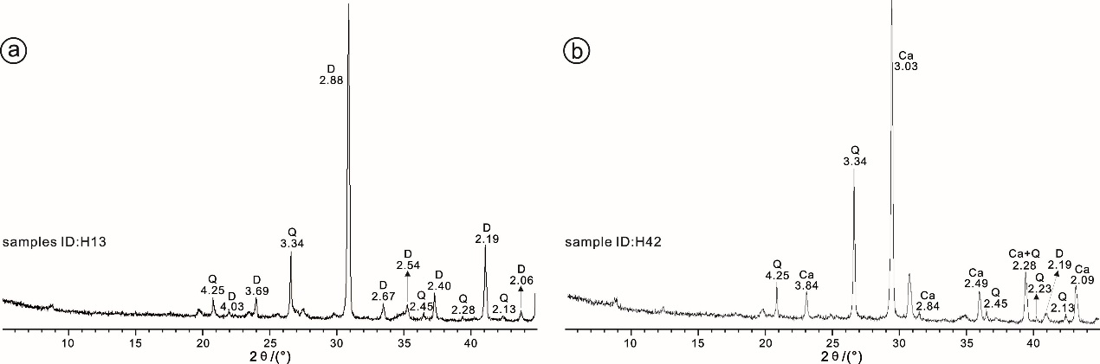
Fig. 3. Typical XRD multiple X-ray diffractograms of two representative bulk samples. a, high dolomite content, b, high calcite content. D- dolomite, Ca- calcite, Q- quartz.

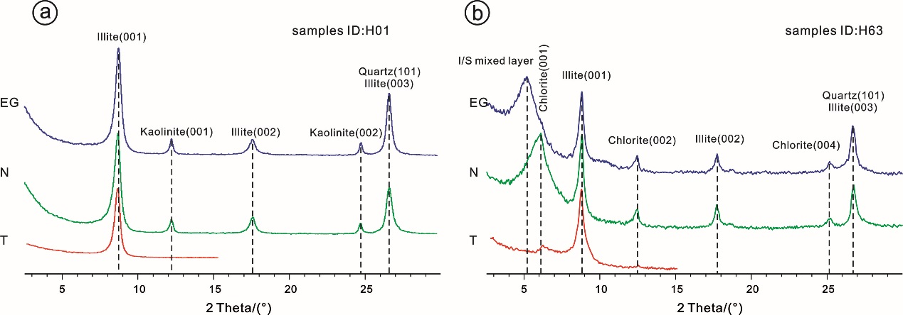
Fig. 4. Typical XRD multiple X-ray diffractograms of two representative clay samples. a, high illite content, b, high I/S mixed layer content.

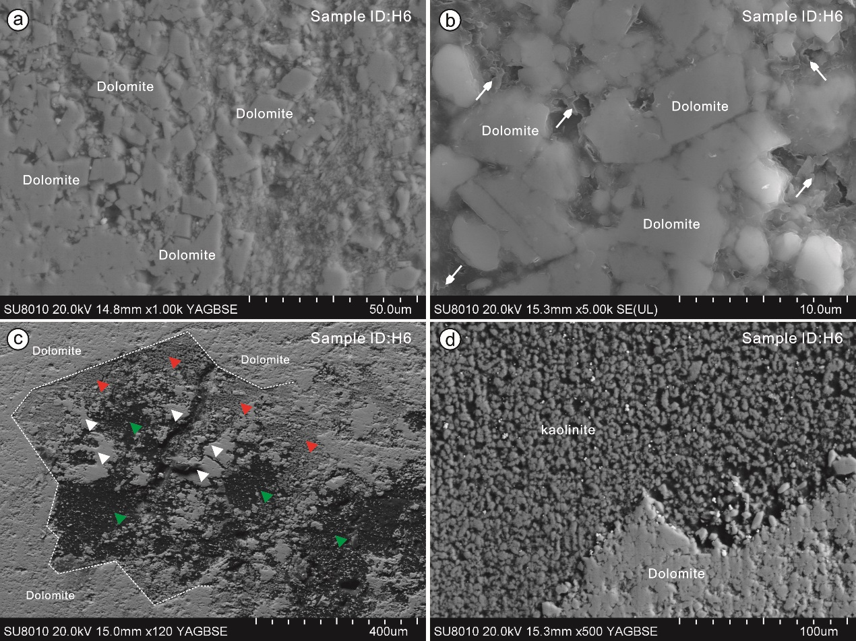
Fig. 5. Typical SEM back-scattered microphotos of the white-grey rocks with ice-related structure. a-b, nearly microcrystalline (mostly 3-8 μm in diameter), rhombohedral dolomite crystals, with illites filled in pore spaces (white arrow). c, Glendonites after ikaite occur as stellate clusters or aggregates (white dotted line) with pyramidal faces of 0.1 mm in size, which are composed of dolomite particles on the periphery. White triangles indicate microcrystalline dolomites within the pseudomorph. Red triangles show kaolinite fills within the pseudomorph. Green triangles refer to pore spaces. d, Details of the pseudomorph periphery.

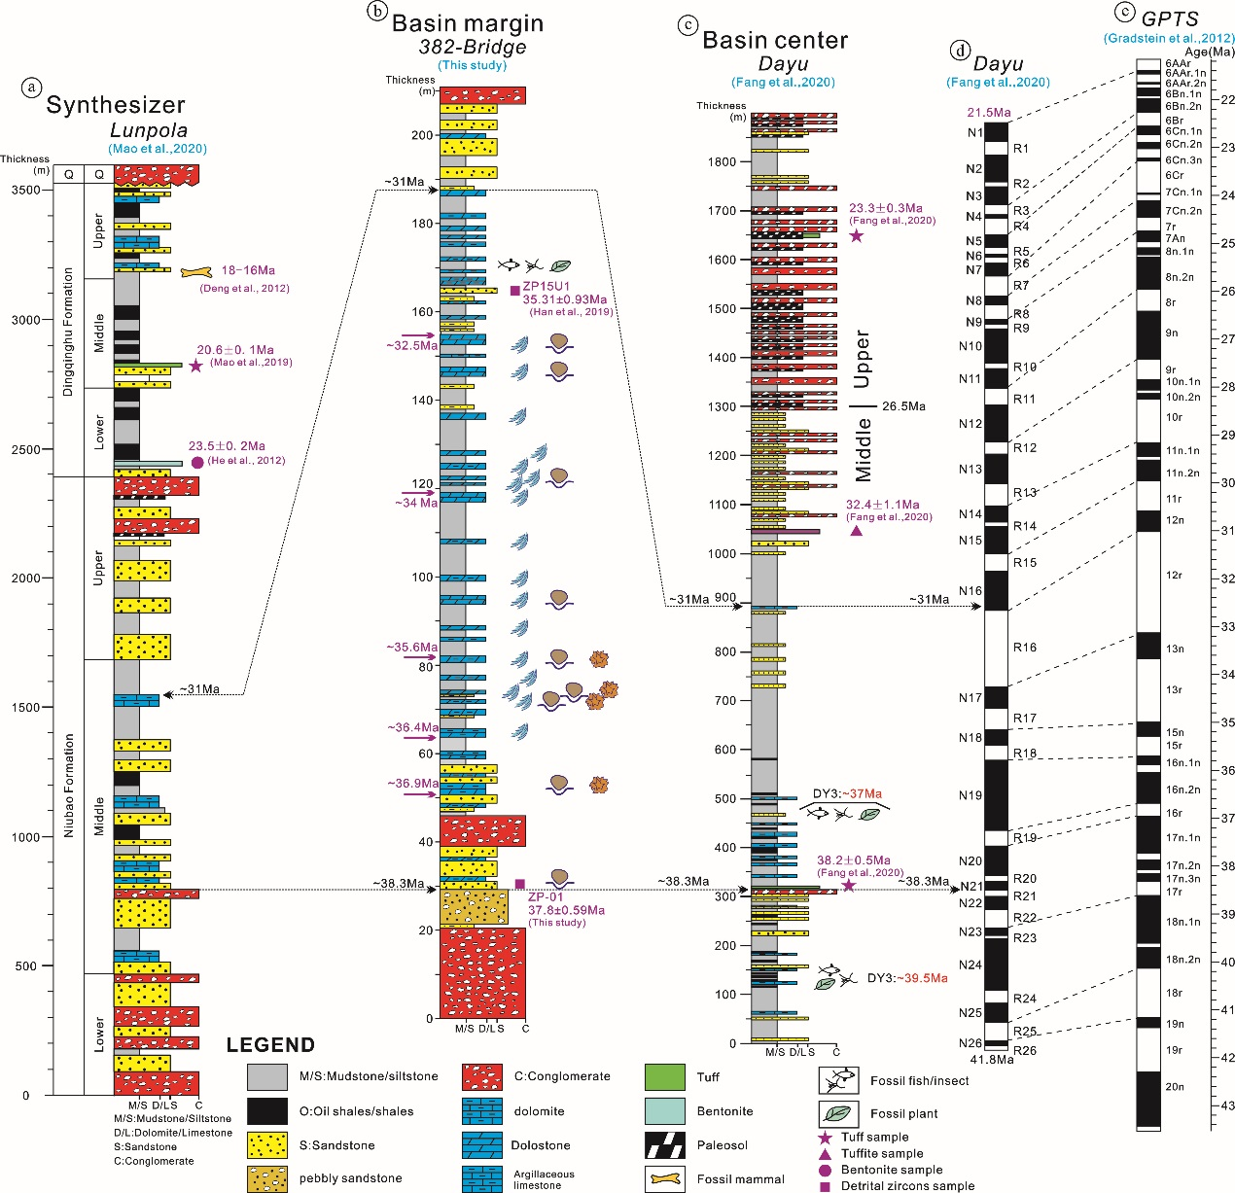
Fig. 6. The Cenozoic stratigraphic column in the Lunpola Basin and age configuration of the ice-related structures. (a) the synthesized general Cenozoic stratigraphic column in the Lunpola Basinand the stratigraphy sequence. The lithology of the middle-upper part of the Niubao Fm. in the 382-bridge (b) and Dayu (c) sections. (d) Polarity zones (N for Normal and R for Reversed) inferred from VGP latitudes of Dayu section (modified from⁹). Top and basal estimated ages are from correlations to the GPTS indicated by dashed lines to the panel I on the right. (e) Geomagnetic Polarity Time Scale³⁰. GPTS, geomagnetic polarity time scale.
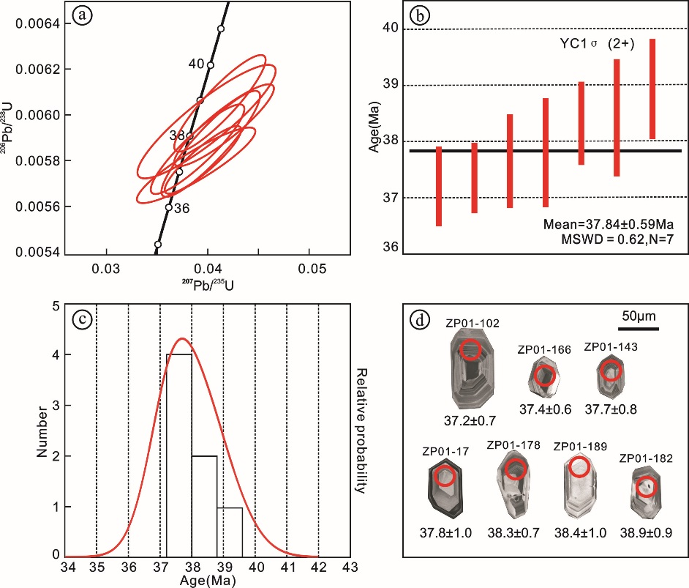
Fig. 7. (a-b) Concordia plots and YC1σ (2+) ages; (c) probability density diagrams; and (d) selected cathodoluminescence images of the night youngest zircons from sand samples.

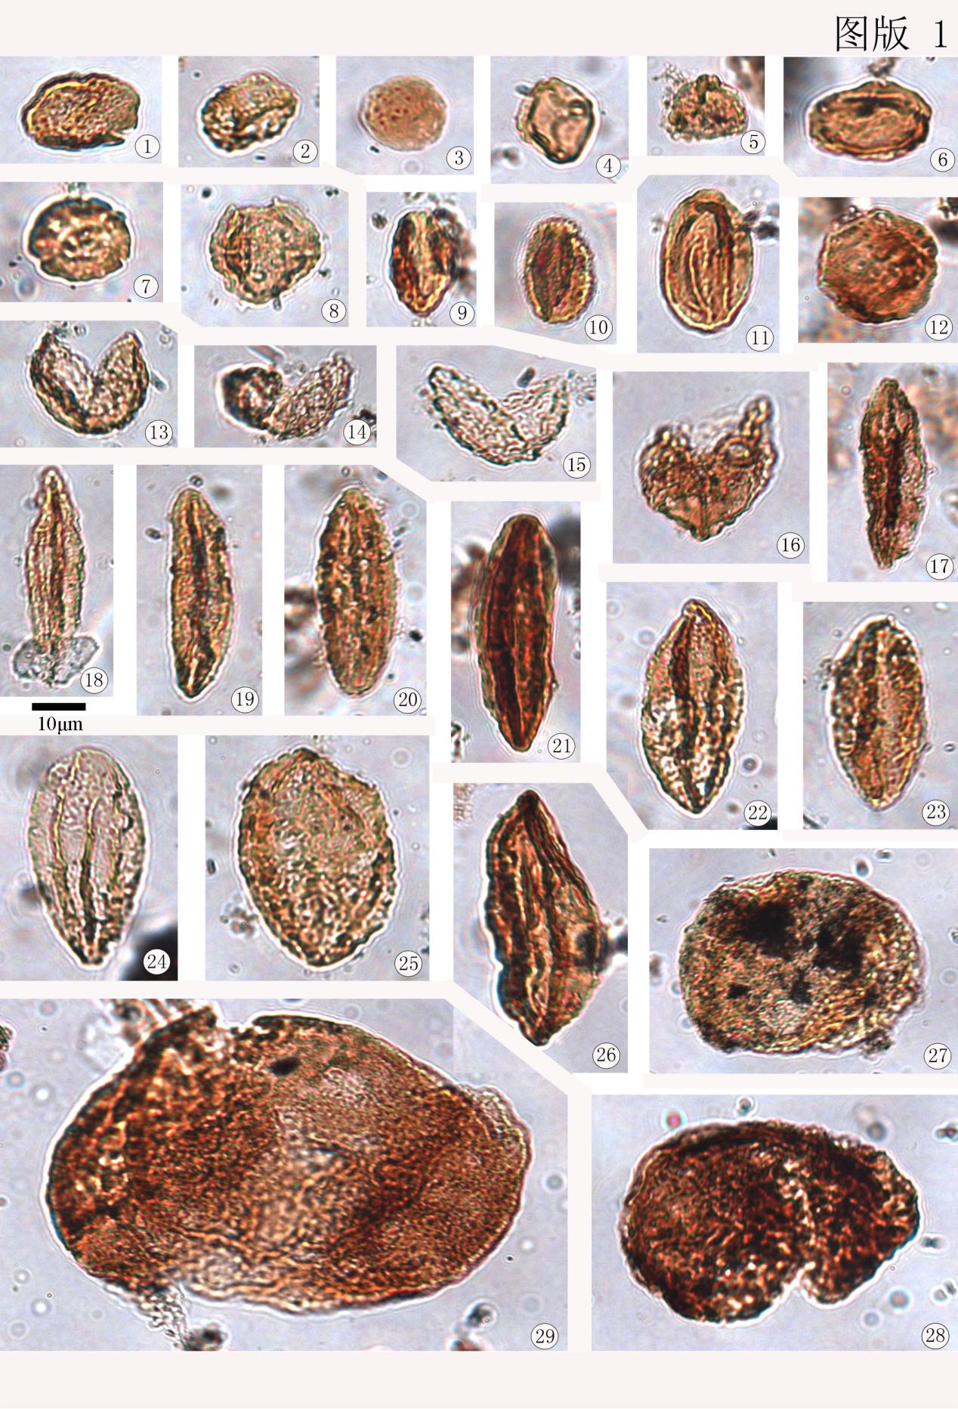
Fig. 8. Transmitted white-light photomicrographs of recorded palynomorphs at 382-Bridge section from the Niubao Formation, Lunpola Basin. 1-2, Ulmipollenites minor, ZP-03. 3, Chenopodipollis sp., ZP-21. 4, Alnipollenites metaplasmus, ZP-23. 5, Betulaceoipollenites bituitus, ZP-19. 6-7, Triporopollenites sp., ZP-21. 8, Rutaceoipollis ovatus, ZP-19. 9, Quercoidites microhenrici, ZP-03. 10, Retitricolpites sp., ZP-22. 11, Quercoidites asper, ZP-33. 12, Juglanspollenites verus, ZP-03. 13-16, Taxodiaceaepollenites hiatus (13-15, ZP-03; 16, ZP-21). 17-21, Ephedripites (Distachyapites) fusiformis, 17-18 recovered from ZP-33, 19-21 recorded in ZP-21. 22-23 Ephedripites (Distachyapites) tertiarius, ZP-21. 24-26 Ephedripites (Distachyapites) sp., ZP-21. 25 Ephedripites（Distachyapites）xinchengsnsis, ZP-26; 27 Abietineaepollenites sp., ZP-23; 28 Podocarpidites sp., ZP-23; 29 Piceapollis sp., ZP-23.

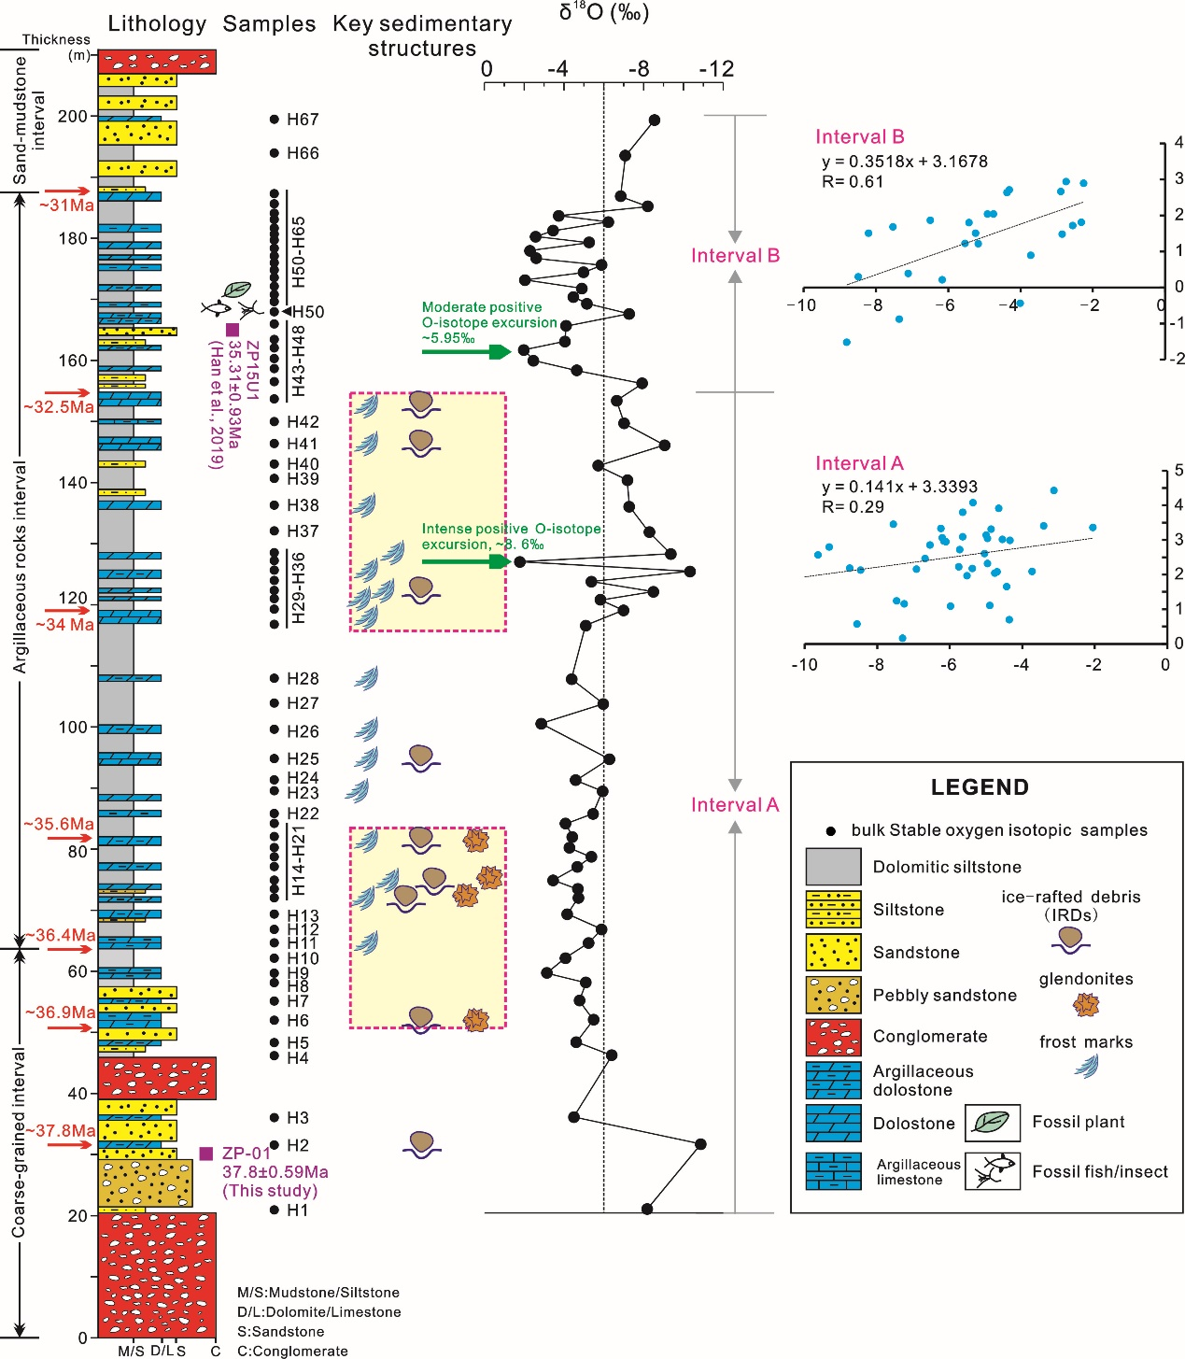
Fig. 9. Lithostratigraphy, carbonate δ¹⁸O chemostratigraphy, and the δ¹³C_{carb} versus δ¹⁸O_{carb} crossplot. See Supplementary Table 1 for data.

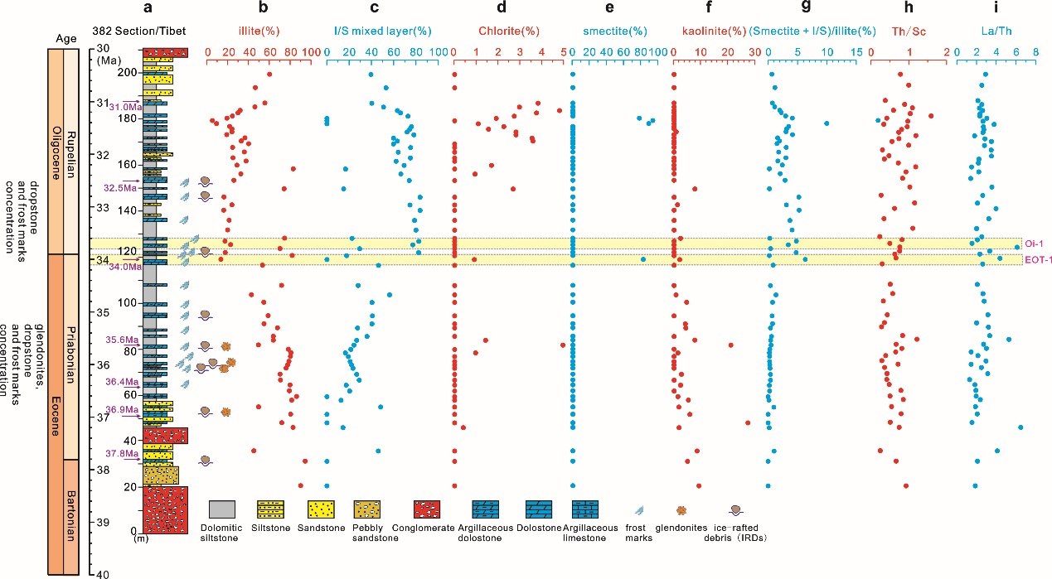
Fig. 10. Depth functions of clay minerals and trace element ratios in the 382 section of the Lunpola Basin.

