ADDITIONAL FILE 1
Figure S1 Frequency distribution of APACHE IV score in eICU dataset and Hong Kong dataset
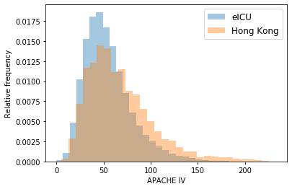
Data were separated into 30 bins. Relative frequency refers to the number of patients in that bin divided by the total number of patients.

Figure S2 Precision-recall curves of eICU and Hong Kong datasets
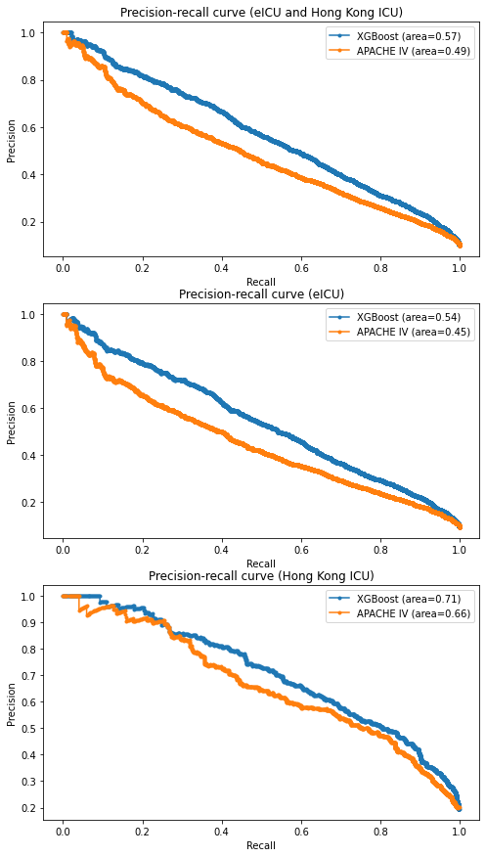

Figure S3 Receiving-Operating Characteristics (ROC) curves of eICU and Hong Kong datasets
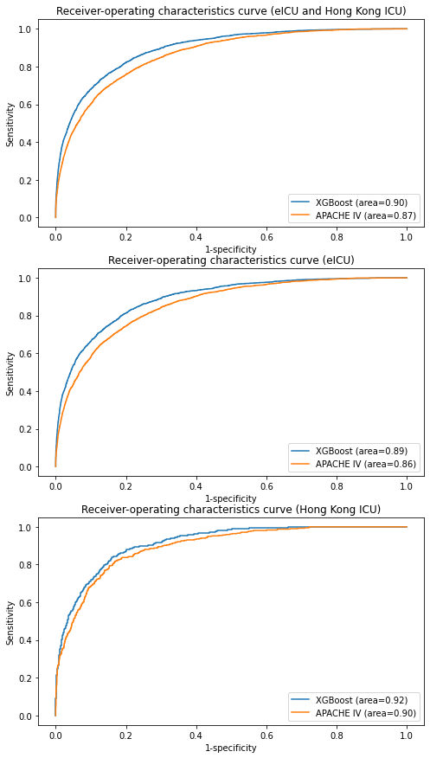
Figure S4 Calibration plots of eICU and Hong Kong datasets
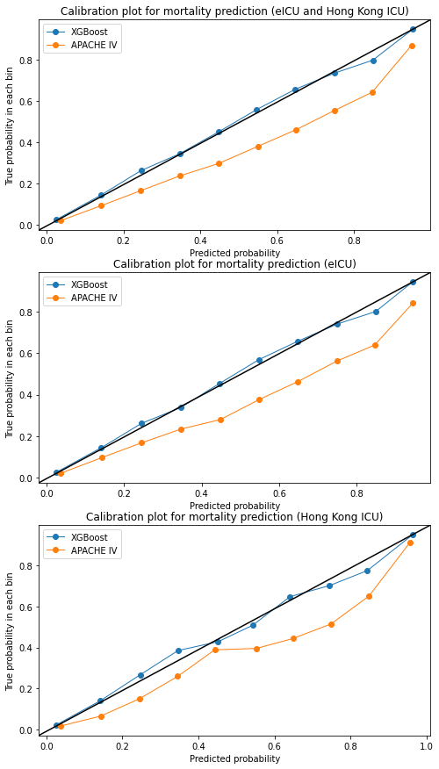
Table S1 Patient characteristics in eICU dataset and Hong Kong dataset
 | eICU dataset  (n=136145) | Hong Kong dataset  (n=10909)
Age (years) | 63.0 ± 17.2 | 61.6 ± 16.5
Male | 73548 (54.0) | 6634 (60.8)
Admission sourceª
Floor | 13781 (10.1) | 3889 (35.6)
OT/ Recovery | 18636 (13.7) | 5082 (46.6)
AED | 63690 (46.8) | 1626 (14.9)
Step-down units | 1744 (1.3) | 286 (2.6)
Other hospitals | 2428 (1.7) | 26 (0.3)
Others | 284 (0.2) | 0
Admission diagnosis
Non-operative | 109037 (80.1) | 5827 (53.4)
Operative | 27108 (19.9) | 5082 (46.6)
Emergency Surgery | 2935 (2.2) | 2603 (23.9)
APS^{b} | 43.17 ± 23.40 | 55.63 ± 32.86
APACHE IV | 55.00 ± 25.34 | 67.09 ± 34.85
ICU mortality | 7603 (5.6) | 902 (8.3)
Hospital mortality | 12052 (8.9) | 1674 (15.3)
Pre-ICU LOS (days) | 0.82 ± 3.54 | 3.86 ± 10.3
ICU LOS (days) | 2.94 ± 4.08 | 4.47 ± 7.91
Hospital LOS (days) | 6.72 ± 7.88 | 24.03 ± 31.53
OT, operating theatre; AED, accident and emergency department; APS, Acute Physiology Score; APACHE, Acute physiology and Chronic Health Evaluation; ICU, intensive care unit; LOS, length of stay
Data are represented as mean ± standard deviation, and n (%)
ªThe percentages of admission source did not add up to 100% because of missing data
^{b}In the original APACHE IV study, the APS scores of the training set and validation set were 38.83 ± 0.10 and 38.72 ± 0.12 respectively. [2]
Table S2 Top ten admission diagnoses in eICU dataset and Hong Kong dataset
eICU dataset (n=136145) |  | Hong Kong dataset (n=10909)
Diagnosis | n (%) | Diagnosis | n (%)
Sepsis, pulmonary | 6823 (5.0) | Sepsis, pulmonary | 898 (8.2)
Acute myocardial infarction | 5919 (4.3) | Sepsis, gastrointestinal | 427 (3.9)
Cerebrovascular accident/stroke | 5284 (3.9) | Renal failure, acute | 370 (3.4)
Congestive heart failure | 4838 (3.6) | Surgery for gastrointestinal Perforation/Rupture | 298 (2.7)
Sepsis, renal/urinary tract infection (including bladder) | 4284 (3.1) | Surgery for neoplasm-cranial (excluding transphenoidal) | 298 (2.7)
Diabetic ketoacidosis | 4001 (2.9) | Cardiac arrest with or without respiratory arrest; for respiratory arrest see Respiratory System | 287 (2.6)
Coronary artery bypass grafting | 3635 (2.7) | Acid-base electrolyte disturbance | 285 (2.6)
Rhythm disturbance (atrial, supraventricular) | 3473 (2.6) | Cancer-other gastrointestinal tract, surgery for (i.e. haepatoma, gallbladder etc.) | 285(2.6)
Cardiac arrest (with or without respiratory arrest; for respiratory arrest see Respiratory System) | 3376 (2.5) | Sepsis, renal/ urinary tract infection (including bladder) | 260 (2.4)
Emphysema/bronchitis | 3304 (2.4) | Surgery for haemorrhage/haematoma-intracranial | 223 (2.0)

