Electronic Supplementary data

High-quality mesoporous SiO₂ nanospheres via a confined jet impingement continuous microchannel reactorr
Qiang Chen^{a,*}, Kai Chen^{a,*}, Feng Yu^{a,b,**}, Aixia Guoª, Siqing Zouª, Mei Zhouª, Jiangwei Liª, Jianming Danª, Yongsheng Li^{a,c}, Bin Dai^{a,**}, Xuhong Guo^{c,**}
ª Key Laboratory for Green Processing of Chemical Engineering of Xinjiang Bingtuan, School of Chemistry and Chemical Engineering, Shihezi University, Shihezi 832003, PR China
^{b} Bingtuan Industrial Technology Research Institute, Shihezi University, Shihezi 832003
^{c} State Key Laboratory of Chemical Engineering, East China University of Science and Technology, 200237 Shanghai, PR China

* The authors contributed equally to this work.
** Corresponding authors.

This PDF file includes:
1. Materials and Method
2. Measurements and Characterization.
3. Mesoscopic Simulations Section
3. Figs. S1 to S9
4. Tables S1to S6
5. Reference List

1.Materials and Method
1. Chemicals.
Tetraethyl orthosilicate (TEOS) and commercial silica are of analytical grade (Shanghai Macklin Biochemical Co., Ltd). Cetyltrimethy-lammonium bromide (CTAB) was supplied by Solarbio. Concentrated ammonia solution (28 wt %) was provided by Tianjin Xinbote Chemical Co., Ltd. Ethanol (AR) and methanol (AR) were purchased from Tianjin Fuyu Fine Chemical Co., Ltd. Lithium nitrate (AR) and SBA-15 (AR) were purchased from damas-beta.
2.Preparation of precursor solution.
Precursor solution A: an amount of 0.2 mL of TEOS(AR) was dissolved in a mixture solution of ethanol (23 mL) and deionized water (23 mL) by vigorous magnetic stirring for 30 min at 25 °C. Precursor solution B: concentrated ammonia solution (0.3 mL, 28 wt%) and CTAB (0.1440 g, 0.395 mM), were added in deionized water (46 mL) consecutively, and the mixed dispersion was magnetically stirred for 1h at 25 °C. To tune the mesopore size, morphology and specific surface area, the solution was added with different concentration of CTAB (0.0720 g, 0.1440 g, 0.2160 g, 0.2880 g, or 0.3600 g, respectively).
3.MSNs synthesis.
(1) The confined jet impingement continuous microchannel reactor. In a typical synthesis, the precursor solution A and the precursor solution B with various concentration of TAB (4.27 mmol/L, 8.55 mmol/L, 12.80 mmol/L,17.06 mmol/L, or 21.33 mmol/L, respectively) were injected into the two-stream confined impingement jet continuous microchannel reactor. To tune the mesopore size and morphology, the flow rates were settled from 40 to 100 mL/min. Subsequently, the mixed solution was mechanically stirred at 800 rpm for 3 h. The product was collected by centrifugation and washed with deionized water and ethanol for three times before dried in vacuum at 80 °C. Finally, the dried microspheres were calcined at 600 °C in air for 3 h for further use. Notably, it was found that the mixing condition in nucleation process were found great influence on the specific surface area of the samples. Therefore, we also used the magnetic stirring method and the high shear mixing (HSM) method under similar conditions as a comparison. The precursor solution A was slowly added to the precursor solution B with magnetic stirring (800 rpm/min) for 3h at 25°C or with HSM (13000 rpm/min) for 15 min at 25°C and then magnetic stirring for 3h. After reaction, the product was collected with same post-processing method as above. The detailed prepared procedure was described in supporting information.
(2) Magnetic stirring. The precursor solution A was slowly added to the precursor solution B with magnetic stirring (800 rpm/min) for 3h at 25°C. After reaction, the obtained sample was dried in vacuum at 80 °C for 3h. And then the dried microspheres were calcined at 600 °C in air for 3 h.
(3) High shear mixing. The precursor solution A was slowly added to the precursor solution B with high shear mixing (13000 rpm/min) for 15 min at 25°C. After reaction with magnetic stirring for 3h, the product was collected, and the post-processing method is the same as above.

4. Synthesis of Li₄SiO₄.
The mesoporous Li₄SiO₄ microspheres samples were prepared by an evaporative self-assembly method. In brief, an amount of 1.3770 g of LiNO₃ was well dissolved in a mixture solution of methanol (20 mL). Into the solution, 1854-MSNs (0.6000 g, the molar ratio of Si:Li was 1:2) was added, and ultrasonication for 1h at 30 °C. The mixed dispersion was evaporated in water bath for another 1 h at 60 °C and dried in vacuum at 80 °C. Finally, the samples were calcined at 700 °C in air for 3 h to obtain the mesoporous Li₄SiO₄ microspheres (1854-MSNs- Li₄SiO₄).
5. Evaluation of CO₂ capture performance.
CO₂ sorption properties of Li₄SiO₄ sorbents were studied by TGA apparatus (Q50 TA Instrument). About 10 mg sample was placed in a platinum tray and heated from room temperature to sorption temperature with a heating rate of 10 °C/min under N₂ atmosphere. After 30 min, the sorption was performed under pure CO₂ atmosphere for 120 min²⁵. For the cycling stability measurements, the sorption was performed under CO₂ atmosphere for 30 min, and desorption was performed at the same temperature but under N₂ atmosphere for 60 min.
2. Measurements and Characterization.
Transmission electron microscopy (TEM) experiments were conducted on a Hitachi HT7800 microscope (Japan) operated at 100 kV. Field-emission scanning electron microscopy (FESEM) images were collected on the Hitachi Model SU8000 field emission scanning electron microscope (Japan). A thin Platinum film was sputtered on the samples before FESEM measurements. Scanning electron microscopy (SEM) images were collected with JEOL JSM7610FPLUS electron microscope (Japan) operated at 5 kV. A thin gold film was sputtered on the samples before SEM measurements. Powder X-ray diffraction (XRD) patterns were recorded on a Bruker D8 X-ray diffractometer (Germany) with Ni-filtered Cu KR radiation (40 kV, 40 mA). Nitrogen sorption isotherms were measured at 77 K with a Micromeritcs ASAP 2460 analyzer and all samples were degassed in a vacuum at 120 °C for 10 h before measurements. The Brunauer−Emmett−Teller (BET) method was utilized to calculate the specific surface areas (S_{BET}) using adsorption data in a relative pressure range from 0.005 to 0.25. By using the Barrett−Joyner−Halenda (BJH) model, the pore volumes and pore size distributions were derived from the adsorption branches of isotherms, and the total pore volumes (Vt) were estimated from the adsorbed amount at a relative pressure P/P₀ of 0.995.
3. Mesoscopic Simulations Section
1. Computational Modeling.
All computational modeling was performed using the Materials Studio 19.0 suite of software (Accelrys Software Inc., San Diego, USA).
2. MesoDyn.
MesoDyn is based on the principle that the free energy F of an inhomogeneous fluid is a function of the local density function ρ, and therefore all thermodynamic functions can be derived by the free energy F^{25, 26}. All interactions, in the MesoDyn project, were described by the harmonic oscillator potentials for the intra-molecular interactions (Gaussian chain) and a meanfield potential ²⁷. The model of MesoDyn was composed of various types of beads, and each bead was of a certain component type representing covalently bonded groups of atoms, such as those given by one or a few structural units of a polymer chain²⁸. The time evolution of the polymer diffusion system is described by a set of functional Langevin eqs²⁹. Thermal fluctuations take account of the noise in the system, which is dictated by the fluctuation-dissipation theorem^{30, 31}. By this model, the phenomenon of diffusive and hydrodynamic are conserved in phase-separation dynamics. Polymer surfactant solution with the same parameter set will behave exactly the same, since the simulation was drove by interaction parameters in a mean field.
3. Interaction Parameters.
The mean field interaction energy with chemical entities is another significant parameter in MesoDyn, which quantify characteristics like hydrophobicity³¹. The interaction parameter (aij) represents the paired interaction of beads, which is similar to the χij parameter defined in the Flory-Huggins model (eq 1). In the aqueous TEOS(O)/ethanol(E)/ammonia(N)/CTAB(CTAB-hydrophilic group(H) and CTAB-hydrophobic group(T))/water(W)system, fifteen parameters are needed: the H−T interaction (χ_{HT}), representing CTAB-hydrophilic group(H)− CTAB-hydrophobic group(T); the H−W interaction (χ_{HW}), representing CTAB-hydrophobic group(T)−water; the H−O interaction (χ_{HO}), representing CTAB-hydrophobic group(T)−TEOS; the H−E interaction (χ_{HE}), representing CTAB-hydrophobic group(T)− ethanol(E); and the H−N interaction (χ_{HN}), representing CTAB-hydrophobic group(T)− ammonia(N).T-W,T-O,T-E,T-N,N-E,N-W,N-O,O-E,O-W and W-E can be obtained in the same way (Table S1).
a_{ij} = a_{ii} + 3.27χ_{ij} (1)²⁸
Where a_{ii} is the repulsion parameter of two beads of the same type.
a_{ii} = 75K_{B*}T/ρ (2) ²⁸
Among them, KB*T is a conservative interaction potential. It corresponds to Boltzmann's constant and absolute temperature. According to convention, this item is simplified to 1 (DPD simplified unit). When a pure fluid is compressible, then ρ = 3. In this study, a_{ii}=25²⁸.
4. MesoDyn Simulation Parameters.
The following parameters were used for all simulations: temperature of 298K, time step of 50 ns, noise scaling parameter of 100, compressibility parameter of 10, grid parameter of 1.1543 and bead diffusion coefficient of 1.0 × 10−7 cm²/s. The dimension of the simulation lattice was set to 32 × 32 × 32 nm to simulate the effect of shear rate on silica nanospheres. Five shear rates were considered: 0 ns⁻¹, 0.0001 ns-¹,0.0002 ns⁻¹,0.0004 ns⁻¹and 0.0008 ns⁻¹, respectively. The dimension of the simulation lattice was set to 16 × 16 × 16 nm to simulate the effect of CTAB concentration on silica nanospheres. Four volume concentrations of CTAB were considered: 0.03, 0.06, 0.12 and 0.24 %. The MesoDyn models were run for 10000 steps of dynamics.

4. Figs. S1 to S9

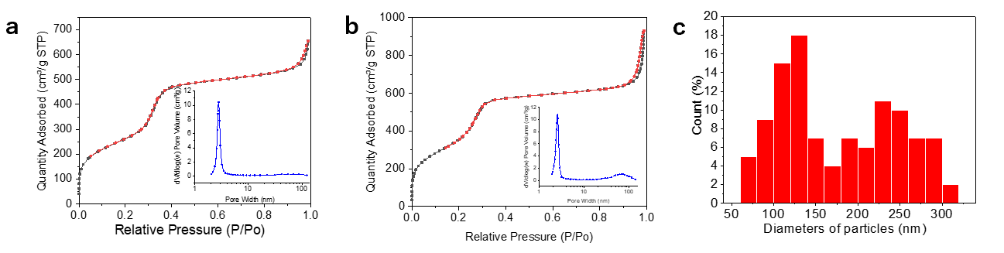
Fig S1 (a) The nitrogen adsorption isotherm and pore size distribution diagram of the two-stream confined impingement jet continuous microchannel reactor (CIJMR); (b) The nitrogen adsorption isotherm and pore size distribution diagram of magnetic stirring; (c) The particle size distribution of mesoporous silica nanospheres prepared by the CIJMR method

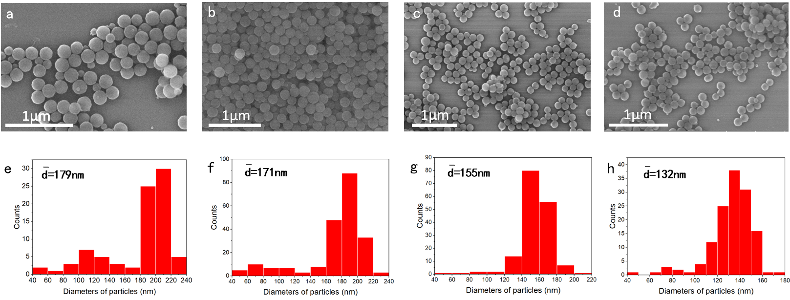
Fig S2 (a-d) The FE-SEM images and (e-h) the particle diameter distribution charts with injections of (a) 40, 60, 80, and 100 mL/min at the CTAB concentration 4.27 mmol/L, respectively
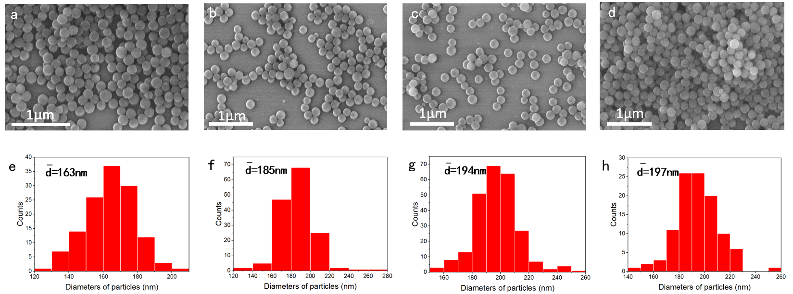
Fig S3 (a-d) The FE-SEM images and (e-h) the particle diameter distribution charts with injections of 40, 60, 80, and 100mL/min at the CTAB concentration 8.55 mmol/L, respectively
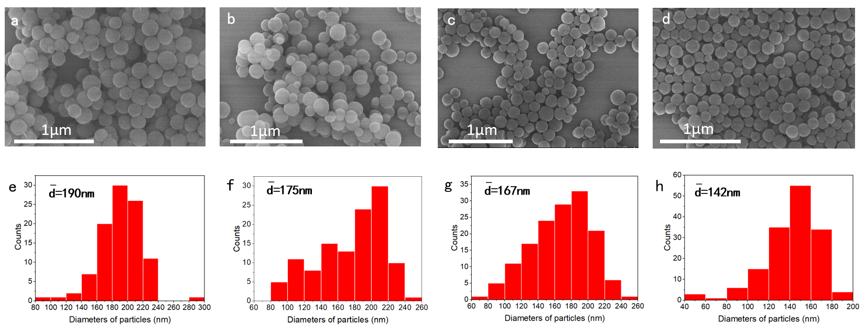
Fig S4 (a-d) The FE-SEM images and (e-h) the particle diameter distribution charts with injections of 40, 60, 80, and 100mL/min at the CTAB concentration 12.80 mmol/L, respectively
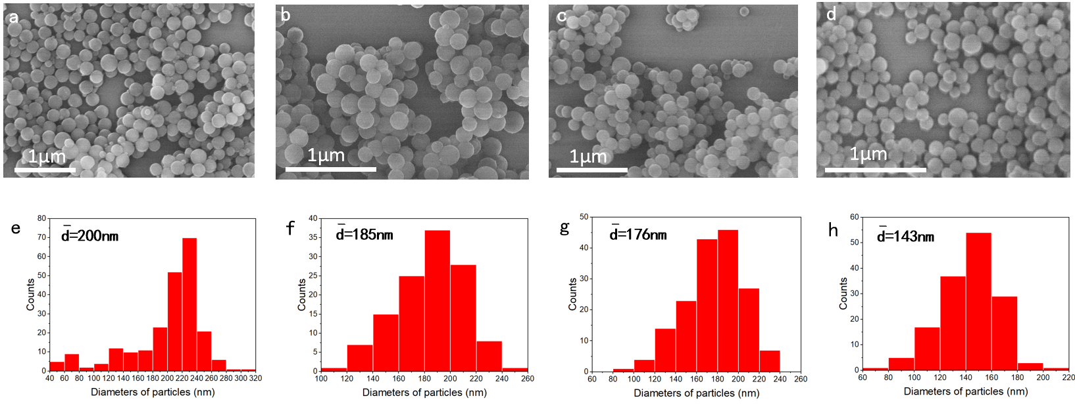
Fig S5 (a-d) The FE-SEM images and (e-h) the particle diameter distribution charts with injections of 40, 60, 80, and 100mL/min at the CTAB concentration 17.06 mmol/L, respectively
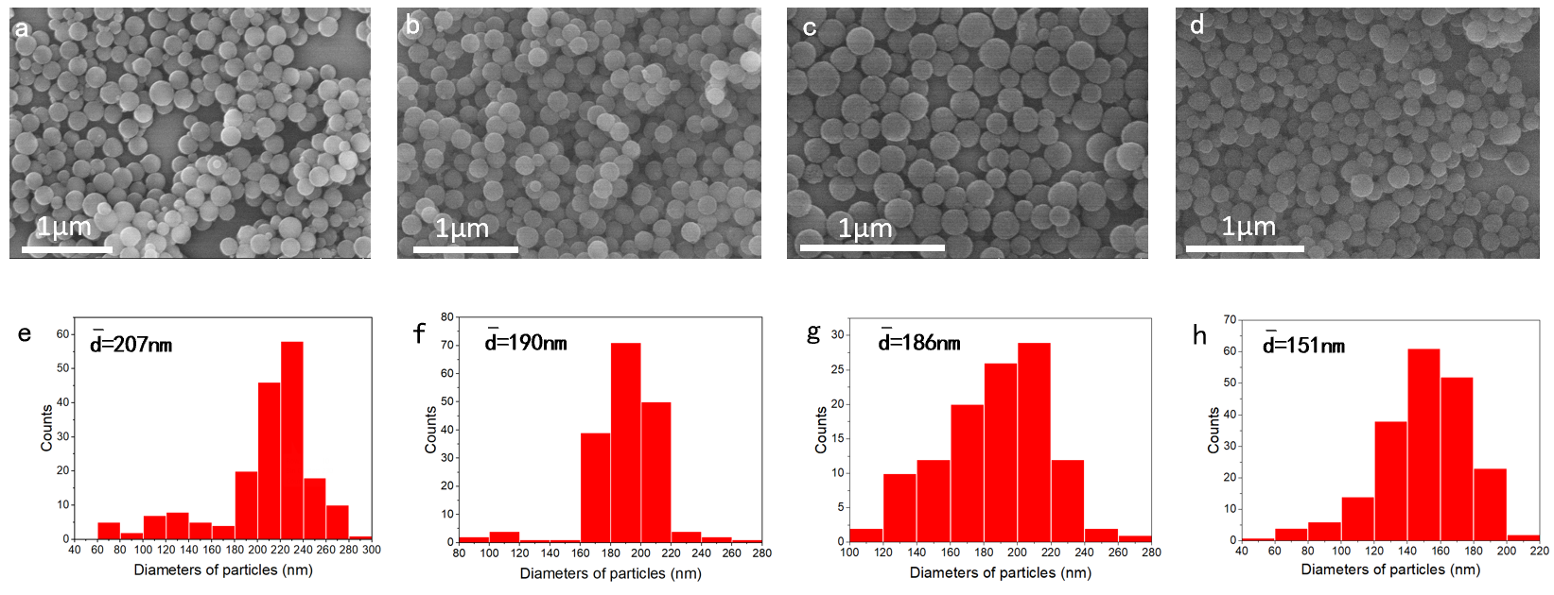
Fig S6 (a-d) The FE-SEM images and (e-h) the particle diameter distribution charts with injections of 40, 60, 80, and 100mL/min at the CTAB concentration 21.33 mmol/L, respectively
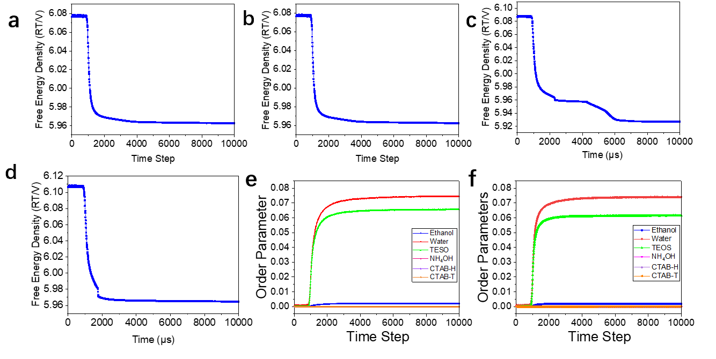
Fig S7 (a-d) The free energy density diagrams with the volume concentration of CTAB of 0.03 %, 0.06 %, 0.12 % and 0.24 %, respectively; and the order parameters diagrams with the volume concentration of CTAB of (d) 0.12 % and (e) 0.24 %, respectively.
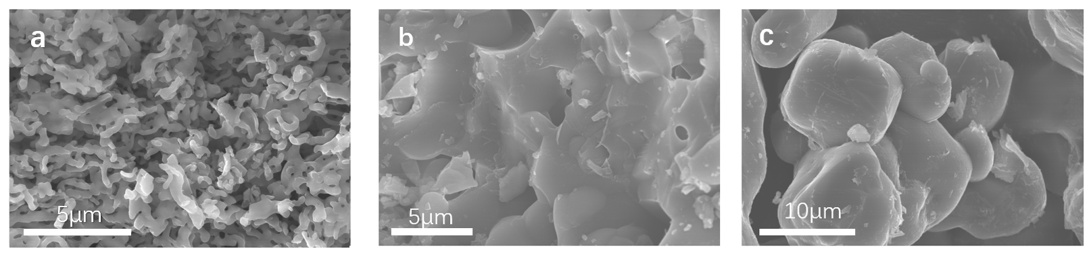
Fig S8 The FESEM image of (a) 2-(SBA-15)-Li₄SiO₄, (b) 4-(SBA-15)- Li₄SiO₄, and (c) 4-(HS1854)- Li₄SiO₄
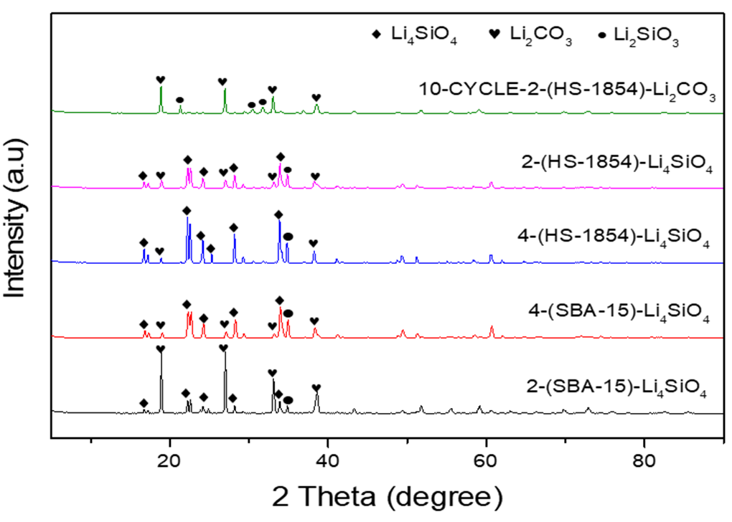
Fig S9 XRD patterns of synthesized 2-(SBA-15)- Li₄SiO₄, 4-(SBA-15)-Li₄SiO₄, 4-(HS1854)-Li₄SiO₄, 2-(HS1854)-Li₄SiO₄, and 10-CYCLE-2-(HS1854)-Li₂CO₃

5. Tables S1to S6

Table S1 a_{ij} Repulsion Parameters
 | Ethanol（E） | Water(W) | TEOS(O) | Ammonia(N) | CTAB- hydrophilic group(H) | CTAB-hydrophobic group(T)
Ethanol（E） | 25 | - | - | - | - | -
Water(W) | 28.4 | 25 | - | - | - | -
TEOS(O) | 29.7 | 41.6 | 25 | - | - | -
Ammonia(N) | 27.4 | 25.3 | 38.8 | 25 | - | -
CTAB-hydrophilic group(H) | 25.1 | 30.1 | 27.1 | 28.6 | 25 | -
CTAB-hydrophobic group(T) | 106.3 | 136.6 | 89.5 | 126.2 | 142.7 | 25

Table S2 The specific surface area, pore volume and pore size of mesoporous silica nanospheres
Samples | BET surface Area (m²/g)  (m²/g) | Total pore volume (m³/g)  (cm²/g) | Pore size (nm)  (nm)
4.27mmol/L-HS-40 | 1463 | 1.26 | 3.3
4.27mmol/L -HS-60 | 1505 | 0.86 | 3.3
4.27mmol/L -HS-80 | 1578 | 0.94 | 2.8
4.27mmol/L -HS-100 | 1630 | 1.08 | 3.2
8.55mmol/L -HS-40 | 1650 | 1.10 | 2.6
8.55mmol/L -HS-60 | 1724 | 0.90 | 2.9
8.55mmol/L -HS-80 | 1785 | 1.07 | 2.9
8.55mmol/L HS-100 | 1854 | 1.22 | 3.3
17.66mmol/L -HS-40 | 1347 | 1.17 | 3.2
17.66mmol/L -HS-60 | 1411 | 1.23 | 3.2
17.66mmol/L HS-80 | 1486 | 0.92 | 2.9
17.66mmol/L -HS-100 | 1570 | 1.01 | 3.0

Table S3 Table of the particle diameter of silica nanospheres at different concentrations as a function of different injection speeds
Samples | Particle size (nm)  (nm) | Samples | Particle size (nm)  (nm)
4.27mmol/L -HS-40 | 179 | 12.80mmol/L -HS-80 | 167
4.27mmol/L -HS-60 | 171 | 12.80mmol/L -HS-100 | 142
4.27mmol/L -HS-80 | 155 | 17.06 mmol/L -HS-40 | 200
4.27mmol/L -HS-100 | 132 | 17.06 mmol/L -HS-60 | 185
8.55mmol/L -HS-40 | 163 | 17.06 mmol/L -HS-80 | 176
8.55mmol/L -HS-60 | 185 | 17.06 mmol/L -HS-100 | 143
8.55mmol/L -HS-80 | 194 | 21.33 mmol/L -HS-40 | 207
8.55mmol/L -HS-100 | 197 | 21.33 mmol/L -HS-60 | 190
12.80mmol/L -HS-40 | 190 | 21.33 mmol/L -HS-80 | 186
12.80mmol/L -HS-60 | 175 | 21.33 mmol/L -HS-100 | 151

Table S4 Summarized synthesis methods/conditions, particle size/shape and textural properties of mesoporous silica submicron spheres compared to the MSP of current work.
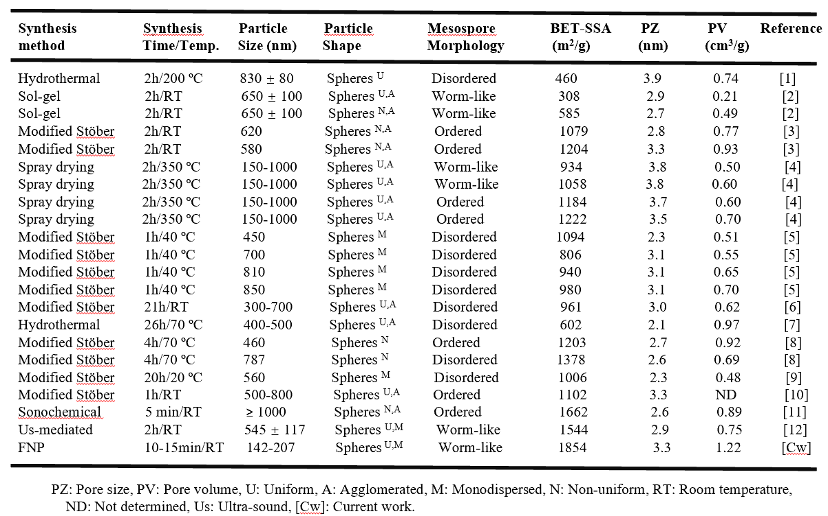

 | Temperature 9()( (9900()  (°C) | CO₂ concentration (vol%) | k₁  (s−1) | k₂  (s−1) | R²
2-(HS1854)-Li₄SiO₄ | 500 ℃ | 100 vol % | 0.00163 | 0.0003 | 0.99957
2-(HS1854)-Li₄SiO₄ | 550 ℃ | 100 vol % | 0.00478 | 0.00057 | 0.99863
2-(HS1854)-Li₄SiO₄ | 600 ℃ | 100 vol % | 0.0145 | 0.00115 | 0.99758
2-(HS1854)-Li₄SiO₄ | 650 ℃ | 100 vol % | 0.25759 | 0.00627 | 0.99695
2-(SBA-15)-Li₄SiO₄ | 500 ℃ | 100 vol % | - | - | -
2-(SBA-15)-Li₄SiO₄ | 550 ℃ | 100 vol % | 0.00123 | 0.00011 | 0.99833
2-(SBA-15)-Li₄SiO₄ | 600 ℃ | 100 vol % | 0.00249 | 0.0003 | 0.99965
2-(SBA-15)-Li₄SiO₄ | 650 ℃ | 100 vol % | 0.00654 | 0.00043 | 0.99851
Table S5 Summary of the CO₂ capture performance of the 2-(HS1854)-Li₄SiO₄ and 2-(SBA-15)-Li₄SiO₄ derived sorbents under different conditions

Table S6 Nitrogen adsorption-desorption form of silicon source and Li₄SiO₄
Samples | BET surface Area(m²/g)  (m²/g) | Total pore volume(cm³/g)  (cm²/g) | Pore size(nm)  (nm)
HS1854 | 1854.24 | 1.22 | 3.3
2-(HS1854)-Li₄SiO₄ | 1.75 | 0.0042 | 21.8
4-(HS1854)-Li₄SiO₄ | 1.60 | 0.0015 | 20.4
SBA-15 | 507.18 | 1.23 | 8.5
2-(SBA-15)-Li₄SiO₄ | 0.39 | 0.0027 | 17.9
2-(SBA-15)-Li₄SiO₄ | 0.42 | 0.0008 | 17.9
4-(SBA-15)-Li₄SiO₄ | 0.93 | 0.0004 | 17.2

6.References
[1] K. Zhu, Y. Du, X. Wu, X. You, Y. He, Y. Qu, Z. Jing, Z. Shan, Fast synthesis of uniform mesoporous silica spheres, Mater. Lett. 273 (2020) 127947.
[2] N.I. Vazquez, Z. Gonzalez, B. Ferrari, Y. Castro, Synthesis of mesoporous silica nanoparticles by sol–gel as nanocontainer for future drug delivery applications, Boletín de la Sociedad Española de Cerámica y Vidrio 56(3) (2017) 139-145.
[3] M. Grün, I. Lauer, K.K. Unger, The synthesis of micrometer- and submicrometer-size spheres of ordered mesoporous oxide MCM-41, Adv. Mater. 9(3) (1997) 254-257.
[4] N. Baccile, D. Grosso, C. Sanchez, Aerosol generated mesoporous silica particles, J. Mater. Chem. 13(12) (2003) 3011-3016.
[5] E.Y. Stovpiaga, D.A. Kurdyukov, Y.A. Kukushkina, V.V. Sokolov, M.A. Yagovkina, Monodisperse spherical silica particles with controlled-varied diameter of micro- and mesopores, Glass Phys. Chem 41(3) (2015) 316-323.
[6] L. Travaglini, P. Picchetti, A. Del Giudice, L. Galantini, L. De Cola, Tuning and controlling the shape of mesoporous silica particles with CTAB/sodium deoxycholate catanionic mixtures, Microporous Mesoporous Mater. 279 (2019) 423-431.
[7] R. Soltani, A. Marjani, S. Shirazian, Novel mesoporous crumpled paper-like silica balls, Mater. Lett. (2020) 128230.
[8] M. Varache, I. Bezverkhyy, L. Saviot, F. Bouyer, F. Baras, F. Bouyer, Optimization of MCM-41 type silica nanoparticles for biological applications: Control of size and absence of aggregation and cell cytotoxicity, J. Non Cryst. Solids 408 (2015) 87-97.
[9] Y. Yamada, K. Yano, Synthesis of monodispersed super-microporous/mesoporous silica spheres with diameters in the low submicron range, Microporous Mesoporous Mater. 93(1) (2006) 190-198.
[10] E. Boccardi, L. Liverani, A.M. Beltrán, R. Günther, J. Schmidt, W. Peukert, A.R. Boccaccini, Mesoporous silica submicron particles (MCM-41) incorporating nanoscale Ag: synthesis, characterization and application as drug delivery coatings, J. Porous Mater. 26(2) (2019) 443-453.
[11] S. Vetrivel, C.-T. Chen, H.-M. Kao, The ultrafast sonochemical synthesis of mesoporous silica MCM-41, New J. Chem. 34(10) (2010) 2109-2112.
[12] Ef A , Mb B . Facile and rapid ultrasound-mediated synthesis of spherical mesoporous silica submicron particles with high surface area and worm-like mesoporosity, Materials Letters, 2020, 281.

