**Extended Data**



**Extended Data Figure 1. The homebrew Simoa planar array p24 ELISA.** **(A)** SP-X image plate of a standard curve of HIV p24 from 2,000 to 0.128 pg/ml. **(B)** Standard curve analyzed using the SP-X analysis software. Upper limit of quantification (ULOQ), low limit of quantification (LLOQ) and low limit of detection (LOD) are indicated with horizontal lines. **(C)** ULOQ, LLOQ, LOD and regression line fit (R2) values for the standard curve indicated in **(B)**. **(D)** Mean Intensity, % of the coefficient of variation (%CV) and % of recovery (%RE) for each of the standard curve concentrations shown in **(B)**.

**

**Extended Data Figure 2. Cross-comparison of the homebrew Simoa planar p24 ELISA immunoassay in diverse matrixes**. **(A)** Compilation of the limit of detection (LOD) for each of the matrixes. NaCitrate plasma was above the upper limit of quantification (ULOQ) of the standard. **(B)** Compilation of the limit of quantification (LOQ) for each of the matrixes. NaCitrate plasma was above the upper limit of quantification of the standard. **(C)**. Compilation of the light intensity (IV) units for each of the matrixes background in the absence of p24 protein. **(D)** Correlation of the IV units given by the background in each matrix and the LOD for that matrix, calculated using Pearson correlation. **(E)** Correlation of the IV units given by the background in each matrix and the LOQ for that matrix, calculated using Pearson correlation. **(F)** Correlation of LOD in each matrix and the LOQ for that matrix, calculated using Pearson correlation. NaCitrate plasma was removed of the analysis for **D**, **E** and **F** as the LOD and LOQ was unable to be calculated.

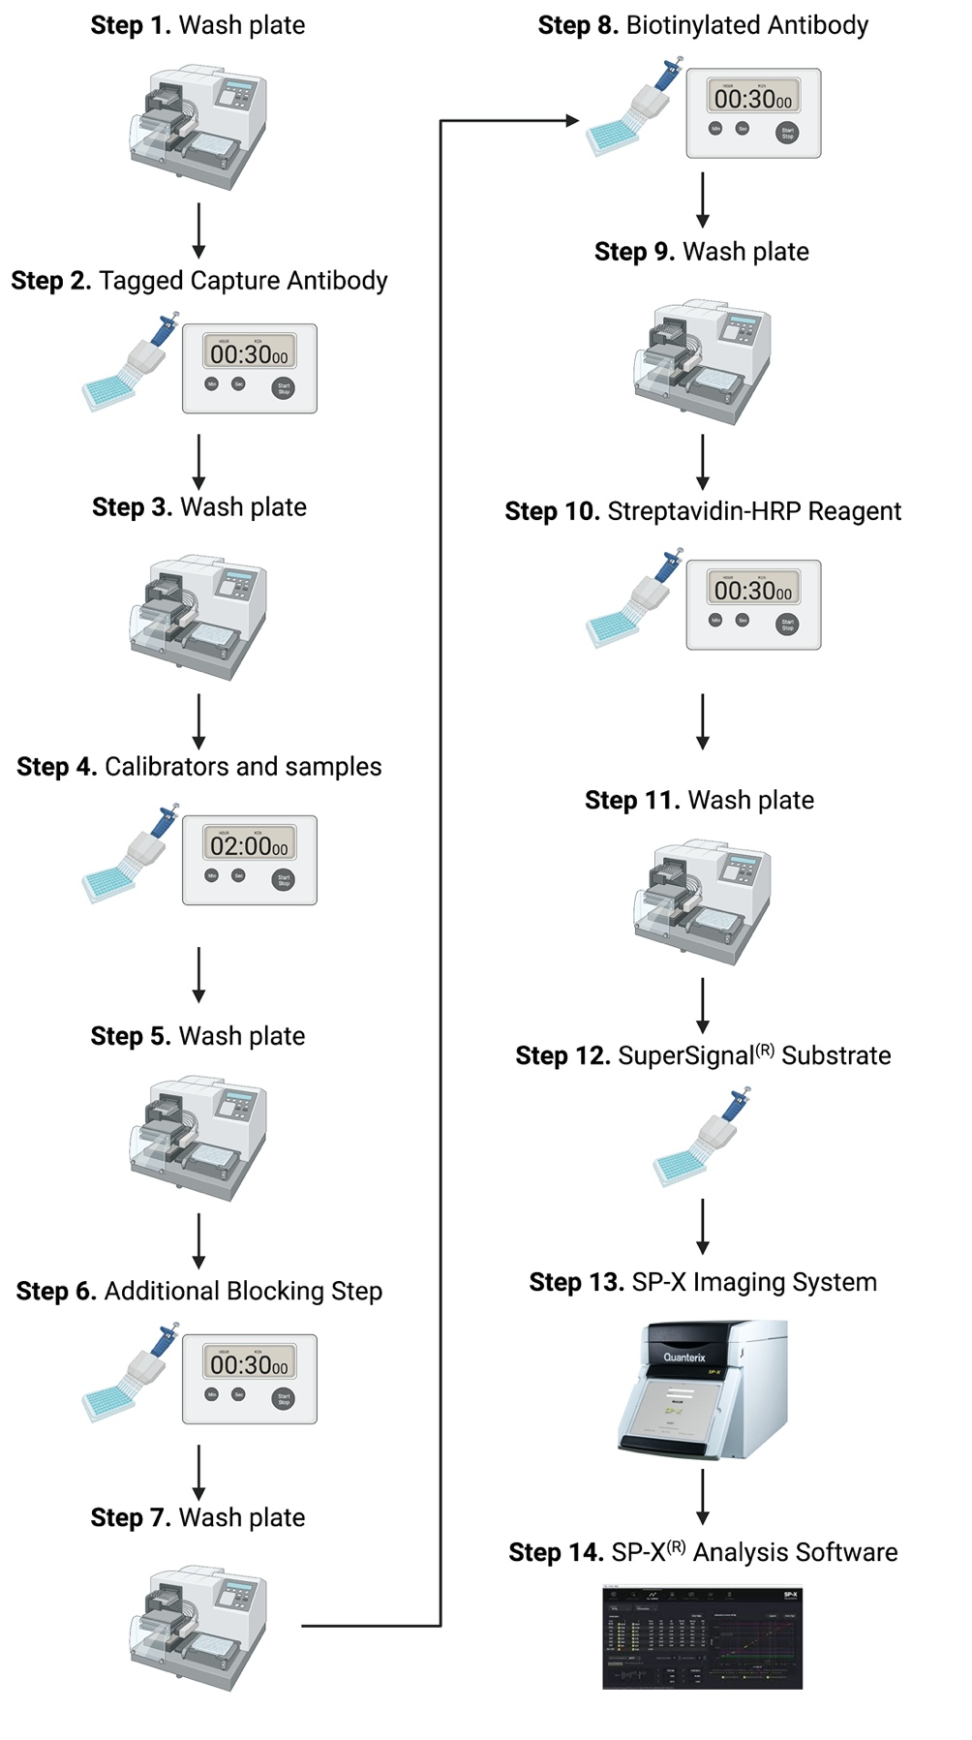

**Extended Data Figure 3. Overview of the homebrew Simoa planar p24 ELISA immunoassay protocol.** Created with Biorender.com



**Extended Table I. Assay performance in diverse matrixes.**