Supplementary Information

Wave-shaped microfluidic chip assisted point-of-care testing for accurate and rapid diagnosis of infections
Binfeng Yin¹*, Xinhua Wan¹, Mingzhu Yang², Changcheng Qian¹, A S M Muhtasim Fuad Sohan¹
¹School of Mechanical Engineering, Yangzhou University, Yangzhou 225127, China
²Department of Biochemistry, Institute of Basic Medical Sciences, Chinese Academy of Medical Sciences (CAMS) & Peking Union Medical College, Beijing 100005, PR China.
* Corresponding author
E-mail: binfengyin@yzu.edu.cn
Tel.: (+86) 514-87978347
Fax: (+86) 514-87311374
Contents
Additional file 1: Fig. S1.
Additional file 2: Fig. S2.
Additional file 3: Fig. S3.
Additional file 4: Fig. S4.
Additional file 5: Fig. S5.
Additional file 6: Fig. S6.
Additional file 7: Fig. S7.
Additional file 7: Fig. S8.

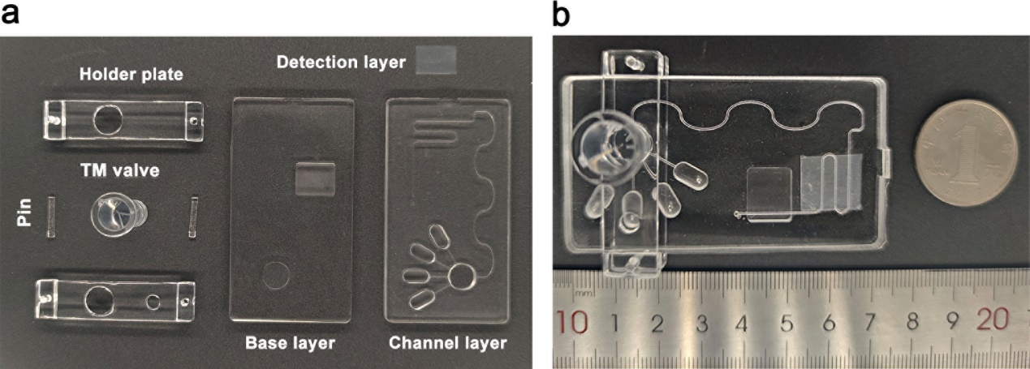
Additional file 1: Fig. S1. Picture of a real wave-shaped microfluidic chip (WMC) assisted multiplexed detection platform (WMC-MDP). a. Picture of WMC-MDP components includes channel layer, detection layer, base layer, holder plate, TM valve, and pins. b. Image of the assembled WMC-MDP. The detection layer is placed between the channel and base layers to form the sandwich structure, and the TM valve is inserted through the sandwich structure to fit the additional features.

Additional file 2: Fig. S2. Process of coating capture antibodies strips on detection layer. a. Preparing a chip to coat capture antibodies strips and cutting the silicone film according to the designed size. b. Placing the chip on the silicone film and injecting CRP-Ab₁, PCT-Ab₁, IL-6-Ab₁ into the channels. c. After incubation for 20 minutes, injecting PBST buffer into channels to wash three times. d. Removing the chip and obtaining the detection layer coated with capture antibodies strips.

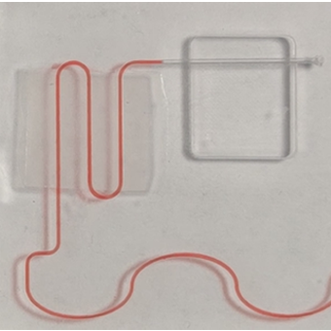
Additional file 3: Fig. S3. The red ink flows in the channel. No liquid leakage indicates that the chip is qualified.

Additional file 4: Fig. S4. The transmittance of WMC is in the range of 380-720 nm. The average transmittance is 85.97%. The transmittance at 425 nm is 86.04%.

Additional file 5: Fig. S5. Optimization of capture antibodies in WMC-MDP. a. CL intensity for detecting 10 μg/mL of CRP with 10, 20, 40, 60, 80 μg/mL of CRP-Ab₁ and 75 μg/mL of CRP-Ab₂. b. CL intensity for detecting 0.8 ng/mL of PCT with 10, 20, 40, 60, 80 μg/mL of PCT-Ab₁ and 75 μg/mL of PCT-Ab₂. c. CL intensity for detecting 100 pg/mL of IL-6 with 20, 40, 60, 80,120 μg/mL of IL-6-Ab₁, 75 μg/mL of B-IL-6-Ab₂ and 4 μg/mL of SA-HRP.
Additional file 6: Fig. S6. Optimization of detection antibodies in WMC-MDP. a. CL intensity for detecting 10 μg/mL of CRP with 6.25, 12.5, 25, 50, 75 μg/mL of CRP-Ab₂ and 40 μg/mL of CRP-Ab₁. b. CL intensity for detecting 0.8 ng/mL of PCT with 12.5, 25, 50, 75, 100 μg/mL of PCT-Ab₂ and 60 μg/mL of PCT-Ab₁. c. CL intensity for detecting 100 pg/mL of IL-6 with 12.5, 25, 50, 75, 100 μg/mL of IL-6-Ab₂, 80 μg/mL of B-IL-6-Ab₁ and 4 μg/mL of SA-HRP.
Additional file 7: Fig. S7. Reproducibility of CRP, PCT, and IL-6. a. Results of detecting 10 μg/mL CRP repeatedly in ten chips. b. Results of detecting 0.8 ng/mL PCT repeatedly in ten chips. c. Results of detecting 100 pg/mL IL-6 repeatedly in ten chips.

Additional file 8: Fig. S8. Storage stability of CRP, PCT, and IL-6. a. Results of detecting 10 μg/mL CRP in WMC-MDP, which have been stored for 1-7 days. b. Results of detecting 0.8 ng/mL PCT in WMC-MDP, which have been stored for 1-7 days. c. Results of detecting 100 pg/mL IL-6 in WMC-MDP, which have been stored for 1-7 days.

