Supplement 2 - Development Analysis for Sierra Valley, CA

Summary: Based on California Farmland Monitoring and Mapping Program (FMMP) data, we found that 198 acres were converted to urban development between 1988 and 2018. In total, 909 acres of the valley were categorized as urban / built-up as of 2018 by the FMMP, or less than 1% of the valley floor.

Data Source: Farmland Mapping and Monitoring Program, Division of Land Resource Protection, California Department of Conservation. Available online:

https://gis.conservation.ca.gov/server/rest/services/DLRP/CaliforniaImportantFarmland_mostrecent/FeatureServer

The CA Department of Conservation’s Farmland Mapping and Monitoring Program is an inventory of agricultural resources in the state between 1984 and 2018, based on aerial photography and U.S. Department of Agriculture Natural Resources Conservation Service (NRCS) soil surveys. The FMMP, also referred to as the California Important Farmland dataset, is a state mandated biennial report of farmland and grazing land conversion.

Analysis: The analysis was conducted in R; see additional materials. This analysis focused on the FMMP land use category called “Urban / Built-up Land” (labelled as category D in the FMMP data) (see table 1 below for definitions).

Table 1. Categories of agricultural land in the FMMP dataset

FMMP Category | Definition
Prime Farmland | Farmland with the best combination of physical and chemical features able to sustain long term agricultural production. This land has the soil quality, growing season, and moisture supply needed to produce sustained high yields. Land must have been used for irrigated agricultural production at some time during the four years prior to the mapping date.
Farmland of Statewide Importance | Farmland similar to Prime Farmland but with minor shortcomings, such as greater slopes or less ability to store soil moisture. Land must have been used for irrigated agricultural production at some time during the four years prior to the mapping date.
Unique Farmland | Farmland of lesser quality soils used for the production of the state's leading agricultural crops. This land is usually irrigated, but may include nonirrigated orchards or vineyards as found in some climatic zones in California. Land must have been cropped at some time during the four years prior to the mapping date.
Grazing Land | Land on which the existing vegetation is suited to the grazing of livestock. This category was developed in cooperation with the California Cattlemen's Association, University of California Cooperative Extension, and other groups interested in the extent of grazing activities.
Farmland of Local Importance* | Land of importance to the local agricultural economy as determined by each county's board of supervisors and a local advisory committee. In some counties, Confined Animal Agriculture facilities are part of Farmland of Local Importance​​, but they are shown separately.
Urban / Built-up Land | Land occupied by structures with a building density of at least 1 unit to 1.5 acres, or approximately 6 structures to a 10-acre parcel. This land is used for residential, industrial, commercial, construction, institutional, public administration, railroad and other transportation yards, cemeteries, airports, golf courses, sanitary landfills, sewage treatment, water control structures, and other developed purposes.
Other Land | Low density rural developments; brush, timber, wetland, and riparian areas not suitable for livestock grazing; confined livestock, poultry or aquaculture facilities; strip mines, borrow pits; and water bodies smaller than forty acres.

* Most of Sierra Valley’s land area is categorized as Farmland of Local Importance, as categorized by the county Board of Supervisors.

Source: https://www.conservation.ca.gov/dlrp/fmmp/Pages/Important-Farmland-Categories.aspx

Results:

According to our analysis, The “Urban / Built-Up” category increased by 198 acres between 1988 and 2018.

Figure 1. Urban / Built-Up Land Use in Sierra Valley
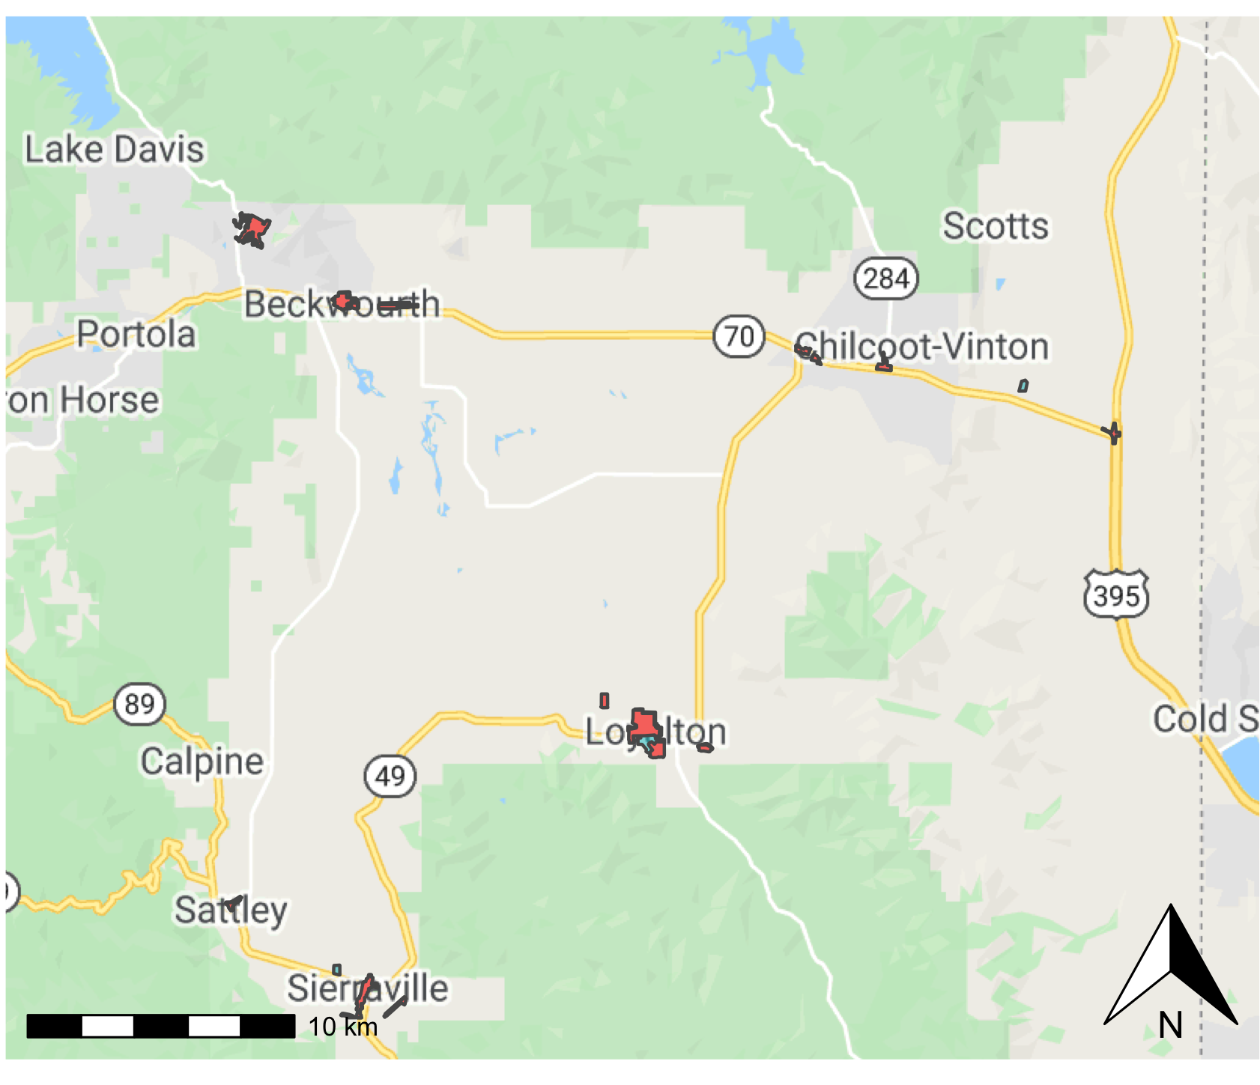
Caption: The map above shows where urban / built-up land use has been identified in Sierra Valley by the California Farmland Mapping and Monitoring Program. The red area indicates land use as of 1988; the blue area indicates land use as of 2018.

Figure 2. Changes in FMMP land use categories between 1988 and 2018
1988 | 2018

Note: The FMMP Category “Urban/Built-up” is shown in blue, agricultural land within various categories in salmon, and “Other Land” in green (including both low density development and brush/timber/riparian areas).

