Supplementary Materials

TableS2. Best predictive polygenic risk scores of lipid traits in Uganda replication cohort
Lipid traits | Populations | Adjusted R² (%) | Crude R² (%) | Predictive R² | P-value† | exit | SE | SNPs | P-value
HDL-C | AFR | 9.556 | 9.553 | 0.003 | 5 x 10⁻⁰⁸ | -0.8021 | 1.731 | 173 | 0.6432
 | EUR | 9.562 | 9.553 | 0.009 | 5 x 10⁻⁰⁸ | 14.171 | 17.57 | 1,053 | 0.4201
 | MEA | 9.614 | 9.553 | 0.061 | 0.0046 | 7.0337 | 3.379 | 2,427 | 0.0374
 | MAA | 9.976 | 9.863 | 0.113 | 0.0012 | -182.975 | 64.51 | 35,160 | 0.0045
LDL-C | AFR | 12.663 | 12.637 | 0.026 | 5 x 10⁻⁰⁸ | -6.742 | 4.909 | 271 | 0.1696
 | EUR | 12.692 | 12.637 | 0.055 | 5 x 10⁻⁰⁸ | -48.158 | 24.18 | 774 | 0.0464
 | MEA | 12.662 | 12.637 | 0.025 | 5 x 10⁻⁰⁸ | -27.288 | 20.43 | 1,008 | 0.1817
 | MAA | 17.629 | 17.548 | 0.081 | 0.0004 | 262.031 | 104.1 | 16,871 | 0.0118
TG | AFR | 2.737 | 2.735 | 0.002 | 5 x 10⁻⁰⁵ | 2.2983 | 7.591 | 720 | 0.7620
 | EUR | 2.786 | 2.735 | 0.051 | 0.0529 | -97.963 | 53.41 | 122,574 | 0.0666
 | MEA | 2.782 | 2.735 | 0.047 | 0.0027 | 4.3846 | 2.494 | 491 | 0.0788
 | MAA | 2.9 | 2.838 | 0.062 | 0.0001 | 61.4703 | 30.59 | 4,416 | 0.0445
TC | AFR | 17.439 | 17.391 | 0.048 | 5 x 10⁻⁰⁸ | -20.679 | 10.71 | 286 | 0.0534
 | EUR | 17.393 | 17.391 | 0.002 | 5 x 10⁻⁰⁸ | 20.809 | 51.18 | 864 | 0.6843
 | MEA | 17.431 | 17.391 | 0.04 | 0.0268 | 9.1977 | 5.165 | 1,095 | 0.0751
 | MAA | 17.596 | 17.548 | 0.048 | 0.0035 | 417.432 | 215.5 | 77,821 | 0.0528
† P-value threshold, SE, standard error; SNPs, single nucleotide polymorphisms; HDL-C, high-density lipoprotein cholesterol; LDL-C, low-density lipoprotein cholesterol; TG, triglycerides; TC, total cholesterol; AFR, African ancestry; EUR, European ancestry; MEA, multiethnic ancestry; MAA, multivariate of the African American.

TableS3. Best fitting models of clumping using total cholesterol serum lipid trait
Clump-kb –r2 | Best P_{T} | Coefficient | SE | SNPs | R² ⁽%) | P-value
250kb-r2 0.1 | 0.0110 | 1071.03 | 145.54 | 2,047,936 | 0.83 | 2.08 x 10⁻¹³
250kb-r2 0.2 | 0.0109 | 1157.86 | 152.56 | 2,557,000 | 0.89 | 3.67 x 10⁻¹⁴
250kb-r2 0.5 | 0.0105 | 1421 | 185.75 | 3,572,766 | 0.91 | 2.30 x 10⁻¹⁴
500kb-r2 0.1 | 0.0109 | 917.46 | 129.52 | 1,740,383 | 0.78 | 1.55 x 10⁻¹²
500kb-r2 0.2 | 0.0109 | 1029.78 | 139.85 | 2,310,793 | 0.84 | 2.01 x 10⁻¹³
500kb-r2 0.5 | 0.0105 | 1376.36 | 179.35 | 3,451,701 | 0.91 | 1.91 x 10⁻¹⁴
P_{T,} p-value threshold; SE, standard error; SNPs, single nucleotide polymorphisms; R²; PRS model fit,

Fig.S2 Correlation coefficients between PRS and serum lipid levels. (A) African American derived PRS in the South African Zulu dataset (B) European derived PRS in the South African Zulu. (C) African American derived PRS in the Uganda dataset (D) European derived PRS in the Uganda dataset. The correlation coefficients r² are given with colours corresponding to the direction and strength of r². The r² on the diagonal represent the strength of correlation of a PRS with its target lipid trait. The off-diagonal r² represent the strength of correlation of a PRS with other lipid traits.

Fig.S3 Comparative polygenic prediction of total cholesterol using the same PRS comprising of 286 SNPs which is developed in Uganda and then replicated in South African Zulu’s

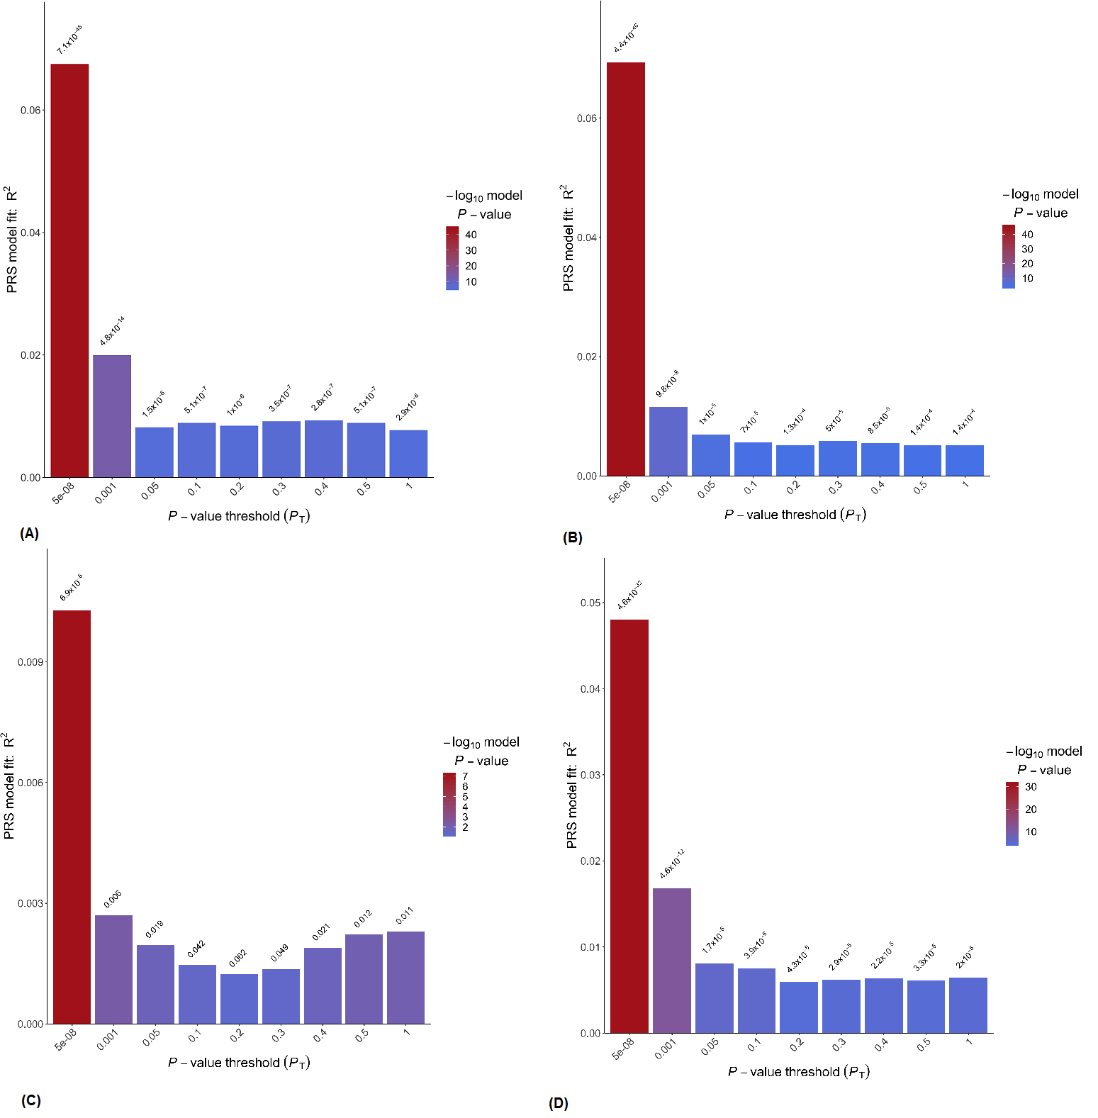
Fig.S4 Proportion of variance of TC explained by polygenic risk score (PRS) in the South African Zulu samples using PRS derived from GWAS (A) multivariate of the African American, (B) African American ancestry, (C) European ancestry and (D) multiethnic ancestry. The bars represent PRS calculated for subsets of markers at different p-value thresholds. The best PRS in red colour was selected based on having the highest variance (R²) for the trait in linear models adjusted for age, sex, and principal components.

