Supplementary Information
Trading deforestation - Why the legality of forest-risk commodities is insufficient
Authors: Tiago N. P. dos Reis^{1*}, Vinicius Guidotti de Faria², Gabriela Russo Lopes³, Gerd Sparovek⁴, Chris West⁵, Raoni G. Rajão⁶, Mariana Napolitano Ferreira⁷, Marcelo M. S. Elvira⁷, Raul S. T. do Valle⁷.
Affiliations:
¹Earth and Life Institute, Université Catholique de Louvain; Louvain-la-Neuve, 1348, Belgium.
²Instituto de Manejo e Certificação Florestal (IMAFLORA); Piracicaba-SP, 13426-420, Brazil.
³Center for Latin America Research and Documentation (CEDLA), University of Amsterdam (UvA); 1018 WB Amsterdam, the Netherlands.
⁴GeoLab, Universidade de São Paulo (USP); Piracicaba-SP, 13418-900, Brazil.
⁵Stockholm Environment Institute York, Department of Environment and Geography, University of York; York YO10 5NG, United Kingdom.
⁶Universidade Federal de Minas Gerais (UFMG); Belo Horizonte 31270-901, Brazil.
⁷WWF-Brazil; Brasília-DF, Brazil.
* Corresponding author. Email: tiago.reis@uclouvain.be

Supplementary Text
We found that unprotected native vegetation equals 69,254,298 hectares in the analyzed rural properties, from which 3.25 million hectares and 26.8 million hectares are under high and medium deforestation risk, respectively. The amount of carbon stock in unprotected native vegetation equals 1.6 Gt, from which 2.6% and 18.9% are under high and medium deforestation risk, respectively. Fig. S2 presents the percentage of carbon stocks in each class of the deforestation risk per biome.
Considering the distribution of the carbon stocks in Brazilian municipalities, our results indicate that 42 municipalities hold 50% of the total carbon stock under high or medium risk of deforestation, and 235 municipalities hold 80% of it, as shown in Figure S2.
We use a factor of 3.67 to convert the amount of carbon stock to CO₂. Our results indicate that the areas under high risk of deforestation until 2025 could release 152,816,881 tonnes of CO₂ (0,15 Gt) to the atmosphere. Considering the areas under medium risk, we found another 1,107,194,477 tonnes of CO₂ (1,11 Gt). Figure S1 and Table S1 summarize the results of the study.

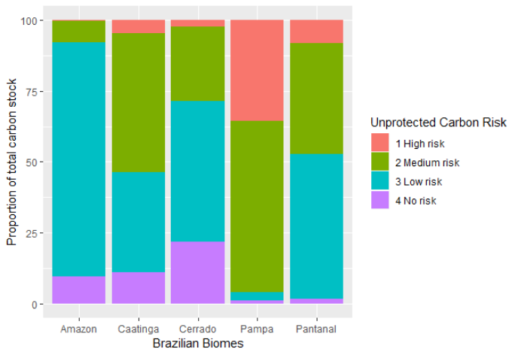

Fig. S1 - Percentage of the Brazilian biomes’ carbon stocks in terms of the deforestation risk.
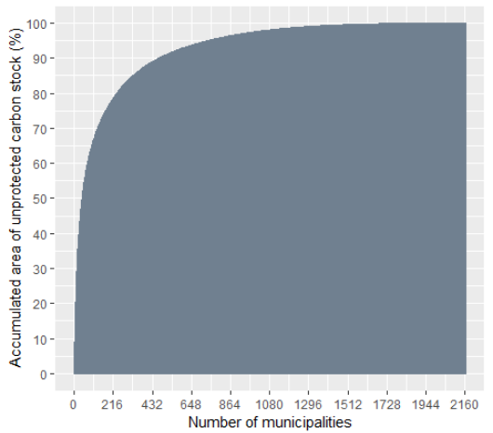

Fig. S2 - Distribution of total carbon stock under high or medium risk of deforestation in Brazilian municipalities.

Table S1 - Unprotected native vegetation and unprotected carbon in terms of deforestation risk. The Atlantic Forest biome is not listed because all remaining vegetation is protected by the Mata Atlântica law.
Risk of loss | Biome | Number of rural properties | Unprotected Native Vegetation (ha) | Unprotected Carbon  (tonnes of CO₂)
1 High risk | Amazon | 1.701 | 140.868 | 14.179.028
 | Caatinga | 43.900 | 1.053.479 | 18.797.515
 | Cerrado | 9.240 | 409.717 | 43.722.038
 | Pampa | 48.523 | 1.280.936 | 61.931.155
 | Pantanal | 781 | 366.961 | 14.187.145
2 Medium risk | Amazon | 17.251 | 993.356 | 255.198.691
 | Caatinga | 274.369 | 9.221.526 | 192.951.775
 | Cerrado | 110.832 | 9.980.063 | 453.045.662
 | Pampa | 59.010 | 3.029.375 | 108.965.362
 | Pantanal | 2.700 | 3.553.590 | 97.032.987
3 Low risk | Amazon | 78.480 | 6.726.239 | 2.822.903.583
 | Caatinga | 91.735 | 3.659.583 | 124.307.373
 | Cerrado | 146.508 | 15.757.564 | 741.290.921
 | Pampa | 2.214 | 94.000 | 5.089.178
 | Pantanal | 871 | 2.800.096 | 102.655.643
4 No risk | Amazon | 13.389 | 1.176.339 | 331.168.100
 | Caatinga | 86.336 | 1.403.248 | 45.395.963
 | Cerrado | 125.620 | 7.484.540 | 398.664.324
 | Pampa | 1.130 | 47.307 | 1.893.000
 | Pantanal | 103 | 75.508 | 5.073.272
Total |  | 1.114.693 | 69.254.298 | 5.838.452.715

List of Brazilian Congress Bills threatening the social-environmental framework
These bills are part of an overarching movement by the Bolsonaro administration in tandem with the agribusiness sector to re-shape the entire socio-environmental legal framework in Brazil, implying further destruction of natural habitats and carbon emissions. Here we show some examples of individual bills belonging to this overarching movement:
- PL 510/2021 and PLC 2633/2020: legalizing land-grabbing: These legal changes, if passed, would privatize 19.6 million hectares of public non-designated land in the Amazon, granting land and amnesty for illegal land-grabbers. It is a reward for crime and fraud. According to this study Brito et al. (2019) ¹, between 1.1. and 1.6 million hectares would be likely to be deforested under this new legislation. This forest loss could emit 4.5–6.5 megatonnes of carbon dioxide, respectively.
- PL 191/2020 - Changes in indigenous land regulation: This bill intends to change the current indigenous lands legislation profoundly. It allows mineral, oil, gas exploitation, hydroelectric building, and conversion of large extensions of forests for agricultural use. All of this, by the bill, could be carried out regardless of Free, Prior, Informed Consent of the affected communities. If approved, this bill will weaken the ability of indigenous territories to block deforestation. Indigenous lands are an effective inhibitor of deforestation and carbon loss².
- PL 3729/04 - Changes in the Licencing system: This bill intends to amend the
Environmental Impact Assessment legislation. It intends to end, for example, the analysis and mitigation of the indirect impacts promoted by infrastructural projects. As the literature shows, “95% of deforestation was within 5.5 km of a road”, and “Accessible unprotected land was 43.6% deforested” ³. These findings show that unassessed infrastructure projects tend to increase deforestation and emissions.
- Bom Futuro National Forest (Rondônia) - reduction - enacted in 2010: With the approval of Law 12.249 / 2010, this protected area was reduced from 280,000 hectares to less than 98,000 hectares. The main reason for decreasing the protected area was to legalize cattle production, which has been illegally occupying the forest’s limits over the years.
- Chico Mendes Extractive Reserve reduction - proposed in 2019: Farmers and irregular occupants in the Chico Mendes Extractive Reserve in Acre are enjoying newfound political power and pressuring to reduce the first protected area of its kind in Brazil. A bill (PL 6024/2019) in the Federal House of Representatives proposes removing areas used for irregular cattle farming from its perimeter, effectively legalizing the activity. Resident associations oppose the move.
- Jamanxim National Forest (Pará) - proposed in 2017: The PL 8107/2017 is now under discussion at the National Congress, allowing the expansion of agricultural production in 26.45% of the Jamanxim National Forest (FLONA). If this project is approved, the FLONA will lose 349 thousand hectares, regularizing the agricultural production that illegally exists in the protected area. This initiative is the second attempt to change the limits of FLONA Jamanxim to legalize cattle production in the protected area. In 2017, the National Congress approved the Provisional Measure 756/2016, which already reduced the protection of 37% of the territory of the National Forest. Widespread national mobilization took place. Brazil’s President contingently vetoed this attempt to change the legal requirements – only to be presented in Congress again some years later.
- RESEX State Jaci Paraná (Rondônia) - proposed in 2019: In 2019, the Governor of the State of Rondônia submitted the bill PL 80/2020 to the State Legislative Assembly, proposing the reduction of 80% of the limits of the Jaci-Paraná Extractive Reserve. From just over 190 thousand hectares, the area would be reduced to barely 22 thousand hectares. The government’s main reason to justify the reduction is the existence of more than 120 thousand head of cattle inside the conservation unit. With the project’s approval, all this livestock production would be considered legal. It could then be exported with no constraints. The project was approved in the state assembly in April 2021 with amendments that increased the original size to be downgraded from the Resex and an adjacent state park. It is now waiting for the governor’s final approval.
- PL3511/2019 - Changing the Forest Code: This legislative proposal aims to decrease the overall Legal Reserve areas in the Cerrado by changing how they are calculated. It would legalize at least 5 million hectares of land illegally converted from native vegetation to agricultural use, especially in the Cerrado biome.
- PL2362/2019 - Changing the Forest Code: This proposal was submitted by the senators Flávio Bolsonaro (son of the President) and Márcio Bittar (key agribusiness leader). It posits the abolishment of the Legal Reserves whatsoever, making deforestation legal in 152.8 million hectares in the whole country, opening potential emissions as large as 40.7 billion tons of CO₂ ⁴. It also regularizes the 11.4 million hectares of agricultural yields illegally cultivated in Legal Reserves at present. Combined, they account for seven times the territory of the United Kingdom. If approved, these areas would be considered legally deforested overnight. They would then be available for exports to whichever country adopts the legislative criteria solely to ensure sustainability in supply chains.
All these bills to change the Forest Code incentivize further non-compliance because it emits a signal that non-compliance can be rewarded in the future by sequential amendments. The Brazilian Forest Code was already heavily revised in 2012 from its original 1965 version. The argument of this revision was to increase compliance levels since the original version was non-enforceable and farmers were unable to comply fully. Thus, as this study shows, this 2012 revision resulted in about 1 million hectares of forest loss between 2012 and 2017⁵.

Supplementary References
1. Brito, B., Barreto, P., Brandão, A., Baima, S. & Gomes, P. H. Stimulus for land grabbing and deforestation in the Brazilian Amazon. Environ. Res. Lett. 14, 064018 (2019).
2. Walker, W. S. et al. The role of forest conversion, degradation, and disturbance in the carbon dynamics of Amazon indigenous territories and protected areas. Proc. Natl. Acad. Sci. 117, 3015–3025 (2020).
3. Barber, C. P., Cochrane, M. A., Souza, C. M. & Laurance, W. F. Roads, deforestation, and the mitigating effect of protected areas in the Amazon. Biol. Conserv. 177, 203–209 (2014).
4. Freitas, F. L. M. M. et al. Who owns the Brazilian carbon? Glob. Chang. Biol. 24, 2129–2142 (2018).
5. Albuquerque Sant’Anna, A. & Costa, L. Environmental regulation and bail outs under weak state capacity: Deforestation in the Brazilian Amazon. Ecol. Econ. 186, 107071 (2021).

