APPENDIX: Classification results from complete-case analysis for both binary classifiers
Table 7: Classification tables from un-imputed data
Binary Logistic Regression
Observed |  | Predicted group membership
 |  | Breast cancer recurrence |  |  | % correct classification
 |  | Yes | No | Total
Breast cancer recurrence | Yes | 53 | 66 | 119 | 44.5
 | No | 38 | 88 | 126 | 69.8
Total |  | 91 | 154 | 245 | 57.6
Linear Discriminant Analysis
Observed |  | Predicted group membership
 |  | Breast cancer recurrence |  |  | % correct classification
 |  | Yes | No | Total
Breast cancer recurrence | Yes | 45 | 74 | 119 | 37.8
 | No | 28 | 98 | 126 | 77.8
Total |  | 73 | 172 | 245 | 58.4

Table 8: Areas under the ROC curves: Null the hypothesis ‘true area = 0.5’
Variable used in classifiers | Area | S.E | P-value | 95% C.I
 |  |  |  | Lower | Upper
Age of patient  Respiratory rate  Body Mass Index  Body surface area | 0.543  0.482  0.509  0.520 | 0.037  0.037  0.037  0.037 | 0.240  0.633  0.811  0.587 | 0.470  0.410  0.436  0.448 | 0.617  0.555  0.581  0.592

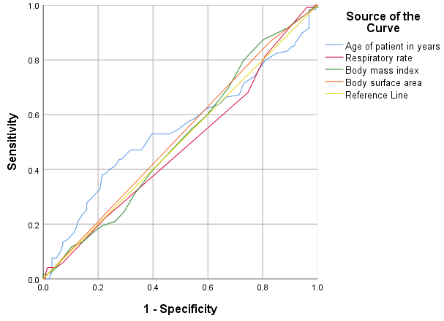
Figure 4: ROC curve from complete-case analysis

