Supplementary Figure 1. Study population

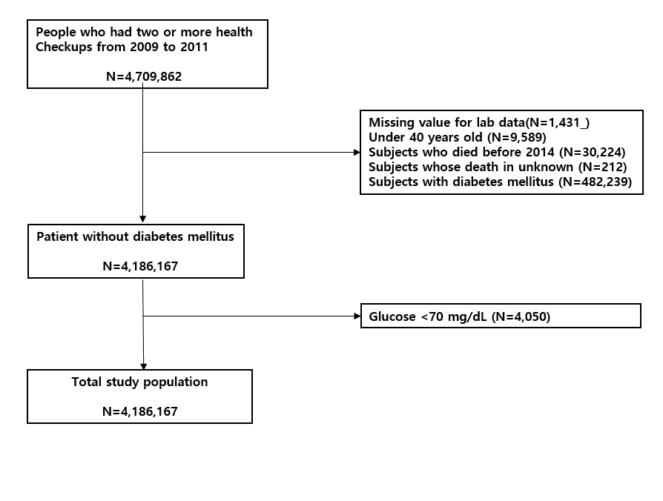

Supplementary Table 2. Risk of cardiovascular disease according to baseline LDL-C levels excluding subjects who died within 2 yers of follow-up
- Risk of MI according to baseline LDL-C levels excluding subjects who died within 2 yers of follow-up
Statin use | LDL-C (mg/dL) | Person-years | Number of events | Incident rate  (10,000 person years) | Age-adjusted HR  (95% CI) | Multivariable adjusted HR#  (95% CI)
Overall | <70 mg/dL | 1280386 | 555 | 4.33 | 1.02 (0.94 - 1.12) | 0.94 (0.85 - 1.02)
 | 70-99 mg/dL | 7763341 | 2818 | 3.63 | 1.00 (Reference) | 1.00 (Reference)
 | 100-129 mg/dL | 13954030 | 6127 | 4.39 | 1.24 (1.18 - 1.29) | 1.25 (1.2 - 1.31)
 | 130-159 mg/dL | 8434176 | 5441 | 6.45 | 1.85 (1.77 - 1.93) | 1.81 (1.73 - 1.89)
 | 160-189 mg/dL | 2245311 | 1931 | 8.60 | 2.58 (2.44 - 2.74) | 2.40 (2.26 - 2.54)
 | ≥ 190 mg/dL | 428088 | 520 | 12.15 | 3.91 (3.56 - 4.29) | 3.35 (3.04 - 3.69)
Non-statin user | <70 mg/dL | 1012694 | 293 | 2.89 | 0.86 (0.76 - 0.98) | 0.82 (0.73 - 0.93)
 | 70-99 mg/dL | 6796195 | 1997 | 2.94 | 1.00 (Reference) | 1.00 (Reference)
 | 100-129 mg/dL | 12320056 | 4839 | 3.93 | 1.35 (1.28 - 1.42) | 1.33 (1.27 - 1.41)
 | 130-159 mg/dL | 6689616 | 4122 | 6.16 | 2.13 (2.02 - 2.24) | 2.07 (1.96 - 2.18)
 | 160-189 mg/dL | 1312618 | 1176 | 8.96 | 3.20 (2.98 - 3.44) | 3.05 (2.83 - 3.28)
 | ≥ 190 mg/dL | 171350 | 229 | 13.36 | 5.02 (4.38 - 5.76) | 4.52 (3.94 - 5.19)
Statin user | <70 mg/dL | 267692 | 262 | 9.79 | 1.02 (0.88 - 1.17) | 0.99 (0.86 - 1.14)
 | 70-99 mg/dL | 967147 | 821 | 8.49 | 1.00 (Reference) | 1.00 (Reference)
 | 100-129 mg/dL | 1633974 | 1288 | 7.88 | 1.04 (0.95 - 1.13) | 1.06 (0.97 - 1.16)
 | 130-159 mg/dL | 1744560 | 1319 | 7.56 | 1.10 (1.00 - 1.20) | 1.16 (1.06 - 1.27)
 | 160-189 mg/dL | 932693 | 755 | 8.09 | 1.25 (1.13 - 1.38) | 1.39 (1.26 - 1.54)
 | ≥ 190 mg/dL | 256739 | 291 | 11.33 | 1.86 (1.63 - 2.13) | 2.02 (1.76 - 2.32)
#Adjusted for age, body mass index, smoking status, alcohol consumption, regular exercise, income and hypertension
LDL-C, low lipoprotein cholesterol; HR, hazard ratios

- Risk of ischemic stroke outcome according to baseline LDL-C levels excluding subjects who died within 2 yers of follow-up
Statin use | LDL-C (mg/dL) | Person-years | Number of events | Incident rate  (10,000 person years) | Age-adjusted HR (95% CI) | Multivariable ajdusted  HR (95% CI)
overall | <70 mg/dL | 1279293 | 1484 | 11.60 | 1.2 (1.14 - 1.27) | 1.07 (1.01 - 1.13)
 | 70-99 mg/dL | 7757907 | 7207 | 9.29 | 1.00 (Reference) | 1.00 (Reference)
 | 100-129 mg/dL | 13945626 | 13274 | 9.52 | 0.98 (0.95 – 1.00) | 1.02 (0.99 - 1.05)
 | 130-159 mg/dL | 8431785 | 8737 | 10.36 | 0.99 (0.96 - 1.02) | 1.07 (1.04 - 1.10)
 | 160-189 mg/dL | 2245476 | 2474 | 11.02 | 1.01 (0.96 - 1.05) | 1.12 (1.07 - 1.18)
 | ≥ 190 mg/dL | 428284 | 603 | 14.08 | 1.25 (1.15 - 1.36) | 1.42 (1.30 - 1.54)
Non-statin user | <70 mg/dL | 1011686 | 1051 | 10.39 | 1.15 (1.07 - 1.22) | 1.07 (1 - 1.14)
 | 70-99 mg/dL | 6791357 | 5748 | 8.46 | 1.00 (Reference) | 1.00 (Reference)
 | 100-129 mg/dL | 12312343 | 11056 | 8.98 | 1.02 (0.99 - 1.05) | 1.04 (1.00 - 1.07)
 | 130-159 mg/dL | 6687745 | 6625 | 9.91 | 1.09 (1.05 - 1.13) | 1.11 (1.07 - 1.15)
 | 160-189 mg/dL | 1312853 | 1401 | 10.67 | 1.19 (1.12 - 1.26) | 1.21 (1.14 - 1.28)
 | ≥ 190 mg/dL | 171430 | 263 | 15.34 | 1.73 (1.53 - 1.96) | 1.69 (1.50 - 1.92)
Statin user | <70 mg/dL | 267607 | 433 | 16.18 | 1.06 (0.95 - 1.18) | 1.01 (0.91 - 1.13)
 | 70-99 mg/dL | 966550 | 1459 | 15.09 | 1.00 (Reference) | 1.00 (Reference)
 | 100-129 mg/dL | 1633282 | 2218 | 13.58 | 0.96 (0.90 - 1.03) | 0.99 (0.93 - 1.06)
 | 130-159 mg/dL | 1744040 | 2112 | 12.11 | 0.92 (0.86 - 0.99) | 0.99 (0.92 - 1.06)
 | 160-189 mg/dL | 932623 | 1073 | 11.51 | 0.92 (0.85 – 1.00) | 1.03 (0.95 - 1.12)
 | ≥ 190 mg/dL | 256853 | 340 | 13.24 | 1.11 (0.98 - 1.25) | 1.24 (1.10 - 1.40)
#Adjusted for age, body mass index, smoking status, alcohol consumption, regular exercise, income and hypertension
LDL-C, low lipoprotein cholesterol; HR, hazard ratios

- Risk of CVD death according to baseline LDL-C levels excluding subjects who died within 2 yers of follow-up
Statin use | LDL-C (mg/dL) | Person-years | Number of events | Incident rate  (10,000 person years) | Age-adjusted HR (95% CI) | Multivariable adjusted HR  (95% CI)
overall | <70 mg/dL | 1281946 | 111 | 0.87 | 1.59 (1.29 - 1.96) | 1.30 (1.05 - 1.60)
 | 70-99 mg/dL | 7770519 | 402 | 0.52 | 1.00 (Reference) | 1.00 (Reference)
 | 100-129 mg/dL | 13968825 | 754 | 0.54 | 0.99 (0.88 - 1.12) | 1.08 (0.96 - 1.22)
 | 130-159 mg/dL | 8447325 | 542 | 0.64 | 1.08 (0.95 - 1.23) | 1.27 (1.12 - 1.45)
 | 160-189 mg/dL | 2249893 | 169 | 0.75 | 1.20 (1.00 - 1.44) | 1.55 (1.29 - 1.86)
 | ≥ 190 mg/dL | 429364 | 61 | 1.42 | 2.19 (1.68 - 2.87) | 2.92 (2.22 - 3.85)
Non-statin user | <70 mg/dL | 1013625 | 88 | 0.87 | 1.61 (1.27 - 2.04) | 1.46 (1.15 - 1.85)
 | 70-99 mg/dL | 6801463 | 314 | 0.46 | 1.00 (Reference) | 1.00 (Reference)
 | 100-129 mg/dL | 12331750 | 609 | 0.49 | 1.08 (0.94 - 1.23) | 1.11 (0.97 - 1.28)
 | 130-159 mg/dL | 6699606 | 413 | 0.62 | 1.36 (1.18 - 1.58) | 1.41 (1.21 - 1.64)
 | 160-189 mg/dL | 1315395 | 108 | 0.82 | 1.93 (1.55 - 2.40) | 2.00 (1.60 - 2.50)
 | ≥ 190 mg/dL | 171917 | 30 | 1.75 | 4.34 (2.98 - 6.32) | 4.27 (2.93 - 6.23)
Statin user | <70 mg/dL | 268321 | 23 | 0.86 | 0.87 (0.55 - 1.38) | 0.81 (0.50 - 1.29)
 | 70-99 mg/dL | 969056 | 88 | 0.91 | 1.00 (Reference) | 1.00 (Reference)
 | 100-129 mg/dL | 1637074 | 145 | 0.89 | 1.11 (0.85 - 1.45) | 1.16 (0.89 - 1.52)
 | 130-159 mg/dL | 1747718 | 129 | 0.74 | 1.05 (0.80 - 1.38) | 1.15 (0.87 - 1.52)
 | 160-189 mg/dL | 934498 | 61 | 0.65 | 1.02 (0.73 - 1.42) | 1.20 (0.86 - 1.68)
 | ≥ 190 mg/dL | 257448 | 31 | 1.20 | 2.05 (1.36 - 3.10) | 2.34 (1.53 - 3.58)
#Adjusted for age, body mass index, smoking status, alcohol consumption, regular exercise, income and hypertension
LDL-C, low lipoprotein cholesterol; HR, hazard ratios

