Supplementary Figures:
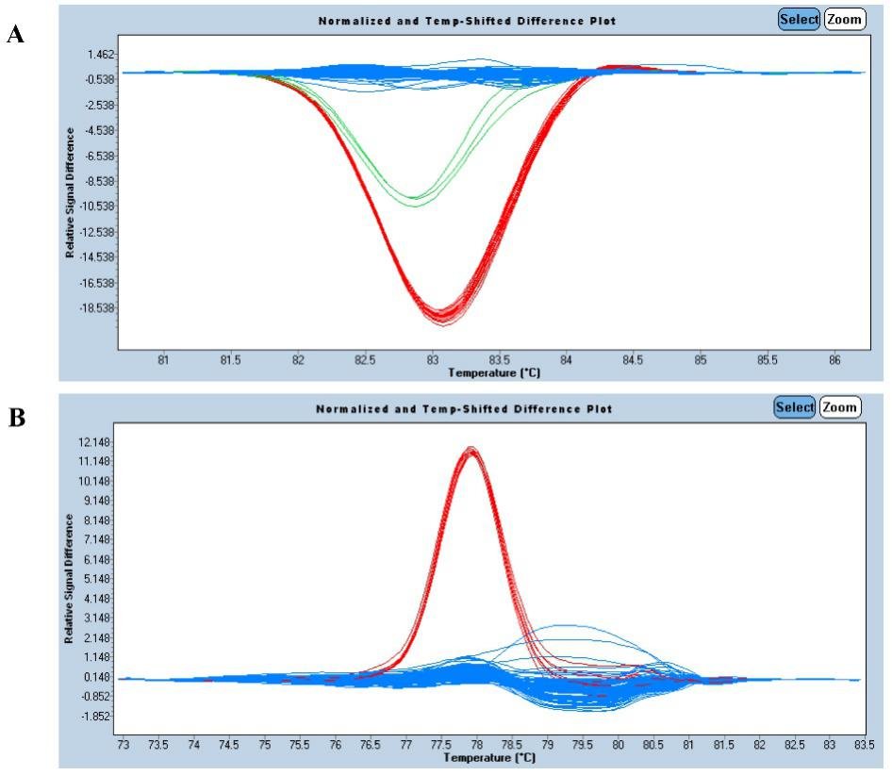
Figure S1. Representative genotyping results by HRM analysis. (A) The normalized and temperature-shifted difference plot indicated that three site-specific haplotypes were identified in a plate of 96 plant DNA samples using HRM407 primers. (B) The normalized and temperature-shifted difference plot showed that two site-specific haplotypes were identified in a plate of 96 plant DNA samples using HRM727 primers.

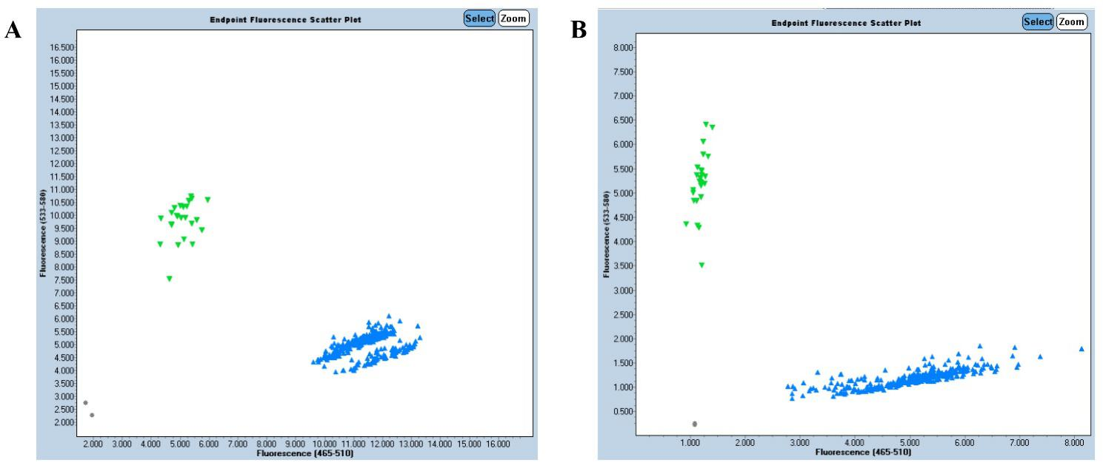
Figure S2. Representative genotyping results in a plate of 384 plant DNA samples by KASP analysis for primers mP1858 (A) and cP1225 (B).

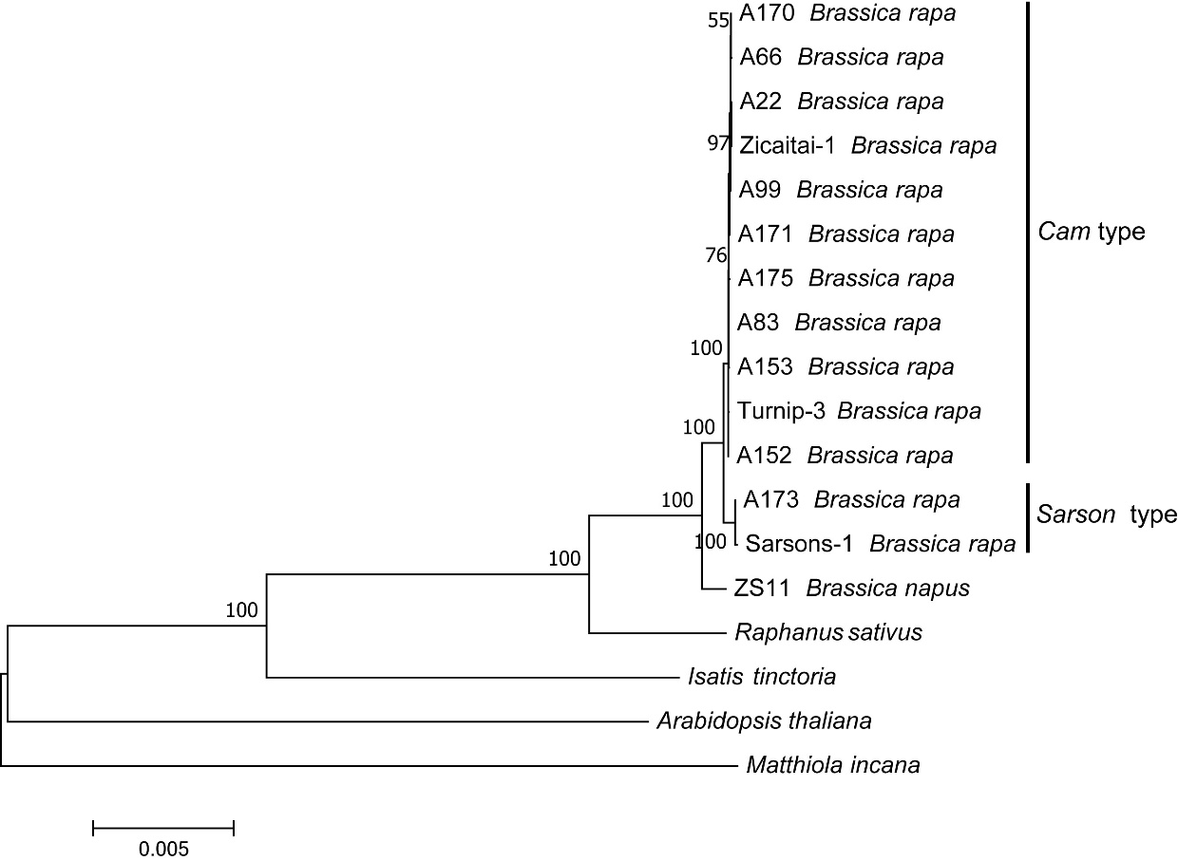
Figure S3. Phylogenetic tree of Brassica rapa. This tree structure was inferred using Maximum Likelihood method based on the entire chloroplast genomes from representative B. rapa materials. The sequence data for materials Zicaitai-1, Turnip-3 and Sarsons-1 from Li et al. (2017) were added.

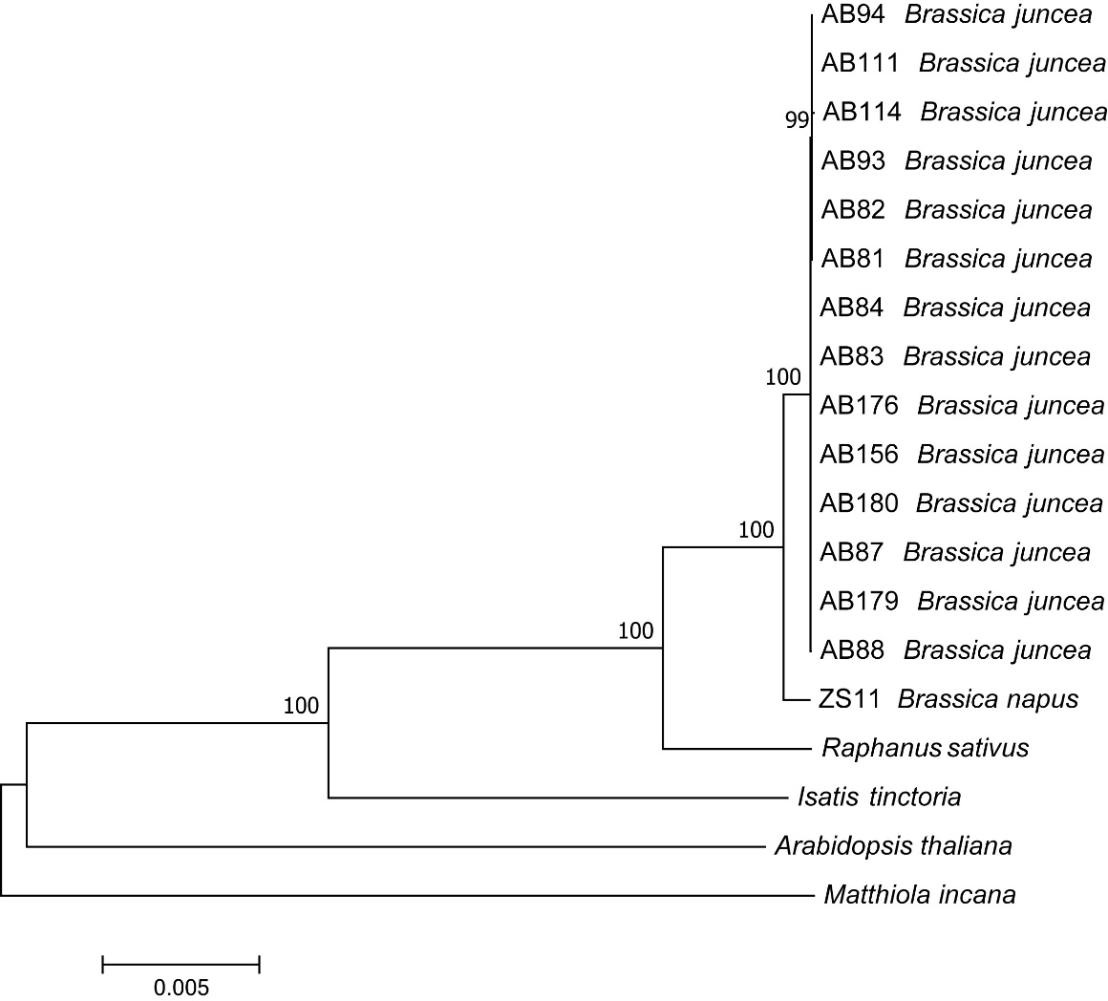
Figure S4. Phylogenetic tree of Brassica juncea. This tree structure was inferred using Maximum Likelihood method based on the entire chloroplast genomes from representative B. juncea materials.

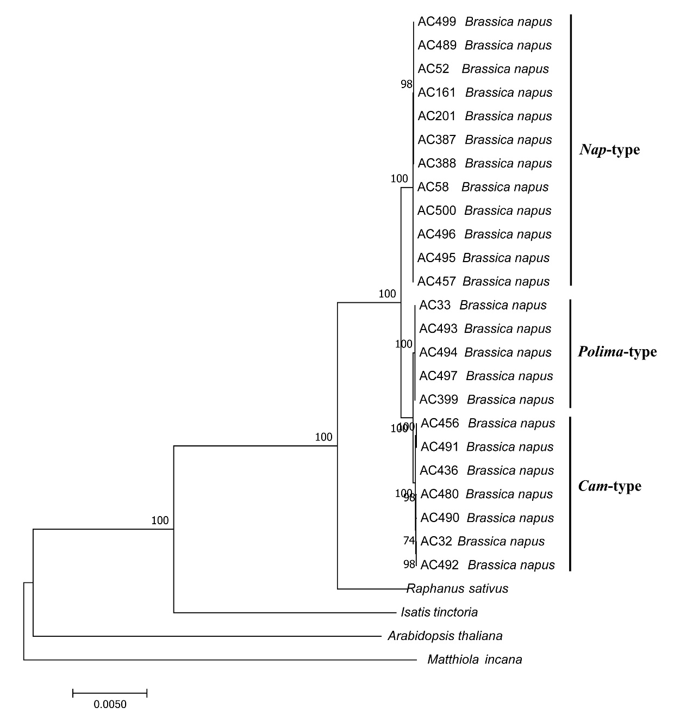
Figure S5. Phylogenetic tree of Brassica napus. This tree structure was inferred using Maximum Likelihood method based on the entire chloroplast genomes from representative B. napus materials.

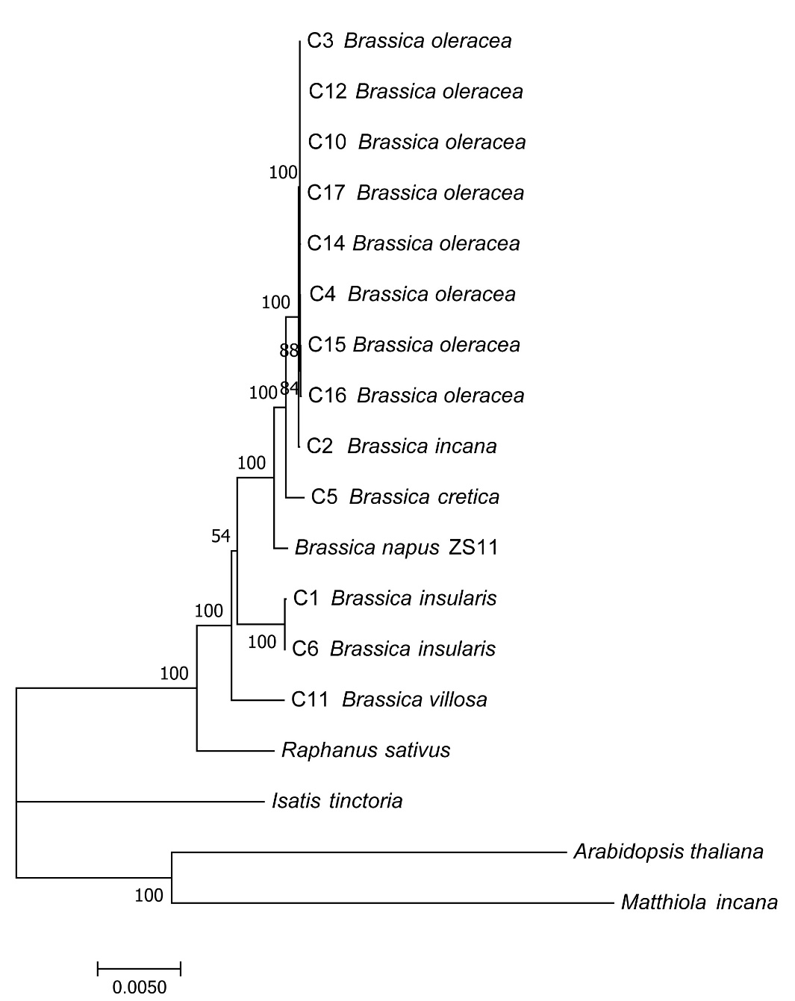
Figure S6. Phylogenetic tree of Brassica C-genome species. This tree structure was inferred using Maximum Likelihood method based on the entire chloroplast genomes from representative B. oleracea materials.

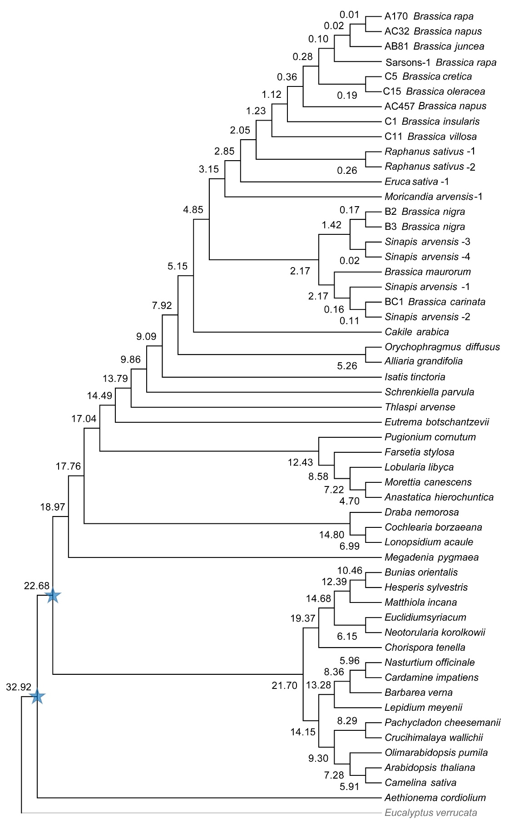
Figure S7. Timetree analysis using the RelTime method. The timetree was computed based on the phylogenetic tree of Brassicaceae family in Figure 4 using two calibration constraints labeled with blue stars and displayed only with topology. Eucalyptus verrucata labeled with lightgray was set as outgroup.

