Supplementary Information

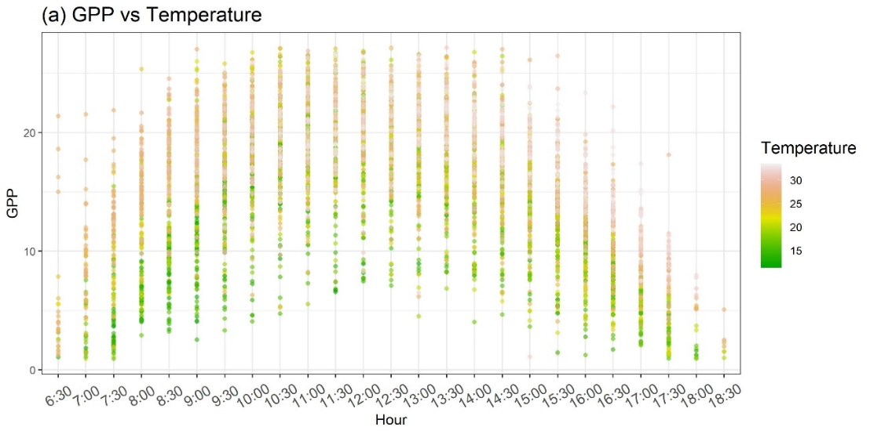
Figure S1 The relationship between half-hourly T_{air} and GPP.

Figure S2 Time series in-situ surface water salinity, satellite-based seawater salinity, and rainfall.

Figure S3 Validation of LUE by individual environmental variables specified: (a) SST, (b) Salinity, and (c) PAR.

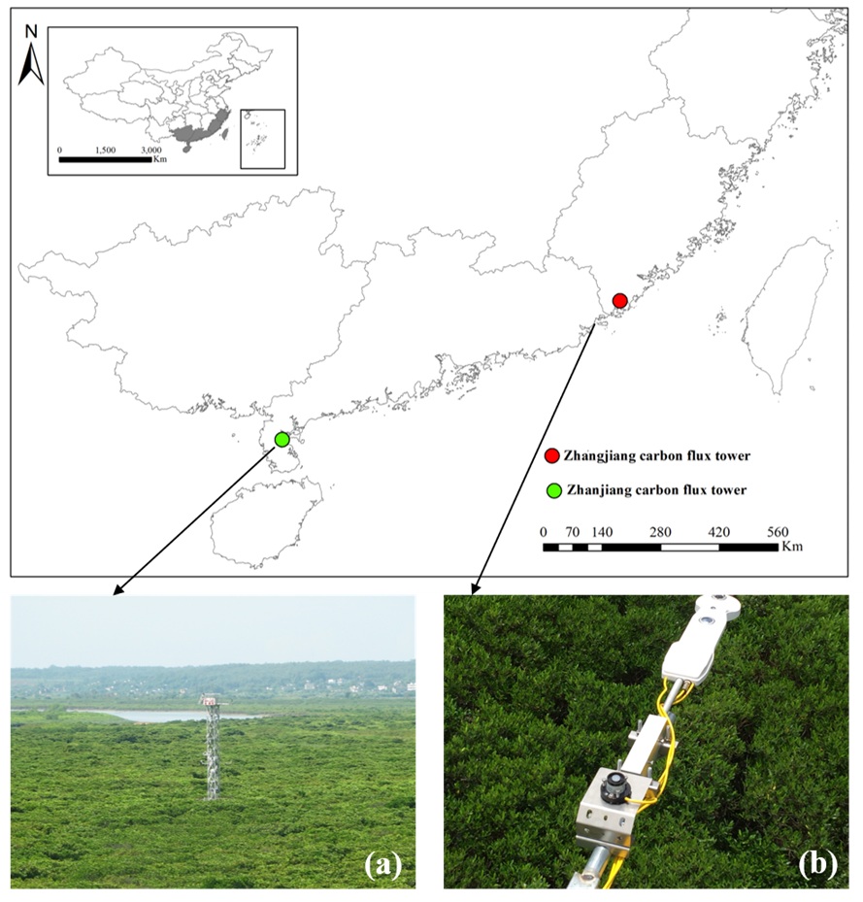
Figure S4 Locations of carbon flux towers in China at: (a) Zhangjiang, and (b) Zhanjiang (Field photos from ChinaFLUX website: http://www.chinaflux.org ).

Table S1 Summary of T_{min}, T_{max} and T_{opt} for T_{air} and SST based on literature reviews.
 | T_{min} (℃) | T_{max} (℃) | T_{opt} (℃) | Reference
Florida, United States (25.36° N, 81.08° W) | 2.6 | 33.5 | 27.8 | Barr et al. (2013)
New Caledonia (20.94° N, 164.66° E) | 10.5 | 34.4 | 26.8 | Leopold et al. (2016)
Trat River, Thailand (12.20° N, 102.57° E) | 24.0 | 32.1 | 27.6 | Poungparn et al. (2020)
Ningde, China (26.68° N) | 1.4 | -- | 19.0 | Chen et al. (2017)
Longhai, China (24.43° N) | 4.6 | -- | 21.0 | Chen et al. (2017)
Zhangjiang, China (23.90° N) | 6.5 | -- | 21.2 | Chen et al. (2017)
Shenzhen, China (22.53° N) | 5.3 | -- | 22.5 | Chen et al. (2017)
Gaoqiao, China (21.56° N) | 5.2 | -- | 23.0 | Chen et al. (2017)
Zhanjiang, China (21.00° N) | 3.8 | -- | 23.0 | Chen et al. (2017)
Fangchenggang, China (21.46° N) | 4.1 | -- | 22.5 | Chen et al. (2017)
Qinzhou, China (21.72° N) | 3.3 | -- | 22.0 | Chen et al. (2017)
Haikou, China (19.90° N) | 7.7 | -- | 23.8 | Chen et al. (2017)
Wenchang, China (19.57° N) | 9.5 | -- | 24.0 | Chen et al. (2017)
Global | -- | 33 | 30 | Alongi (2018)
Yueqing, China (28.42° N) | 9.3 (T_{air})  10.6 (SST) | -- | -- | Huang et al. (2009)
Fuding, China (27.33° N) | 9.8 (T_{air})  10.9 (SST) | -- | -- | Zhang et al. (2001)
Global (Avicennia species) | 8.1 (T_{air})  12.7 (SST) | 35.6 (T_{air})  32.8 (SST) | -- | Quisthoudt et al. (2012)
Global (Rhizophora species) | 13.1 (T_{air})  16.4 (SST) | 34.6 (T_{air})  32.6 (SST) | -- | Quisthoudt et al. (2012)
Global | 19 | 35 | -- | Noor et al. (2015)
Global | 16 | 38-40 | 28-32 | Gilman et al. (2008)

Table S2 Summery of VPD_{min} and VPD_{max} in mangrove forests.
Locations | VPD_{min} | VPD_{max} | Reference
Everglades National Park, USA (25.36° N, 81.08° W) | 0.16 | 2.23 | Barr et al. (2014)
North Peninsula State Park, USA (29.42° N, 81.10° E) | 0.15 | 2.20 | Devaney et al. (2021)
Old Point Mangrove Regional Park, San Andrés Island (12.58° N, 81.74° W) | 1.18 | 1.72 | Sánchez-Núñez and Mancera-Pineda (2011)
North Stradbroke Island, Australia (27.45° S, 135.43° E) | 0.10* | 1.25* | Vandegehuchte et al. (2014)
Amelia Island, USA (30.67° N, 81.43° W) | 0.90* | 3.70* | Aspinwall et al. (2021)
Terranora Broadwater, Australia (28.22° S, 153.51° E) | 0.10* | 1.20* | Vilas et al. (2019)
Okinawa Island, Japan (26.18° N, 127.67° E) | 0.64 | 1.15 | Sharma et al. (2012)
Pichavaram, India (11.33° N, 79.92° E) | 0.10* | 4.50* | Gnanamoorthy et al. (2020)
Sinnamary, France (52.93° E, 5.39° N) | 0.10* | 1.25* | Muller et al. (2009)
Sundarban, India (20.53 - 20.67° N, 88.08 - 89° E) | 0.09 | 2.17 | Ganguly et al. (2014)
*Values extracted from figures by visual interpretation.

Table S3 Information on the mangrove forest structures and local climate.
Site | Mangrove forest |  |  |  | Microclimate (Annual mean)
 | Height (m) | Species | Age  (yr) |  | T_{air}  (°C) | humidity | Tide range (m) | Rainfall  (mm)
Zhangjiang | 6 | Kandelia obovate, Avicennia marina, Aegiceras corniculatum | -- |  | 21.2 | 79% | 2.3 | 1715
Zhanjiang | 12 | Sonneratia apetala | >20 |  | 24.5 | -- | 3.0 | 1619

Table S4 In-situ data availability.
Site | Carbon flux tower data |  |  |  |  |  | Meteorological data
 | GPP | NEE | R_{e} | fAPAR | LUE |  | PAR | T_{air} | VPD | SST | Salinity
 | μmol/m²/s |  |  |  |  |  | mol/m²/s | °C | kPa | °C | ppt
Zhangjiang | Half-hourly, 2012.01-12, 2016.08-2017.08 |  | Half-hourly, 2012.01-12 | Half-hourly, 2016.08-2017.08 |  |  | Half-hourly,  2012.01-12,  2016.08-2017.08 |  |  | Half-hourly, 2016.08-2017.08
Zhanjiang | Half-hourly,  2015.01-2015.12 |  |  |  |  |  | Half-hourly,  2015.01-2015.12
* NEE = net ecosystem exchange; fAPAR = fraction of absorbed photosynthetic active radiation.

References
Alongi DM. Impact of global change on nutrient dynamics in mangrove forests. Forests 2018; 9: 596.
Aspinwall MJ, Faciane M, Harris K, O’Toole M, Neece A, Jerome V, et al. Salinity has little effect on photosynthetic and respiratory responses to seasonal temperature changes in black mangrove (Avicennia germinans) seedlings. Tree Physiology 2021; 41: 103-118.
Barr JG, DeLonge MS, Fuentes JD. Seasonal evapotranspiration patterns in mangrove forests. Journal of Geophysical Research: Atmospheres 2014; 119: 3886-3899.
Barr JG, Engel V, Fuentes J, Fuller D, Kwon H. Modeling light use efficiency in a subtropical mangrove forest equipped with CO 2 eddy covariance. Biogeosciences 2013; 10: 2145-2158.
Chen L, Wang W, Li QQ, Zhang Y, Yang S, Osland MJ, et al. Mangrove species' responses to winter air temperature extremes in China. Ecosphere 2017; 8: e01865.
Devaney JL, Pullen J, Feller IC, Parker JD. Low humidity and hypersalinity reduce cold tolerance in mangroves. Estuarine, Coastal and Shelf Science 2021; 248: 107015.
Ganguly D, Ray R, Majumder N, Chowdhury C, Jana TK. Monsoonal Influence on Evapotranspiration of the Tropical Mangrove Forest in Northeast India. American Journal of Climate Change 2014; 2014.
Gilman EL, Ellison J, Duke NC, Field C. Threats to mangroves from climate change and adaptation options: a review. Aquatic botany 2008; 89: 237-250.
Gnanamoorthy P, Selvam V, Burman PKD, Chakraborty S, Karipot A, Nagarajan R, et al. Seasonal variations of net ecosystem (CO2) exchange in the Indian tropical mangrove forest of Pichavaram. Estuarine, Coastal and Shelf Science 2020; 243: 106828.
Huang X, Peng X, Qiu J, Chen S. Mangrove status and development prospects in southern Zhejiang Province. Journal of Zhejiang Forestry College 2009; 26: 427-433.
Leopold A, Marchand C, Renchon A, Deborde J, Quiniou T, Allenbach M. Net ecosystem CO2 exchange in the “Coeur de Voh” mangrove, New Caledonia: Effects of water stress on mangrove productivity in a semi-arid climate. Agricultural and forest meteorology 2016; 223: 217-232.
Muller E, Lambs L, Fromard F. Variations in water use by a mature mangrove of Avicennia germinans, French Guiana. Annals of Forest Science 2009; 66: 803.
Noor T, Batool N, Mazhar R, Ilyas N. Effects of siltation, temperature and salinity on mangrove plants. European Academic Research 2015; 2: 14172-14179.
Poungparn S, Komiyama A, Umnouysin S, Rodtassana C, Sangtiean T, Maknual C, et al. Ten-Year Estimation of Net Primary Productivity in a Mangrove Forest under a Tropical Monsoon Climate in Eastern Thailand: Significance of the Temperature Environment in the Dry Season. Forests 2020; 11: 987.
Quisthoudt K, Schmitz N, Randin CF, Dahdouh-Guebas F, Robert EM, Koedam N. Temperature variation among mangrove latitudinal range limits worldwide. Trees 2012; 26: 1919-1931.
Sánchez-Núñez DA, Mancera-Pineda JE. Flowering patterns in three neotropical mangrove species: Evidence from a Caribbean island. Aquatic Botany 2011; 94: 177-182.
Sharma S, Kamruzzaman M, Hoque AR, Hagihara A. Leaf phenological traits and leaf longevity of three mangrove species (Rhizophoraceae) on Okinawa Island, Japan. Journal of oceanography 2012; 68: 831-840.
Vandegehuchte MW, Guyot A, Hubau M, De Groote SR, De Baerdemaeker NJ, Hayes M, et al. Long-term versus daily stem diameter variation in co-occurring mangrove species: Environmental versus ecophysiological drivers. Agricultural and Forest Meteorology 2014; 192: 51-58.
Vilas MP, Adams MP, Ball MC, Meynecke J-O, Santini NS, Swales A, et al. Night and day: Shrinking and swelling of stems of diverse mangrove species growing along environmental gradients. PloS one 2019; 14: e0221950.
Zhang Q, Sui Z, Zhang Y, Yu H, Sun Z, Wen X. Marine environmental indexes related to mangrove growth. Acta Ecologica Sinica 2001; 21: 1427-1437.

