Appendix 1: Individual patient spike event analysis 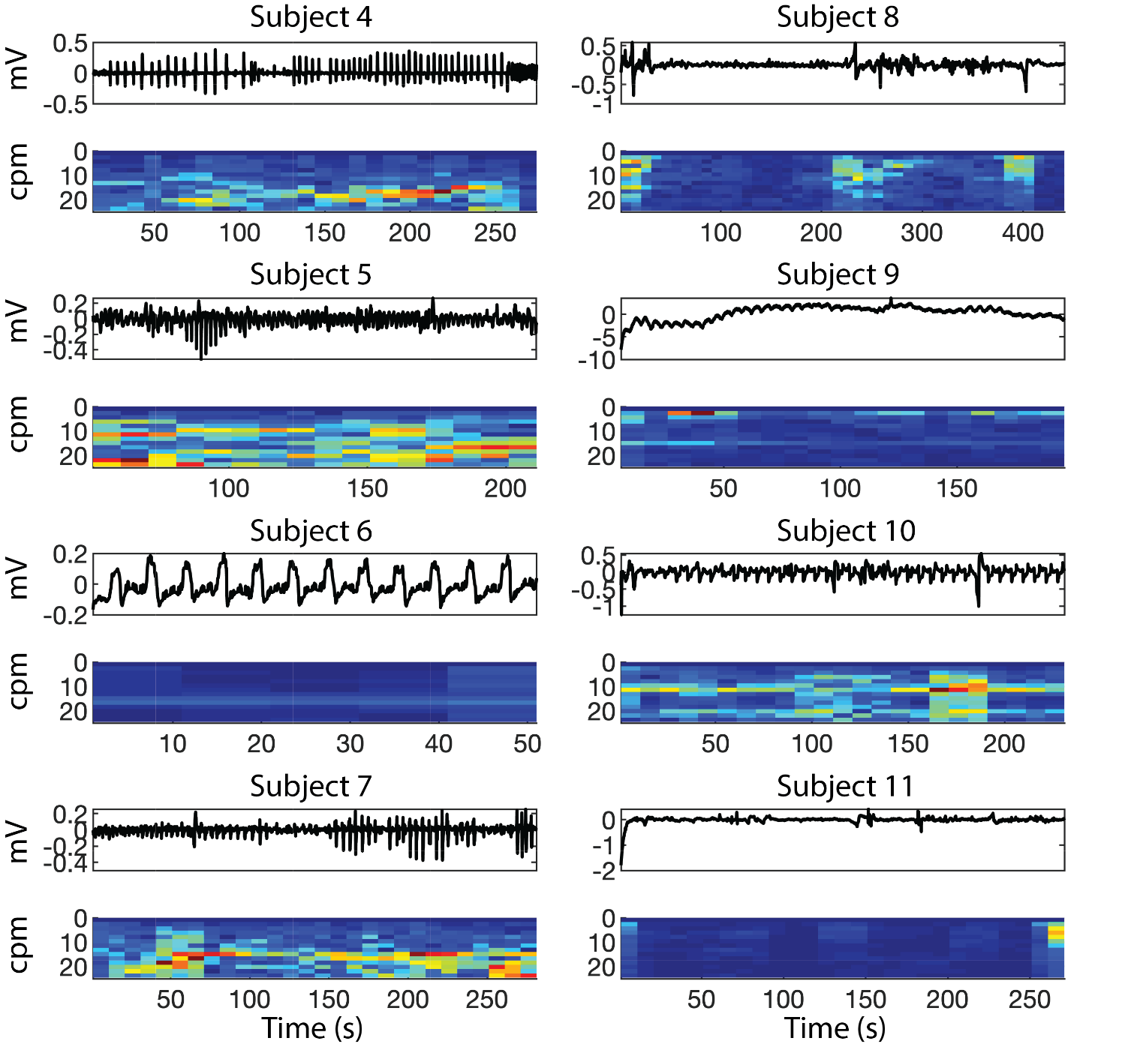

Figure S1: Patient 7 with 15 cpm, irregular activity with variable propagation and slow recovery phase after each initial depolarisation. This was seen in 5-channels over a period of <20 s.

Appendix 2: Artefacts
Recordings of other physiological data were obtained at times, including ventilator and cardiac parameters, according to the descriptors of Paskaranandavadivel et al. (43,48). The frequencies of these activities were consistent with the physiological range recorded on the anaesthetic monitor. Figure S2 shows several examples of these activities.
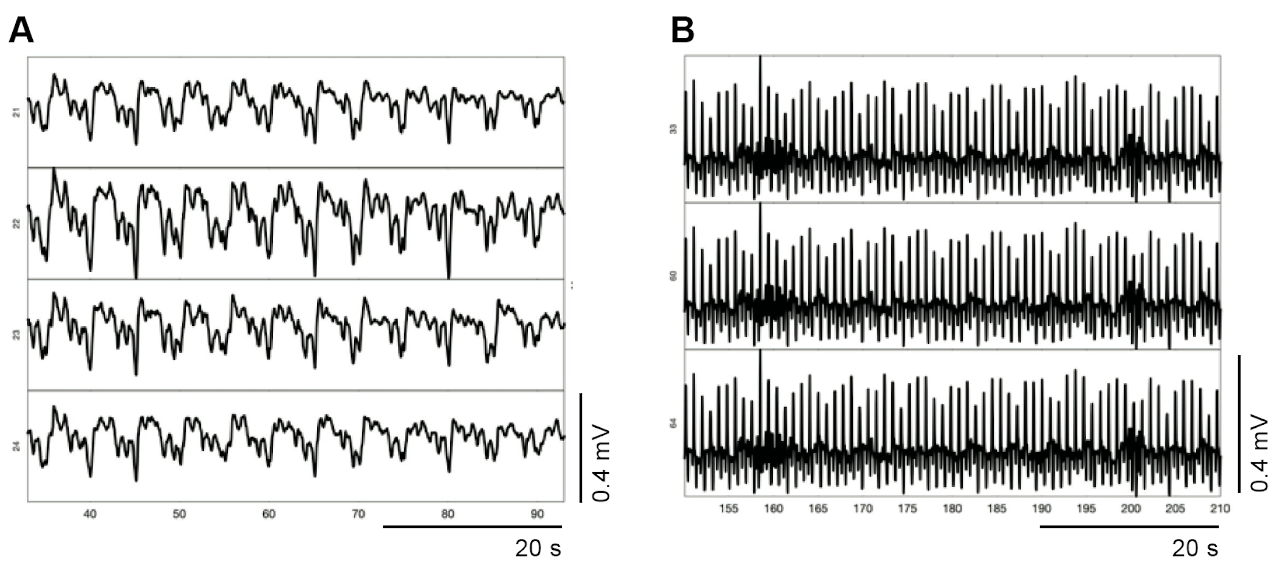
Figure S2: Artefacts obtained on recordings. (A) Ventilator artefacts. (B) Cardiac activity.

