Supplementary Materials

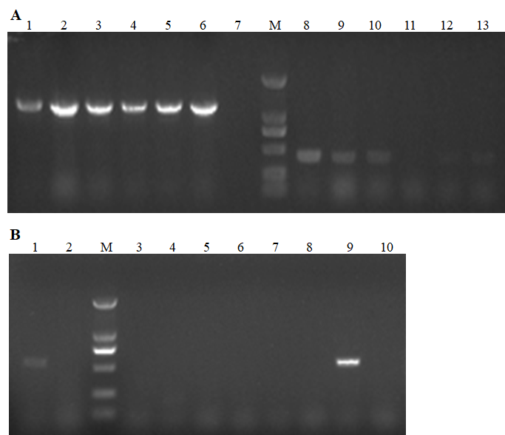
Supplementary Figure 1: Nucleic acid gel electrophoresis of specific PCR products. (A) ITS2 (~1200 bp) and16S rRNA (~450 bp) of ticks. 1-6 and 8-13, tick genome as PCR templates; 7, negative control. (B) 16S rRNA (~555 bp) of Ehrlichia spp. 1 and 2, cDNA of tick samples as PCR templates. M, DNA ladder.

