Supplementary Figures
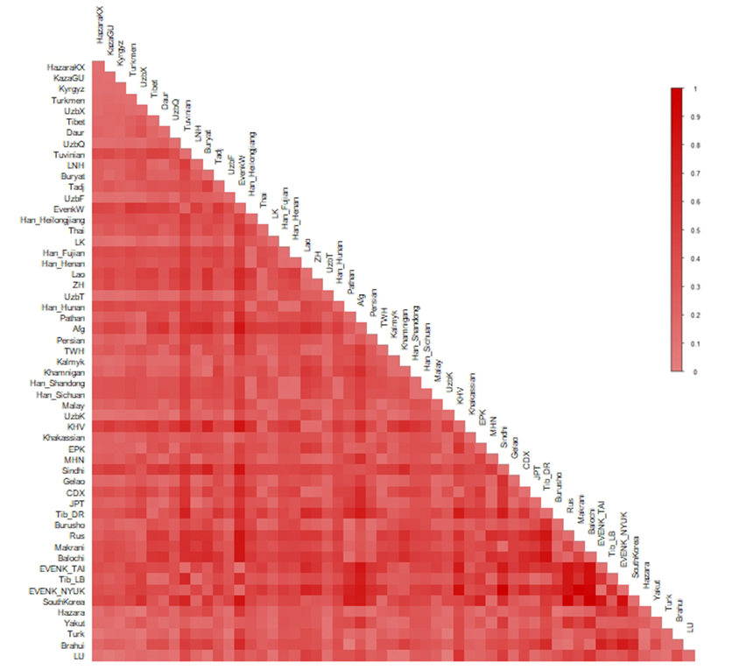

Figure S1. Heat map of pairwise Fst values based on mtDNA partial sequence (16024-16383) variations for 55 populations. Note: full names of the populations are described in Supplementary Table S3.

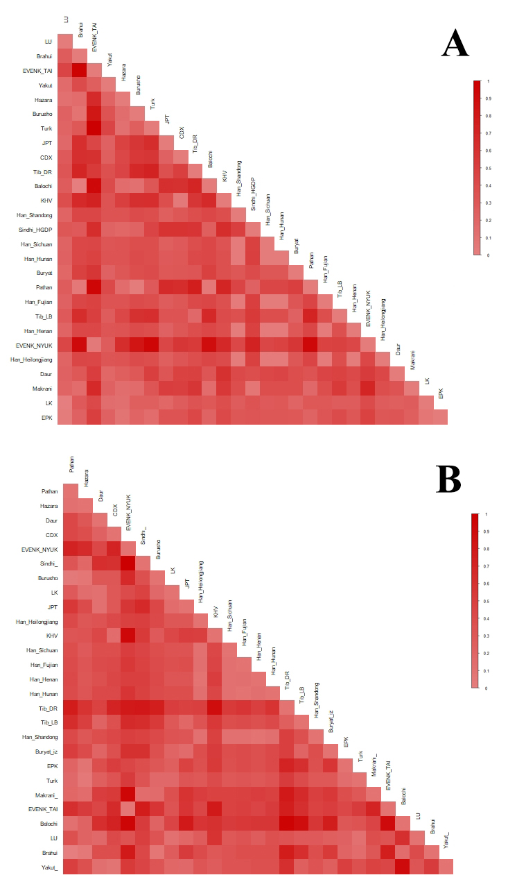

Figure S2. Heat map of pairwise Fst values based on whole mtDNA sequences (A) and the HVS1 sequences taken from the whole mtDNA sequences (B). Note: full names of the populations are described in Supplementary Table S3.

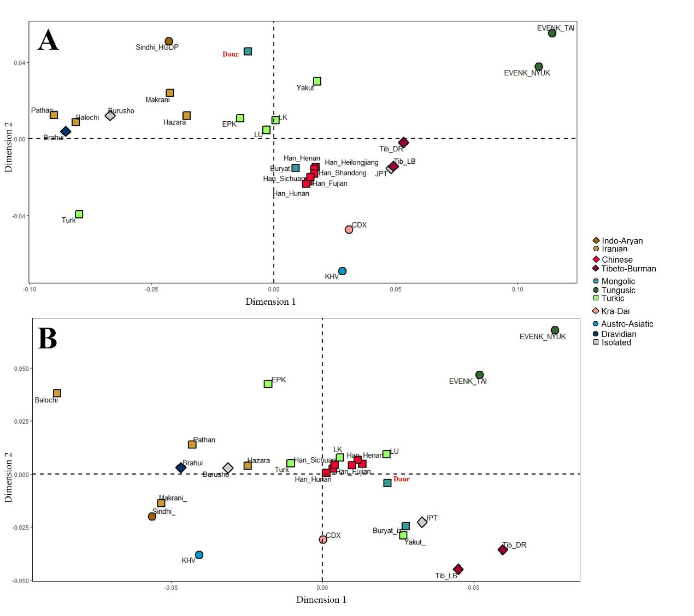

Figure S3. MDS plot constructed based on whole mtDNA sequences (A) and HVS1 sequences taken from the whole mtDNA sequences (B). Note: full names of the populations are described in Supplementary Table S3.

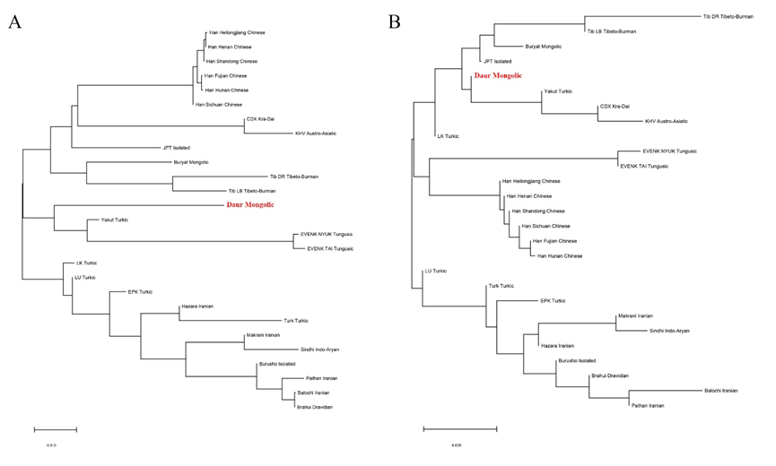

Figure S4. Phylogenetic tree built with neighbor-joining methods based on whole mtDNA sequences (A) and HVS1 sequences taken from the whole mtDNA sequences (B). Note: full names of the population are described in Supplementary Table S3.

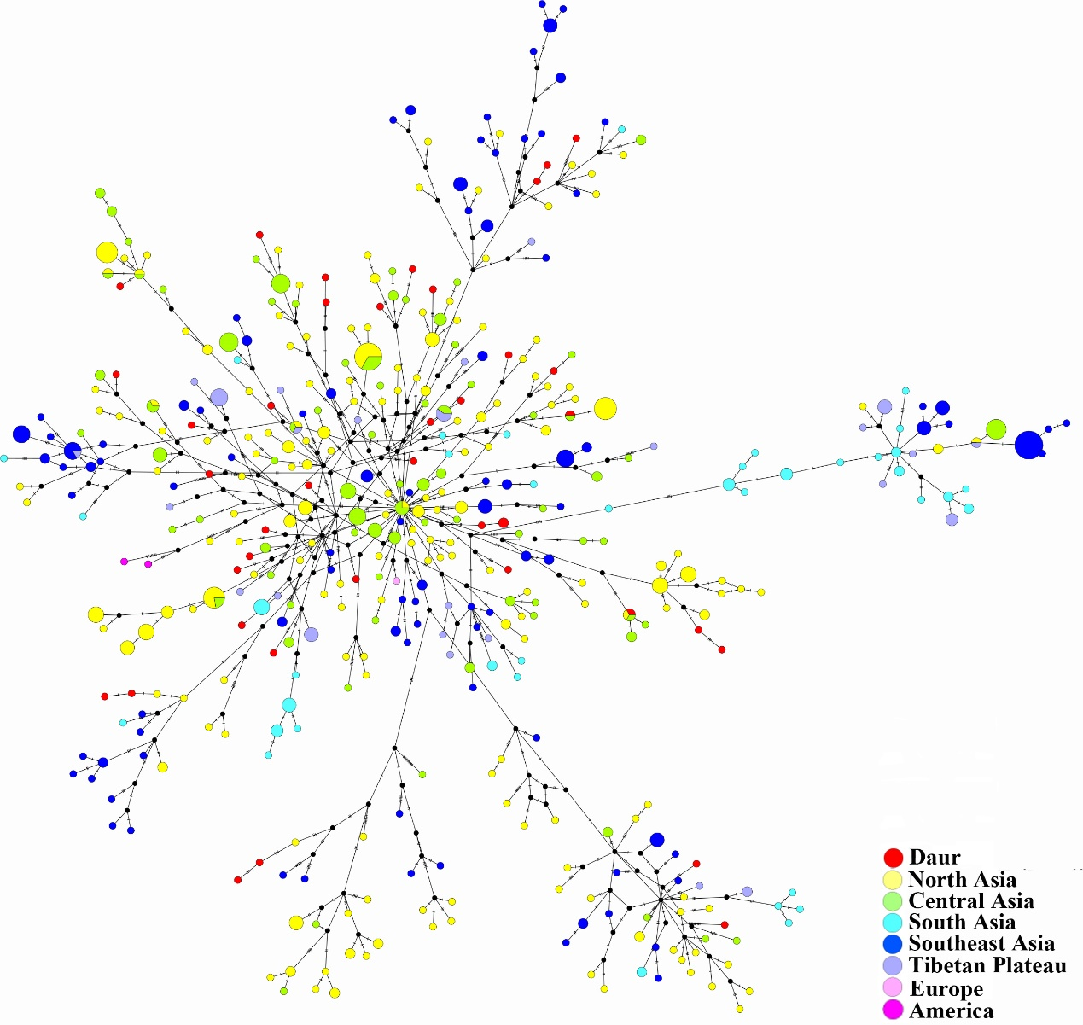

Figure S5. Median-joining haplogroup D4 networks (present groups).

