**Supplementary Information**

**Membrane depolarization kills dormant *Bacillus subtilis* cells by generating a lethal dose of ROS**

Declan A. Gray, Biwen Wang, Pamela Gamba, Henrik Strahl, Leendert W. Hamoen

Table of content

* Table S1. Strains used in this study
* Table S2. Plasmids used in this study
* Table S3. Primers used in this study
* Table S4. Minimum inhibitory concentration of *B subtilis* PG344 for 4 antibiotics
* Fig. S1. Membrane depolarization of *B. subtilis* cells in the exponential or stationary phase
* Fig. S2. Large field fluorescence images of stationary phase cells expression cytochrome bc1 and cytochrome-c oxidase subunits and cytochrome c550 fused to GFP
* Fig. S3. Large field fluorescence images of exponential phase cells expression cytochrome bc1 and cytochrome-c oxidase subunits and cytochrome c550 fused to GFP
* Fig. S4. Killing of stationary phase *S. aureus* cells by valinomycin
* References

**Table S1. Strains used in this study**

|  |  |  |
| --- | --- | --- |
| **Strain** | **Genotype** | **Source or reference** |
| 2682 | *recA::tet* | Lab strain |
| 1A1299 | *Δskin, Δprophage1, Δprophage3, ΔSPbeta, ΔPBSX, pks::Cm, ICEBs1(0)* | BGSC |
| BKE01830 | *ndhF::erm* | BGSC |
| BKE08820 | *katA::erm* | BGSC |
| BKE09300 | *glpD::erm* | BGSC |
| BKE14590 | *pdhB::erm* | BGSC |
| BKE14890 | *ctaC::erm* | BGSC |
| BKE14900 | *ctaD::erm* | BGSC |
| BKE14910 | *ctaE::erm* | BGSC |
| BKE14920 | *ctaF::erm* | BGSC |
| BKE17930 | *ccdA::erm* | BGSC |
| BKE19330 | *sodF::erm* | BGSC |
| BKE19400 | *sodC::erm* | BGSC |
| BKE22540 | *qcrC::erm* | BGSC |
| BKE22550 | *qcrB::erm* | BGSC |
| BKE22560 | *qcrA::erm* | BGSC |
| BKE23150 | *resA::erm* | BGSC |
| BKE25020 | *sodA::erm* | BGSC |
| BKE25190 | *cccA::erm* | BGSC |
| BKE28450 | *sdhC::erm* | BGSC |
| BKE35270 | *cccB::erm* | BGSC |
| BKE38760 | *cydA::erm* | BGSC |
| BSB1 | *trp+* | Lab strain |
| BWB03 | *spoIIE::spec, cccA::erm* | This work |
| BWB04 | *spoIIE::spec, cccB::erm* | This work |
| BWB76 | *spoIIE::erm, amyE::Pxyl-gfp-qcrA-spec* | This work |
| BWB77 | *spoIIE::erm, amyE::Pxyl-gfp-qcrB-spec* | This work |
| BWB78 | *spoIIE::erm, amyE::Pxyl-gfp-qcrC-spec* | This work |
| BWB79 | *spoIIE::erm, amyE::Pxyl-gfp-cccA-spec* | This work |
| BWB80 | *spoIIE::erm, amyE::Pxyl-gfp-ctaC-spec* | This work |
| BWB81 | *spoIIE::erm, amyE::Pxyl-gfp- ctaD-spec* | This work |
| BWB92 | *spoIIE::erm, qcrBC::kan* | This work |
| BWB93 | *spoIIE::erm, qcrABC::kan* | This work |
| BWB96 | *ΔspoIIE, recA::erm, qcrA::kan* | This work |
| DG001 | *spoIIE::erm, divIVA-gfp* | 1 |
| DG003 | *Δskin, Δprophage1, Δprophage3, ΔSPbeta, ΔPBSX, pks::Cm, ICEBs1(0), spoIIE::erm* | This work |
| DG010 | *spoIIE::erm, recA::tet* | This work |
| DG022 | *lytABC::neo, lytD::tet, lytE::chl, lytF::spc, spoIIE::erm* | This work |
| DG025 | *spoIIE::erm, spx::kan* | This work |
| DG037 | *spoIIE::erm, ΔsodA* | This work |
| DG038 | *spoIIE::erm, ΔsodC* | This work |
| DG042 | *spoIIE::erm, ΔsodF* | This work |
| DG051 | *spoIIE::erm, ΔkatA* | This work |
| DG082 | *spoIIE::spec, glpD::erm* | This work |
| DG102 | *spoIIE::spec, pdhB::erm* | This work |
| DG103 | *spoIIE::spec, sdhC::erm* | This work |
| DG106 | *spoIIE::spec, qcrA::erm* | This work |
| DG110 | *spoIIE::spec, qcrB::erm* | This work |
| DG111 | *spoIIE::spec, cydA::erm* | This work |
| DG112 | *spoIIE::spec, ctaE::erm* | This work |
| DG113 | *spoIIE::spec, ccdA::erm* | This work |
| DG115 | *spoIIE::spec, resA::erm* | This work |
| DG116 | *spoIIE::spec, ctaC::erm* | This work |
| DG117 | *spoIIE::spec, ctaF::erm* | This work |
| DG118 | *spoIIE::spec, ctaD::erm* | This work |
| DG119 | *spoIIE::spec, qcrC::erm* | This work |
| DG120 | *ndh::erm, spoIIE::spec* | This work |
| DGYK1460 | *spoIIE::erm, divIVA-gfp, ctaB::tn-kan* | This work |
| DGYK1461 | *spoIIE::erm, divIVA-gfp::chl, yjlD(ndh)::tn-kan* | This work |
| DGYK1462 | *spoIIE::erm, divIVA-gfp::chl, qoxB::tn-kan* | This work |
| PG344 | *spoIIE::erm* | 1 |
| PG344_2 | *spoIIE::spec* | 1 |
| SH1000 | *Staphylococcus aureus wildtype Newman* | 2 |
| SH1000 ∆sodA | *S. aureus, sodA::erm* | 2 |
| SH1000 ∆sodAM | *S. aureus, sodA::erm, sodM::tet* | 2 |
| SH1000 ∆sodM | *S. aureus, sodM::tet* | 2 |
| YK1461 | *yjlD(ndh)::tn-kan* | 3 |
| YK1462 | *qoxB::tn-kan* | 3 |
| Δspx | *spx::kan* | Lab strain |

**Table S2. Plasmids used in this study.**

|  |  |  |
| --- | --- | --- |
| **Plasmid** | **Genotype** | **Source or reference** |
| pBW6 | *amyE::(Pxyl-msfgfp-qcrC-spec)* | This work |
| pDR244 | *cre, spec, amp* | BGSC |
| pErm::Spec | *erm::spec* | 4 |
| pHJS105 | *amyE::(Pxyl-mSFgfpV206K spec)* | 5 |
| pLB2 | *amyE::(Pxyl-msfgfp-qcrA-spec)* | This work |
| pLB4 | *amyE::(Pxyl-msfgfp-ctaD-spec)* | This work |
| pLB6 | *amyE::(Pxyl-msfgfp-ctaC-spec)* | This work |
| pLB8 | *amyE::(Pxyl-msfgfp-qcrB-spec)* | This work |

**Table S3. Primers used in this study.**

|  |  |  |
| --- | --- | --- |
| Primer | *Sequence 5’—3’* | Gene |
| BW_100 | TTAACAAAATTCTCCAGTCTTCA | Rv-amyE5' |
| BW_104 | TCACATTTATATTGTGCAACACTTCACAAA | Fw-amyE3' |
| BW_105 | TGACCCTCCAGAGCCACCTTTGTAGAGCTCATCCATGCCATGT | Fw-sfGFP3 |
| BW_106 | GGTGGCTCTGGAGGGTCAAAATCAAAGTTATCGATACTAATGAT | Fw-cccB |
| BW_107 | TGGATCCGAAGTCTGGACATTTTttaCTTTTTTTCTGACAGCCATTT | Rv-cccB |
| BW_241 | CTAAAACAATTCATCCAGTAAAATAT | Rv-Km |
| BW_242 | TAAAGAGAATGTCATGACTACC | Fw-qcrAupstream |
| BW_245 | TTTTGTGTGTCTGATGTATCAG | Rv-qcrBCdownstream |
| BW_247 | TCCGGTGATATTCTCATTTTAGCCATCTCTTCTCCCCCCTCTAA | Rv-qcrAupstream |
| BW_299 | TAAAATATTATATTTTACTGGATGAATTGTTTTAGCGTATTGTGAATTGTCAAATGG | Fw-qcrBCdownstream |
| BW_303 | ACATAGTATCGACGGAGCCGATTGTCACCCTTCCCCCTTAG | Rv-qcrAupstream2 |
| BW_313 | CTTTGCTTTTCCAAGATACAG | Rv-qcrAinternal |
| BW_314 | CAATTTTTGAATTATACGCTCAC | Fw-qcrAinternal |
| BW_61 | AAAATGTCCAGACTTCGGA | Fw-amyE5' |
| BW_64 | AAAATGTCCAGACTTCGGATCCACatgCACCGGGGCAAAGGGAT | Fw-qcrC |
| BW_65 | ATCAAGCTTATCGATACCGTCGACttaTTTTGCGGTTGTTTCAGAAAT | Rv-qcrC |
| BW_66 | TGTCCAGACTTCGGATCCACATGGGCGGAAAACATGATAT | Fw-qcrA |
| BW_67 | ATCAAGCTTATCGATACCGTCGACTCACCCTTCCCCCTTAGGCT | Rv-qcrA |
| BW_72 | AAAATGTCCAGACTTCGGATCCACATGTTGAATGCGCTTACAGA | Fw-ctaD |
| BW_73 | ATCAAGCTTATCGATACCGTCGACTTATGCCTTCACCCCTTTAT | Rv-ctaD |
| BW_86 | ATGTCCAGACTTCGGATCCACATGGTAAAGCATTGGCGTC | Fw-ctaC |
| BW_87 | GATCCGAAGTCTGGACATTTTCTACTTGCTTTCCGC | Rv-ctaC |
| BW_90 | GGCTCCGGAAGTGGCTCTCTGAACAAAATTTATGAC | Fw-qcrB |
| BW_91 | CGAAGTCTGGACATTTTTTTAAAGCGGTCCTGAAATCCC | Rv-qcrB |
| BW_92 | ACTTCCGGAGCCGCTACCTTTGTAGAGCTCATCCAT | Rv-sfGFP2 |
| BW_97 | TGACCCTCCAGAGCCACCTTTGTAGAGCTCATCCATGC | Rv-sfGFP3 |
| BW_98 | GGTGGCTCTGGAGGGTCAAAATGGAACCCGCTTATTCC | Fw-cccA |
| BW_99 | TGGATCCGAAGTCTGGACATTTTttaTTTAATTTTTGACACCCACT | Rv-cccA |
| EKP22 | GTCGACGGTATCGATAAGCTTGAT | Fw-sfGFP |
| EKP30 | GTGGATCCGAAGTCTGGACATTTT | Rv-sfGFP |
| MW245 | AAAATGTCCAGACTTCGGATC | Fw-sfGFP2 |
| Ters158 | TCACATTTATATTGTGCAACACT | Rv-amyE3' |
| Ters350 | CACCGCCGACATTCGCGTGGCTCCA | Rv-amyEDown |
| Ters351 | GCATCAGGGCTGCGGCATCCGGA | Fw-amyEUp |
| ZT202 | AATCGGCTCCGTCGATACTATG | Fw-Km |

**Table S4. Minimum inhibitory concentration (MIC) of *B. subtilis* PG344 for 4 antibiotics.**

|  |  |  |
| --- | --- | --- |
| **Antibiotics** | **MIC** | **Funtional Target** |
| Vancomycin | 2 µg/mL | cell wall synthesis |
| Ciprofloxacin | 0.2 µg/mL | DNA synthesis |
| Kanamycin | 1 µg/mL | protein synthesis |
| Valinomycin | 10 µM | membrane potential dissipation |

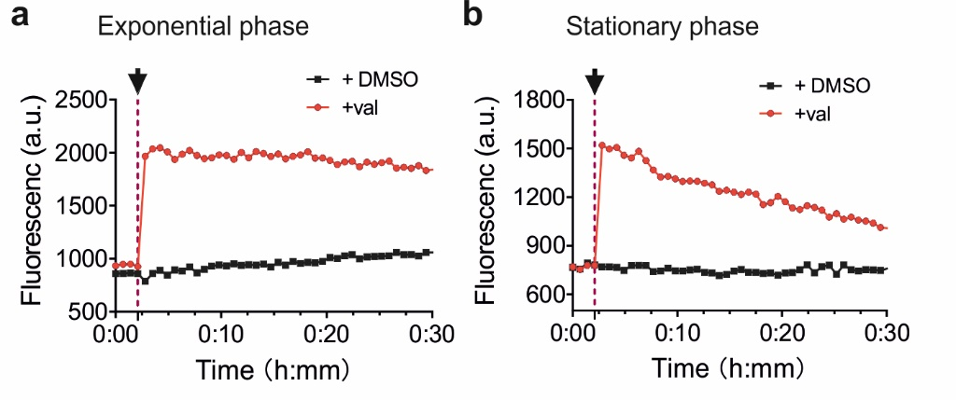

**Fig. S1. Membrane depolarization of *B. subtilis* cells in the exponential or stationary phase.**

The membrane potential was measured using the membrane potential-sensitive fluorescent probe DiSC3(5). Cells from either an exponentially growing (**a**) or stationary phase culture (**b**) were incubated in microtiter plates and when the baseline was stable either 10 µM valinomycin (val) or 1 % DMSO was added to the cells. The arrow indicates the time point of valinomycin or DMSO addition. Of note, we used a ten-times lower valinomycin concentration in this assay compared with the concentration used in the experiments because at high concentrations valinomycin affects the fluorescence of DiSC3(5).

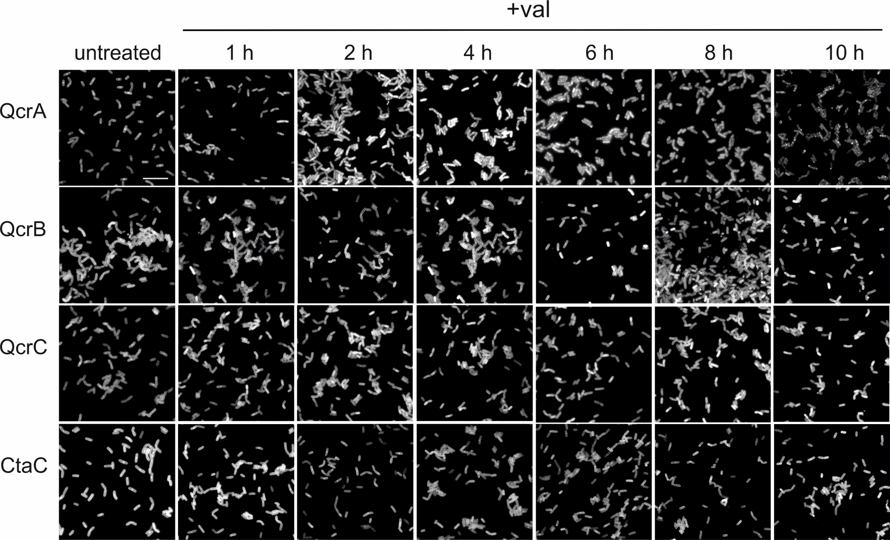

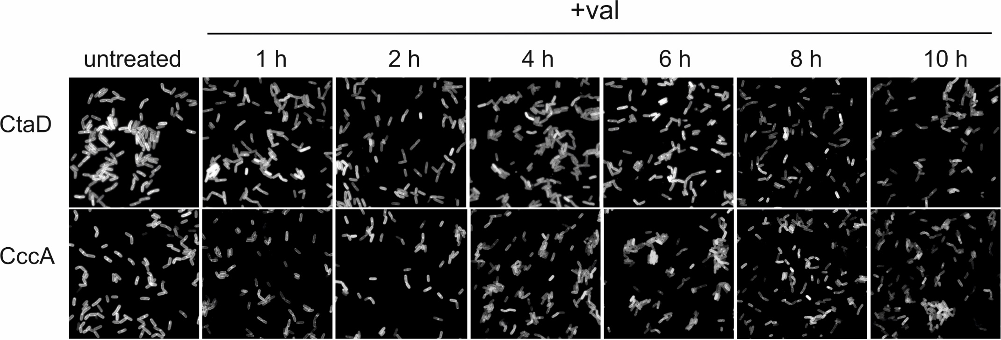

**Fig. S2. Large field fluorescence images of stationary phase cells expression cytochrome bc1 and cytochrome-c oxidase subunits and cytochrome c550 fused to GFP.**

Cellular localization of GFP tagged cytochrome bc1 subunits QcrA (Rieske protein), QcrB and QcrC, cytochrome-c oxidase subunits CtaC and CtaD, and cytochrome c550 in stationary phase cells incubated with 100 μM valinomycin (+ val) for up to 10 h. Scale bar represents 10 μm. This figure is related to Fig. 6A in the main text.

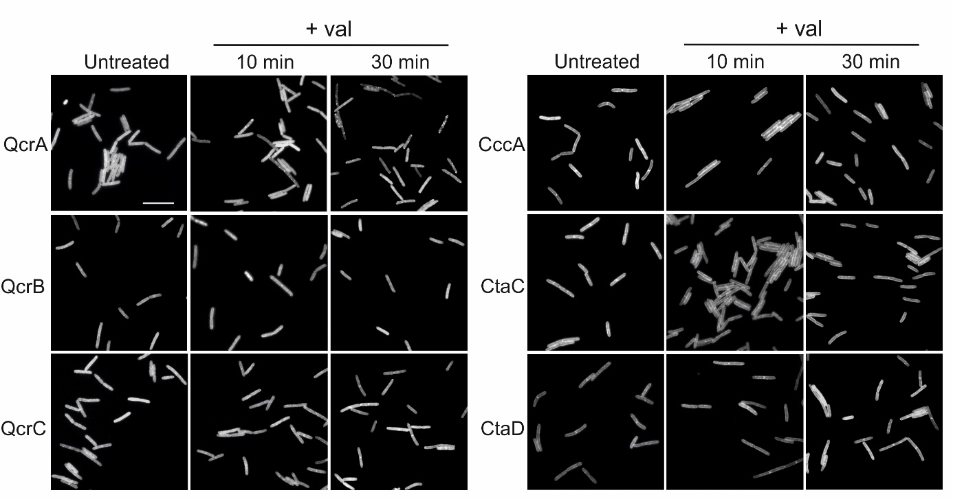

**Fig. S3. Large field fluorescence images of exponential phase cells expression cytochrome bc1 and cytochrome-c oxidase subunits and cytochrome c550 fused to GFP.**

Cellular localization of GFP-tagged cytochrome bc1 subunits QcrA (Rieske protein), QcrB and QcrC, cytochrome-c oxidase subunits CtaC and CtaD, and cytochrome c550 in exponentially growing cells incubated with 100 μM valinomycin (+ val) for up to 30 min. Scale bar represents 10 μm. This figure is related to Fig. 6B in the main text.



**Fig. S4. Killing of stationary phase *S. aureus* cells by valinomycin.**

Survival curves of stationary phase *S. aureus* wild type cells (*wt*) and the *S. aureus* superoxide dismutase mutants Δ*sodA*, Δ*sodM* and double mutant Δ*sodAM* when incubated with 100 µM valinomycin (val). 1 % DMSO was used as negative control. The survival curves of the superoxide dismutase mutants with DMSO were similar to that of the wild type strain and not shown here. Data shown reflect mean ± SD of three biological replicates.

**Reference**

1. Gray, D. A. *et al.* Extreme slow growth as alternative strategy to survive deep starvation in bacteria. *Nat. Commun.* **10**, (2019).

2. Tarrant, E. *et al.* Copper stress in Staphylococcus aureus leads to adaptive changes in central carbon metabolism. *Metallomics* **11**, 183–200 (2019).

3. Kawai, Y. *et al.* Cell Growth of Wall-Free L-Form Bacteria Is Limited by Oxidative Damage. *Curr. Biol.* (2015).

4. Steinmetz, M. & Richter, R. Plasmids designed to alter the antibiotic resistance expressed by insertion mutations in Bacillus subtilis, through in vivo recombination. *Gene* **142**, 79–83 (1994).

5. Gamba, P., Jonker, M. J. & Hamoen, L. W. A Novel Feedback Loop That Controls Bimodal Expression of Genetic Competence. *PLoS Genet.* (2015).