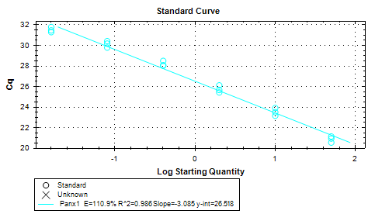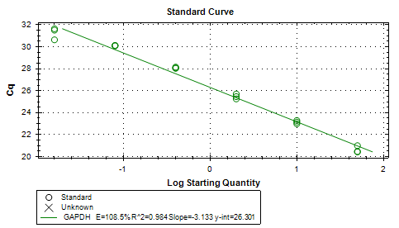
Figure S1. Amplification efficiency standard curve of target gene Panx1 and GAPDH

