Supplementary Table 1 The primers used for yeast two-hybrid assays (AD and BD).
Gene | Forward primers | Reverse primers
GmPIP1;2 | cgCCATGGcaATGGAGGGAAGAGATGAGGATG | cGGAATTTCATTTTGACTTGAAAGGAATGGCCCT
GmPIP1;3 | cgCCATGGcaATGGAGAGGGAGGAAGATGT | cGGAATTCTCAACCCCTTGTCTTGAAAGGAA
GmPIP1;4 | cgCCATGGcaATGGAGAGGGAGGAAGATGT | cGGAATTCTCAACCCCTTGTCTTGAATGGAATT
GmPIP1;5 | cgCCATGGcaATGGAGAGCAAAGAGGAAGATGT | cGGAATTCTCAAGCCCTTGTCTTGAAAGGGA
GmPIP1;6 | cgCCATGGcaATGGAGAGTAAAGAGGAAGAT | cGGAATTCTCAAGCCCTTGTCTTGAAAGGA
GmPIP1;7 | cgCCATGGcaATGGAGGGGAAGGAGCAGGAT | cGGAATTCTCACTTGGACTTGAAGGGAAT
GmPIP1;8 | cgCCATGGcaATGGAGGGAAAAGAGGAAGAT | cGGAATTCTCAACTGGATTTGAAGGGAAT
GmPIP2;2 | cgCCATGGcaATGTCGAAGGAAGTGAGCCAAGA | cGGAATTCTCAGTTGGTAGGGTTGCTCCTGA
GmPIP2;4 | cgCCATGGcaATGGCTAAAGATGTTGAGGT | cGGAATTCTCAAGCGTTGCTCCTGAAGGATCCA
GmPIP2;6 | cgCCATGGcaATGGCGAAAGACGTTGAGCAG | cGGAATTCTCAAGCGTTGCTCCTGAAGGATCCA
GmPIP2;8 | cgCCATGGcaATGGCCAAAGACCTCGAAACG | cGGAATTCTCACAGGTTTGAGGAGCTCCTGA
GmPIP2;9 | cgCCATGGcaATGGCTAAGCATGATGTTGA | cGGAATTCTCAAATAGTGGGGTTGCTCCTGA
GmPIP2;11 | cgCCATGGcaATGGCTAAGCATGATGTTGAG | cGGAATTCTCAAATAGCGGGGTTGCTCCTGAAT
GmPIP2;13 | cgCCATGGcaATGAGCGTGTTTTGGCAGGA | cGGAATTCTCAATTATGGGGGTTACTCCTGAATGA

Supplementary Table 2 The primers used for qRT-PCR.
Gene | Forward primers | Reverse primers
GmPIP1;1 | GAGGGAAAAGAAGAGGAC | CTTCGACGAGAAGGGGATG
GmPIP1;2 | GAGGGAAGAGATGAGGATG | ACTTGAAAGGAATGGCCCT
GmPIP1;3 | GAGAGGGAGGAAGATGT | CCTTGTCTTGAAAGGAAT
GmPIP1;4 | GAGAGGGAGGAAGATGT | CCTTGTCTTGAATGGAATTG
GmPIP1;5 | GAGAGCAAAGAGGAAGATGT | CACAAAATTGGCTCCACCT
GmPIP1;6 | GAGTAAAGAGGAAGAT | CCTTGTCTTGAAAGGAA
GmPIP1;7 | GAGGGGAAGGAGCAGGAT | GGACTTGAAGGGAATGG
GmPIP1;8 | GAGGGAAAAGAGGAAGAT | GGATTTGAAGGGAATGG
GmPIP2;1 | TCGAAGGAAGTGAGCCAGCA | TGGTAGGGTTGCTCCTGA
GmPIP2;2 | TCGAAGGAAGTGAGCCAAGA | GGTAGGGTTGCTCCTGA
GmPIP2;3 | GCTAAAGATGTTGAGGT | CGTTGCTTCTGAAGGATCCA
GmPIP2;4 | GCTAAAGATGTTGAGGT | GCGTTGCTCCTGAAGGATCCA
GmPIP2;5 | GCCAAAGACGTTGAGCA | AGTGTTGCTCCTGAATGATC
GmPIP2;6 | GCGAAAGACGTTGAGCAG | AGCGTTGCTCCTGAAGGATCCA
GmPIP2;7 | GCGAAAGACATCGAAACT | CAGGTTTGAGGAGCTCCTGA
GmPIP2;8 | GCCAAAGACCTCGAAACG | CAGGTTTGAGGAGCTCCTGA
GmPIP2;9 | GCTAAGCATGATGTTGA | AATAGTGGGGTTGCTCCTGA
GmPIP2;10 | GCTAAGCATGATGTTGAG | AATAGCGGGGTTGCTCCTGAAT
GmPIP2;11 | TAAGCATGATGTTGAG | CGGGGTTGCTCCTGAAT
GmPIP2;13 | AGCGTGTTTTGGCAGGA | TTATGGGGGTTACTCCTGAATGA
GmPIP2;14  GmTUBB3  GmActin | GCGAAGGACGTTGAGGTT  GGAGGGTGAGTGAGCAGTTC  CGGTGGTTCTATCTTGGCATC | ATTATGGGGGTTACTCCTGAA  GCCGCATAACATTGTTCCCA  GTCTTTCGCTTCAATAACCCTA

Supplementary Figure 1: Multiple alignment of soybean GmPIP1 type and GmPIP2 type aquaporins using Clustal X. GmPIP1s had longer N-terminal ends and GmPIP2s had longer C-terminal ends. All the GmPIPs contained six transmembrane domains (rectangles) and two conserved NPA motifs (red circles).

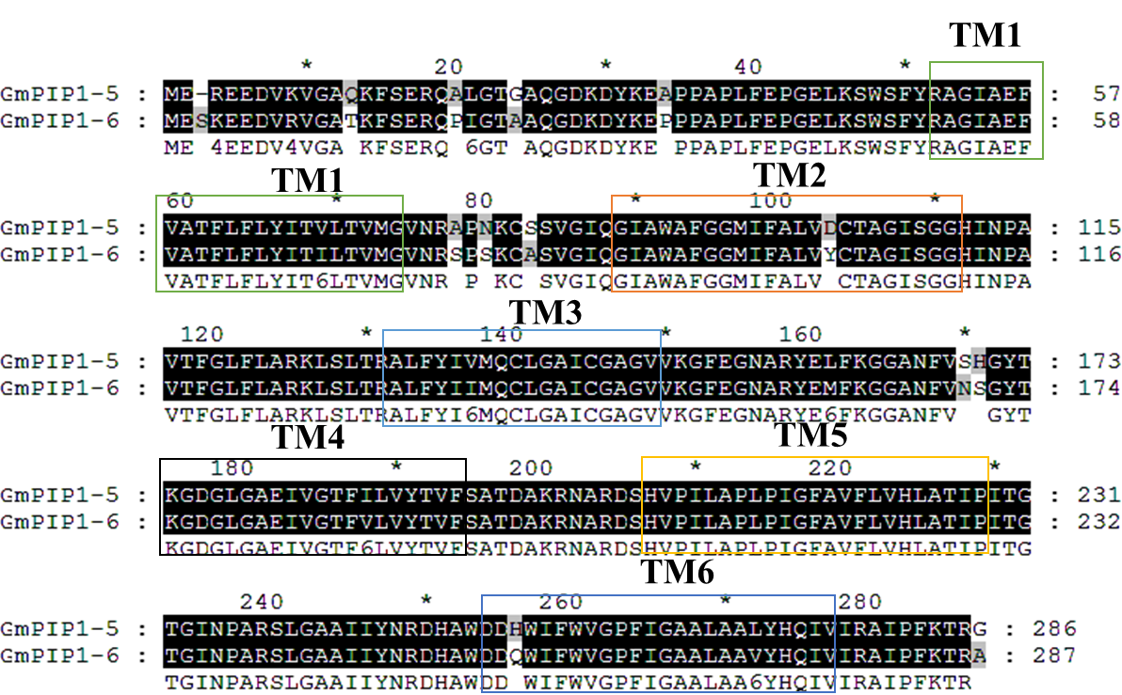
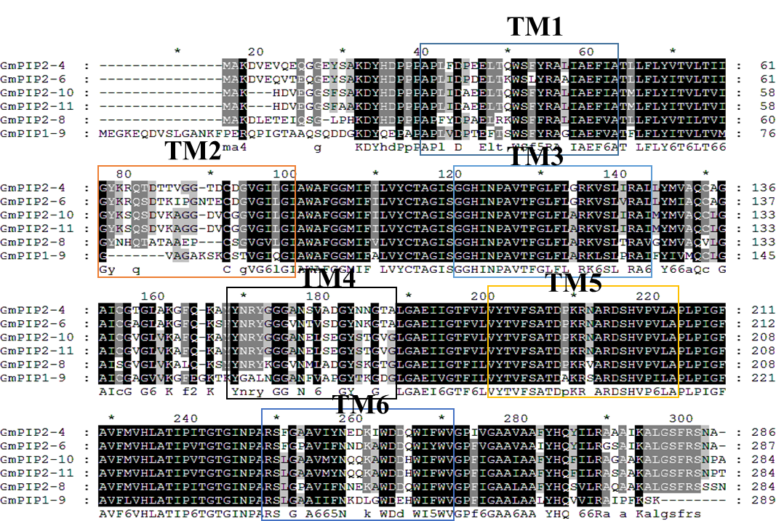
Supplementary Figure 2: The phylogenetic tree of GmPIPs.

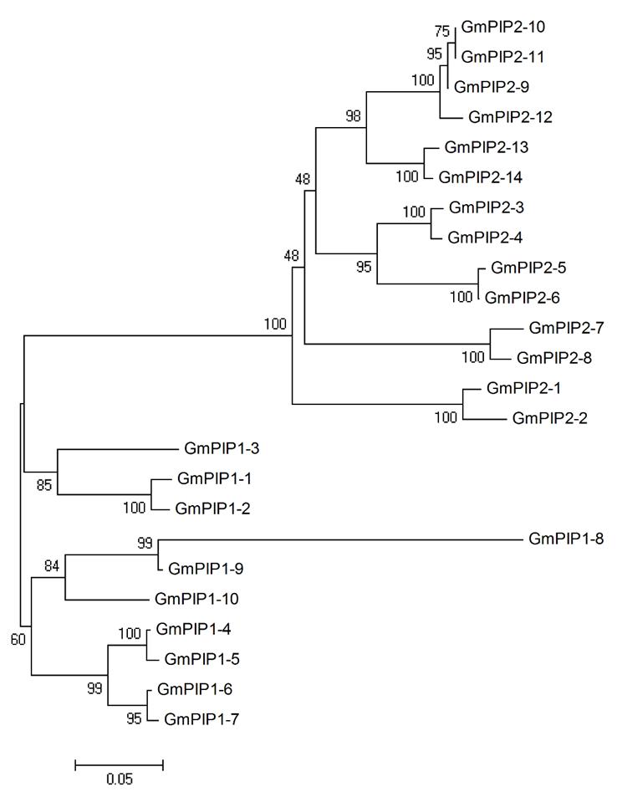
Supplementary Figure 3: The phylogenetic tree of GmPIPs, AtPIPs and OsPIPs.

