Additional File 1
Temperature | Duration
12C | 60min
18C | 45min
24C | 45min
28C | 45min
30C | 45min
32C | 30min
34C | 30min
36C | 30min
Supplemental Table 1. Analysis of Thermoneutral Zone. Timing (right) and parameters (left) for TNZ assessment.
Outcome | Baseline | CL | TNZ
Rm temp | 22°C | 22°C | see table at right
Duration | ~72 hr | ~1hr | see table at right
Start | Fri AM | ~10:00-14:00 | ~6:30
Stop | Mon AM | ~11:00- 15:00 | ~12:30
food status | free | ~3hr from start | At start of TNZ
interval CLAMS | 12min | 5s | 5s

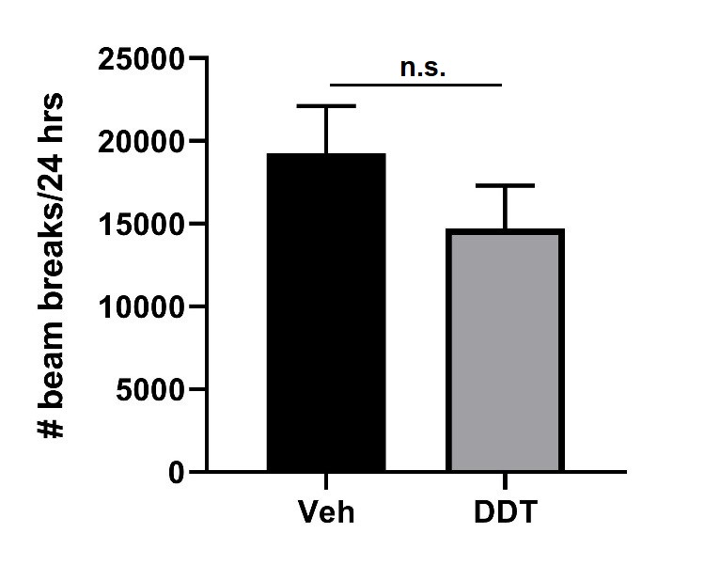
Supplemental Figure 1. Perinatal DDT does not alter physical activity in 4 month old female mice. Locomotor activity measured as number of beam breaks over 24 h during indirect calorimetry. Data are expressed as mean SEM; n= mice per treatment group. Statistical analysis performed using unpaired t-test with Welch’s correction. DDT, dichlorodiphenyltrichloroethane.

