Supplemental data
- Sup-Figure 1
Analysis of whole gene expression profiling in rat hepatocarcinogenesis

Dynamic models of liver carcinogenesis in SD rats were successfully established and alterations of whole genes were detected by gene expression profiling analysis. Microarray analysis of total 28,000 gene expression in rat HCC tissues (Left) and the scatter plot of gene alterations (Right) between rHCC and control liver tissues are shown in Sup-Figure 1. Left: the false color image of rat HCC tissues. Right: the scatter plot between rat HCC tissue and control liver tissue.

- Alterations of gene expressions in rat hepatocarcinogensis
The total numbers of many genes with up- or down-regulation during malignant transformation of rat hepatocytes are summaried in Sup-Table 1. These altered genes involved so many related-genes such as cell proliferation, signal transduction, tumor metastasis, and cell apoptosis, also, including up-regulating HIF-1α, VEGF and Ang-2.

Sup-Table 1
Comparative analysis of whole gene expression in rat hepatocarcinogensis
Up-regulation genes * Down-regulation genes*
Group ---------------------------------- -------------------------------------
≥ 8 ≥ 2 ≥ 8 ≥ 2
Pre-C vs rHCC 132 1269 116 629
Pre-C vs NC 268 1179 57 767
rHCC vs NC 312 1371 201 1355
*SLR (signal logarithm ratio, log₂^{cy5/cy3}）fold. NC, normal control liver; Pre-C, precancerous lesions, and rHCC, rat HCC.

- Sup-Figure 2
Analysis of HIF-1α expression in rat hepatocarcinogensis by IHC
The statues of liver HIF-1α expressions in rats were analyzed by immunohistochemical assay (IHC) from normal control (A. NC) liver to granulose degeneration (B. Deg) at early stage, precancerous lesions (C. Pre-C) at middle stage, and rat HCC (D. rHCC) formation at later stage. Hepatic HIF-1αwith increasing expressions were confirmed form weak at early stage (B) to stronger at Pre-C stage (C) to strongest expression at rHCC formation (D).

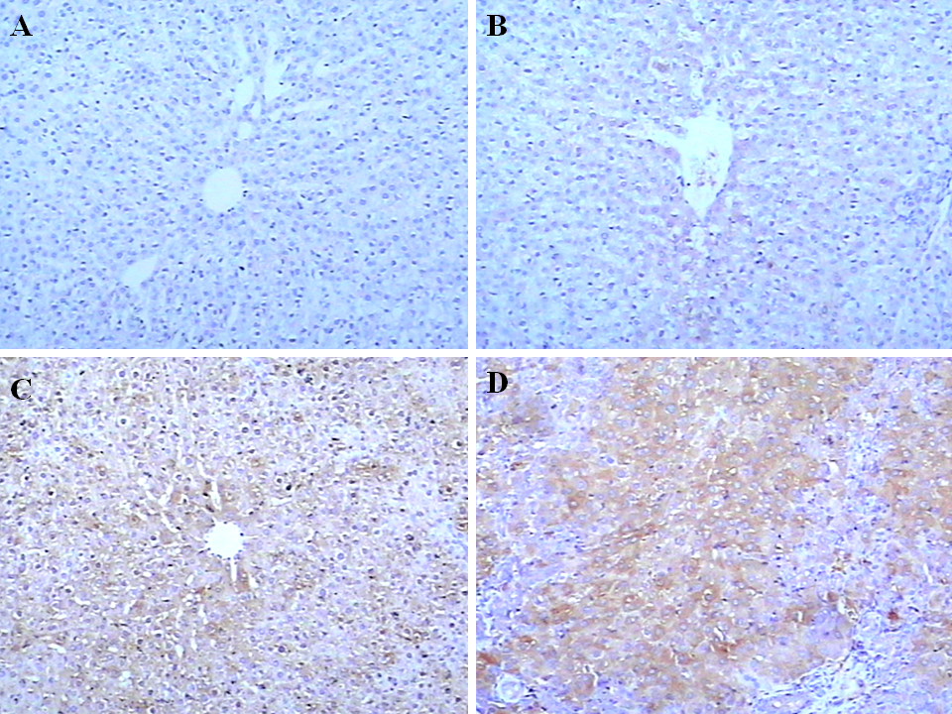

Sup-Figure 2 analysis of HIF-1α expression in rat hepatocarcinogensis (SP×100)
- NC rats. B. Deg rats. C. Pre-C rats. D. rHCC rats

