KLRK1 as a Prognostic Biomarker for Lung Adenocarcinoma Cancer

Yanan Zhang^{1,2}, Zeyang Chen^{3,4}, Guanqi Gao^{2※}

1 Clinical Medical College, Weifang Medical University,Weifang, 261000, China
2 Linyi People’s Hospital, Linyi, China, 276000
3 Clinical Medical College, Qingdao University, Yantai, China, 266000
4 The Affiliated Yantai Yuhuangding Hospital of Qingdao University, Yantai, China, 264000
※Corresponding. lygqgao@163.com

Table S1. Univariate analysis of overall and relapse free survival in patients with lung squamous cell cancer
 | Overall survival |  |  | Relapse free survival
 | Hazard Ratio | 95%CI | P value | Hazard Ratio | 95%CI | P value
Age | 1.59 | 0.84-3 | 0.155 | - | - | -
Gender | 1.20 | 0.87-1.65 | 0.273 | - | - | -
T classification | 1.34 | 1.12-1.6 | 0.001 | 1.25 | 1.01-1.55 | 0.044
N classification | 1.12 | 0.93-1.36 | 0.239 | - | - | -
M classification | 0.77 | 0.52-1.15 | 0.206 | - | - | -
Radiation therapy | 0.84 | 0.6-1.17 | 0.295 | - | - | -
Residual tumor | 1.12 | 0.93-1.36 | 0.229 | - | - | -
Stage | 1.26 | 1.07-1.48 | 0.006 | 1.12 | 0.91-1.37 | 0.281
KLRK1 | 1.36 | 0.7-2.66 | 0.365 | - | - | -

Table S2. Multivariate analysis of overall and relapse free survival in patients with lung squamous cell cancer
 | Overall survival |  |  | Relapse free survival
 | Hazard Ratio | 95%CI | P value | Hazard Ratio | 95%CI | P value
T classification | 1.44 | 1.1-1.89 | 0.009 | 1.25 | 0.87-1.8 | 0.234
N classification | 1.34 | 1.02-1.76 | 0.033 | 1.11 | 0.73-1.68 | 0.629
Radiation therapy | 1.45 | 0.89-2.36 | 0.132 | - | - | -
Residual tumor | 1.49 | 1.16-1.91 | 0.002 | 1.46 | 1.13-1.88 | 0.004
Stage | 1.38 | 1.09-1.76 | 0.008 | 1.18 | 0.76-1.83 | 0.465
KLRK1 | 0.92 | 0.42-1.99 | 0.825 | - | - | -

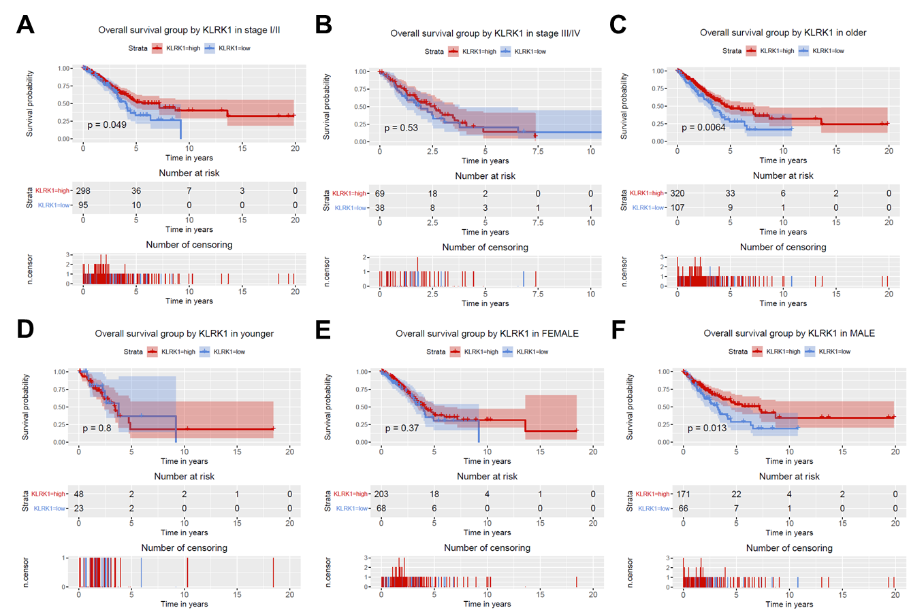
Figure S1. Relationship of KLRK1 expression with overall survival in all patients with lung adenocarcinoma cancer in (A) stage I/II, (B) stage III/IV, (C) older patients, (D) younger patients, (E) female and (F) male.

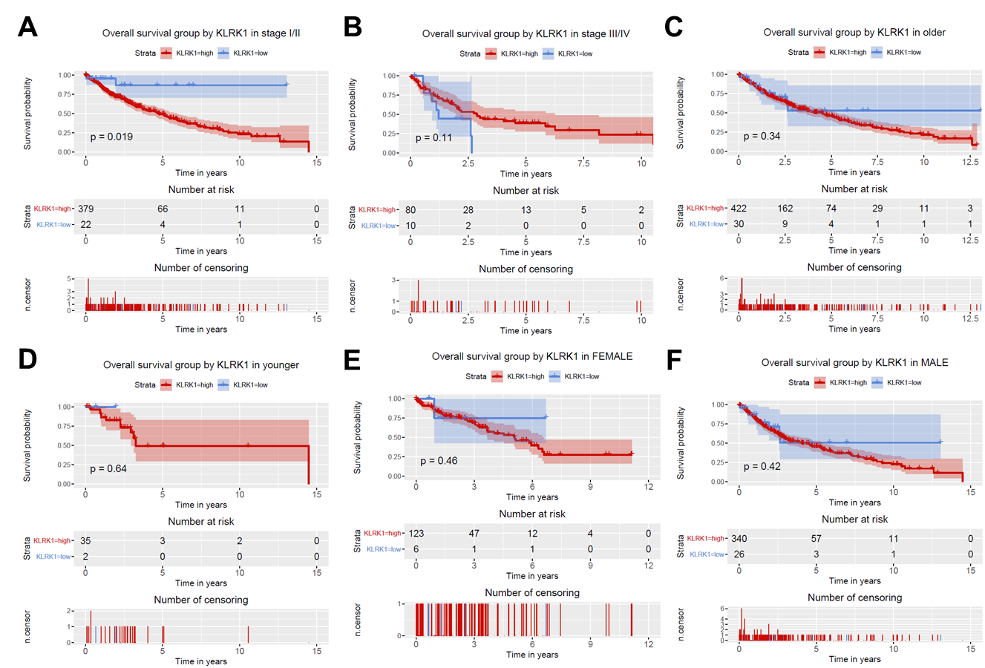
Figure S2. Relationship of KLRK1 expression with overall survival in all patients with lung squamous cell cancer in (A) stage I/II, (B) stage III/IV, (C) older patients, (D) younger patients, (E) female and (F) male.
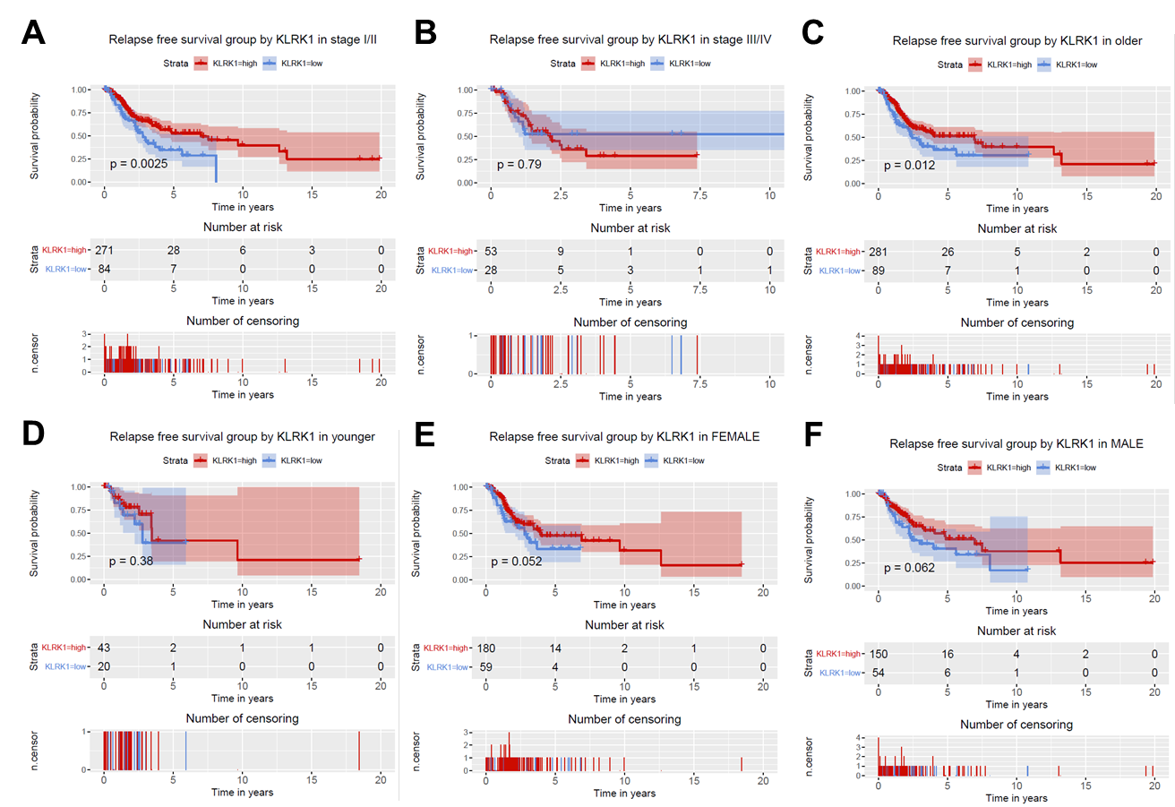
Figure S3. Relationship of KLRK1 expression with relapse free survival in all patients with lung adenocarcinoma cancer in (A) stage I/II, (B) stage III/IV, (C) older patients, (D) younger patients, (E) female and (F) male.

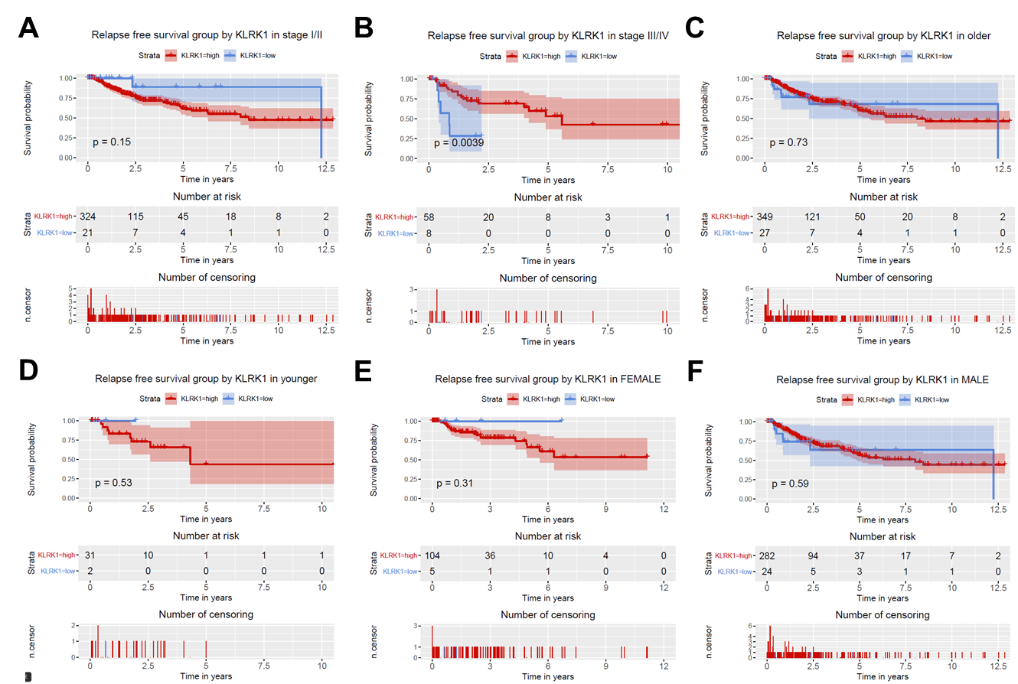
Figure S4. Relationship of KLRK1 expression with relapse free survival in all patients with lung squamous cell cancer in (A) stage I/II, (B) stage III/IV, (C) older patients, (D) younger patients, (E) female and (F) male.

