Supplementary information
SI text #1
ε-FeOOH: A set of weak peaks appeared during laser heating were indexed with ε-FeOOH (P2₁mn, Gleason et al., 2008). Due to the spotty nature of the diffraction in 2D images, however, only a certain peak was observed (especially one near at 10.1 degrees in 2θ) (a pattern in Fig. 1A at 33 GPa and 1770 K). After recovery to 1 bar, the peaks from ε-FeOOH still remained with decreased intensity. This phase was likely formed from Fe released from olivine. The limited amount of FeO in our starting olivine ((Mg_{0.9},Fe_{0.1})₂SiO₄) sample, i.e., 9.8 wt%, explains the weak intensities of the ε-FeOOH peaks compared to those from brucite and stishovite (Fig. 1A).
Phase D and Akimotoite: Phase D (MgSi₂O₄(OH)₂) and akimotoite (MgSiO₃) were observed during laser heating (Fig. 1A). Within 1 minute of laser heating, phase D and akimotoite appeared in the diffraction patterns. Although the (101) peak of phase D overlapped with the (110) peak of stishovite, and other peaks, such as (111) at 11.73 and (112) at 15.36 degrees in 2θ, as marked with (bright) green bars, were matched uniquely with phase D. On the other hand, akimotoite could be identified by several diffraction peaks, most notably by its (012) and (104) peaks at 6.97 and 9.53 degrees in 2θ, respectively (Fig. 1A). However, most of the phase D and akimotoite peaks disappeared after quenching temperature at high pressure. Some broad peaks (star marks in Fig. 1A) were found after quenching temperature at high pressure. These broad peaks appeared to be originated from akimotoite (Extended Data Fig. 2). Based on these X-ray diffraction results, we interpreted that phase D and akimotoite would be metastable at high P–T conditions. Additionally, the appearance of phase D and akimotoite at high pressure and temperature (P–T) conditions could not explain the missing Mg component because two phases have lower Mg/Si ratio than olivine.
SI text #2
Infrared spectra, measured after 20 minutes of laser heating of the olivine + H₂O sample to 1100–1300 K at 26–28 GPa (Extended Data Table 1), showed broad bands from high-pressure H₂O-ice at high pressures. However, after the recovery of the sample to 1 bar and 300 K, a sharp peak of the IR-active O-H vibration mode of brucite appeared at 3,686 cm⁻¹ (Ma et al., 2013) (Extended Data Fig. 3), supporting the dissolution and precipitation of Mg as observed from the XRD experiments.
SI text #3
As described in the main text, our heating temperatures, 1330–1770 K, are well above the dehydration temperature of brucite at corresponding pressures (Extended Data Table 1). Previous in situ high P–T studies have found that brucite would dehydrate into periclase at 19.4 GPa and 1320 K, and 64 GPa and 800 K (Fei and Mao, 1993; Fukui et al., 2005). However, we could not find any peaks of periclase (MgO) in diffraction patterns measured at high P–T or even from the quenched samples (Fig. 1A). This indicates that MgO should be dissolved into the surrounding H₂O medium as Mg²⁺ ions at high temperatures.
It should also be noted that the X-ray beam sampled the entire cross-section across the heating spot, including the top and bottom regions which are comparatively colder than the central heating spot (Fig. 2E). Therefore, MgO would have been leached out from the central region to the surroundings via the circulating liquid-H₂O medium. Upon temperature quenching to 300 K, some amount of Mg²⁺ in the fluid crystallize into brucite due to the solubility decrease with cooling. Upon decompression, the remaining Mg²⁺, frozen in the high pressure ice, is converted to brucite because of the low solubility of Mg²⁺ in H₂O at ambient conditions (0.0086 g/L; Amundsen et al., 2000). These processes are likely responsible for the formation of the dome-like porous structures shown in Fig. 2.
SI text #4
After recovery to ambient conditions, some experimental runs showed the existence of ferropericlase as weak peaks. Because maintaining the same alignment between the sample and X-ray is challenging during decompression, particularly when water escapes at 1 bar, such observation is likely due to the detection of unreacted ferropericlase outside of the heating spots (Fig. 1B).
SI text #5
We observed post-perovskite type-(η) Fe₂O₃ (Bykova et al., 2016) (of the upper two diffraction patterns in Extended Data Fig. 6) during the heating at 58–76 GPa range (Extended Data Table 1). This phase is likely the dehydration product of ε-FeOOH (Koemets et al., 2019), supporting the proposed reaction between H₂O and ferropericlase (Extended Data Fig. 6).
SI text #6
From the sample morphology shown in Fig. 2B and 2C, we interpreted the interface of MgO-rich liquid and H₂O-ice should be at least outermost layer of dome-like structure (Fig. 2E). This indicates a region of reacted H₂O was much thicker than sample pellet. Therefore, we assume that a 5~10:2/3 volume ratio (at 1 bar) of H₂O and MgO in olivine, as composed of 2MgO and SiO₂, reacted at 30 GPa. After considering different compressibility of H₂O-ice VII and olivine, the volume ratio of H₂O and MgO in olivine at 30 GPa would be 5.23~10.5:1. The molar volume (at 1 bar) of H₂O-ice VII and olivine are 8.0 cm³/mol (Somayazulu et al., 2008) and 44.73 cm³/mol (Liu and Li, 2006), respectively. Therefore, the molar ratio of olivine and H₂O becomes 8.02. Consequently, the molar ratio of H₂O and MgO would be 20~40:1. We assume most olivine reacted with H₂O, leading to the reaction products, stishovite and brucite (room P–T in Fig. 1A). Then we can calculate how much MgO mass dissolved into H₂O. We can calculate the value in a gram/L of H₂O using the above procedure, i.e., 200~400 g/L at 1 bar.

SI text #7
Pure silica is approximately 1% denser than bridgmanite and pyrolite (which we assume for the composition of the rocky mantle) at 30 GPa. If than the topmost silica-rich layer is cooler than the remaining rocky mantle by 500 K, the density contrast will be enhanced by up to 2%. However, dense silicate polymorphs stable at the pressures expected for the topmost layer are known to be able to store H₂O as OH species in the crystal structures which would then affect the density (Nisr et al., 2017; Nisr et al., 2020). For example, 3 wt% H₂O in silica would decrease the density by ca. 2%. As a result, the silica-rich layer could be neutrally buoyant, which does not rule out possible mixing with the less reacted part of the rocky layer below through solid state convection.

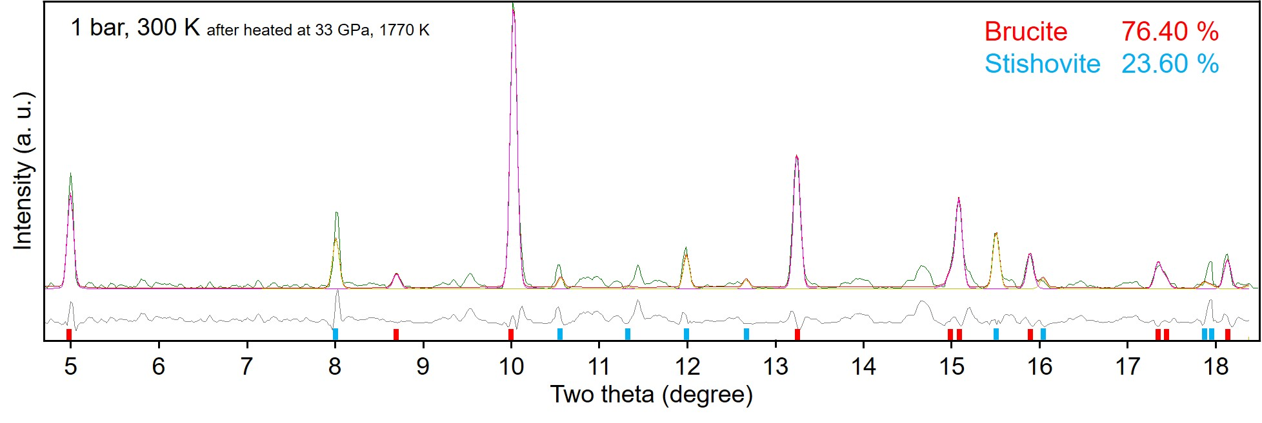
Extended Data Fig. 1. The phase fraction of brucite and stishovite as derived from Rietveld refinements (Rietveld, 1969). The diffraction pattern was measured at 1 bar, 300 K after heating to 1770 K at 33 GPa. The positions of red and blue bars indicate the diffraction peak positions of brucite and stishovite, respectively.

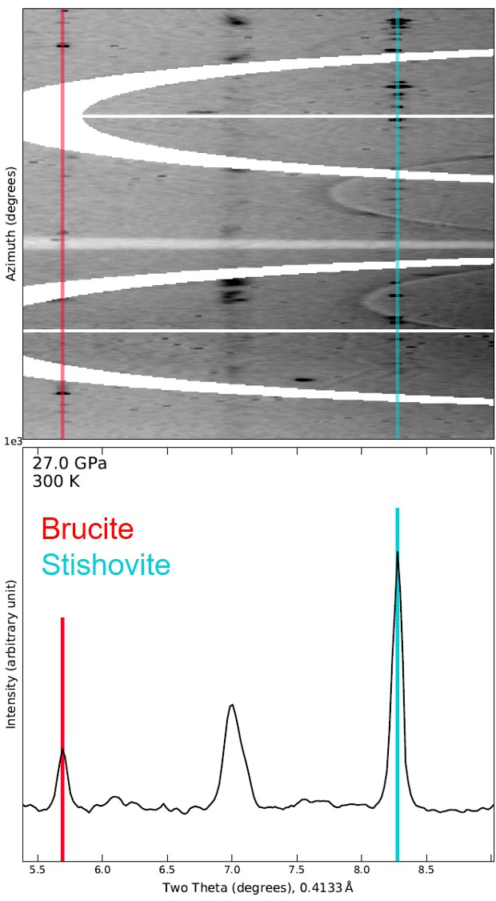
Extended Data Fig. 2. The low 2θ region of the X-ray diffraction image and corresponding pattern measured at 27 GPa, 300 K (after heating). The diffraction peak near 7 degrees in 2θ is from akimotoite and broader than the other peaks from brucite and stishovite.

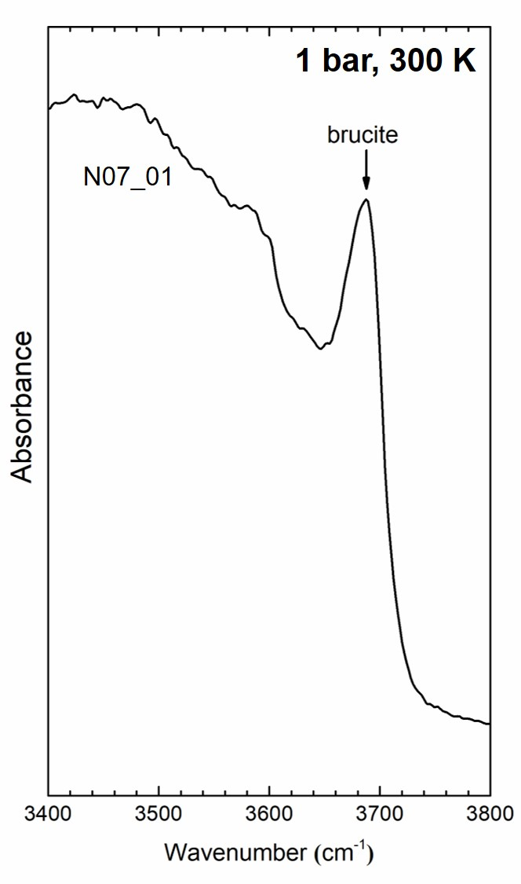
Extended Data Fig. 3. The FT-IR spectra of the laser-heated olivine in H₂O (Run # N07_01: 26 GPa, 1300 K) measured at 1 bar, 300 K.

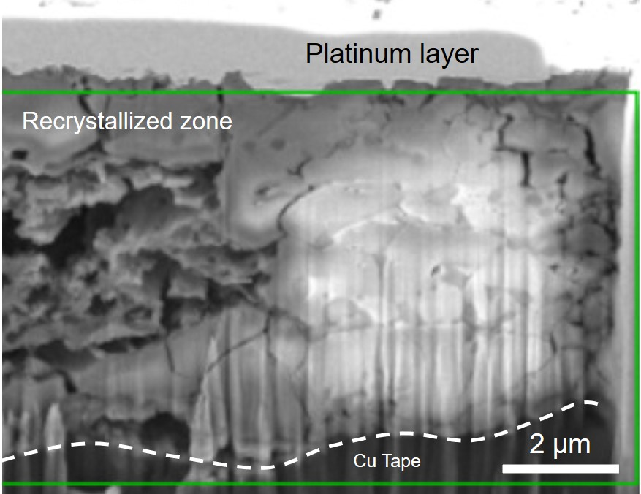
Extended Data Fig. 4. An SEM image from the sample recovered from the high pressure experiments (58 GPa and 1867 K) on the ferropericlase + H₂O sample. The highly porous area on the left half of the image is the center of the hot spot.

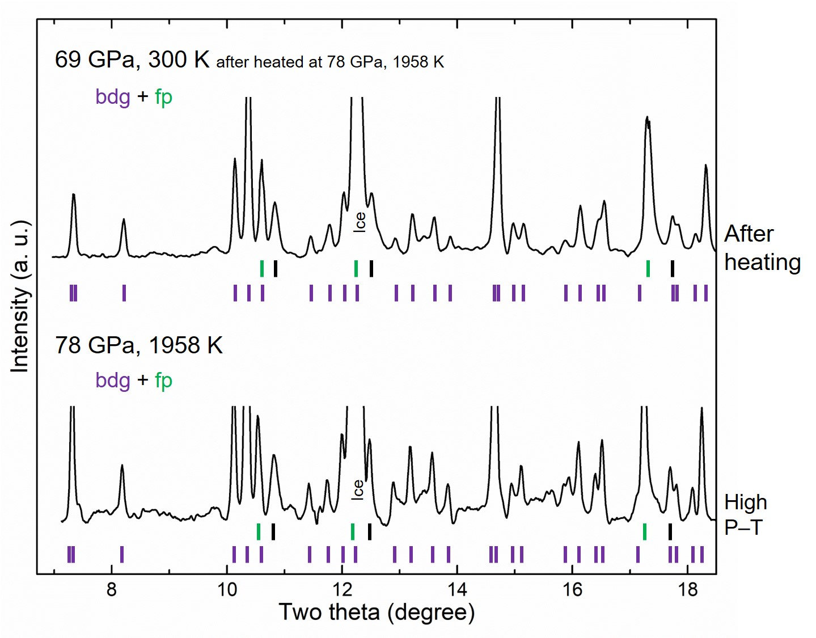
Extended Data Fig. 5. In situ synchrotron X-ray powder diffraction patterns measured during laser heating of the olivine + H₂O starting material above 60 GPa. The vertical bars indicate peak positions of bridgmanite (bdg) and ferropericlase (fp). The black bars indicate the peak positions of gold pressure standard. For this run, we could not obtain quenched XRD data due to the sample loss during decompression.

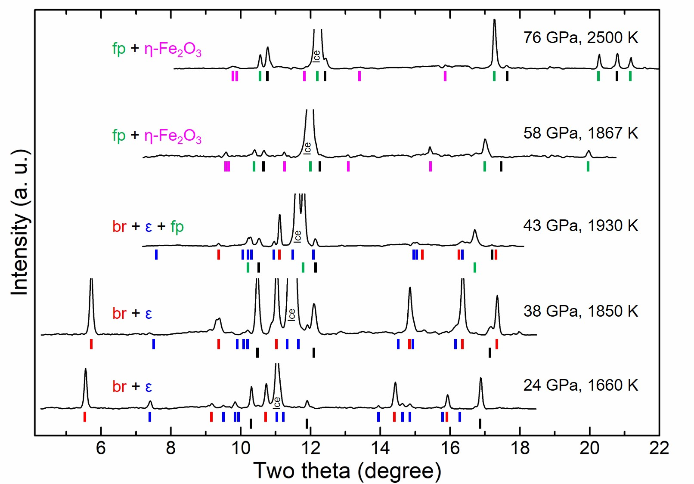
Extended Data Fig. 6. In situ synchrotron X-ray powder diffraction patterns measured during laser heating of the ferropericlase + H₂O starting material between 24 and 76 GPa. Pressure and temperature conditions for each pattern is given. In some patterns, low 2θ region was blocked by the carbon mirrors of the laser heating system. Some of the expected diffraction peaks are weak in the patterns. The black bars indicate the peak positions of gold (pressure standard). Abbreviation: brucite (br), ε-FeOOH (ε), ferropericlase (fp).

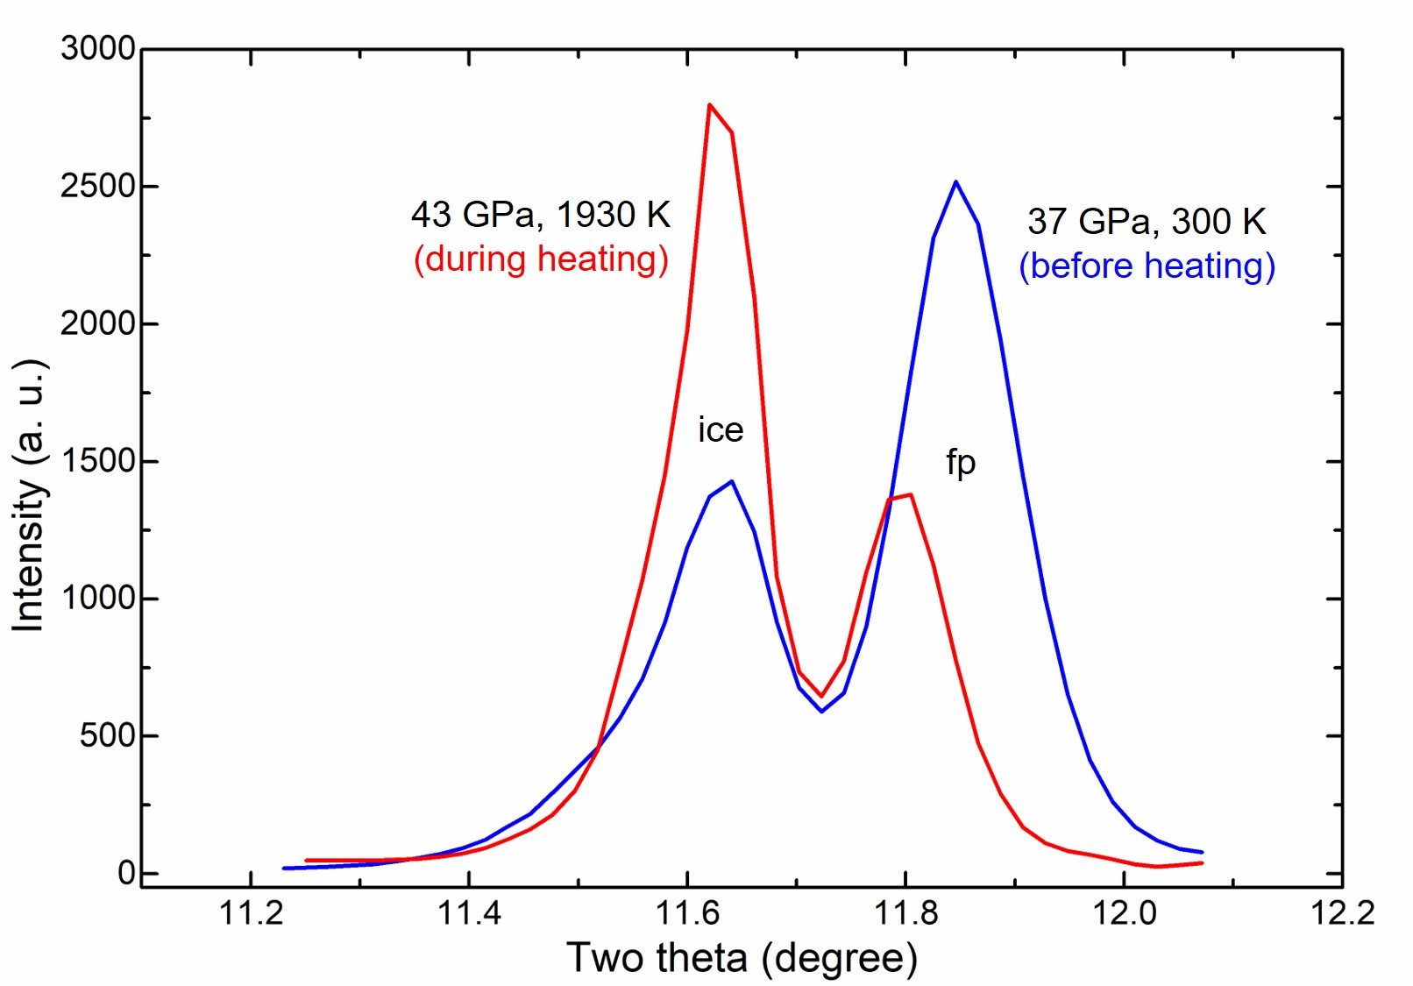
Extended Data Fig. 7. In situ synchrotron X-ray diffraction patterns measured before (blue solid line) and during heating (red solid line). The peak near 11.6 degrees in 2θ is ice VII (011) (ice) and the other one near 11.8 degrees in 2θ is ferropericlase (200) (fp). Note the relative changes in the peak intensity and positions upon heating.

Extended Data Table 1. A summary of the P–T conditions and corresponding phase assignments presented in this paper: Phase abbreviations: stishovite (st), brucite (br), ε-FeOOH (ε), phase D (D), akimotoite (ak), bridgmanite (bdg), ferropericlase (fp), and η-Fe₂O₃ (η).
Starting materials | Run # | Pressure (GPa) | Temperature (K) | Observed Phases | Analysis
Olivine + H₂O | A02_54 | 27(1) | 1400(100) | st, br, ε, D¹, ak¹ | XRD
 | A06_24 | 30(1) | 1330(100) | st, br, ε, D¹, ak¹ | XRD, SEM
 | A06_09 | 33(1) | 1770(100) | st, br, ε, D¹, ak¹ | XRD, SEM
 | A02_74 | 40(1) | 1655(100) | st, br, ε, D¹, fp | XRD
 | A02_96 | 48(2) | 1595(100) | st, br, ε, fp | XRD
 | A02_116 | 59(2) | 1794(100) | bdg, fp | XRD
 | A02_115 | 60(2) | 1831(100) | bdg, fp | XRD
 | A03_37 | 78(2) | 1958(100) | bdg, fp | XRD
 | A03_15 | 78(2) | 2557(140) | bdg, fp | XRD
 | A03_55 | 81(4) | 4325(110) | bdg, fp | XRD
 | N07_01 | 26(2) | 1300(100) | br | IR
 | N07_02 | 28(2) | 1100(100) | br | IR
Ferropericlase + H₂O | P09_05 | 24(1) | 1660(100) | br, ε | XRD
 | A06_03 | 29(1) | 1800(100) | br, ε, fp² | XRD
 | A03_23 | 36(1) | 1660(100) | br, ε | XRD
 | P03_19 | 36(1) | 1400(100) | br, ε, fp² | XRD
 | P03_10 | 38(1) | 1850(150) | br, ε, fp² | XRD
 | A06_48 | 39(1) | 1200(100) | br, ε, fp² | XRD
 | A06_38 | 43(1) | 1930(120) | br, ε, fp² | XRD
 | A11_30 | 54(2) | 1860(100) | br, fp² | XRD
 | A11_06 | 58(2) | 1867(100) | fp², η | XRD, SEM
 | A11_18 | 59(2) | 1840(100) | fp², η | XRD
 | P09_03 | 61(2) | 1620(100) | fp² | XRD
 | A11_69 | 75(2) | 2041(110) | fp², η | XRD
 | A11_66 | 76(2) | 1880(100) | fp², η | XRD
 | A11_76 | 76(3) | 2500(270) | fp², η | XRD
¹ Metastable phases were observed only at the high P–T conditions and/or high P after heating (see SI text #1).
² Observed phase from the starting material.
References
A. E. Gleason et al., Pressure-temperature stability studies of FeOOH using X-ray diffraction. Am. Mineral. 93, 1882–1885 (2008).
M. Ma et al., Compression and structure of brucite to 31 GPa from synchrotron X-ray diffraction and infrared spectroscopy studies. Am. Mineral. 40, 33–40 (2013).
Y. Fei and H.-K. Mao, Static Compression of Mg(OH)₂ to 78 GPa at High Temperature and Constraints on the Equation of State of Fluid H₂O. J. Geophys. Res. Solid Earth 98, 11875–11884 (1993).
H. Fukui et al., Decomposition of brucite up to 20 GPa: evidence for high MgO-solubility in the liquid phase. Eur. J. Mineral 17, 261–267 (2005).
K. Amundsen et al., Magnesium. Ullmann’s Encyclopedia of Industrial Chemistry. Wiley-VCH Verlag GmbH & Co. KGaA. (2000), doi:10.1002/14356007.a15_559.
E. Bykova et al., Structural complexity of simple Fe₂O₃ at high pressures and temperatures. Nat. Commun. 7:10661 (2016).
E. Koemets et al., FeOOH instability at the lower mantle conditions. arXiv:1908.02114 (6 Aug 2019).
M. Somayazulu et al., In situ high-pressure x-ray diffraction study of H₂O ice VII. J. Chem. Phys. 128:064510 (2008).
W. Liu and B. Li, Thermal equation of state of (Mg_{0.9}Fe_{0.1})₂SiO₄ olivine. Phys. Earth Planet. Inter. 157, 188-195 (2006).
C. Nisr et al., Phase transition and equation of state of dense hydrous silica up to 63 GPa. J. Geophys. Res. Solid Earth 122, 6972–6983 (2017).
C. Nisr et al., Large H₂O solubility in dense silica and its implications for the interiors of water-rich planets. Proc. Natl. Acad. Sci. U.S.A. 117, 9747–9754 (2020).
H. M. Rietveld, A profile refinement method for nuclear and magnetic structures. J. Appl. Cryst. 2, 65–71 (1969).

