Additional file

Supplementary Figure
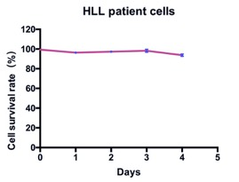

Figure S1. Detection the cell viability of the separated cells from HLL patients by MTT assay. 1×10⁴ HLL cells per well were seeded into a 96-well plate and cultured for 24 h, 48 h, 72 h and 96 h and 120 h. Then, MTT buffer was added to each well and the plate was incubated for the appropriate time. Then, the absorbance was measured at 570 nm using a microplate reader (SpectraMax M2, Molecular Devices, China).

