Appendices of:
The Gender of COVID-19 Experts in Newspaper Articles:
A Descriptive Cross-Sectional Study

Appendix 1: Search strategy for Factiva.
Appendix 2: Search strategy for the US Major Dailies.
Appendix 3: Data extraction form.
Appendix 1. Search Strategy for Factiva.
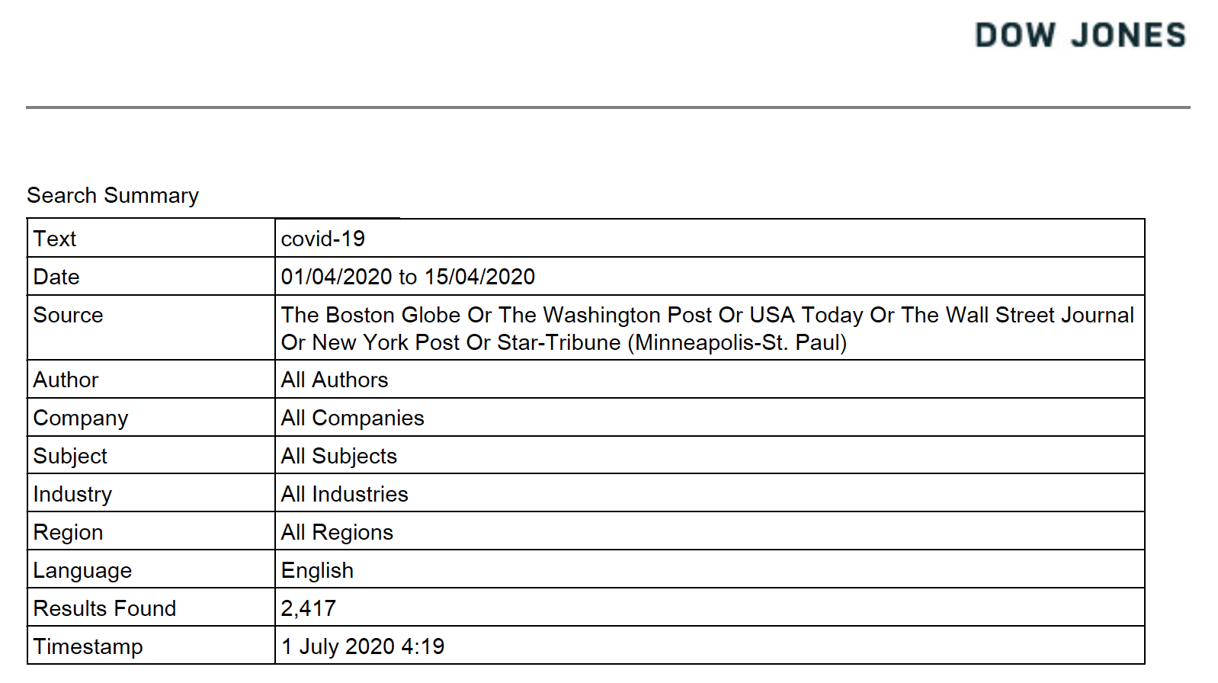

Appendix 2. Search Strategy for US Major Dailies.

Appendix 3. Data Extraction form.
Newspaper | Date | Article Title | Reporter Name(s) | Expert Name | Expert Sex (Pronouns in article) | Expert Sex (Other Method) | Describe Other Methods | Expert Field (from article)

