Table 2: Endoscopy related outcome and surgical aspects
case | size of BSCM (cm) | volume of BSCM (cm³) | size of corticotomy (mm) | Schematic illustration | approach | angled endoscopes needed | detection of residual cavernoma | E  O  R
1 | 3.3 x 3.2 x 3.3 | 34.85 | 7.9 x 1.6 | 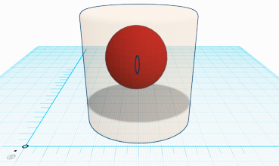 | SM | yes | no | G  T  R
2 | 1.1 x 0.9 x 1.6 | 1.58 | 3.4 x 2.6 | 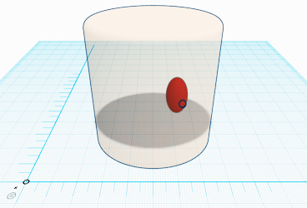 | SM | no | no | G  T  R
3 | 1.4 x 1.4 x 1.5 | 2.94 | 4.8 x 5.3 | 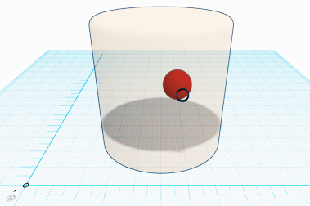 | SM | yes | no | G  T  R
4 | 1.4 x 1.3 x 1.0 | 1.95 | 3.9 x 4.6 | 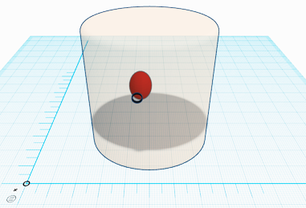 | SM | yes | yes | G  T  R
5 | 1.6 x 1.5 x 1.3 | 3.12 | 4.8 x 2.6 | 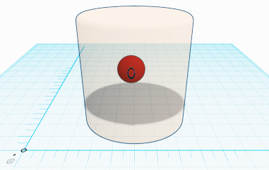 | SM | yes | no | G  T  R
6 | 1 x  1 x  1 | 1 | 4.4 x 3.1 | 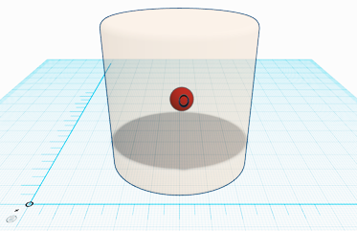 | SM | no | no | G  T  R
7 | 1.4 x 1.3 x 1.4 | 2.55 | 5.1 x 6.7 | 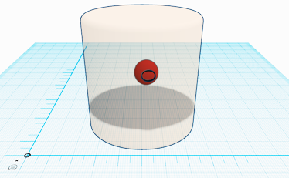 | SM | yes | no | G  T  R
8 | 1.7 x  2 x  1.4 | 4.76 | 3.9 x 3.6 | 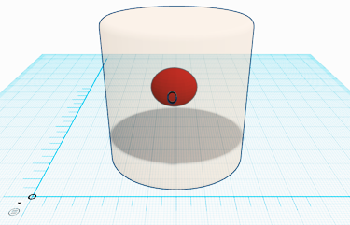 | SM | yes | no | G  T  R
9 | 1.4 x 1.2 x 1.5 | 2.52 | 4.6 x 4.1 | 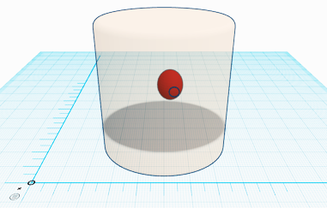 | SM | yes | no | G  T  R
10 | 0.8 x 1.2 x  1 | 0.96 | 5.5 x 4.2 | 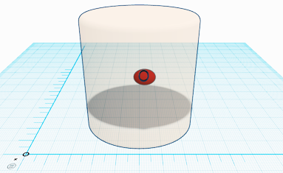 | SM | yes | no | G  T  R
11 | 0.5 x 0.8 x 0.6 | 0.24 | 2.8 x 3.2 | 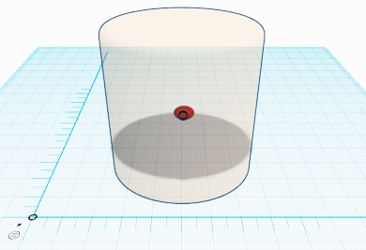 | SM | no | no | G  T  R
12 | 0.7 x 0.8 x 0.7 | 0.39 | 4.9 x 4.1 | 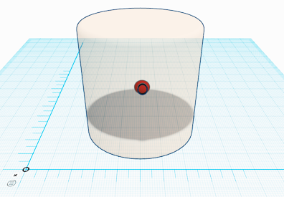 | SM | yes | yes | G  T  R
13 | 2.7 x 1.5 x 1.6 | 6.48 | 3.6 x 4.2 | 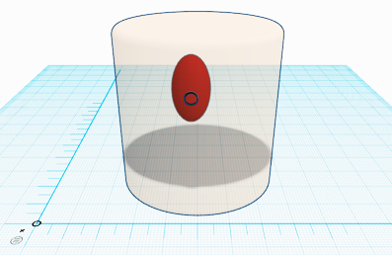 | SM | no | no | G  T  R
14 | 2.4 x 2.4 x 2.6 | 14.98 | 4.1 x 3.2 | 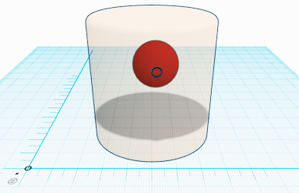 | TTT | yes | no | G  T  R
15 | 1.3 x 1.0 x 1.7 | 2.21 | 4.7 x 2.8 | 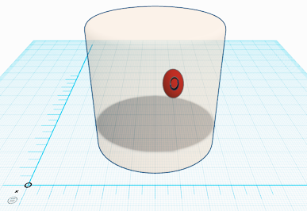 | RM | yes | no | G  T  R
16 | 1.8 x 1.6 x 1.3 | 3.74 | 4.2 x 3 | 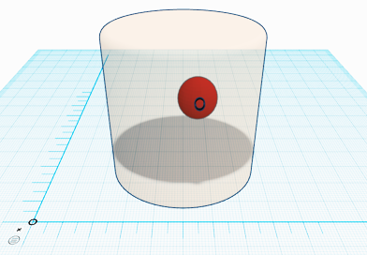 | RM | yes | no | G  T  R
17 | 1.9 x 1.9 x 2.2 | 7.94 | 4.4 x 3.7 | 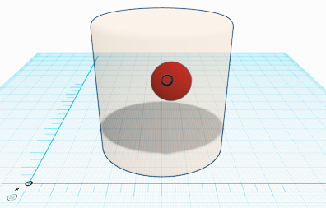 | RM | yes | yes | S  T  R
18 | 1.4 x 0.8 x 1.5 | 1.68 | 4 x 3.2 | 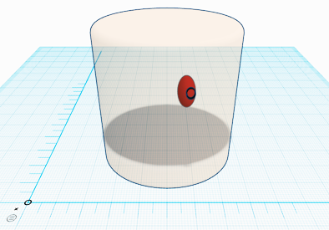 | RM | yes | yes | G  T  R
19 | 1.1 x 1.2 x 1.1 | 1.45 | 4.4 x 3.3 | 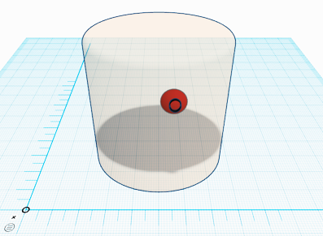 | FT | yes | no | G  T  R
20 | 2.7 x 2.4 x  2 | 12.96 | 4.9 x 4.3 | 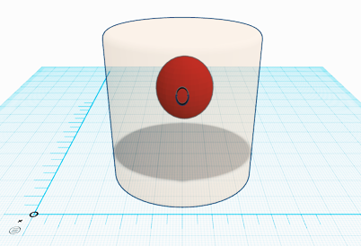 | SM | yes | no | G  T  R

