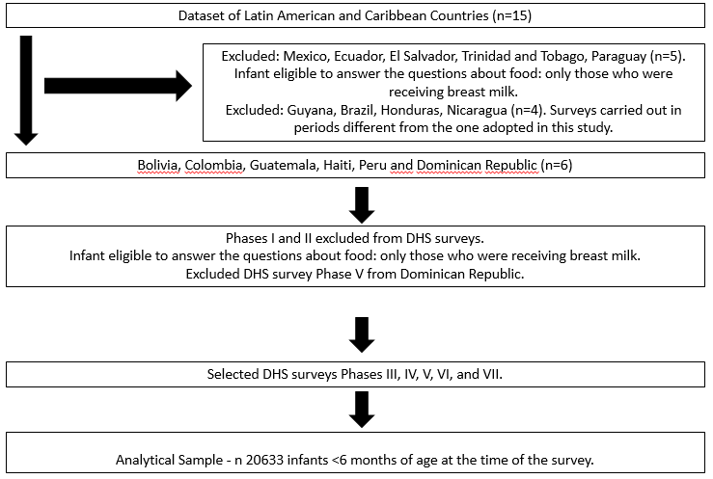

Figure S1. Flowchart of Demographic and Health Survey (DHS) selection from Latin American and Caribbean countries. DHS, 1990s, 2000s and 2010s.

