Supplementary Figure S2. Correlation of KIF23 expression with immune infiltration levels in diverse types of cancer in the TIMER database.
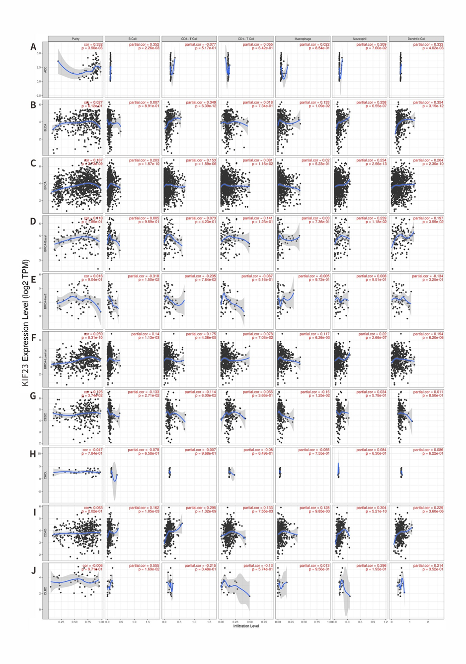
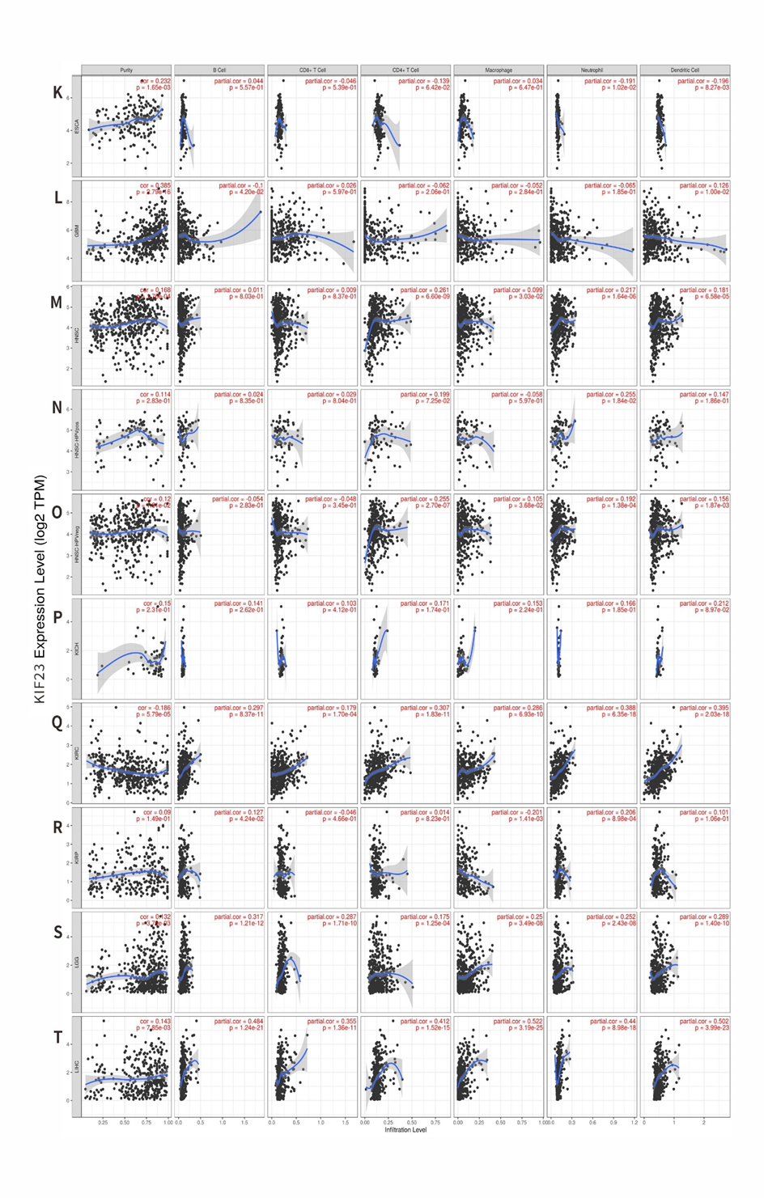
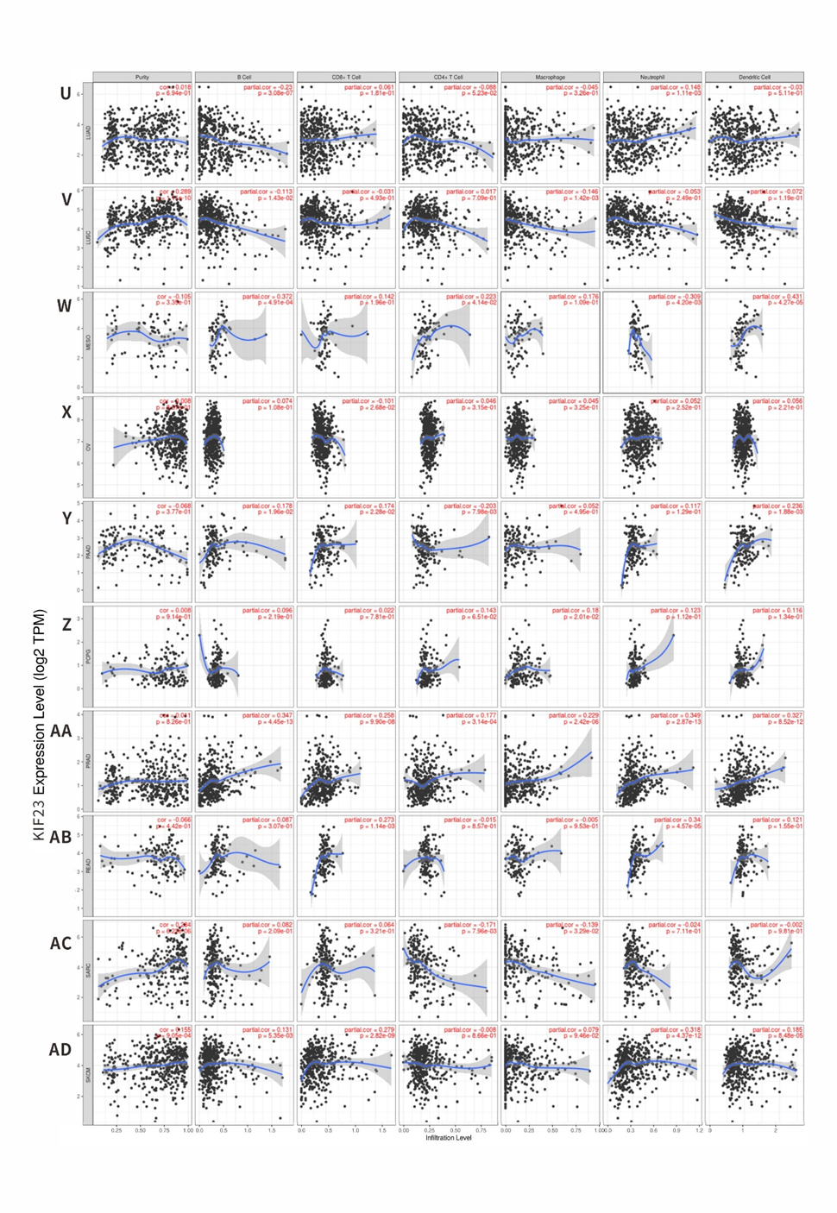
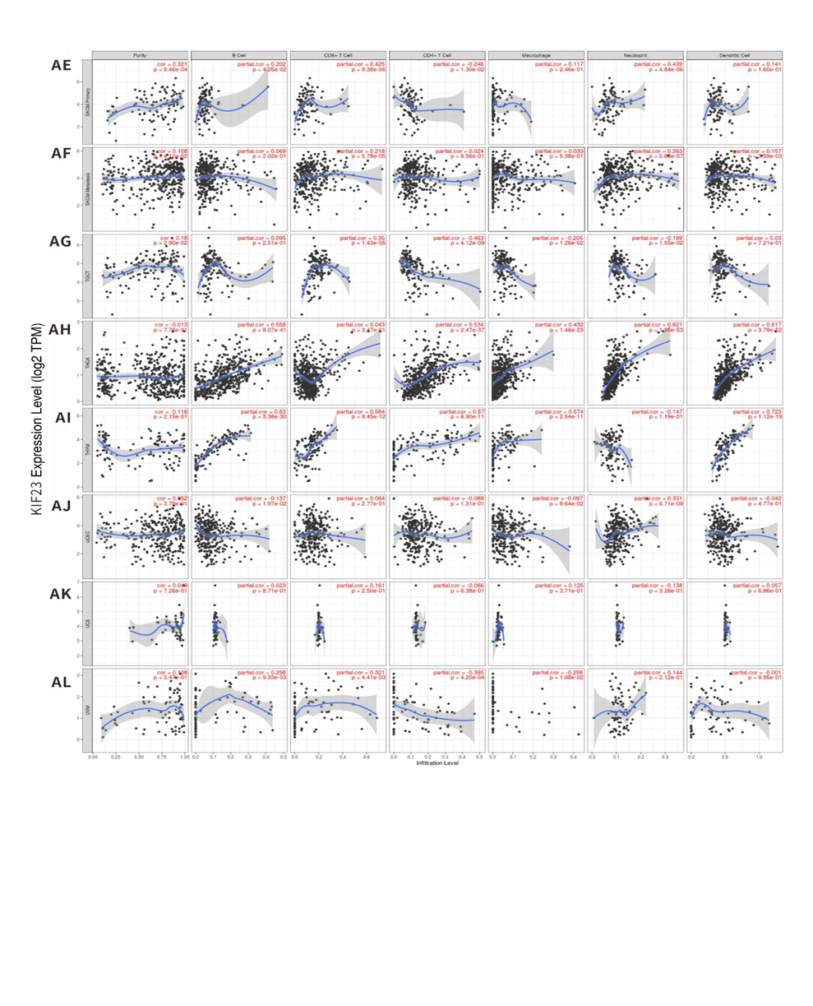
Supplementary Figure S2. Correlation of KIF23 expression with immune infiltration levels in diverse types of cancer in the TIMER database.

