The impact of obesity and adiposity on mortality risk in older adults: a ten-year survival analysis
Supplementary material

Figure 1. Survival curves for cancer according to three different diagnostic criteria for classifying obesity.
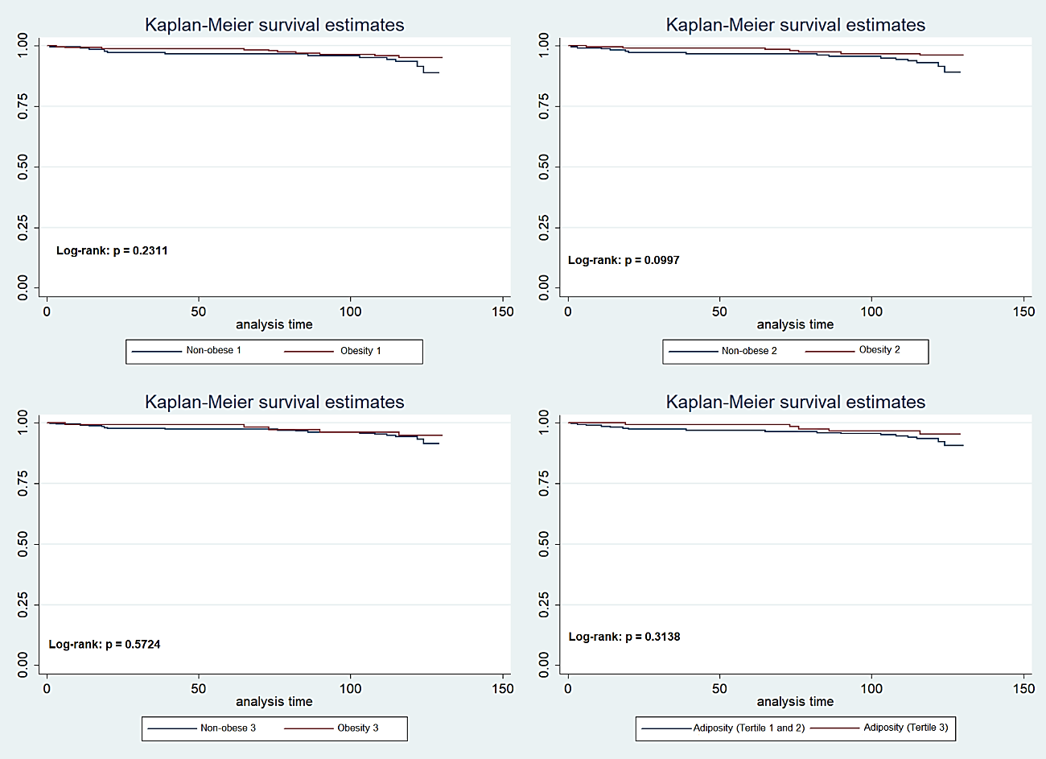

Figure 2. Survival curves for CVD according to three different diagnostic criteria for classifying obesity.
