Appendices

Appendix 1. p-values, F-values and degrees of freedom (df).

Butterfly | p-value | df | F
Total time across 3 trials (200-m) | 0.166 | 1.569 | 2.224
Total time across 3 trials (400-m) | 0.089 | 1.131 | 0.589
CS across 3 trials | 0.802 | 2 | 0.225
D’ across 3 trials | 0.776 | 2 | 0.260
Backstroke | p-value | df | F
Total time across 3 trials (200-m) | 0.462 | 2 | 0.816
Total time across 3 trials (400-m) | 0.052 | 2 | 0.384
CS across 3 trials | 0.506 | 2 | 0.716
D’ across 3 trials | 0.335* | 2 | 1.182
Breaststroke | p-value | df | F
Total time across 3 trials (200-m) | 0.075 | 2 | 3.235
Total time across 3 trials (400-m) | 0.202 | 2 | 1.831
CS across 3 trials | 0.186 | 2 | 1.940
D’ across 3 trials | 0.162 | 2 | 2.127
Front crawl | p-value | df | F
Total time across 3 trials (200-m) | 0.054 | 2 | 3.447
Total time across 3 trials (400-m) | 0.316 | 2 | 1.230
CS across 3 trials | 0.802 | 2 | 0.225
D’ across 3 trials | 0.224 | 1.307 | 1.688
* = D’ data calculated from trial 2 not normally distributed
Appendix 2: 200-m descriptive data, TEM, SDC_{ind}, SDC_{group}, SWC and ICC for 50m splits.
200-m Trials
Butterfly | 0-50 m | 50-100 m | 100-150 m | 150-200 m
Mean ± SD | 31.2 ± 1.5 | 35.3 ± 2.1 | 36.1 ± 2.2 | 36.2 ± 2.2
Mean TEM (% CoV) | 0.51 (1.64) | 0.54 (1.54) | 0.43 (1.18) | 0.79 (2.19)
SDC_{ind} (% of the mean) | 0.98 (3.13) | 1.04 (2.95) | 0.82 (2.26) | 1.51 (4.19)
SDC_{group} (% of the mean) | 0.37 (1.18) | 0.39 (1.11) | 0.31 (0.86) | 0.57 (1.58)
SWC (% of the mean) | 0.14 (0.46) | 0.15 (0.44) | 0.12 (0.34) | 0.22 (0.62)
ICC (95% CI) | 0.23  (-0.20-0.78) | 0.42 (-0.05-0.84) | 0.41 (-0.07-0.84) | 0.45 (-0.02-0.85)
Backstroke | 0-50 m | 50-100 m | 100-150 m | 150-200 m
Mean ± SD | 31.7 ± 1.7 | 34.4 ± 1.9 | 34.8 ± 1.9 | 33.9 ± 2.3
Mean TEM (% CoV) | 0.69 (2.16) | 0.66 (1.91) | 0.84 (2.40) | 0.90 (2.66)
SDC_{ind} (% of the mean) | 1.31 (4.13) | 1.26 (3.65) | 1.60 (4.59) | 1.72 (5.08)
SDC_{group} (% of the mean) | 0.46 (1.46) | 0.44 (1.29) | 0.57 (1.62) | 0.61 (1.80)
SWC (% of the mean) | 0.19 (0.61) | 0.19 (0.54) | 0.24 (0.68) | 0.26 (0.75)
ICC (95% CI) | -0.06 (-0.19-0.43) | 0.49 (0.07-0.85) | 0.22 (-0.12-0.69) | 0.45 (0.05-0.83)
Breaststroke | 0-50 m | 50-100 m | 100-150 m | 150-200 m
Mean ± SD | 35.4 ± 2.5 | 39.4 ± 2.9 | 39.8 ± 2.8 | 39.7 ± 2.7
Mean TEM (% CoV) | 0.66 (1.87) | 0.74 (1.88) | 0.46 (1.15) | 0.73 (1.83)
SDC_{ind} (% of the mean) | 1.27 (3.58) | 1.41 (3.59) | 0.88 (2.20) | 1.39 (3.49)
SDC_{group} (% of the mean) | 0.48 (1.35) | 0.53 (1.36) | 0.33 (0.83) | 0.52 (1.32)
SWC (% of the mean) | 0.19 (0.53) | 0.21 (0.53) | 0.13 (0.33) | 0.21 (0.52)
ICC (95% CI) | 0.03 (-0.25-0.58) | -0.01 (-0.28-0.54) | 0.02 (-0.35-0.62) | -0.12 (-0.30-0.38)
Front crawl | 0-50 m | 50-100 m | 100-150 m | 150-200 m
Mean ± SD | 29.4 ± 1.4 | 32.1 ± 1.6 | 32.4 ± 1.8 | 31.4 ± 2.0
Mean TEM (% CoV) | 0.54 (1.82) | 0.56 (1.74) | 0.77 (2.38) | 0.79 (2.51)
SDC_{ind} (% of the mean) | 1.02 (3.48) | 1.07 (3.32) | 1.47 (4.54) | 1.50 (4.79)
SDC_{group} (% of the mean) | 0.32 (1.10) | 0.34 (1.05) | 0.46 (1.43) | 0.48 (1.51)
SWC (% of the mean) | 0.15 (0.52) | 0.16 (0.49) | 0.22 (0.67) | 0.22 (0.71)
ICC (95% CI) | 0.72 (0.39-0.92) | 0.48 (0.06-0.83) | 0.56 (0.14-0.86) | 0.44 (0.07-0.80)

Appendix 3: 400-m descriptive data, TEM, SDC_{ind}, SDC_{group}, SWC and ICC for 50-m splits.
400-m Trials
Butterfly | 0-50 m | 50-100 m | 100-150 m | 150-200 m | 200-250 m | 250-300 m | 300-350 m | 350-400 m
Mean ± SD | 32.9 ± 1.6 | 37.2 ± 2.3 | 38.3 ± 2.6 | 38.8 ± 2.7 | 39.0 ± 2.6 | 39.5 ± 2.9 | 39.6 ± 3.0 | 38.6 ± 3.0
Mean TEM (% CoV) | 0.53 (1.61) | 0.54 (1.45) | 0.89 (2.31) | 0.70 (1.81) | 0.76 (1.95) | 0.63 (1.59) | 0.56 (1.42) | 0.50 (1.30)
SDC_{ind} (% of the mean) | 1.01 (3.07) | 1.03 (2.76) | 1.69 (4.41) | 1.34 (3.46) | 1.45 (3.73) | 1.20 (3.04) | 1.08 (2.72) | 0.96 (2.49)
SDC_{group} (% of the mean) | 0.38 (1.16) | 0.39 (1.04) | 0.64 (1.67) | 0.51 (1.31) | 0.55 (1.41) | 0.45 (1.15) | 0.41 (1.03) | 0.36 (0.94)
SWC (% of the mean) | 0.15 (0.46) | 0.15 (0.41) | 0.25 (0.65) | 0.20 (0.51) | 0.22 (0.55) | 0.18 (0.45) | 0.16 (0.40) | 0.14 (0.37)
ICC (95% CI) | 0.86 (0.59-0.97) | 0.79 (0.43-0.96) | 0.70 (0.30-0.93) | 0.12 (-0.32-0.71) | 0.37 (-0.13-0.83) | 0.56 (0.11-0.89) | 0.87 (0.63-0.97) | 0.46 (-0.00-0.86)
Backstroke | 0-50 m | 50-100 m | 100-150 m | 150-200 m | 200-250 m | 250-300 m | 300-350 m | 350-400 m
Mean ± SD | 33.0 ± 2.1 | 35.8 ± 2.4 | 36.3 ± 2.2 | 36.4 ± 2.0 | 36.0 ± 2.0 | 36.2 ± 1.9 | 36.0 ± 1.9 | 34.9 ± 2.1
Mean TEM (% CoV) | 0.39 (1.19) | 0.38 (1.07) | 0.46 (1.26) | 0.32 (0.88) | 0.41 (1.15) | 0.38 (1.04) | 0.41 (1.15) | 0.51 (1.45)
SDC_{ind} (% of the mean) | 0.75 (2.27) | 0.73 (2.04) | 0.87 (2.40) | 0.61 (1.68) | 0.79 (2.20) | 0.72 (1.98) | 0.79 (2.19) | 0.97 (2.77)
SDC_{group} (% of the mean) | 0.26 (0.80) | 0.26 0.72) | 0.31 (0.85) | 0.22 (0.59) | 0.28 (0.78) | 0.25 (0.70) | 0.28 (0.77) | 0.34 (0.98)
SWC (% of the mean) | 0.11 (0.34) | 0.11 (0.30) | 0.13 (0.36) | 0.09 (0.25) | 0.12 (0.33) | 0.11 (0.29) | 0.12 (0.32) | 0.14 (0.41)
ICC (95% CI) | 0.52 (0.10-0.86) | 0.84 (0.58-0.96) | 0.56 (0.15-0.87) | 0.69 (0.32-0.92) | 0.63 (0.23-0.90) | 0.66 (0.28-0.91)) | 0.67 (0.30-0.91) | 0.71 (0.35-0.92)
Breaststroke | 0-50 m | 50-100 m | 100-150 m | 150-200 m | 200-250 m | 250-300 m | 300-350 m | 350-400 m
Mean ± SD | 36.6 ± 2.2 | 41.2 ± 2.3 | 41.6 ± 2.2 | 41.5 ± 2.3 | 41.2 ± 2.4 | 41.3 ± 2.5 | 41.0 ± 2.6 | 40.5 ± 2.7
Mean TEM (% CoV) | 0.82 (2.25) | 1.31 (3.18) | 1.02 (2.46) | 0.91 (2.20) | 0.87 (2.11) | 0.64 (1.56) | 0.54 (1.33) | 0.86 (2.11)
SDC_{ind} (% of the mean) | 1.57 (4.29) | 2.50 (6.08) | 1.96 (4.71) | 1.74 (4.19) | 1.66 (4.03) | 1.23 (2.98) | 1.04 (2.54) | 1.64 (4.04)
SDC_{group} (% of the mean) | 0.59 (1.62) | 0.95 (2.30) | 0.74 (1.78) | 0.66 (1.59) | 0.63 (1.52) | 0.47 (1.13) | 0.39 (0.96) | 0.62 (1.53)
SWC (% of the mean) | 0.23 (0.64) | 0.37 (0.90) | 0.29 (0.70) | 0.26 (0.62) | 0.25 (0.60) | 0.18 (0.44) | 0.15 (0.38) | 0.24 (0.60)
ICC (95% CI) | 0.78 (0.39-0.95) | -0.06 (-0.42-0.57) | 0.18 (-0.26-0.74) | -0.02 (-0.37-0.60) | 0.03 (-0.35-0.64 | 0.24 (-0.24-0.77) | 0.14 (-0.30-0.71) | -0.12 (-0.45-0.53)
Front crawl | 0-50 m | 50-100 m | 100-150 m | 150-200 m | 200-250 m | 250-300 m | 300-350 m | 350-400 m
Mean ± SD | 30.4 ± 1.6 | 33.2 ± 1.8 | 33.7 ± 1.9 | 33.8 ± 1.8 | 33.6 ± 1.7 | 33.8 ± 1.6 | 33.6 ± 1.6 | 32.4 ± 1.9
Mean TEM (% CoV) | 0.48 (1.58) | 0.52 (1.56) | 0.50 (1.48) | 0.64 (1.89) | 0.55 (1.62) | 0.48 (1.41) | 0.51 (1.53) | 0.50 (1.54)
SDC_{ind} (% of the mean) | 0.92 (3.03) | 0.99 (2.99) | 0.95 (2.83) | 1.22 (3.61) | 1.04 (3.10) | 0.91 (2.69) | 0.98 (2.93) | 0.95 (2.94)
SDC_{group} (% of the mean) | 0.29 (0.96) | 0.31 (0.94) | 0.30 (0.90) | 0.39 (1.14) | 0.33 (0.98) | 0.29 (0.85) | 0.31 (0.93) | 0.30 (0.93)
SWC (% of the mean) | 0.14 (0.45) | 0.15 (0.44) | 0.14 (0.42) | 0.18 (0.53) | 0.15 0.46) | 0.13 (0.40) | 0.15 0.43) | 0.14 (0.44)
ICC (95% CI) | 0.72 (0.08-0.81) | 0.31 (-0.04-0.73) | 0.08 (-0.27-0.59) | 0.15 (-0.22-0.64) | 0.25 (-0.07-0.68) | 0.51 (0.12-0.83) | 0.09 (-0.20-0.56) | 0.34 (-0.02-0.74)

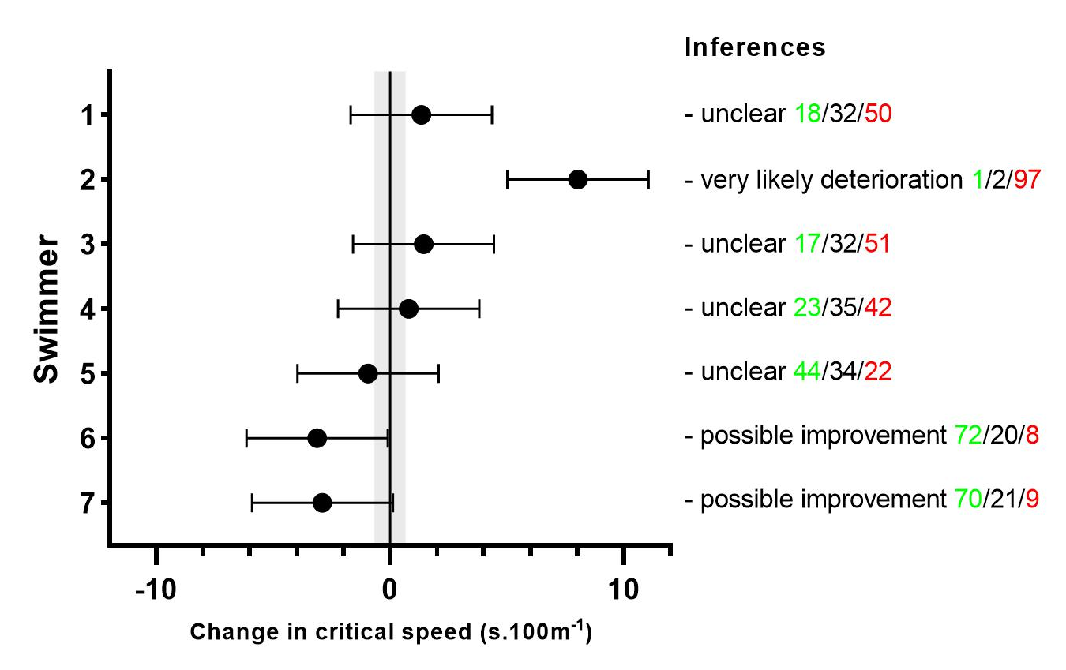
Appendix 4. Example of how coaches and practitioners may make practically meaningful inferences from individual swimmer’s critical speed data from before and after a training block, using smallest worthwhile change (grey zone) and 68% confidence limits of true change (bars).
Appendix 5. Test-retest reliability of critical speed (s.100m⁻¹) across three performance trials
 | Critical Speed (s.100m⁻¹)
 | Butterfly | Backstroke | Breaststroke | Front crawl
Trial 1 | 82.26 ± 6.19 | 75.10 ± 4.11 | 85.70 ± 4.48 | 70.52 ± 3.12
Trial 2 | 82.93 ± 7.40 | 74.34 ± 6.23 | 86.29 ± 3.59 | 69.28 ± 3.76
Trial 3 | 82.18 ± 7.06 | 75.32 ± 4.37 | 83.89 ± 5.45 | 69.14 ± 4.39
TEM 1-2 (% CoV) | 2.66 (3.22) | 1.71 (2.29) | 2.59 (3.01) | 2.02 (2.88)
TEM 2-3 (% CoV) | 0.83 (1.01) | 2.18 (2.92) | 2.60 (3.05) | 2.49 (3.59)
Mean TEM (% CoV) | 1.97 (2.39) | 1.96 (2.52) | 2.59 (3.04) | 2.26 (3.25)
SDC_{ind} (% of the mean) | 5.46 (6.63) | 5.43 (7.25) | 7.19 (8.43) | 6.27 (9.01)
SDC_{group} (% of the mean) | 2.06 (2.50) | 1.92 (2.56) | 2.72 (3.18) | 1.98 (2.85)
SWC (% of the mean) | 1.38 (1.67) | 1.00 (1.33) | 0.91 (1.07) | 0.76 (1.09)

