ADDITIONAL FILE 1 (Appendix):

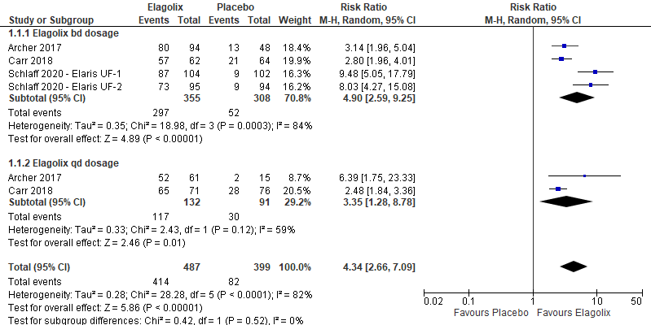
Additional Figure 1: Comparison between elagolix and placebo for the outcome reduction of menstrual blood loss of less than 80 ml by frequency of drug administration.

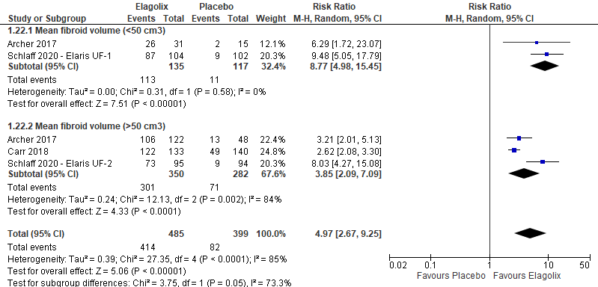
Additional Figure 2: Comparison between elagolix and placebo for the outcome reduction of menstrual blood loss of less than 80 ml by fibroid volume.
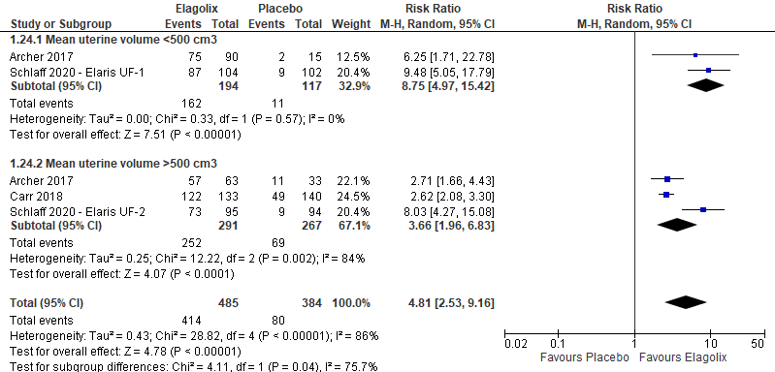
Additional Figure 3: Comparison between elagolix and placebo for the outcome reduction of menstrual blood loss of less than 80 ml by uterine volume.

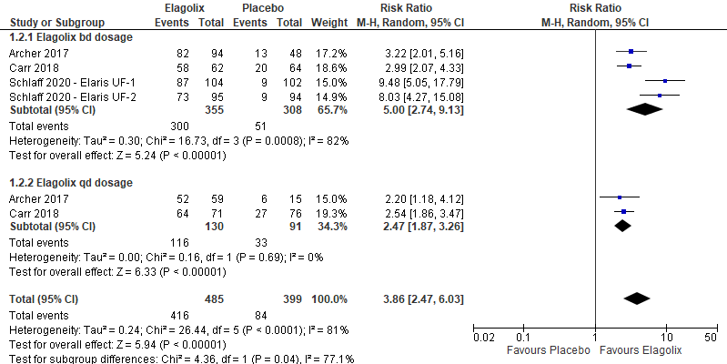
Additional Figure 4: Comparison between elagolix and placebo for the outcome reduction of menstrual blood loss of more than 50% by frequency of drug administration.

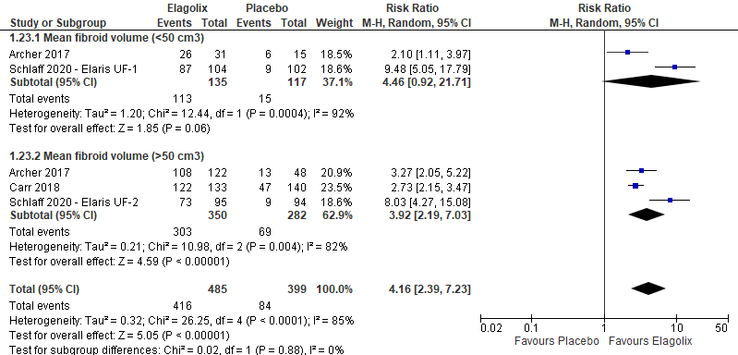
Additional Figure 5: Comparison between elagolix and placebo for the outcome reduction of menstrual blood loss of more than 50% by fibroid volume.

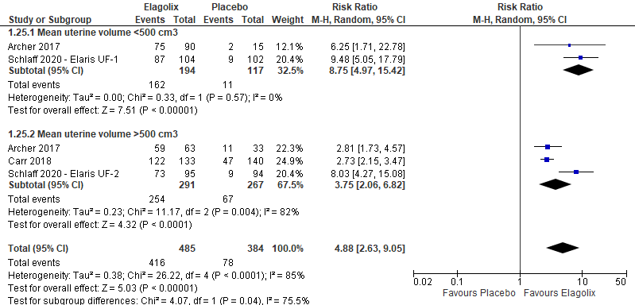 Additional Figure 6: Comparison between elagolix and placebo for the outcome reduction of menstrual blood loss of more than 50% by uterine volume.

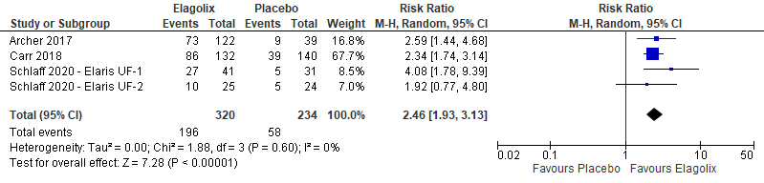 Additional Figure 7: Comparison between elagolix and placebo for the outcome improvement in hemoglobin level.

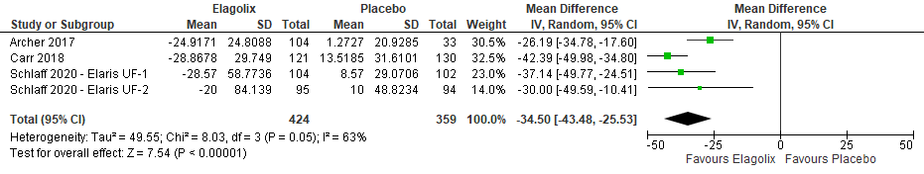 Additional Figure 8: Comparison between elagolix and placebo for the outcome uterine volume.

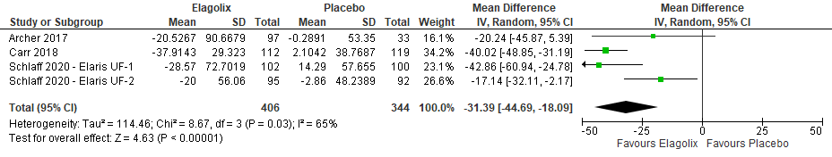 Additional Figure 9: Comparison between elagolix and placebo for the outcome fibroid volume.
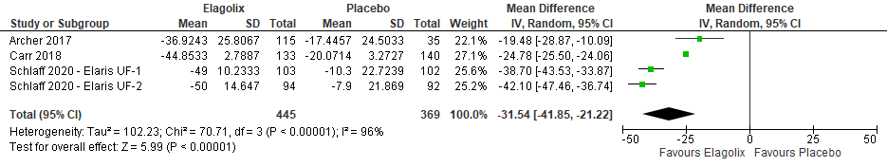 Additional Figure 10: Comparison between elagolix and placebo for the outcome symptom severity.
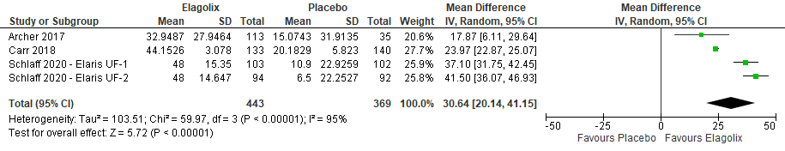
Additional Figure 11: Comparison between elagolix and placebo for the outcome health-related quality of life.

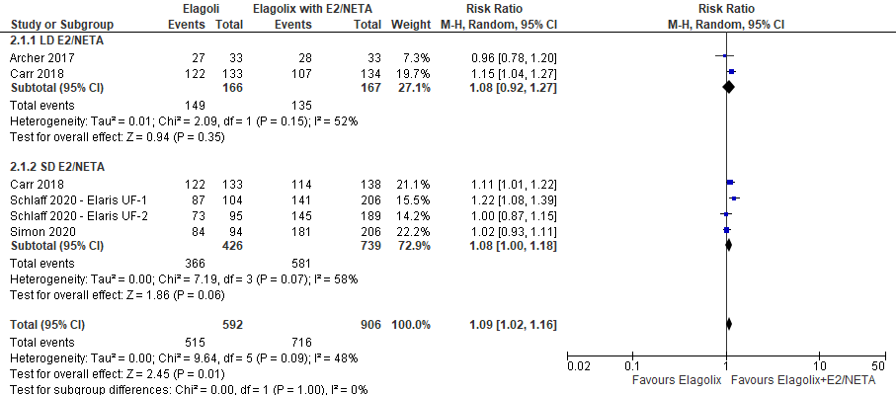
Additional Figure 12: Comparison between elagolix and elagolix with estradiol/norethindrone acetate for the outcome reduction of menstrual blood loss of less than 80 ml by dosage.

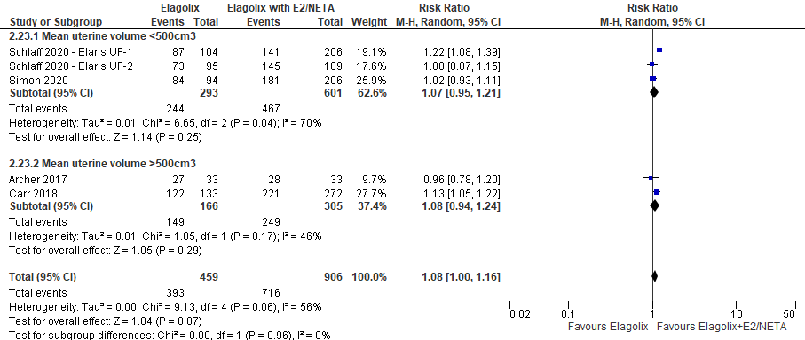
Additional Figure 13: Comparison between elagolix and elagolix with estradiol/norethindrone acetate for the outcome reduction of menstrual blood loss of less than 80 ml by uterine volume.

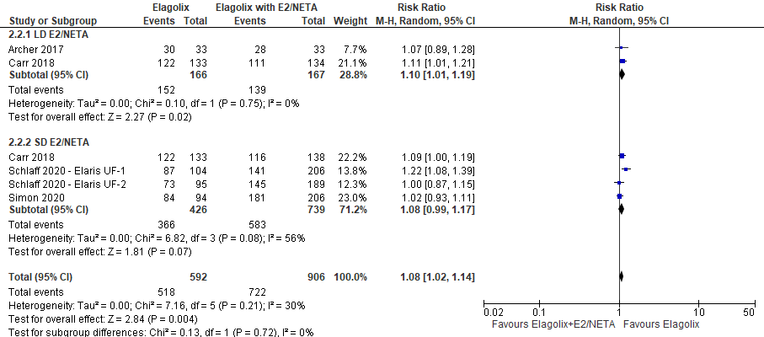
Additional Figure 14: Comparison between elagolix and elagolix with estradiol/norethindrone acetate for the outcome reduction of more than 50% menstrual blood loss by dosage.
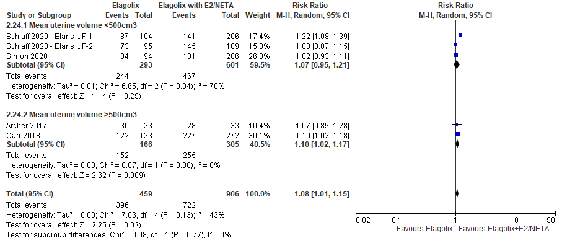
Additional Figure 15: Comparison between elagolix and elagolix with estradiol/norethindrone acetate for the outcome reduction of more than 50% menstrual blood loss by uterine volume.
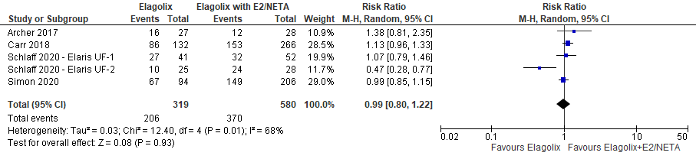
Additional Figure 16: Comparison between elagolix and elagolix with estradiol/norethindrone acetate for the improvement in hemoglobin level.
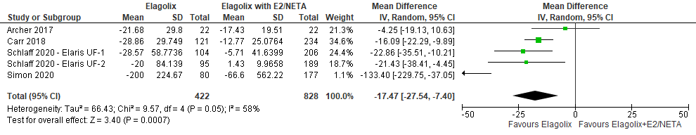
Additional Figure 17: Comparison between elagolix and elagolix with estradiol/norethindrone acetate for the outcome uterine volume.
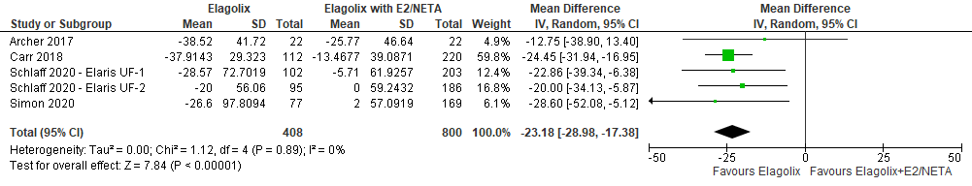
Additional Figure 18: Comparison between elagolix and elagolix with estradiol/norethindrone acetate for the outcome fibroid volume.

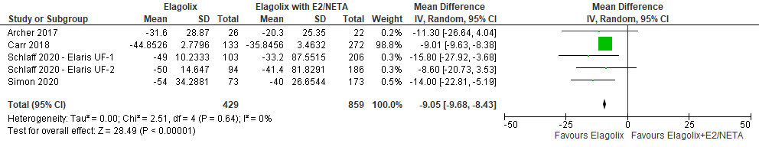
Additional Figure 19: Comparison between elagolix and elagolix with estradiol/norethindrone acetate for the outcome symptoms severity.

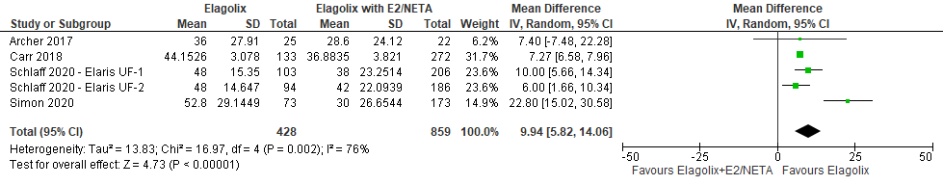
Additional Figure 20: Comparison between elagolix and elagolix with estradiol/norethindrone acetate for the health-related quality of life.

APPENDIX 1
Search strategy
CENTRAL, PubMed, ScienceDirect, SCOPUS, EBSCOHOST
1 leiomyoma
2 fibroid
3 #1 OR #2
4 menorrhagia
5 #3 AND #4
6 ELAGOLIX
7 #5 AND #6
8 "menorrhagia"[MeSH Terms] OR "menorrhagia"[All Fields] OR "menorrhagias"[All Fields] OR ("menorrhagia"[MeSH Terms] OR "menorrhagia"[All Fields] OR ("heavy"[All Fields] AND "menstrual"[All Fields] AND "bleeding"[All Fields]) OR "heavy menstrual bleeding"[All Fields])
9 "elagolix"[Supplementary Concept] OR "elagolix"[All Fields]
10 ((menorrhagia) OR (heavy menstrual bleeding) AND ((ffrft[Filter]) AND (fha[Filter]) AND (randomizedcontrolledtrial[Filter]) AND (fft[Filter]))) AND (elagolix AND ((ffrft[Filter]) AND (fha[Filter]) AND (randomizedcontrolledtrial[Filter]) AND (fft[Filter])))
11 ("menorrhagia"[MeSH Terms] OR "menorrhagia"[All Fields] OR "menorrhagias"[All Fields] OR ("menorrhagia"[MeSH Terms] OR "menorrhagia"[All Fields] OR ("heavy"[All Fields] AND "menstrual"[All Fields] AND "bleeding"[All Fields]) OR "heavy menstrual bleeding"[All Fields])) AND ("loattrfree full text"[Filter] AND "hasabstract"[All Fields] AND "randomized controlled trial"[Publication Type] AND "loattrfull text"[Filter]) AND (("elagolix"[Supplementary Concept] OR "elagolix"[All Fields]) AND ("loattrfree full text"[Filter] AND "hasabstract"[All Fields] AND "randomized controlled trial"[Publication Type] AND "loattrfull text"[Filter]).

