Supplemental Materials
Development of a gRNA-tRNA array of CRISPR/Cas9 in combination with grafting technique to improve gene editing efficiency of sweet orange

Xiaomei Tang¹ · Shulin Chen¹ · Huiwen Yu² · Xiongjie Zheng^{1, 3} · Fei Zhang¹ · Xiuxin Deng¹ · Qiang Xu¹*
1 Key Laboratory of Horticultural Plant Biology Ministry of Education, Huazhong Agricultural University, Wuhan, the People’s Republic of China
2 Key Laboratory of Landscape Plants with Fujian and Taiwan Characteristics of Fujian Colleges and Universities, Minnan Normal University, Zhangzhou 363000, China
3 Present address: Division of Biological and Environmental Science and Engineering, Center for Desert Agriculture, the BioActives Lab, King Abdullah University of Science and Technology (KAUST), Thuwal 23955-6900, Saudi Arabia
* xuqiang@mail.hzau.edu.cn
Xiaomei Tang and Shulin Chen contributed equally to this work.

Supplementary Tab. S1 Primers used in this study for the PCR amplification of PTG/Cas9 vectors and CsPDS gene, sequencing of AtU6-26-sgRNA-SK and PTG/Cas9 and amplification of off target gene.

Primer name | Sequence of primers (5’-3’) | Usage
tRNA-F | AACAAAGCACCAGTGGTCTAGTGGTAGAATAGTACCCTGCCACGGTACAG | tRNA fragment amplifying
tRNA-R | TGCACCAGCCGGGAATCGAACCCGGGTCTGTACCGTGGCAGGGTACTATTC
BsaI-tRNA-F | GCTAGAGTCGAAGTAGTGATTGAACAAAGCACCAGTGGTCTAG | PTG/Cas9 vectors construction
BsaI-tRNA-gRNA1-R | GCTATTTCTAGCTCTAAAACGCACCAGCAATTACAACTT
BsaI-tRNA-gRNA2-R | GCTATTTCTAGCTCTAAAACGATGAACTGTCAATGCAATG
BsaI-tRNA-gRNA3-R | GCTATTTCTAGCTCTAAAACGTACAATTGCTTGTGCACAC
sgRNA-tRNA-F | GCACCGAGTCGGTGCTTTTTTTAACAAAGCACCAGTGGTCTAGTGG
sgRNA-tRNA-R | CCACTAGACCACTGGTGCTTTGTTAAAAAAAGCACCGACTCGGTGC
SK-gRNA-F | CTCACTATAGGGCGAATTGG | Primers for gene editing vectors verification
1300-gRNA-F | CCAGTCACGACGTTGTAAAAC
1300-gRNA-R | CAATGAATTTCCCATCGTCGAG
gRNA1-F | TTTCCGAGATAGTGAACCGATGG | Amplification primers for target gRNA1
gRNA1-R  gRNA2-F | ACACACCCATAGGCTCCATTTCA
 | CAACCTTCAGATTTGGTGAGAGA | Amplification primers for target gRNA2
gRNA2-R | ATACAGGTTTCACAAGGCAGAGA
gRNA3-F | TCCGAGCCATACAAATACTACGA | Amplification primers for target gRNA3
gRNA3-R | CGAGTCGGAGATTAGCAACAAGT
gRNA1-DQ-F | ggagtgagtacggtgtgcAGGTTTGGTTGTTATTATTCTT | Amplification primers of target gRNAs for Hi-Tom sequencing
gRNA1-DQ-R  gRNA2-DQ-F | gagttggatgctggatggTAGAGGAGAAGAAAATGAAGTC  ggagtgagtacggtgtgcTTCTCCATCTTCAAAAGTTCAA
gRNA2-DQ-R | gagttggatgctggatggATACAGGTTTCACAAGGCAGA
gRNA3-DQ-F | ggagtgagtacggtgtgcTGTGAACCTTGCCGTCCCTTA
gRNA3-DQ-R | gagttggatgctggatggCAGCAATGCCAAGCCACAAAG
Off target1-F | ATTTTTAAGTTCGAAGATATG | Off target primers for gRNA1
Off target1-R | ATCTTACTCCAGTCATTTAATC
Off target2-F | CCATCTTCTAATCTTTCTCTG | Off target primers for gRNA2
Off target2-R | ATTTTGTCAAAGTAGTGTTAC
Off target3-F | CCACTGGAACTGGTGGAATC | Off target primers for gRNA3
Off target3-R | TGATCATGGATATAAGAAGAC
Note: the nucleotides in red color represent Hi-Tom sequencing adapter primers.

Supplementary Fig. 1 Mutation detection of three target sites induced by PTG/Cas9. T0 lines are A1#12, B1#2, and C1#31. The sequences in green indicates three gRNAs, PAM are marked in blue. Deleted nucleotides are listed as dots, the mutated nucleotides are shown in red. The lengths of the deletions (D), insertions (I) and mutations are presented on the right of the sequences.
Supplementary Fig. 2 Agrobacterium-mediated highly efficient genetic transformation of Anliu sweet orange. (a) Schematic represents the complete procedure for the generation of gene-edited sweet orange. (b) The transformation efficiency of Anliu sweet orange transformed with PTG/Cas9 vectors A1, B1 and C1.

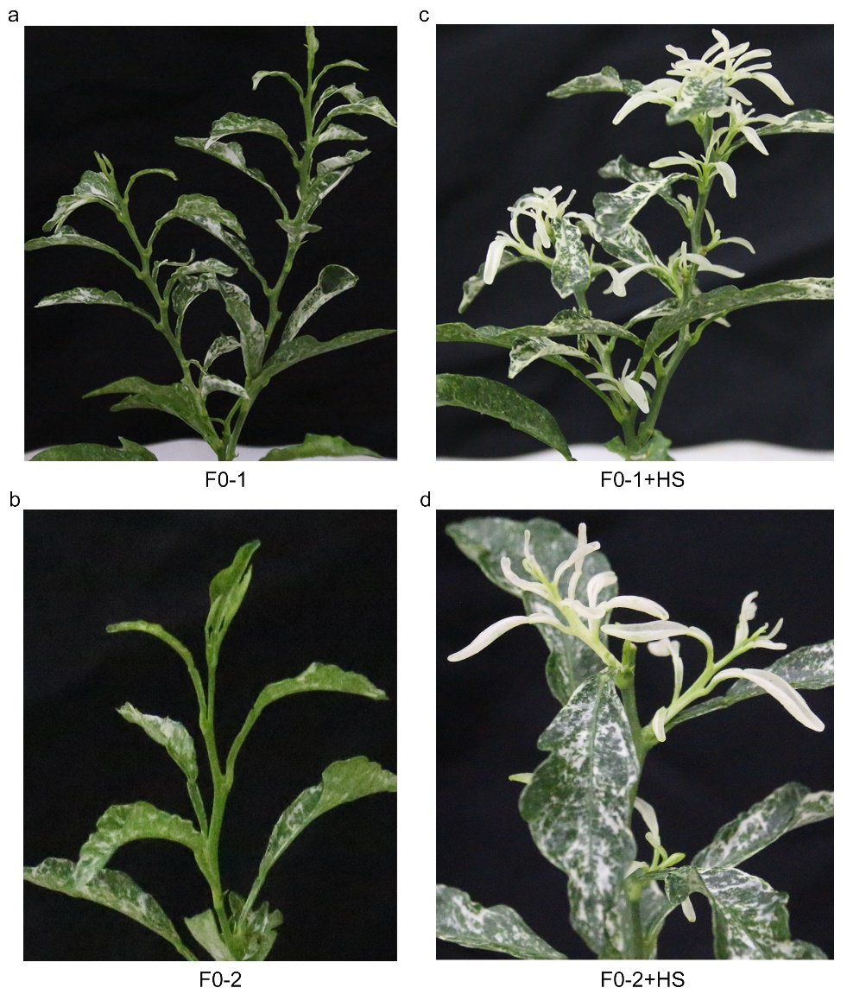
Supplementary Fig. 3 (a-b) Phenotypes of grafted CsPDS gene-edited chimeric seedlings (F0-1 and F0-2) cultivated in green house at 25°C. (c-d) New albino leaf-shoots formed on F0-1 and F0-2 chimeric seedlings 15 days after heat stress treatment of 37°C (The shoots of F0-1 and F0-2 chimeric seedlings were removed before heat stress treatment).

Materials and Methods
Plant materials and growth conditions
Seeds of Anliu sweet orange (Citrus sinensis Osbeck) were collected and sterilized with 30% (v/v) sodium hypochlorite for 15-20 mins, following with sterile water for three to five times, the seeds were sowed in MT basal medium and cultured in the dark room at 25ºC for 20-30 days. The etiolated seedlings were transferred into light room for 7-10 days with 16 h of light and 8 h of darkness.
Expression vector construction
Phytoene desaturase (PDS) gene was selected as targeted gene. Three gRNAs were selected in the coding region, namely gRNA1, gRNA2 and gRNA3 as previously reported (Jia and Wang 2014; Zhang et al. 2017), and the Cas9 binary construct was pCAMBIA1300-pYAO:Cas9-eGFP (Yan et al. 2015; Zhang et al. 2017). Fragments containing tRNA and gRNA were amplified from the vector pGTR (Xie et al. 2015) using the forward primer BsaI-tRNA-F and the reverse primers BsaI-tRNA-gRNA1-R/BsaI-tRNA-gRNA2-R/BsaI-tRNA-gRNA3-R, and inserted into the vector AtU6-26-sgRNA-SK (Yan et al. 2015) linearized with Bsa I. Fragments g1, g2 and g3 were amplified from vector AtU6-26-sgRNA-SK containing tRNA and gRNAs using primers BsaI-tRNA-F/sgRNA-tRNA-R, sgRNA-tRNA-F/BsaI-tRNA-gRNA2-R or BsaI-tRNA-gRNA3-R. Fragments g12 and g13 were amplified from fragments g1 and g2 or g1 and g3 using primers BsaI-tRNA-F, BsaI-tRNA-gRNA2-R/BsaI-tRNA-gRNA3-R, and inserted into vector AtU6-26-sgRNA-SK. Fragment g12-1 was amplified from vector AtU6-26-sgRNA-SK containing g12 using primers BsaI-tRNA-F/sgRNA-tRNA-R, Fragment g123 was amplified from g12-1 and g3 using primers BsaI-tRNA-F/BsaI-tRNA-gRNA3-R and inserted into vector AtU6-26-sgRNA-SK. The constructs of AtU6-26-sgRNA-SK containing corresponding gRNAs were sequenced by primer SK-gRNA-F, the positive plasmids were digested with Spe I and Nhe I, and transferred into the binary vector of pCAMBIA1300-pYAO:Cas9-eGFP as previous reported (Yan et al. 2015; Zhang et al. 2017).
Genetic transformation of sweet orange
The three constructs were transferred into Agrobacterium tumefaciens strain EHA105. The stems (1-2 cm) were dipped into Agrobacterium tumefaciens suspension medium containing different vectors and shaken for 15 mins at 200 rpm, following with vacuum negative pressure of 0.6 Mpa for 5 mins. The stems were transferred into MS medium containing 20 mg/L Acetosyringone (AS), 0.5 g/L Malt extract and 1.5 g/L L-glutamine at 21-23ºC for 3 days. The stems were washed three times with sterilized water and transferred to the regeneration medium (MT + 40 g/L sucrose + 0.5 mg/L 6-BA + 0.5 mg/L KT + 0.1 mg/L NAA + 8.0 g/L Agar+ 25 mg/L Km + 400 mg/L Cef, pH 5.85) under a 7 days dark culture at 25ºC, following with 16 h of light / 8 h of darkness at 25ºC for 30-60 days.
Mutation detection and off-targets analysis
Genomic DNA was extracted from Anliu sweet orange leaves according to previous report (Cheng et al. 2003). In order to validate T-DNA insertion, target specific primers (S1 Table) were designed and used for PCR amplification containing the gRNAs, the PCR products were sequenced using Hi-Tom sequencing technology (Liu et al. 2019) at the experimental base of National Rice Research Institute in Fuyang city of China. We further verified the mutation types by introducing the PCR products to the TA/Blunt-Zero vector (Vazyme, Nanjing, China), eight positive clones were selected for sanger sequencing. The primers to detect the potential off-target sites of three gRNAs were listed in S1 Table, the amplified products were purified for sanger sequencing. The sequence alignment analysis was performed using the BioEdit and DNAMAN software.
Grafting and heat stress treatment of transgenic seedlings
The transgenic seedlings with 3-4 true leaves were used for grafting and 30-60 days old Anliu sweet orange seedlings were used as rootstocks. The base of the transgenic scions were cut to a matching V-shape and inserted into the rootstocks, the grafting point was wrapped with parafilm. The grafted seedlings were cultured in the tube with running water and transferred into light room with 16/8 h (day/night) photoperiod about 2 weeks until new leaves came out. Decapitated 10-month old grafting plants were subjected to heat stress treatments (37°C for 24 h, 25°C for 24 h) for 15 days.

Supplementary references
Cheng Y, Guo W, Yi H, Pang X, Deng X (2003) An efficient protocol for genomic DNA extraction from Citrus species. Plant Mol Biol Rep 21 (2):177-178. doi:10.1007/BF02774246
Jia H, Wang N (2014) Targeted Genome Editing of Sweet Orange Using Cas9/sgRNA. Plos One 9:e93806. doi:10.1371/journal.pone.0093806
Liu Q, Wang C, Jiao X, Zhang H, Song L, Li Y, Gao C, Wang K (2019) Hi-TOM: a platform for high-throughput tracking of mutations induced by CRISPR/Cas systems. Sci China Life Sci 62 (1):1-7. doi:10.1007/s11427-018-9402-9
Xie K, Minkenberg B, Yang Y (2015) Boosting CRISPR/Cas9 multiplex editing capability with the endogenous tRNA-processing system. Proc Natl Acad Sci U S A 112 (11):3570-3575. doi:10.1073/pnas.1420294112
Yan L, Wei S, Wu Y, Hu R, Li H, Yang W, Xie Q (2015) High-Efficiency Genome Editing in Arabidopsis Using YAO Promoter-Driven CRISPR/Cas9 System. Mol Plant 8 (12):1820-1823. doi:10.1016/j.molp.2015.10.004
Zhang F, LeBlanc C, Irish VF, Jacob Y (2017) Rapid and efficient CRISPR/Cas9 gene editing in Citrus using the YAO promoter. Plant Cell Rep 36 (12):1883-1887. doi:10.1007/s00299-017-2202-4

