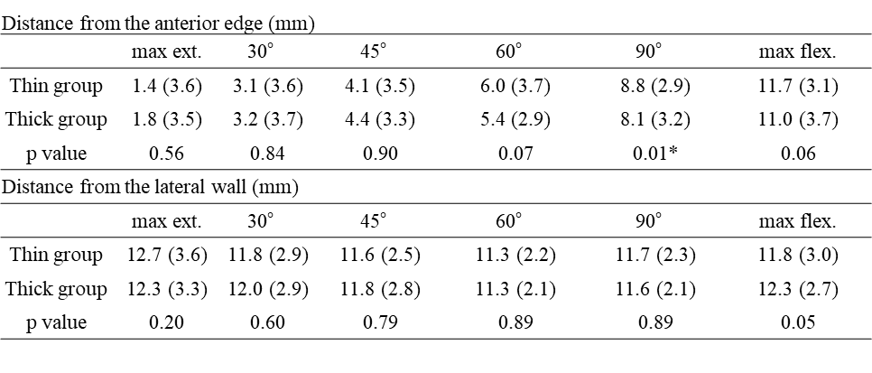
Average (standard deviation)
max. ext.: maximum extension, max flex.: maximum flexion
Table 3 Intraoperative bearing movement of Point B for the mobile bearing

