CD123 expression (MFI) (x 1.000)

IL-3 GM-CSF
IL-4 IL-2 IL-15 IFN- IFN-
IL-6 TNF-

IL-3 GM-CSF
IL-5 IL-2 IL-15 IFN- IFN-
IL-6 TNF-
✱✱✱
✱✱✱
✱✱✱
CD14+ monocytes
c
15
✱✱✱
✱✱✱
10
5
0
CD131 expression (MFI) (x 1.000)

CD11b expression (MFI) (x 1.000)
✱✱✱
✱✱✱
✱✱✱
80
60
40
✱✱✱
✱✱✱
20
✱✱
✱
0
Suppl. Fig. 1

CD131 expression (MFI) (x 1.000)

IL-3 GM-CSF
IL-4 IL-2 IL-15 IFN- IFN-
IL-6 TNF-

IL-3 GM-CSF
IL-5 IL-2 IL-15 IFN- IFN-
IL-6 TNF-
3
2
1
✱✱✱
✱✱✱
0
Neutrophils
d
✱✱✱

Basophils
pDCs
a
b
✱✱✱
✱✱✱
✱✱
✱✱✱
✱✱✱
✱✱✱
✱✱✱
✱✱✱
✱
✱

Supplementary Fig. 1 Cytokine induced changes of surface markers in a whole blood assay. a-d Whole blood from a healthy donor was cultured in duplicates for 24 hours at 37°C with or without cytokines (IL-2, IL-3, IL-4, IL-5, IL-6, IL-15, GM-CSF, IFN-γ, IFN-α and TNF-α, 20 ng/ml each).
Samples were analyzed by flow cytometry and absolute values of indicated cell surface markers are depicted as mean fluorescence intensity (MFI). a Expression of CD131 on basophils. b Expression of CD131 on pDCs. c Expression of CD123 on CD14+ monocytes. d Expression of CD11b on neutrophils. Data represent mean +/- standard deviation. Statistical differences between medium control and the various cytokines were calculated by one-way ANOVA with Bonferroni multiple comparison test (* p<0.05, ** p<0.01, *** p<0.001).

- Basophils
✱✱✱
✱✱✱
✱✱✱
✱✱✱
✱✱✱
✱✱✱
✱✱✱
Healthy Non-vent. Vent.

5
(x 1.000)

4

3
CD131 MFI

2

1

0

- pDCs
✱✱✱
✱✱✱ ✱✱
✱✱✱
Healthy Non-vent. Vent.

3
(x 1.000)

2
CD131 MFI

1
Basophils
✱✱✱
5 ✱✱✱
4

3

2

1

0 Survived Dead.
Ventilated
pDCs

3
CD131 MFI (x 1.000)

2

1

Medium Anti-CD3
Anti-CD3 + anti-IL-3

Medium Anti-CD3
Anti-CD3 + anti-IL-3

0

- Monocytes
0 Survived Dead
Ventilated

Monocytes

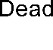
40
✱✱✱
✱✱✱
✱✱✱
✱✱✱
Healthy Non-vent. Vent.

✱✱✱
✱✱✱
CD123 MFI (x 1.000)

30 Medium
Anti-CD3
20 Anti-CD3 + anti-IL-3
10

0

- Neutrophils Neutrophils

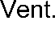
Medium Anti-CD3
✱✱✱
✱✱✱ ✱✱✱
✱✱✱ ✱✱✱
✱✱✱

✱✱✱
✱✱✱
CD11b MFI
(x 1.000)
CD11b MFI (x 1.000)
Anti-CD3 + anti-IL-3

Suppl. Fig. 2

Supplementary Fig. 2 T cell reactivity in COVID-19 patients and healthy controls. a-d Whole blood from 38 healthy controls (Healthy; 38 samples), 33 non-ventilated (Non-vent.; 58 samples) and 21 mechanically ventilated (Vent.; 77 samples) COVID-19 patients was cultured without stimulation (medium), with immobilized anti-CD3, or with immobilized anti-CD3 plus anti-IL-3 (10 µg/ml) for 24h. Ventilated patients were stratified into “survived” (17 patients, 69 samples) and “dead” (4 patients, 8 samples). Expression of surface markers was quantified by flow cytometry and absolute expression values of indicated markers are shown as mean fluorescence intensity (MFI) on basophils (a), pDCs (b), CD14+ monocytes (c) and neutrophils (d). Bar graphs show mean +/- SEM (standard error of the mean). One-way ANOVA with Bonferroni multiple comparison test was used and statistical significance is only shown for differences between medium, anti-CD3 and anti-CD3+anti- IL-3 within each group of individuals. (* p<0.05, ** p<0.01, *** p<0.001).

Basophils Monocytes Neutrophils

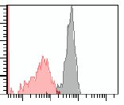
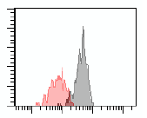
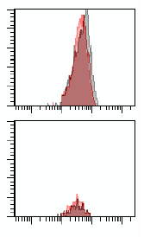
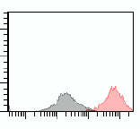
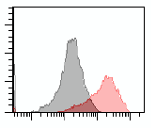
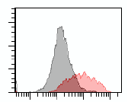
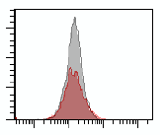
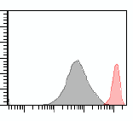
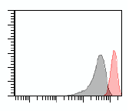
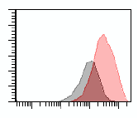
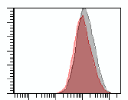
Healthy
25
20
15
10
5
0
102 103 104 105
150
100
50
0
102 103 104 105
1500
1250
1000
750
500
250
0
102 103 104 105

Non- ventilated

Ventilated Survived

Ventilated Dead
Cell count
Cell count
Cell count

CD131-PE
CD123-PE-Cy5
CD11b-PE-Cy7

Medium Anti-CD3

Suppl. Fig. 3

Supplementary Fig. 3 Representative FACS histogram plots for whole blood stimulation. Whole blood from various donors as indicated was cultured with (red) or without (grey) immobilized anti- CD3 for 24h. Expression of surface markers was quantified by flow cytometry and representative histogram plots are shown.

a b
Basophils
M F
M F
M F
Healthy Non-vent. Ventilated
pDCs
M F
M F
M F
Healthy Non-vent. Ventilated
5 3

4
CD131 MFI (x 1.000)
CD131 MFI (x 1.000)
2
3
Medium
2 1 Anti-CD3
1

0 0

c Monocytes d Neutrophils

Medium Anti-CD3
✱✱✱
✱
CD123 MFI (x 1.000)
CD11b MFI (x 1.000)

Suppl. Fig. 4

Supplementary Fig. 4 Gender specific analysis of T cell activation and immunophenotypes. a-d Whole blood from healthy controls (14 samples from 14 males and 24 samples from 24 females), non- ventilated COVID-19 patients (27 samples from 16 males and 31 samples from 17 females) and mechanically ventilated COVID-19 patients (62 samples from 16 males and 15 samples from 5 females) was cultured with or without immobilized anti-CD3 for 24h. Expression of surface markers was quantified by flow cytometry and absolute expression values of indicated markers are shown as mean fluorescence intensity (MFI) on basophils (a), pDCs (b), CD14+ monocytes (c) and neutrophils (d). Bar graphs show mean +/- SEM (standard error of the mean). One-way ANOVA with Bonferroni multiple comparison test was used and statistical significance is only shown for differences between males and femals within each group of individuals. (* p<0.05, *** p<0.001).

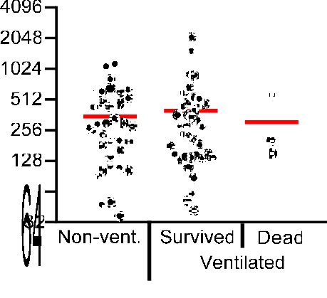
a Basophils b Monocytes
CD131 downregultion by
(% of control)
CD123 upregulationI by
T cell activation (% of control)

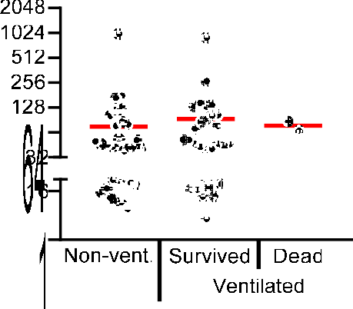

c CD8+ T cells d
CD25 upregulation by
T cell activation (% of control)
T cell activation
CD25 upregulation by
T cell activation (% of control)
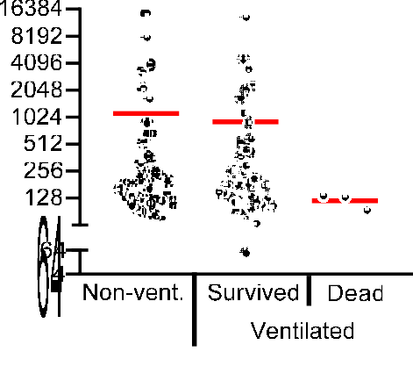
e
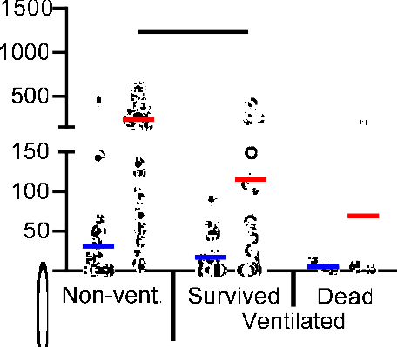
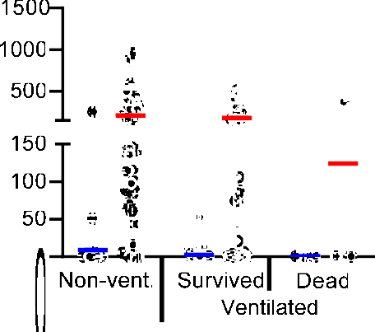
✱✱✱ ✱✱✱
✱✱✱
✱✱✱ ✱✱
CD4+ T cells
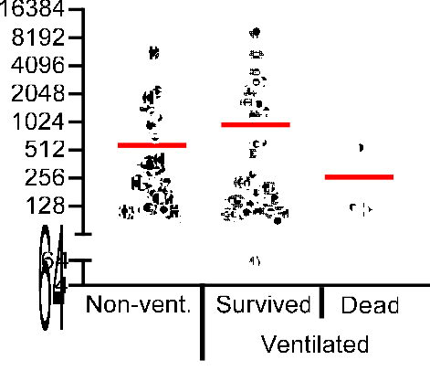

8000

Suppl. Fig. 5

4000
IL-3 (pg/ml)
GM-CSF (pg/ml)
1000
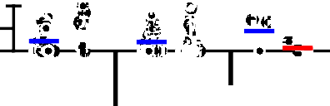
100
50
0

f

Non-vent. Survived Dead
IFNy (pg/ml)
Ventilated

1500
1000
500
1500 ✱✱
1000
500
GM-CSF (pg/ml)
IFNy (pg/ml)
✱ Medium Anti-CD3
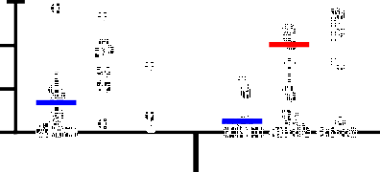
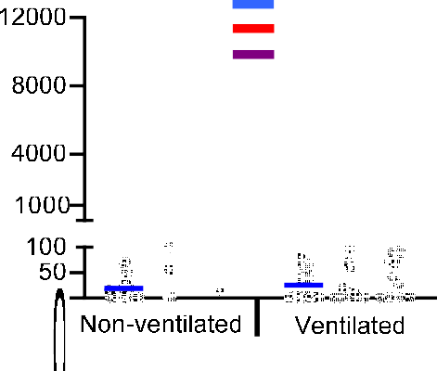
Anti-CD3+IL-2

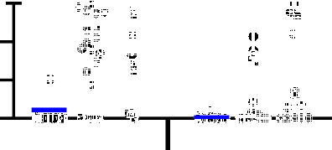
150
Non-ventilated
Ventilated
100
50
0
150
100
50
0

Non-ventilated Ventilated

Supplementary Fig. 5 T cell reactivity analyzed with PBMC from COVID-19 patients. a-e PBMCs from 25 non-ventilated COVID-19 patients (Non-vent.; 36 samples), 14 mechanically ventilated COVID-19 patients that were discharged from the ICU (Ventilated Survived, 39 samples) and 2 mechanically ventilated COVID-19 patients that died on the ICU (Ventilated Dead, 3 samples) were cultured with or without anti-CD3 (5 µg/ml) for 24h. Analysis of basophils was not possible in all samples because basophil numbers were too low in some samples. Expression of indicated surface markers was quantified by flow cytometry on basophils (a), CD14+ monocytes (b), CD8+ T cells (c) and CD4+ T cells (d). Values depict the ratio of surface marker expression with anti-CD3 and surface marker expression without anti-CD3 in percent. Each sample is represented by one dot and the mean is marked in red. e Concentrations of IL-3, GM-CSF and IFNγ were measured in the culture supernatant by ELISA. Each sample is represented by one dot and the mean is marked in blue (Medium) or red (anti-CD3). One-way ANOVA with Bonferroni multiple comparison test was used. (* p<0.05, ** p<0.01, *** p<0.001). f PBMCs from 22 non-ventilated COVID-19 patients (28 samples) and 12 ventilated COVID-19 patients (26 samples) were cultured with medium alone, with anti-CD3 or with anti-CD3 plus IL-2 (20 ng/ml) for 24h. Concentrations of IL-3, GM-CSF and IFNγ were measured in the culture supernatant by ELISA. Each sample is represented by one dot and the mean is marked in blue (Medium), red (anti-CD3) or purple (anti-CD3+IL-2). One-way ANOVA with Bonferroni multiple comparison test was used. (* p<0.05, ** p<0.01, *** p<0.001).

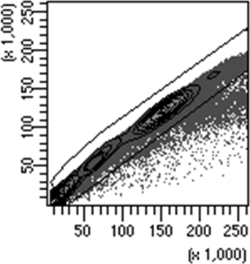
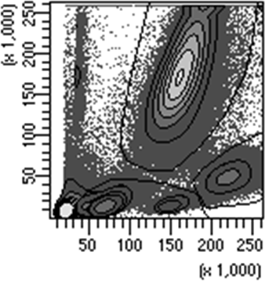
a Gating Singlets
Singlets
N
M
L
FSC-A
FSC-A
FSC-H

b Panel 1

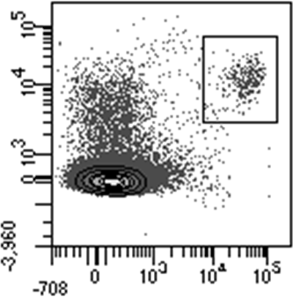
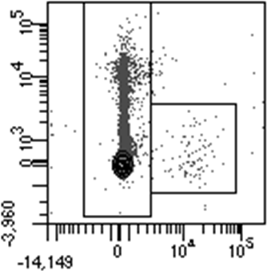
From Gate „L“
Non-pDCs
Basos
pDCs
CD11b-PE-Cy7-A

CD304 APC-A
From Gate „N“
CD11b-PE-Cy7-A

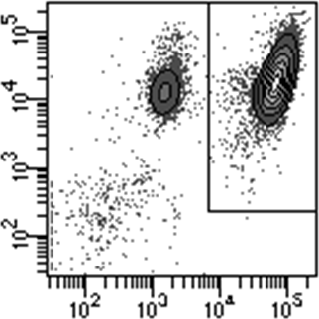
Neutros
CD16 Pacific Blue-A

From Singlets

From Gate Non-pDCs
SSC-A
CD11b-PE-Cy7-A

CD123 PerCP-Cy5-5-A

From Gate „M“
CD14 AmCyan-A

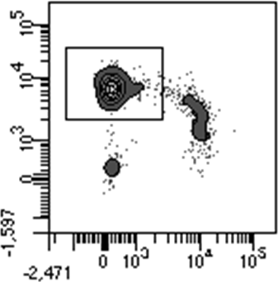
CD14+
Monos
CD16 Pacific Blue-A
Panel 1: Panel 2:

Antibody | Format
CD116 | FITC
CD123 | PE-Cy5
CD131 | PE
CD304 | APC
CD11b | PE-Cy7
CD193 | APC-Cy7
CD16 | Pacific Blue
CD14 | V500

Antibody | Format
CD116 | FITC
CD123 | PE-Cy5
CD131 | PE
HLA-DRII | APC
CD8 | PE-Cy7
CD3 | APC-Cy7
CD19 | Pacific Blue
CD4 | V500

Panel 3: Panel 4:

Antibody | Format
CD116 | FITC
CD169 | PE
CD3 | APC-Cy7
CD16 | Pacific Blue
CD14 | V500

Antibody | Format
HLA-DRII | FITC
CD123 | PE-Cy5
CD131 | PE
CD25 | APC
CD11b | PE-Cy7
CD8 | APC-Cy7
CD16 | Pacific Blue
CD4 | V500

From Gate „M“
CD123 PerCPCy5.5-A

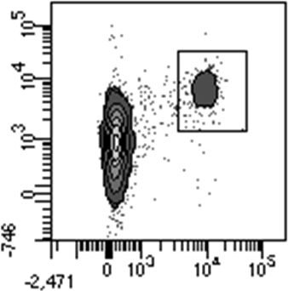

CD16+
Monos
CD16 Pacific Blue-A

c Panel 2
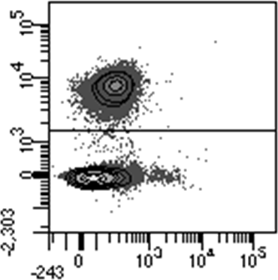
From Gate „L“
T cells
CD3 APC-Cy7-A
CD8 PE-Cy7-A

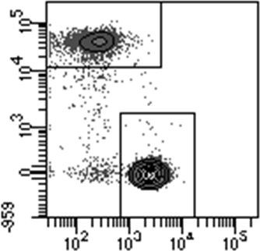
From T cells
CD8+
T cells
CD4+
T cells
CD116 FITC-A

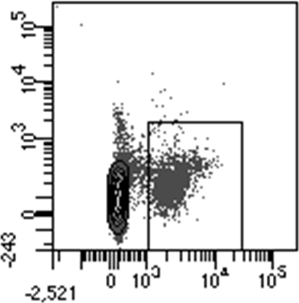
From Gate „L“
B cells

CD116 FITC-A
CD4 AmCyan-A
CD19 Pacific Blue-A

Suppl. Fig. 6

Supplementary Fig. 6 Gating strategy to detect key leukocyte subpopulations by flow cytometry. Gating strategy to identify pDCs, basophils, CD14+ monocytes, CD16+ monocytes (a), and T and B cells (b).

 | Healthy | Covid-19 all | Covid-19 non-ventilated | Covid-19 ventilated  all | Covid-19 ventilated  survived | Covid-19 ventilated  dead
Laboratory values: (demographics)
Number of samples (n) | 42 | 188 | 68 | 120 | 101 | 19
Number of patients (n) | 42 | 55 | 39 # | 30 | 23 | 7
Laboratory values: (mean)
Procalcitonin (ng/ml) |  | 1.6 | 1.1 | 1.7 | 1.1 | 4.5 **
CRP (mg/l) |  | 69.6 | 35.6 | 86.1 *** | 76.1 | 141,2 **
IL-6 (pg/ml) |  | 85.0 | 23.9 | 94.3 | 71.1 | 216,4 ***
Ferritin (ng/ml) |  | 2721.9 | 1158.2 | 3018.5 | 1561.6 | 10950,4 ***
LDH |  | 340.2 | 273.9 | 370.6*** | 361.1 | 423,3
ALAT (U/L) |  | 75.0 | 62.9 | 80.7 | 74.0 | 116,6 *
Bilirubin (mg/dl) |  | 2.2 | 0.9 | 2.8 * | 0.9 | 12,5 ***
CK (U/L) |  | 125.7 | 65.5 | 153.1 | 156.7 | 132,6
D-Dimer (mg/L) |  | 8.2 | 4.0 | 8.6 * | 9.0 | 6,4
Leucocytes (/nl) |  | 13.0 | 11,4 | 13.8 | 11.5 | 25,8 ***

# 14 patients were sampled on ventilation and also after weaning.

Suppl. Tab. 1

Supplementary Tab. 1 Clinical laboratory characteristics of COVID-19 patients and healthy controls
COVID-19 patients were subgrouped into non-ventilated and ventilated patients. Ventilated patients were further subgrouped into “Survived” and “Dead”. In most patients several consecutive blood samples were available. 14 patients were first sampled on ventilation and also after weaning from ventilation. 2-tailed unpaired t-test was used to calculate statistical differences between non-ventilated and ventilated patients as well as between “Survived” and “Dead” patients. 2-tailed unpaired t-test was used to calculate statistical differences (* p<0.05, ** p<0.01, *** p<0.001).

 | Virus persistence in days  (mean +/- SEM) | Persistence of T cell anergy in days (mean +/- SEM), measured by CD123 upregulation on monocytes | Persistence of T cell anergy in days (mean +/- SEM), measured by CD11b upregulation on neutrophils
Patients with virus persistence < 15 days | 5.8 (± 1.1) | 5.3 (± 2.7) | 10.6 (± 3.3)
Patients with virus persistence ≥ 15 days | 31.0 *** (± 3.1) | 24.0 ** (± 4.8) | 23.9 * (± 4.6)

Suppl. Tab. 2

Supplementary Tab. 2 Correlation between persistence of SARS-CoV-2 replication and persistence of T cell anergy. Virus persistence was defined as the period from the day of first clinical symptoms to the last day of positive virus RT-PCR. Patients were stratified in two groups by virus persistence < 15 days (n=18) or ≥ 15 days (n=25). T cell reactivity was quantified by upregulation of CD123 on monocytes or CD11b on neutrophils as described in Fig. 1. T cell anergy was defined as an upregulation < 300% for both surface markers. Persistence of T cell anergy was defined as the period from the day of first clinical symptoms to the last day of T cell anergy. 2-tailed unpaired t-test was used to calculate statistical differences between the two groups of patients. (* p<0.05, ** p<0.01, *** p<0.001).

