Relationship between leukocyte counts and large vessel occlusion in acute ischemic stroke
Tarkanyi G, Karadi ZN, Szabo Z, Szegedi I, Csiba L, Szapary L.
Supplementary material

Table S1. Univariable associations between baseline characteristics and the presence of LVO in acute ischemic stroke
 | Crude odds ratio  (95% CI) | P value
Demographic characteristics
Age, 1-year increase | 1.011 (0.994 to 1.027) | 0.200
Gender, female gender | 1.738 (1.170 to 2.581) | 0.006*
Elapsed times
Onset-to-sample time, 1 min increase | 0.998 (0.995 to 1.002) | 0.396
Sample-to-CTA time, 1 min increase | 0.998 (0.988 to 1.008) | 0.715
Parameters on admission
NIHSS score on admission, 1-point increase | 1.230 (1.173 to 1.289) | <0.001*
On admission SBP, 1 mmHg increase | 0.990 (0.983 to 0.997) | 0.005*
On admission DBP, 1 mmHg increase | 0.983 (0.970 to 0.996) | 0.010*
Body temperature, 1⁰C increase | 0.437 (0.190 to 1.006) | 0.052*
Blood glucose, 1 mmol/L increase | 1.010 (0.947 to 1.077) | 0.758
INR, 1-point increase | 10.947 (2.383 to 50.287) | 0.002*
Vascular risk factors
Smoking | 1.401 (0.896 to 2.192) | 0.139
Hypertension | 1.267 (0.770 to 2.085) | 0.353
Diabetes mellitus | 0.626 (0.392 to 1.000) | 0.050*
Hyperlipidaemia | 0.887 (0.588 to 1.338) | 0.569
Atrial fibrillation | 2.357 (1.469 to 3.781) | <0.001*
Coronary artery disease | 1.258 (0.790 to 2.004) | 0.333
Chronic heart failure | 2.137 (1.118 to 4.084) | 0.022*
Previous stroke/TIA | 0.634 (0.384 to 1.048) | 0.075*
Malignancy | 1.915 (1.037 to 3.537) | 0.038*
Therapy at stroke onset
Antiplatelet | 1.201 (0.792 to 1.819) | 0.388
Anticoagulant | 2.003 (1.101 to 3.643) | 0.023*
Lipid lowering | 1.330 (0.836 to 2.115) | 0.229
Antihypertensive | 1.345 (0.863 to 2.098) | 0.191
Antidiabetic | 0.620 (0.368 to 1.043) | 0.071*
Abbreviation: LVO, large vessel occlusion; CI, Confidence Interval, NIHSS, National Institutes of Health Stroke Scale; SBP, systolic blood pressure; DBP, diastolic blood pressure; INR, International Normalized Ratio; TIA, transient ischemic attack.
* Variables included in the multivariable analysis.

Table S2. Baseline characteristics of patients according to the site of occlusion in the anterior circulation
 | Proximal occlusion  (N=105) | Distal occlusion  (N=42) | P value
Demographic characteristics
Age, years, median (IQR) | 69 (62-78) | 70 (64-81) | 0.346
Gender, female, % (n) | 52.3 (55) | 54.8 (23) | 0.794
Elapsed times
Onset-to-sample time, min, median (IQR) | 75 (52-112) | 91 (70-143) | 0.032
Sample-to-CTA time, min, median (IQR) | 14 (6-22) | 16 (5-28) | 0.985
Parameters on admission
NIHSS score on admission, median (IQR) | 15 (11-19) | 8 (6-11) | <0.001
On admission SBP, mmHg, median (IQR) | 159 (136-180) | 154 (140-169) | 0.514
On admission DBP, mmHg, median (IQR) | 84 (76-96) | 89 (80-96) | 0.489
Body temperature, ºC, median (IQR) | 36.4 (36.1-36.5) | 36.4 (36.0-36.7) | 0.680
Blood glucose, mmol/L, median (IQR) | 6.77 (5.84-7.92) | 6.57 (5.80-7.94) | 0.874
INR, ratio, median (IQR) | 1.02 (0.95-1.09) | 1.02 (0.99-1.12) | 0.259
Vascular risk factors
Smoking, % (n), 33 missing | 36.6 (30) | 35.3 (12) | 0.895
Hypertension, % (n), 4 missing | 78.2 (79) | 85.7 (36) | 0.304
Diabetes mellitus, % (n), 8 missing | 22.2 (22) | 17.5 (7) | 0.535
Hyperlipidaemia, % (n), 17 missing | 52.2 (48) | 47.4 (18) | 0.618
Atrial fibrillation, % (n), 9 missing | 31.6 (31) | 45.0 (2) | 0.170*
Coronary artery disease, % (n), 10 missing | 28.9 (28) | 30.0 (12) | 0.894
Chronic heart failure, % (n), 7 missing | 15.2 (15) | 17.1 (7) | 0.776
Previous stroke/TIA, % (n), 8 missing | 18.4 (18) | 14.6 (6) | 0.595
Malignancy, % (n), 13 missing | 18.8 (18) | 15.8 (6) | 0.687
Therapy at stroke onset
Antiplatelet, % (n), 9 missing | 46.9 (45) | 30.0 (12) | 0.069
Anticoagulant, % (n), 12 missing | 14.4 (14) | 31.6 (12) | 0.023
Lipid lowering, % (n), 10 missing | 29.2 (28) | 24.4 (10) | 0.567
Antihypertensive, % (n), 10 missing | 71.9 (69) | 75.6 (31) | 0.652
Antidiabetic, % (n), 11 missing | 17.7 (17) | 15.0 (6) | 0.701
Leukocyte counts (1x10⁹/L)
Total WBC, median (IQR) | 8.75 (7.13-11.00) | 9.13 (7.22-10.42) | 0.585
Neutrophil, median (IQR) | 5.93 (4.29-7.57) | 5.79 (3.87-7.66) | 0.646
Lymphocyte, median (IQR) | 1.97 (1.38-2.67) | 1.75 (1.33-2.84) | 0.528
Monocyte, median (IQR) | 0.67 (0.49-0.83) | 0.62 (0.50-0.79) | 0.759
Eosinophil, median (IQR) | 0.12 (0.07-0.21) | 0.12 (0.07-0.20) | 0.666
Basophil, median (IQR) | 0.05 (0.03-0.07) | 0.05 (0.04-0.07) | 0.642
NLR, median (IQR) | 2.79 (1.99-4.73) | 2.79 (1.95-6.04) | 0.959
Abbreviation: LVO, large vessel occlusion; NIHSS, National Institutes of Health Stroke Scale; SBP, systolic blood pressure; DBP, diastolic blood pressure; IQR, interquartile range; INR, International Normalized Ratio; TIA, transient ischemic attack; NLR, neutrophil-to-lymphocyte ratio.
Proximal occlusion: ICA and MCA M1; distal occlusion: MCA M2, M3 and ACA A1 and A2
* Fischer exact test
Table S3. Baseline characteristics of patients according to collateral status in the anterior circulation
 | Good collaterals  (N=86) | Poor collaterals (N=56) | P value
Demographic characteristics
Age, years, median (IQR) | 69 (62-79) | 71 (62-81) | 0.448
Gender, female, % (n) | 52.3 (55) | 54.8 (23) | 0.794
Elapsed times
Onset-to-sample time, min, median (IQR) | 79 (50-128) | 83 (60-115) | 0.594
Sample-to-CTA time, min, median (IQR) | 13 (5-22) | 17 (6-26) | 0.256
Parameters on admission
NIHSS score on admission, median (IQR) | 11 (6-16) | 16 (12-19) | <0.001
On admission SBP, mmHg, median (IQR) | 158 (139-170) | 155 (140-179) | 0.685
On admission DBP, mmHg, median (IQR) | 82 (78-92) | 90 (80-99) | 0.337
Body temperature, ºC, median (IQR) | 36.4 (36.0-36.5) | 36.4 (36.1-36.5) | 0.876
Blood glucose, mmol/L, median (IQR) | 6.63 (5.90-7.70) | 6.69 (5.75-8.60) | 0.943
INR, ratio, median (IQR) | 1.00 (0.95-1.07) | 1.03 (0.97-1.12) | 0.141
Vascular risk factors
Smoking, % (n), 30 missing | 36.6 (26) | 34.1 (15) | 0.783
Hypertension, % (n), 4 missing | 82.9 (68) | 76.3 (45) | 0.328
Diabetes mellitus, % (n), 8 missing | 23.1 (18) | 18.6 (11) | 0.529
Hyperlipidaemia, % (n), 17 missing | 54.7 (41) | 47.2 (25) | 0.403
Atrial fibrillation, % (n), 11 missing | 35.4 (28) | 36.8 (21) | 0.867
Coronary artery disease, % (n), 10 missing | 28.2 (22) | 31.6 (12) | 0.672
Chronic heart failure, % (n), 7 missing | 12.5 (10) | 20.7 (12) | 0.195
Previous stroke/TIA, % (n), 8 missing | 17.5 (14) | 17.5 (10) | 0.995
Malignancy, % (n), 13 missing | 16.9 (13) | 20.0 (11) | 0.647
Therapy at stroke onset
Antiplatelet, % (n), 10 missing | 41.0 (32) | 43.9 (25) | 0.742
Anticoagulant, % (n), 11 missing | 18.2 (14) | 21.2 (12) | 0.678
Lipid lowering, % (n), 10 missing | 30.8 (24) | 24.6 (14) | 0.428
Antihypertensive, % (n), 10 missing | 79.5 (58) | 71.9 (41) | 0.753
Antidiabetic, % (n), 10 missing | 20.5 (16) | 12.3 (7) | 0.209
Leukocyte counts (1x10⁹/L)
Total WBC, median (IQR) | 9.23 (7.84-10.97) | 8.55 (6.50-10.42) | 0.105
Neutrophil, median (IQR) | 6.04 (4.47-7.57) | 5.64 (3.87-7.54) | 0.198
Lymphocyte, median (IQR) | 1.96 (1.36-2.86) | 1.97 (1.25-2.40) | 0.226
Monocyte, median (IQR) | 0.67 (0.50-0.87) | 0.61 (0.48-0.78) | 0.203
Eosinophil, median (IQR) | 0.13 (0.07-0.24) | 0.12 (0.07-0.18) | 0.998
Basophil, median (IQR) | 0.05 (0.03-0.08) | 0.04 (0.03-0.06) | 0.360
NLR, median (IQR) | 2.69 (1.97-5.08) | 2.83 (1.85-5.38) | 0.822
Abbreviation: LVO, large vessel occlusion; NIHSS, National Institutes of Health Stroke Scale; SBP, systolic blood pressure; DBP, diastolic blood pressure; IQR, interquartile range; INR, International Normalized Ratio; TIA, transient ischemic attack; NLR, neutrophil-to-lymphocyte ratio.

Table S4. Demography and clinical characteristics of LVO patients according to the location of LVO
 | Anterior LVO  (N=147) | Posterior LVO  (N=20) | P value
Demographic characteristics
Age, years, median (IQR) | 69 (62-79) | 62 (60-69) | 0.016
Gender, female, % (n) | 53.1 (78) | 45.0 (9) | 0.498
Elapsed times
Onset-to-sample time, min, median (IQR) | 82 (54-119) | 94 (61-160) | 0.244
Sample-to-CTA time, min, median (IQR) | 14 (6-24) | 22 (10-31) | 0.060
Parameters on admission
NIHSS score on admission, median (IQR) | 13 (8-18) | 6 (4-12) | 0.004
On admission SBP, mmHg, median (IQR) | 158 (140-174) | 165 (143-190) | 0.213
On admission DBP, mmHg, median (IQR) | 85 (80-96) | 80 (74-99) | 0.767
Body temperature, ºC, median (IQR) | 36.4 (36.1-36.5) | 36.5 (36.2-36.5) | 0.871
Blood glucose, mmol/L, median (IQR) | 6.70 (5.81-7.94) | 7.63 (6.49-9.97) | 0.014
INR, ratio, median (IQR) | 1.02 (0.95-1.09) | 0.99 (0.96-1.03) | 0.087
Vascular risk factors
Smoking, % (n), 34 missing | 36.2 (42) | 58.8 (10) | 0.104*
Hypertension, % (n), 4 missing | 80.4 (115) | 90.0 (18) | 0.374*
Diabetes mellitus, % (n), 8 missing | 20.9 (29) | 25.0 (5) | 0.771*
Hyperlipidaemia, % (n), 17 missing | 50.8 (66) | 50.0 (10) | 0.949 *
Atrial fibrillation, % (n), 9 missing | 35.6 (49) | 15.0 (3) | 0.078*
Coronary artery disease, % (n), 11 missing | 29.2 (40) | 16.7 (3) | 0.402*
Chronic heart failure, % (n), 7 missing | 15.7 (22) | 10.0 (2) | 0.741*
Previous stroke/TIA, % (n), 8 missing | 17.3 (24) | 25.0 (4) | 0.756*
Malignancy, % (n), 15 missing | 17.9 (24) | 5.6 (1) | 0.310*
Therapy at stroke onset
Antiplatelet, % (n), 13 missing | 41.9 (57) | 27.8 (5) | 0.312*
Anticoagulant, % (n), 14 missing | 19.3 (26) | 5.6 (1) | 0.200*
Lipid lowering, % (n), 12 missing | 27.7 (38) | 27.8 (5) | 0.997*
Antihypertensive, % (n), 12 missing | 73.0 (100) | 72.2 (13) | 0.945*
Antidiabetic, % (n), 14 missing | 16.9 (23) | 11.8 (2) | 0.741*
Leukocyte counts (1x10⁹/L)
Total WBC, median (IQR) | 8.77 (7.13-10.97) | 10.46 (9.30-12.41) | 0.005
Neutrophil, median (IQR) | 5.89 (4.20-7.60) | 7.06 (5.98-9.99) | 0.010
Lymphocyte, median (IQR) | 1.94 (1.34-2.70) | 2.22 (1.60-3.32) | 0.224
Monocyte, median (IQR) | 0.64 (0.49-0.83) | 0.76 (0.54-0.93) | 0.114
Eosinophil, median (IQR) | 0.12 (0.07-0.20) | 0.09 (0.05-0.21) | 0.226
Basophil, median (IQR) | 0.05 (0.03-0.07) | 0.05 (0.04-0.08) | 0.682
NLR, median (IQR) | 2.79 (1.97-5.28) | 3.13 (2.29-5.44) | 0.344
Abbreviation: LVO, large vessel occlusion; NIHSS, National Institutes of Health Stroke Scale; SBP, systolic blood pressure; DBP, diastolic blood pressure; IQR, interquartile range; INR, International Normalized Ratio; TIA, transient ischemic attack; NLR, neutrophil-to-lymphocyte ratio.
* Fischer exact test.

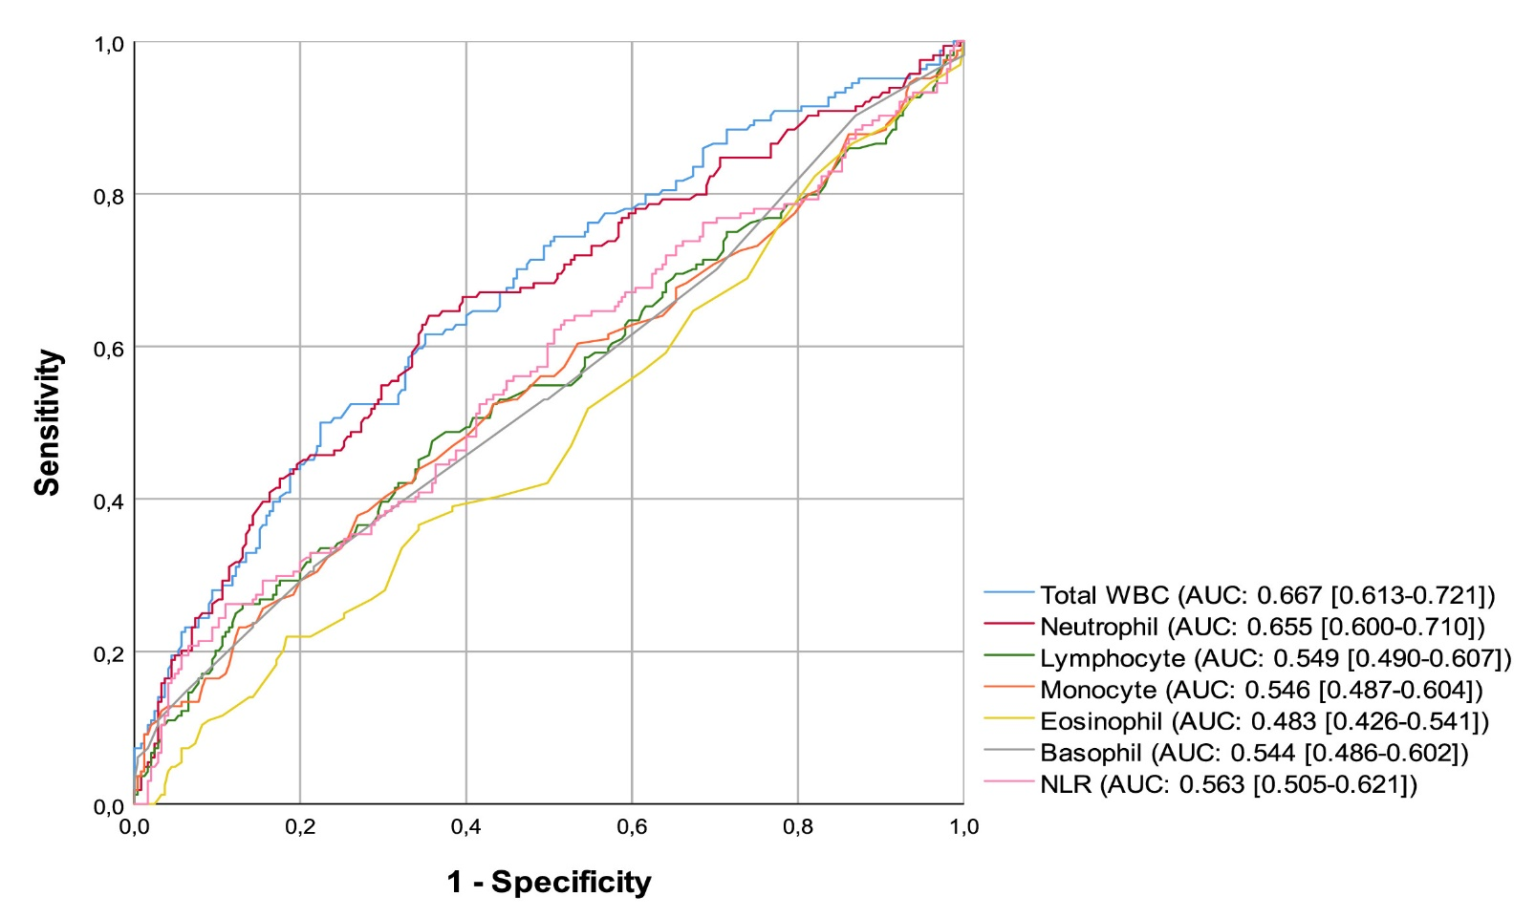
Figure S1. Receiver operating characteristic curves demonstrating the ability of total and differential leukocyte counts to discriminate the presence of LVO in AIS. Area under the curve (AUC) values and 95% confidence intervals are presented.

