eFigure 1: Impacts of each 10% increment of tumor-infiltrating lymphocytes on overall survival in Luminal subtype.
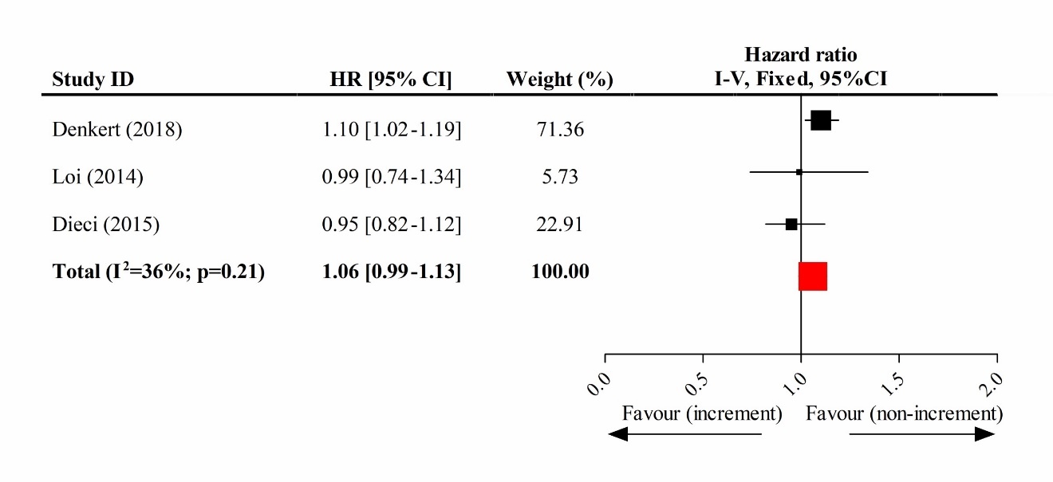

eFigure 2: Impacts of each 10% increment of tumor-infiltrating lymphocytes on overall survival in HER2-overexpression subtype.
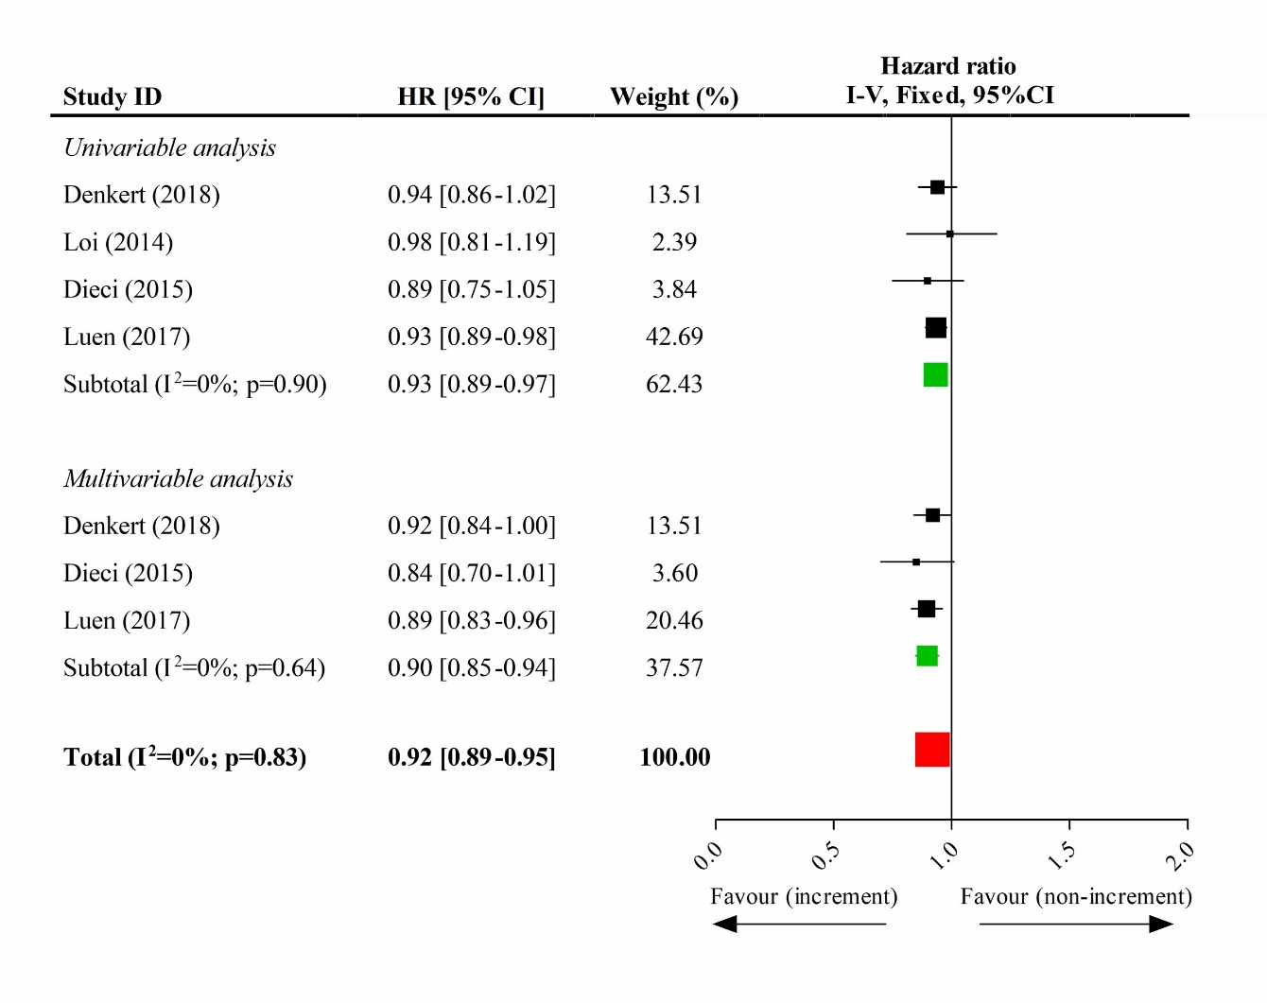

eFigure 3: Impacts of each 10% increment of tumor-infiltrating lymphocytes on overall survival in triple-negative subtype.
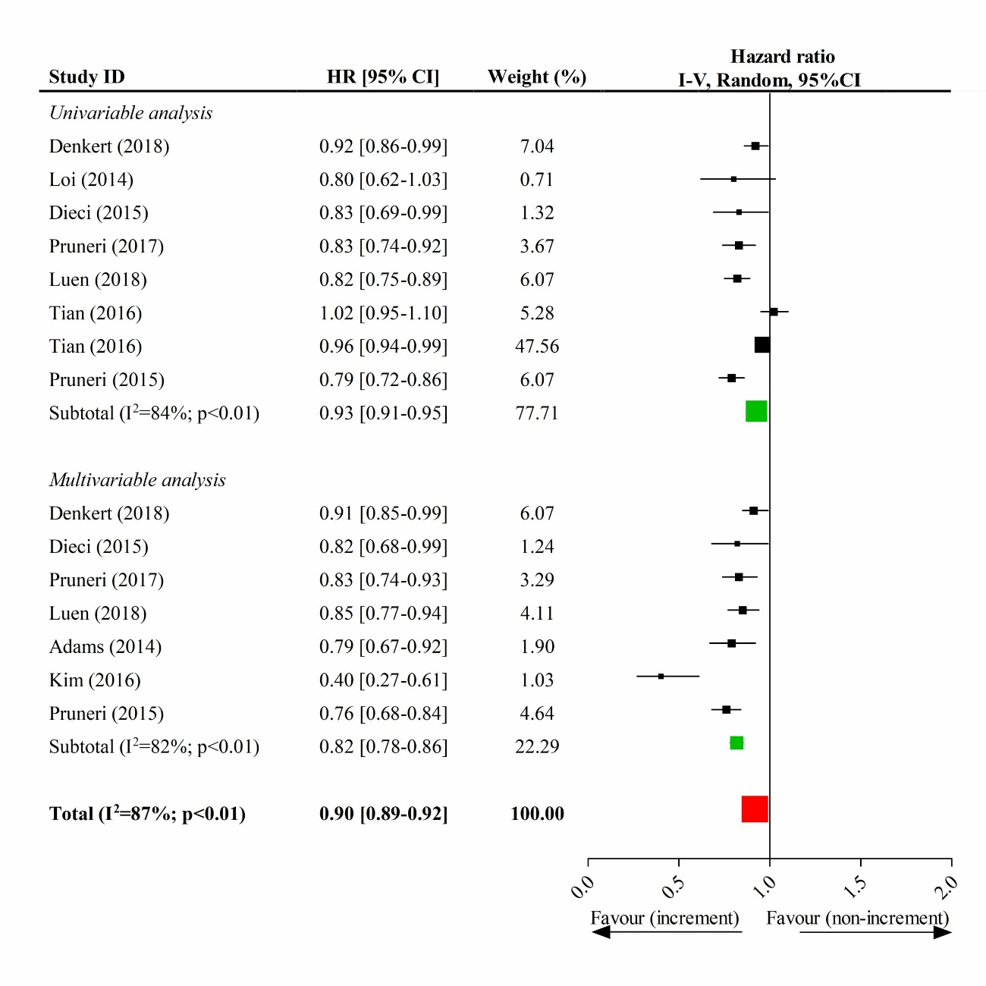

eFigure 4: Impacts of the high-level TILs on the pathological completed response in different tumor subtypes.
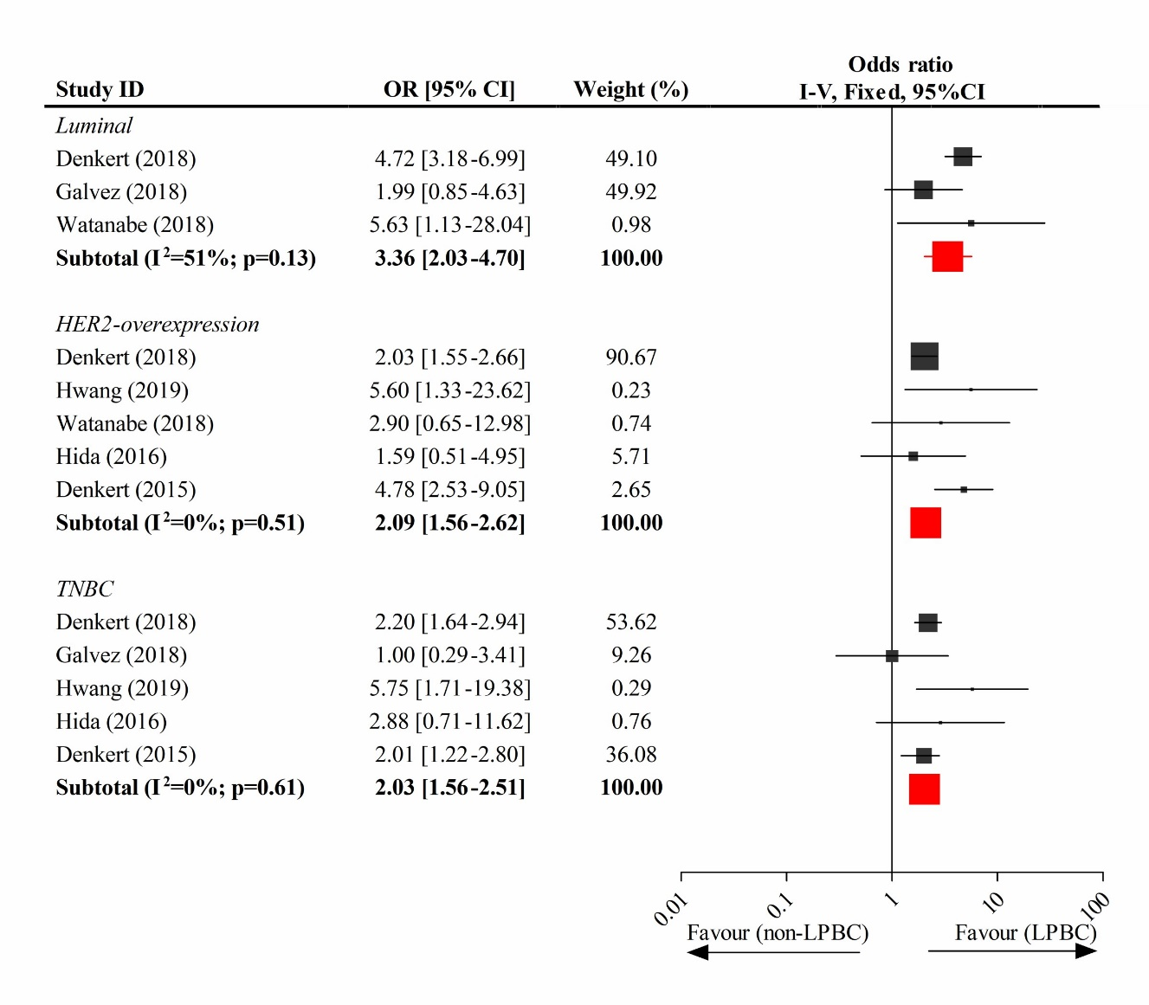

eTable 1. Publication bias by Egg’s test in meta-analysis.

Analysis label | p value*
10% increment of TILs
OS in all subtype | 0.192
OS in Luminal subtype | 0.437
OS in HER2-enriched subtype | 0.536
OS in TN subtype | 0.001
pCR in all subtype | 0.303
High-level TILs
pCR in all subtype | 0.007
pCR in Luminal subtype | 0.745
pCR in HER2-enriched subtype | 0.379
pCR in TN subtype | 0.775
High-level TILs
HER2-enriched vs Luminal | 0.115
TNBC vs Luminal | 0.680
TNBC vs HER2-enriched | 0.350

*significant level p<0.1.
Abbreviations: TILs, tumor-infiltrating lymphocytes; OS, overall survival; pCR, pathological complete response; HER2, human epidermal growth factor receptor 2; TN, triple-negative.

eFigure 5. Funnel plots for the significant analyses of publication bias.

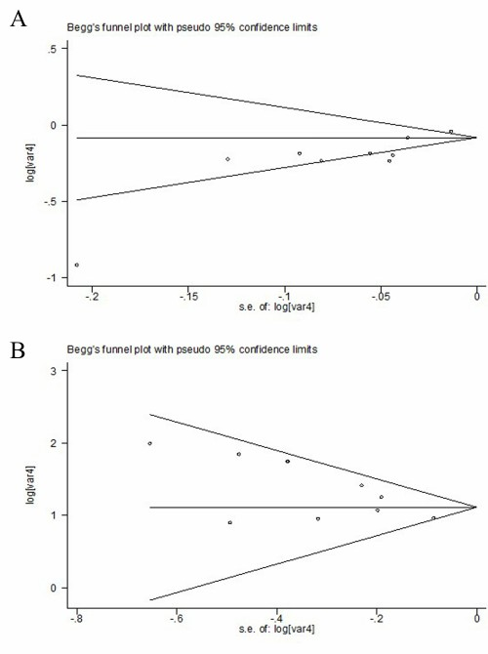

A. 10% increment of TILs and OS in TN subtype; B. High-level TILs and pCR in all subtypes

