**Supplemental figures and tables**



**Supplemental Table 1.** Complete information of the PABC cohort, with clinical features and results from the somatic mutation analysis. The table summarizes all the cases recruited with or without milk sample (included or not for sBM ctDNA further study, respectively), tumor clinical features, HRD scoring, the chosen somatic mutation and its MAF % obtained by NGS panel and further analyzed by ddPCR in plasma and sBM. Presence of the tumor at the time of milk sample collection, therapy previous to milk sample collection, time lapse from childbirth to milk sample collection and maturity stage classification (1-5 days was classified as colostrum, 6 to 14 days as transitional, and more than 2 weeks was classified as mature).

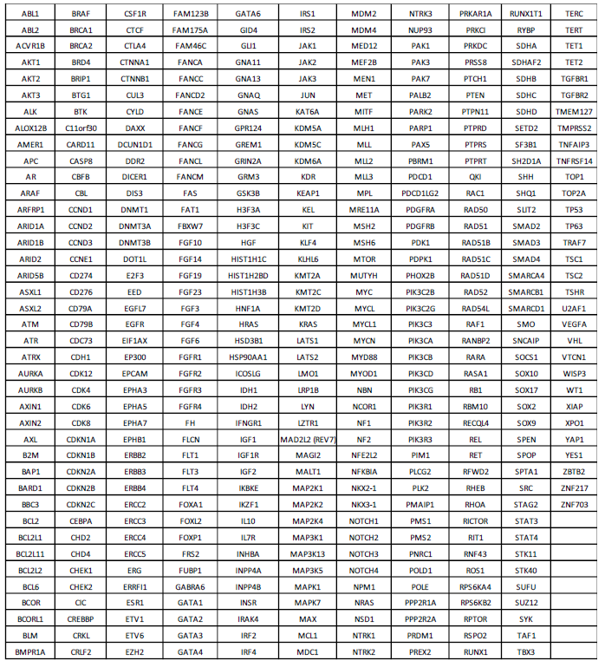

**Supplemental Table 2.** VHIO-300 NGS panel gene list.

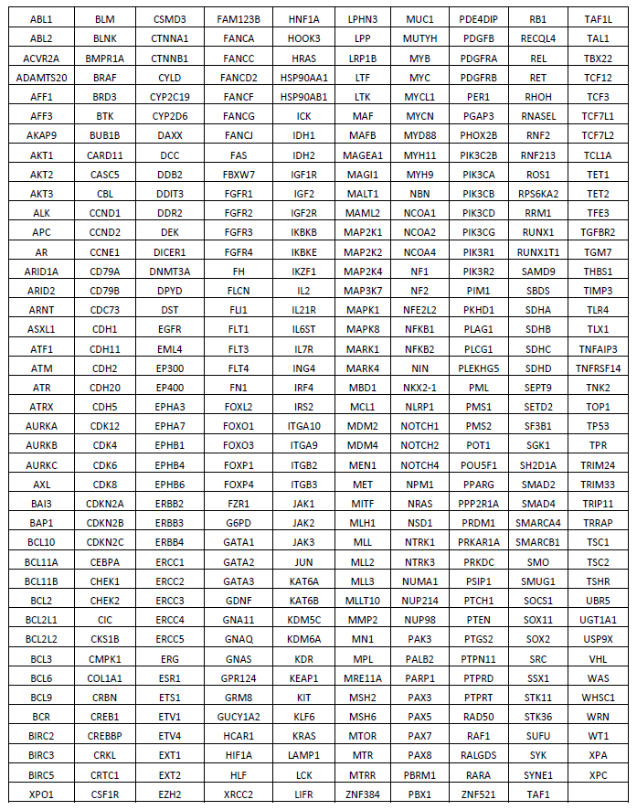

**Supplemental Table 3.** AURORA NGS panel gene list.



**Supplemental Table 4**. Complete set of SNVs and indel mutations observed by NGS DNA analysis from FFPE-derived tumor tissues from 16 PABC cases. The table summarizes the mutated genes, clinical significance of the mutation (pathogenic or likely pathogenic in orange, VUS in yellow), number of mutations per gene (number in each square when superior to 1 event per gene and sample), total number of cases mutated in each gene (count) and frequency of mutations per gene in the cohort (%).









**Supplemental Table 5**. Complete set of CNA alterations observed by NGS DNA panel from FFPE-derived tumor tissues from 16 PABC cases. The table summarizes the genes with gain (green) or loss (orange) alterations seen in the entire cohort of 16 PABC cases. Exact number of copies are specified in each box.

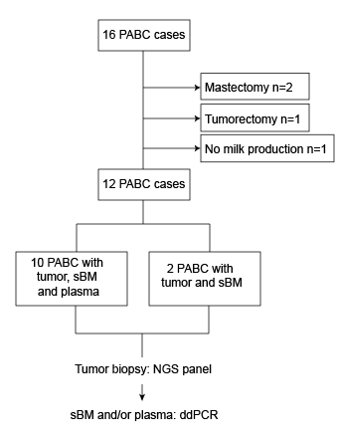

**Supplemental Figure 1**. Study cohort, patient selection and analysis workflow.

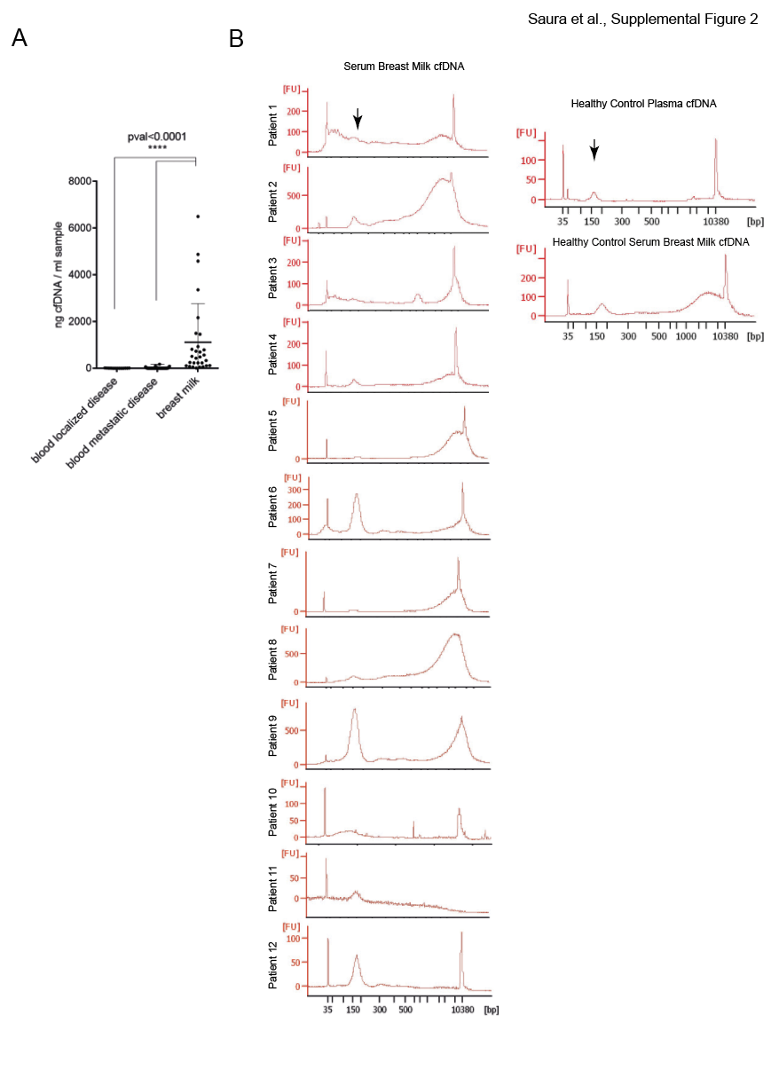

**Supplemental Figure 2.** Abundance and integrity of BM derived cfDNA. **A**. Concentration of purified cfDNA per ml of blood in localized (n=13) or metastatic disease (n=56) or BM (n=29). **B**. Distribution of cfDNA fragmentome from BM and compared to plasma and breast milk from healthy control samples. All samples were analyzed in a high-sensitivity bioanalyzer chip (Agilent). Arrows depict a 167 bp peak of the expected mononucleosomal DNA.