Supplementary Methods
Disease model and ACMG classification
We applied an autosomal dominant (AD) or autosomal recessive (AR) disease model based on the inheritance pattern and/or age at onset. In the AD disease model, heterozygous (Het) variants and in AR disease model, homozygous (Hmz), as well as compound heterozygous (CHet) variants, were selected. In ADCA samples we have followed the AD model, besides if re-evaluation suggests (affected siblings with more than 25 age at onset and unavailable affection data of parents) AR inheritance, we also followed the AR model. In SPEOCA group as age at onset (AO) is earlier with the severe clinical condition, the AR disease model applied initially and the AD disease model considered in some families. In SPLOCA cases as AO is later, AD disease model applied initially, followed by the AR disease model to look for low-impact Hmz or CHet variants.
For variants categorization, ACMG guidelines¹ were followed using two tools, VarSome² and InterVar (user adjusted)³. In the User adjustment criteria in InterVar, we have added moderate and supporting class evidence stated by automated VarSome besides evidence PM1, PP1, PP3, and PP4 added wherever required or applicable. For some identified variant PM1 class included (if absent in VarSome) with the reported evidence of; a) the presence of other pathogenic variants in identified variants localized region, b) variants spectrum across the protein domain/exons, c) missense variants reported as pathogenic variants for the respective gene. PP1 class included when variant present in other affected family member or absent in unaffected parent. Different in silico protein prediction tools were used for supporting evidence of variants pathogenicity (PP3). We have redefined PP3 (if absent in VarSome) for few variants if stating damaging by two of the four tools, Polymorphism Phenotyping v2 (PolyPhen-2) ⁴, Sorting Intolerant From Tolerant (SIFT) ⁵, Mutation Taster ⁶ and Combined Annotation Dependent Depletion (CADD) ⁷.
Variants classified as; 1) Pathogenic variants if reported pathogenic in HGMD and/or Clinvar and/or ACMG-AMP evidence stated pathogenic. 2) Likely pathogenic if ≤1% frequency in 257 ethnically matched controls and in-house data (756 clinical WES samples), ≤0.1% in 1000GP and gnomAD with rare disease frequency ( gnomAD have ≤ 8 heterozygotes for AD inheritance variants and ≤2 homozygotes for AR inheritance variants) and ACMG-AMP followed criteria. 3) Variant of unknown significance (VUS) if >8 heterozygotes in gnomAD, and stated VUS by ACMG-AMP evidence. 4) Likely benign- >1% frequency in 257 healthy controls and in-house data (756 WES samples) if AD inheritance variants, and stated likely benign by ACMG criteria.

Protein homology modelling
For SPTB, FAT1 and, FAT2 proteins homology modeling was done using I-TASSER ⁸ for the domains in which variants were present. Quality of models checked and then Molecular Dynamics Simulation performed to study the effect of the variant on domain structure. (Table S5). Molecular dynamics simulations were performed using GROMACS (v5.1.2)⁹. OPLS-AA (Optimized Potential for Liquid Simulation- for All Atoms) force field used for simulations. Energy minimized using the 5000 steps of steepest descent at 310K. The equilibration was performed in two phases: NVT ensemble (constant number of particles, pressure, and temperature at 100 ps) and NPT ensemble (constant number of particles, pressure, and temperature at 100 ps). Root-mean-square deviation (RMSD) and Root Mean Square Fluctuation (RMSF) of wild and mutant protein were calculated (Figure S3).
The protein structure for the MME (6GID) was taken from Protein Data Bank (PDB)^{10,11}. Molecular docking using the AutoDock (v.4.2.6) ¹² suite was performed for MME to study the impact of variant on the binding of substrate. Binding pocket residues (G195, K196, K197, R373, R222) and substrate (EDO:1,2-ETHANEDIOL) were selected as mentioned in the PDB(6GID).

Establishment and characterization of LCLs
A 5-10 ml blood sample was collected then PBMCs were isolated using histopaque (Sigma-Aldrich). 2-3 million thawed or fresh PBMCs were infected with Epstein Barr Virus (EBV) and cultured in 20% RPMI (FBS - Invitrogen, RPMI-Himedia) with 1X anti anti (Invitrogen) and 500μM cyclosporine (Sigma-Aldrich) as per the protocol described ¹³. 3-5 days of post-infection, PBMCs transformed into lymphoblastoid cell lines, which become stable after 25-30 days of routine culture. Stable LCLs were cultivated in 15% RPMI medium with 1X anti anti. LCLs were characterized by immunophenotyping of CD markers and resequencing of underlying variants. Fluorophore labeled CD markers: CD19-APC, CD3-FITC, and CD56-PerCPCy5.5 were used to estimate the population of B cell, T cell, and NK cell respectively. Cells stained with CD marker and acquired on FACS Aria (BD biosciences).
Reactive oxygen species assay
5 X 10⁵ cells in 500μl of 15% RPMI were seeded on 24 well plates. After 24 hours, cells were pellet down and washed with 1X DPBS. The cell pellet re-suspended in 1 ml of HBSS (For positive control, oxidative activity induced by using t-BHP. tBHP was added in positive control tubes and incubated at 37⁰C for 30 min. Positive control and test samples were pellets down and resuspended in 1 ml of 5μM working dilution of CM-H₂DCFDA dye. Negative control tubes left untreated. Samples incubated at 37⁰C for 30 minutes in dark then pellet down. The cell pellet was resuspended in 200μl of HBSS, and acquired on FACS Aria (BD biosciences) in the FITC channel.
Unfolded protein response marker expression
Unfolded protein responses (UPR) were accessed by estimating expression of BiP and CHOP. To check the expression of BiP and CHOP in cerebellar ataxias and controls LCLs, cells were seeded in 6 well plates with 1million cells/ml for 48 hours. 24 hours after seeding, positive controls sample treated with tunicamycin with 4ug/ml concentration for 24 hours. BiP and CHOP protein expression checked using western blotting.
Cell culture and transfection
SKNSH cell line was cultured in 10% DMEM (Invitrogen) with 1x anti anti (Invitrogen) at 37⁰C with 5% CO₂. For routine passaging, cells were detached from the culture dish through trypsinization using 0.25% trypsin EDTA (Invitrogen), split in a 1:4 ratio, and further seeded in a fresh culture dish.
3X10⁵ SKNSH cells with 2 ml of 10% DMEM without antibiotics were seeded in 6 well plates and cultured for 24 hours. Pre-diluted 20 nM SPTB siRNA and scrambled siRNA mixed with fugene in 1:2 ratios in Opti MEM media then the pooled components incubated for 20 minutes. After that, cells were transfected with siRNA-fugene mix with fresh Opti-MEM culture media. Post transfection, cells were incubated for 6 hours. After that medium was removed and replenished with fresh 10% DMEM without antibiotics. Cells returned to the incubator for next the 18 hours. 24 hours post-transfection, SPTB expression was assessed or proceeded for further experiments.
Western blotting
For western blotting, suspension cells (LCLs) were pellet down directly and adherent cells (SKNSH) first trypsinized and then pellet down by centrifugation. The cell pellet was washed with 1X DPBS and further cell lysate prepared using RIPA buffer mix (100 μl RIPA buffer, DTT, and protease inhibitor cocktail). For Bip and CHOP, 60 μg of total lysate were loaded in 10% SDS-PAGE. Blocking done in 5% skimmed milk in 0.1% TBST. PVDF blot with 1:1000 dilution of the primary antibody incubated overnight at 4⁰C and 1 hour with secondary antibody (1:2000 dilutions) at room temperature. ECL method used for detection.
MTT assay
In 96 well plates, 10 X 10³ SKNSH cells were seeded with 100ul of 10% DMEM without antibiotics and cultured for 24 hours. After 24 hours, cells were transfected with siRNA. 24 hours post-transfection, 20ul of 5mg/ml MTT (100 µg of MTT) added in each well in dark, and incubated for 4 hours at 37⁰C. Medium was taken out and 100 µl of DMSO was added and incubated for 15 minutes at room temperature. O.D was taken at 540 nm with a reference set at 620nm in the reader instrument.

References
1. Richards, S. et al. Standards and guidelines for the interpretation of sequence variants: a joint consensus recommendation of the American College of Medical Genetics and Genomics and the Association for Molecular Pathology. Genet. Med. Off. J. Am. Coll. Med. Genet. 17, 405–424 (2015).
2. Kopanos, C. et al. VarSome: the human genomic variant search engine. Bioinformatics 35, 1978–1980 (2019).
3. Li, Q. & Wang, K. InterVar: Clinical Interpretation of Genetic Variants by the 2015 ACMG-AMP Guidelines. Am. J. Hum. Genet. 100, 267–280 (2017).
4. Adzhubei, I. A. et al. A method and server for predicting damaging missense mutations. Nat. Methods 7, 248–249 (2010).
5. Sim, N.-L. et al. SIFT web server: predicting effects of amino acid substitutions on proteins. Nucleic Acids Res. 40, W452-457 (2012).
6. Schwarz, J. M., Rödelsperger, C., Schuelke, M. & Seelow, D. MutationTaster evaluates disease-causing potential of sequence alterations. Nat. Methods 7, 575–576 (2010).
7. Rentzsch, P., Witten, D., Cooper, G. M., Shendure, J. & Kircher, M. CADD: predicting the deleteriousness of variants throughout the human genome. Nucleic Acids Res. 47, D886–D894 (2019).
8. Zhang, Y. I-TASSER server for protein 3D structure prediction. BMC Bioinformatics 9, 40 (2008).
9. Abraham, M. J. et al. GROMACS: High performance molecular simulations through multi-level parallelism from laptops to supercomputers. SoftwareX 1–2, 19–25 (2015).
10. Li, Q., Hanzlik, R. P., Weaver, R. F. & Schönbrunn, E. Molecular mode of action of a covalently inhibiting peptidomimetic on the human calpain protease core. Biochemistry (Mosc.) 45, 701–708 (2006).
11. Moss, S., Subramanian, V. & Acharya, K. R. High resolution crystal structure of substrate-free human neprilysin. J. Struct. Biol. 204, 19–25 (2018).
12. Morris, G. M. et al. AutoDock4 and AutoDockTools4: Automated docking with selective receptor flexibility. J. Comput. Chem. 30, 2785–2791 (2009).
13. Kumar, D. et al. Generation of three spinocerebellar ataxia type-12 patients derived induced pluripotent stem cell lines (IGIBi002-A, IGIBi003-A and IGIBi004-A). Stem Cell Res. 31, 216–221 (2018).

Supplementary Table
Table S1: Gender, age at exam and age at onset of patients of 3 groups
 | Gender,  Male: Female | Age at exam,  mean (SD) years | Age at onset,  mean (SD), years
ADCA | 14:4 | 43.4(13.1) | 35.6(11.6)
SPEOCA | 12:10 | 26.0(8.8) | 18.2(9.4)
SPLOCA | 12:2 | 56.2(8.5) | 51.2(6.3)

Table S2: Clinical spectrum of selected cases
 | Frequency % (Number of evaluated patients)
Clinical features | Total | ADCA | SPEOCA | SPLOCA
Gait ataxia | 94 (52) | 82 (17) | 100 (21) | 100 (14)
Intention tremor | 70 (50) | 59 (17) | 84 (19) | 64 (14)
Dysarthria | 85 (52) | 71 (17) | 90 (21) | 93 (14)
Nystagmus | 56 (50) | 56 (16) | 65 (20) | 43 (14)
Absent Reflexes | 8 (49) | 0 (17) | 17 (18) | 7 (14)
Areflexia | 2 (49) | 0 (17) | 6 (18) | 0 (14)
Hyperreflexia | 31 (49) | 29 (17) | 39 (18) | 21 (14)
Clonus | 8 (49) | 24 (17) | 0 (18) | 0 (14)
Spasticity | 16 (50) | 29 (17) | 10 (20) | 8 (13)
Babinski sign | 32 (47) | 47 (17) | 28 (18) | 17 (12)
Postural Tremor | 10 (50) | 13 (16) | 15 (20) | 0 (14)
Bradykinesia | 48 (50) | 53 (17) | 53 (19) | 36 (14)
Rigidity | 8 (50) | 12 (17) | 11 (19) | 0 (14)
Slow saccades | 22 (49) | 12 (17) | 37 (19) | 15 (13)
Broken pursuit | 28 (50) | 18 (17) | 37 (19) | 29 (14)
Skeletal deformities | 8 (50) | 0 (17) | 21 (19) | 0 (14)
Psychiatric symptoms | 22 (49) | 31 (16) | 16 (19) | 21 (14)
Peripheral Neuropathy | 33 (33) | 17 (6) | 35 (17) | 40 (10)
Autonomic Dysfunction | 86 (35) | 89 (9) | 75 (16) | 100 (10)

Table S3: Family based segregation analysis of S-WES identified variants in informative families
S.N | Group | Proband ID | Gene | Variant Details | FAM  Sample_ID | Relation | Affection | Allele status | Segregation
1 | ADCA | AT2137 | SETX | 9:135187240, C/T, Het, p.A1760T | AT3903 | Sister | Affected | Het | Yes
 |  |  |  |  | AT3904 | Brother | Unaffected | Hmz Ref
2 |  | AT2521 | TTBK2 | 15:43069330, ATC/A, Het,  p.D436Yfs*13 | AT2523 | Brother | Affected | Het | Yes
 |  |  |  |  | AT2524 | Brother's son | Asymptomatic | Hmz Ref
 |  |  |  |  | AT2525 | Son | Asymptomatic | Het
 |  |  |  |  | AT2902 | Sister | Asymptomatic
 |  |  |  |  | AT2903 | Nephew | Asymptomatic | Hmz Ref
 |  |  |  |  | AT2904 | Son | Asymptomatic | Het
 |  |  |  |  | AT2905 | Brother | Unaffected | Hmz Ref
 |  |  |  |  | AT2906 | Nephew | Asymptomatic | Het
 |  |  |  |  | AT2907 | Sister | Affected | Het
 |  |  |  |  | AT2908 | Daughter | Asymptomatic | Het
 |  |  |  |  | AT2909 | Father | Unaffected | Hmz Ref
3 | SPEOCA | AT1018 | SETX | 9:135152523, G/A, Het, p.R2287X | AT3764 | Mother | Unaffected | Hmz Ref | Yes
 |  |  |  |  | AT1018B | Father | Unaffected | Het
 |  |  |  | 9:135204358, ATAAC/A, Het, p.V875Ffs*20 | AT3764 | Mother | Unaffected | Het
 |  |  |  |  | AT1018B | Father | Unaffected | Hmz Ref
4 |  | AT1554 | SETX | 9:135172296, A/C, Het, p.L1976R | AT3842 | Mother | Unaffected | Hmz Ref | Yes
 |  |  |  |  | AT3843 | Father | Unaffected | Het
 |  |  |  | 9:135206703, T/C, Het, p.Y324C | AT3842 | Mother | Unaffected | Het
 |  |  |  |  | AT3843 | Father | Unaffected | Hmz Ref
5 |  | AT2807 | SETX | 9:135147179, T/C, Het, ,p.T2373A | AT2819 | Mother | Unaffected | Het | Yes
 |  |  |  |  | AT2820 | Father | Unaffected | Hmz Ref
 |  |  |  | 9:135158724, C/T,Het,p.S2158N | AT2819 | Mother | Unaffected | Hmz Ref
 |  |  |  |  | AT2820 | Father | Unaffected | Het
6 |  | AT1941 | AFG3L2 | 18:12337480, G/A,Het,p.R679C | AT2145 | Mother | Unaffected | Hmz Ref | Yes
 |  |  | SPG7 | 16:89576947, T/A,Hmz,p.L78X | AT2145 | Mother | Unaffected | Het | Yes
7 |  | AT2278 | SACS | 13:23939331, CAA/C, Hmz,p.W144Vfs*38 | AT2362 | Father | Unaffected | Het | Yes
 |  |  |  |  | AT2363 | Mother | Unaffected | Het
 |  |  | TTBK2 | 15:43038027, C/A, Het, p.G1234V | AT2362 | Father | Unaffected | Het | No
 |  |  |  |  | AT2363 | Mother | Unaffected | Hmz ref
8 |  | AT2560 | RELN | 7:103194249, C/G, Hmz, p.D1943H | AT2563 | Father | Unaffected | Het | Yes
 |  |  |  |  | AT2564 | Mother | Unaffected | Het
9 |  | AT2808 | NPC1 | 18:21124370, T/A, Hmz, p.I690F | AT2809 | Father | Unaffected | Het | Yes
 |  |  |  |  | AT2823 | Mother | Unaffected | Het
10 |  | AT2880 | ATM | 11:108199965, G/A, Het, p.R2436K | AT2885 | Father | Unaffected | Hmz Ref | Yes
 |  |  |  |  | AT2886 | Mother | Unaffected | Het
 |  |  |  | 11:108175535, TCTCG/T, Het, p.S1878Kfs*37 | AT2885 | Father | Unaffected | Het
 |  |  |  |  | AT2886 | Mother | Unaffected | Hmz Ref
11 | SPLOCA | AT1889 | ELOVL5 | 6:53135458, C/A,Het,p.G230V | AT3997 | Sister | Unaffected | Hmz Ref | Yes
 |  |  |  |  | AT3998 | Son | Unaffected | Het
 |  |  |  |  | AT4012 | Daughter | Unaffected | Hmz Ref
 |  |  |  |  | AT4013 | Son | Unaffected | Hmz Ref
 |  |  |  |  | AT4014 | Son | Unaffected | Hmz Ref
 |  |  |  |  | AT4015 | Mother | Unaffected | Hmz Ref
 |  |  |  |  | AT4016 | Wife | Unaffected | Hmz Ref
12 |  | AT2216 | KCNC3 | 19:50827014, G/A,Het,p.S399L | AT4053 | Son | Unaffected | Het | Yes
FAM- family member, Hmz Ref- Homozygous reference, Het-heterozygous, Hmz- Homozygous alternate

Table S4: Family based segregation assessments of prioritized variants in F-WES design
S.N. | Group | Proband ID | Gene | Variant Details | FAM Sample ID | Relation | Affection | Allele status | Segregation
1 | ADCA | AT2832 | MME | 3:154860052, G/A, Het, p.R374K | AT3834 | Brother | Affected | Het | Yes
 |  |  |  |  | AT3835 | Brother | Affected | Het
2 | ADCA | AT1796 | CAPN1 | 11:64953708, G/A, Hmz, p.G220R | AT3760 | Brother | Affected | Hmz | Yes
 |  |  |  |  | AT3761 | Brother | Affected | Hmz
 |  |  |  |  | AT3762 | Father | Unaffected | Het
 |  |  |  |  | AT3763 | Mother | Unaffected | Het
3 | ADCA | AT2221 | FAT2 | 5:150923909, A/T, Het, p.V2260D | AT4009 | Mother | Unaffected | Hmz Ref | Yes
4 | SPEOCA | AT1929 | SPTB | 14:65260396, G/A, Het, p.S662F | AT3634 | Father | Unaffected | Het | Yes
 |  |  |  |  | AT3635 | Mother | Unaffected | Hmz Ref
 |  |  |  | 14:65249127, G/T, Het, p.L1383M | AT3634 | Father | Unaffected | Hmz Ref
 |  |  |  |  | AT3635 | Mother | Unaffected | Het

Table S5: Samples selected for S-WES with obtained number of reads and mean coverage
Group | Sample ID | Row reads | Filtered reads | Drop of reads (%) | Mean Coverage
ADCA  (N=15) | AT1671 | 16040424 | 15529499 | 96.81% | 21.01
 | AT1682 | 21705376 | 21005561 | 96.78% | 29.64
 | AT1796 | 20061898 | 19145743 | 95.43% | 26.8
 | AT1965 | 23576696 | 22768279 | 96.57% | 32.64
 | AT2003 | 22548743 | 21820545 | 96.77% | 30.69
 | AT2098 | 41022632 | 39510146 | 96.31% | 58.14
 | AT2137 | 18603325 | 18030178 | 96.92% | 23.68
 | AT2221 | 44890347 | 42916123 | 95.60% | 62.95
 | AT2267 | 34091588 | 33016690 | 96.85% | 51.42
 | AT2521 | 29561422 | 28451902 | 96.25% | 39.36
 | AT2523 | 6043516 | 5857150 | 96.92% | 8.72
 | AT2832 | 14451520 | 14008102 | 96.93% | 17.67
 | AT2864 | 36658220 | 35477770 | 96.78% | 44.64
 | AT2910 | 22175029 | 21542356 | 97.15% | 27.54
 | AT2915 | 26069347 | 25293226 | 97.02% | 34.32
SPEOCA  (N=22) | AT1018 | 26847717 | 25880327 | 96.40% | 38.95
 | AT1554 | 28866691 | 26873437 | 93.09% | 38.38
 | AT1803 | 39296292 | 36518336 | 92.93% | 51.58
 | AT1876 | 40266403 | 37942752 | 94.23% | 54.17
 | AT1929 | 45218039 | 42566732 | 94.14% | 63.32
 | AT1941 | 37740627 | 36421333 | 96.50% | 50.75
 | AT1943 | 30476795 | 29367366 | 96.36% | 39.89
 | AT1968 | 36482765 | 34266085 | 93.92% | 50.45
 | AT2028 | 30542194 | 28808740 | 94.32% | 42.1
 | AT2037 | 33964798 | 31790928 | 93.60% | 44.73
 | AT2099 | 33164243 | 31274985 | 94.30% | 41.23
 | AT2166 | 38508682 | 36279147 | 94.21% | 48.93
 | AT2176 | 29136193 | 27450212 | 94.21% | 36.89
 | AT2257 | 45746378 | 43028537 | 94.06% | 63.23
 | AT2278 | 44377791 | 41912494 | 94.44% | 62.01
 | AT2329 | 28903114 | 27144757 | 93.92% | 35.08
 | AT2560 | 27125850 | 26012848 | 95.90% | 36.57
 | AT2705 | 26138176 | 24484327 | 93.67% | 34.11
 | AT2807 | 35512491 | 33694069 | 94.88% | 45.41
 | AT2808 | 45833967 | 43441754 | 94.78% | 58.52
 | AT2880 | 34144059 | 32415042 | 94.94% | 42.32
 | AT2933 | 26588801 | 25164905 | 94.64% | 36.2
SPLOCA  (N=14) | AT1756 | 18483803 | 17809929 | 96.35% | 26.88
 | AT1864 | 29552762 | 28540329 | 96.57% | 41.62
 | AT1889 | 22606955 | 21759523 | 96.25% | 31.51
 | AT2004 | 28885640 | 27870287 | 96.48% | 40.28
 | AT2027 | 20187356 | 19142444 | 94.82% | 28.51
 | AT2216 | 37224787 | 36025072 | 96.78% | 53.97
 | AT2833 | 36754325 | 35412425 | 96.35% | 48.13
 | AT2834 | 33089146 | 31910486 | 96.44% | 43.55
 | AT1699 | 28704634 | 25940390 | 90.37% | 29.45
 | AT1765 | 28677314 | 25904680 | 90.33% | 32.51
 | AT1798 | 32539303 | 29246140 | 89.88% | 37.54
 | AT1955 | 27128735 | 24138292 | 88.98% | 29.81
 | AT2029 | 42641783 | 38432303 | 90.13% | 53.28
 | AT2217 | 35748946 | 32227578 | 90.15% | 44.57
Control  (N=11) | AT_Control1 | 40380571 | 34239026 | 84.79% | 52.31
 | AT_Control2 | 26610757 | 22847671 | 85.86% | 34.58
 | AT_Control3 | 28702914 | 25251758 | 87.98% | 37.41
 | AT_Control4 | 28095386 | 24149175 | 85.95% | 35.84
 | AT_Control5 | 22839396 | 20110491 | 88.05% | 31.12
 | AT_Control6 | 26715066 | 23504153 | 87.98% | 35.67
 | AT_Control7 | 33632778 | 28560875 | 84.92% | 40.79
 | AT_Control8 | 24277003 | 21405880 | 88.17% | 32.85
 | AT_Control9 | 22218223 | 19040463 | 85.70% | 28.67
 | AT_Control10 | 36258190 | 30860448 | 85.11% | 47.12
 | AT_Control11 | 25869350 | 22686403 | 87.70% | 34.43

S.N. | Group | Sample ID | Family member  Sample ID | Age/ Gender | Relation | Affection
1 | ADCA | AT1671 | AT1997 | F | Mother | Affected
 |  |  | AT1998 | M | Brother | Unaffected
 |  |  | AT2000 | M | Paternal Uncle | Affected
2 | ADCA | AT1796 | AT3760 | 40/M | Brother | Affected
 |  |  | AT3761 | 37/M | Brother | Affected
 |  |  | AT3762 | 65/M | Father | Unaffected
 |  |  | AT3763 | 64/F | Mother | Unaffected
3 | ADCA | AT2267 | AT2268 | F | Sister | Affected
4 | ADCA | AT2832 | AT3834 | 58/M | Brother | Affected
 |  |  | AT3835 | 55/M | Brother | Affected
5 | ADCA | AT2221 | AT4009 | 60/F | Mother | Unaffected
6 | SPEOCA | AT1929 | AT3634 | M | Father | Unaffected
 |  |  | AT3635 | F | Mother | Unaffected
7 | SPLOCA | AT2217 | AT4010 | 66/F | Sister | Unaffected
Table-S6: Details of family members sample used in F-WES

Table S7: Primer sequences that used in the Sanger sequencing for validation of obtained variants
S.N. | Coordinates of variant | Sample ID | Primer Name | PRIMER SEQUENCES | Tm | GC%
1 | 18:12337342, T/C | AT1682 | AFG3l2_FP | TGCAGTCTACACACCAACCA | 57.3 | 50
 |  |  | AFG3l2_RP | GGGGACATGGTATTGGAGAAAC | 60.3 | 50
2 | 9:135187240, C/T | AT2137 | SETX_E11_1-F | CACTTTCCAGAATGTTGCTTTC | 58.88 | 40.91
 |  |  | SETX_E11_1-R | TCCCCCTAAATTCAAATAATGC | 59.22 | 36.36
3 | 16:89576947, T/A | AT1941, AT1756 | SPG7_FP | GTCTGCATTGCTTTGGTACTCT | 58.4 | 45.5
 |  |  | SPG7_RP | CAGTCATGCTCAGCTGCTTC | 59.4 | 55
4 | 12:88476910, A/G | AT2028 | CEP290_88476910_FP | GCCTGGCATAGCAAACACTT | 57.3 | 50
 |  |  | CEP290_88476910_RP | TGGAACAGACAGTAGCAGAACA | 58.4 | 45.5
5 | 9:35737771, C/T | AT2037 | GBA2_FP | ACAGATGGTGGAGAGATGGG | 59.4 | 55
 |  |  | GBA2_RP | GGTCCGTGCTCTCCAAACTA | 59.4 | 55
6 | 18:21124370, T/A | AT2808 | NPC1_FP | ATGCTGAGCCCTGTGAGAAT | 57.3 | 50
 |  |  | NPC1_RP | TGATTGTGTCTGTCGCCTCT | 57.3 | 50
7 | 7:103194249, C/G | AT2560 | RELN_FP | GTCTTCTCTGGGCCCAAAATC | 59.8 | 52.4
 |  |  | RELN_RP | GGCTCAAACAATCCTCCTGTAG | 60.3 | 50
8 | 9:135147179, T/C | AT2807 | SETX_135147179_FP | GCCAAGATTGCACCAAGATCTA | 58.4 | 45.5
 |  |  | SETX_135147179_RP | CAGAGCTTGCAGTGAACT | 53.7 | 50
9 | 9:135158724, C/T | AT2807 | SETX_135158724 _FP | TCCTCAACATTTCAGCAGCC | 57.3 | 50
 |  |  | SETX_135158724 _RP | CATAGGCCTGTCATAGTCAAGG | 60.3 | 50
10 | 9:135172296, A/C | AT1554 | SETX_E14_1-F | CCAAAGCTTTTGTCTCATGC | 58.5 | 45
 |  |  | SETX_E14_1-R | CAAATCAAAGAGGAAATGGCA | 60.06 | 38.1
11 | 15:43069330, ATC/A | AT2521/AT2523 | TTBK2_43069330_FP | ACATGGATGAAAATTGGAGCTGA | 57.1 | 39.1
 |  |  | TTBK2_43069330_RP | TCCTCTCATGTGTGTTGCCT | 53.3 | 50
12 | 13:23939331, CAA/C | AT2278 | SACS_23939331_FP | CCTTCCCACCAAAAGCAGAG | 59.4 | 55
 |  |  | SACS_23939331_RP | AGCCTCACCAGATCTTAAAGGT | 58.4 | 45.5
13 | 11:108199965, G/A | AT2880 | ATM_108199965_FP | AGCCCGGTTTTCAGATACTCA | 57.9 | 47.6
 |  |  | ATM_108199965_RP | AGCCGACCTTTAGAGCTCAA | 57.3 | 50
14 | 11:108175535, TCTCG/T and  11:108175462, G/A) | AT2880 (AT2028& AT2880) | ATM_108175535_FP | ACTTTTGTCAGACTGTACTTCCA | 57.1 | 57.1
 |  |  | ATM_108175535_RP | ACTTGTTGCAACTGTTGGCA | 55.3 | 55.3
15 | 14:91739187, G/A | AT2221 | CCDC88C_91739187_FP | GAGGCCGGACTGCTCTTT | 58.2 | 61.1
 |  |  | CCDC88C_91739187_RP | GACACGAGGCGCTTCTCC | 60.5 | 66.7
16 | 1:17326804, T/A | AT2910 | ATP13A2_FP | TCACTGGAGTCCACCCACT | 58.8 | 57.9
 |  |  | ATP13A2_RP | CCACTACTACTGGTACGCCC | 61.4 | 60
17 | 9:135204358, ATAAC/A | AT1018 | SETX_135204358_FP | GGCCTGTTCTCTTGTCAAGTT | 57.9 | 47.6
 |  |  | SETX_135204358_RP | AGGAGTTCAGAAAGGAGATGGT | 58.4 | 45.5
18 | 16:89598385, G/C | AT1756 | SPG7_89598385_FP | CCCCAAGTAGTTAGTGTTGCA | 57.9 | 47.6
 |  |  | SPG7_89598385_RP | AGGATGTGTGAAAGGAGCCA | 57.3 | 50
19 | 3:63981756, C/G | AT1756 | ATXN7_FP | GGCTCAGGAAAGAAACGCAA | 57.3 | 50
 |  |  | ATXN7_RP | GACTGGTGAATGAATGGCCC | 59.4 | 55
20 | 6:53135458, C/A | AT1889 | ELOVL5_FP | GCTCCACATGCCCATTAAGT | 57.3 | 50
 |  |  | ELOVL5_RP | CATGCACTGTCCCTGTTCAG | 59.4 | 55
21 | 11:66460141, G/A | AT1699 | SPTBN2_66460141_FP | CACTCACAGTCACATGCTCG | 59.4 | 55
 |  |  | SPTBN2_66460141_RP | CTGTTGGGAGACTCAGAGGG | 61.4 | 60
22 | 19:3984193, C/G | AT1798 | EEF2_FP | AACCAGGGGAAAGAGACGTT | 57.3 | 50
 |  |  | EEF2_RP | GGTCTGAGCCTCCTTGTCTT | 59.4 | 55
23 | 11:66475625, C/T | AT1864 | SPTBN2_66475625_FP | CCCAGGTGACGGATTTTGTG | 59.4 | 55
 |  |  | SPTBN2_66475625_FP | CACTAACCCTGTCCCCACC | 61 | 63.2
24 | 19:50827014, G/A | AT2216 | KCNC3_FP | AGGGCCAGGAAGATGATGAG | 59.4 | 55
 |  |  | KCNC3_RP | CTCATGCGCATCACCTTCTG | 59.4 | 55
25 | 15:43045273, C/T | AT2004 | TTBK2_43045273_FP | TCTCTTCAGTTTCCCCAGGG | 59.4 | 55
 |  |  | TTBK2_43045273_RP | GGTCAGCAGCCAGAGAAGAA | 59.4 | 55
26 | 14:91780032, G/A, and  14:91779885, G/A) | AT2833 and AT2027) | CCDC88C_91780032_FP | CTCGCCCAGCTCACTCTC | 60.5 | 66.7
 |  |  | CCDC88C_91780032_RP | AACCGGACTCTGAGGAAGTC | 59.4 | 55
27 | 11:66459044, T/C | AT2833 | SPTBN2_66459044_FP | CACCTGACCCCGTGTGTC | 60.5 | 66.7
 |  |  | SPTBN2_66459044_RP | GGAGAGGTGGGTTCTGAGTT | 59.4 | 55
28 | 13:23915032, C/A | AT2257 | SACS_23915032_FP | TCAGGGTCAAAGAGTTCACC | 57.3 | 50
 |  |  | SACS_23915032_RP | GTCTTACACCATACTGCCAAACT | 58.9 | 43.5
29 | 11:108098576, C/G | AT2028 | ATM_108098576_FP | TCTGCTGCCGTCAACTAGAA | 57.3 | 50
 |  |  | ATM_108098576_RP | TGCCAAATTCATATGCAAGGC | 55.9 | 42.9
30 | 3:154860052, G/A | AT2832 | MME_R374K_FP | ACAGTCCCCATGTCCTCAAA | 57.3 | 50
 |  |  | MME_R374K_RP | TTGCAAAGTTCACCATGTCC | 55.3 | 45
31 | 14:65260396, G/A | AT1929 | SPTB_ S662F_FP | GTGCCGACACCTCCTTTATG | 59.4 | 55
 |  |  | SPTB_ S662F_RP | ACTGGAGCAGTCCAAACGAC | 59.4 | 55
 |  |  | SPTB_ S662F_IP | GGTCTTTGCCATAGTCCAGG | 59.4 | 55
32 | 14:65249127, G/T |  | SPTB_ L1383M_FP | CAACATCCGATTGACACTGG | 57.3 | 50
 |  |  | SPTB_ L1383M_RP | AGGAAAGCAGCTGATGGATG | 57.3 | 50
 |  |  | SPTB_ L1383M_IP | GCATGGGTCTGCAAGCGCA | 61 | 63.2
33 | 11:64953708, G/A | AT1796 | CAPN1_G220R_FP | CTCAGAGGGTCCTGCTTGAT | 59.4 | 55
 |  |  | CAPN1_G220R_RP | TTCCAGGGTACCAAAGCATC | 57.3 | 50
34 | 9:135152523, G/A | AT1018 | SETX_E22_1-F | CCCACATCACCACACAGAAA | 60.42 | 50
 |  |  | SETX_E22_1-R | TTCTGGGACTATCAGAGGACTG | 58.4 | 50
35 | 9:135206703, T/C | AT1554 | SETX_E8_1-F | TTGGCTTTTAGTTGGGTTGC | 60.11 | 45
 |  |  | SETX_E8_1-R | TACTGAAACGAAGGGGGAAA | 59.54 | 45
36 | 18:12337480, G/A | AT1941 | AFG3L2_Exon 16_FP | TGGGATTTGCGTCCTAAC | 53.2
 |  |  | AFG3L2_Exon 16_RP | GCAGACAACGAAACATCAGAAC | 58
37 | 13:23910867, C/T | AT2257 | SACS_E10_13-F | CCCATTCTTTTAGAGGTTGTGG | 59.87 | 45.45
 |  |  | SACS_E10_13-R | TCACTGATTATTCGTCGGCA | 60.22 | 45
38 | 4:187524910, G/C | AT2176 | FAT1_910_FP | TGGTGTGGTTCAACATCTCCT | 57.9 | 47.6
 |  |  | FAT1_910_RP | GGTGGCAGATAATGGAAAGC | 57.3 | 50
39 | 4:187628361, G/A | AT2176 | FAT1_361_FP | ATGATGACGGTTCCTTCTGG | 57.3 | 50
 |  |  | FAT1_361_RP | TCCACCCGAGTTTTTACAGG | 57.3 | 50
40 | 2:201943669, T/C | AT2176 | NDUFB3_669_FP | TGGGTATTTGATATCTACAATTTGC | 56.4 | 32
 |  |  | NDUFB3_669_RP | GCCATTTTTCATGATTCTCTAAGG | 57.6 | 37.5
41 | 6:146720778, G/C | AT2705 | GRM1_778_FP | CCCATTTACTTTGGGAGCAA | 55.3 | 45
 |  |  | GRM1_778_RP | ATGGGGGAAATGGAAGAGAC | 57.3 | 50
42 | 1:1470752, G/A | AT2166 | TMEM240_752_FP | ACAGCACCTTCCACTGGACT | 59.4 | 55
 |  |  | TMEM240_752_RP | CTACGGTGAGTGCCTCGTG | 61 | 63.2
43 | 1:101004765, C/G | AT1876 | GPR88_765_FP | CTCTGCGAGGAAGAGGAGTC | 61.4 | 60
 |  |  | GPR88_765_RP | TGAGCAGGTAGCGGTTCAG | 58.8 | 57.9
44 | 5:150923909, A/T | AT2221 and AT4009 | FAT2_909_FP | GCTCCCATTGATCTGGAAGA | 57.3 | 50
 |  |  | FAT2_909_RP | AGGGACTCCGGCTCATCTAC | 61.4 | 60

Table- S8: Detail of homology modelling used template for selected proteins
Protein-variant position (amino acid residue taken) | Variant (residue at modelled PDB) | Templates | Ident1 | Ident2 | Coverage | Normal Z-score | C-score | Simulation time (ns)
SPTB-662 (529-741) | S662F (S134F) | 1cunA | 0.26 | 0.26 | 0.99 | 2.14 | 0.78 | 500ns
 |  | 1s35A | 0.18 | 0.2 | 0.98 | 3.21
 |  | 1cunA | 0.26 | 0.26 | 0.99 | 2.11
 |  | 1cun | 0.26 | 0.26 | 0.99 | 2.02
 |  | 1s35 | 0.18 | 0.2 | 0.99 | 1.46
 |  | 1cunA | 0.26 | 0.26 | 0.98 | 2.52
 |  | 1s35 | 0.18 | 0.2 | 0.98 | 2.28
 |  | 1u5pA | 0.33 | 0.34 | 0.98 | 4.13
 |  | 1cunA | 0.26 | 0.26 | 0.99 | 1.77
 |  | 1s35A | 0.18 | 0.2 | 0.99 | 2.65
SPTB-1383 (1275-1465) | L1383M (L109M) | 1cunA | 0.2 | 0.25 | 1 | 1.93 | 0.71
 |  | 1s35A | 0.14 | 0.25 | 0.99 | 2.77
 |  | 1cunA | 0.2 | 0.25 | 1 | 1.85
 |  | 1cun | 0.21 | 0.25 | 1 | 1.97
 |  | 1cun | 0.2 | 0.25 | 1 | 1.42
 |  | 1cunA | 0.21 | 0.25 | 0.99 | 2.07
 |  | 1cun | 0.21 | 0.25 | 0.99 | 2.23
 |  | 1cunA | 0.21 | 0.25 | 1 | 3.12
 |  | 1cunA | 0.2 | 0.25 | 1 | 1.62
 |  | 5j4oA | 0.17 | 0.24 | 1 | 2.34
FAT1-874 (823-927) | T874M (T52M) | 5w4tC | 0.31 | 0.31 | 0.99 | 2.42 | 0.66 | 200ns
 |  | 3mvsA | 0.32 | 0.3 | 0.94 | 2.57
 |  | 3mvsA | 0.32 | 0.3 | 0.96 | 2.69
 |  | 3q2w | 0.23 | 0.33 | 0.98 | 0.89
 |  | 3q2w | 0.23 | 0.33 | 0.98 | 0.65
 |  | 5w4tC | 0.3 | 0.29 | 0.91 | 2.37
 |  | 5erp | 0.35 | 0.36 | 0.98 | 1.02
 |  | 3mvsA | 0.32 | 0.3 | 0.96 | 1.84
 |  | 5w4tC | 0.3 | 0.29 | 0.92 | 2.65
 |  | 2ystA | 0.27 | 0.28 | 0.96 | 1.92
FAT1-3590 (3546-3647) | F3590L (F45L) | 5czrA | 0.22 | 0.27 | 0.86 | 1.99 | -1.76
 |  | 5i8dA | 0.25 | 0.24 | 0.86 | 1.74
 |  | 5uz8A | 0.27 | 0.28 | 0.87 | 1.76
 |  | 2x2uA | 0.13 | 0.21 | 0.9 | 0.98
 |  | 2x2uA | 0.13 | 0.21 | 0.9 | 0.69
 |  | 5czrA | 0.22 | 0.27 | 0.86 | 1.88
 |  | 2x2uA | 0.13 | 0.21 | 0.89 | 1.05
 |  | 2ee0A | 0.22 | 0.23 | 0.88 | 1.35
 |  | 5czrA | 0.22 | 0.27 | 0.85 | 1.42
 |  | 1l3wA | 0.15 | 0.21 | 0.92 | 1.04
FAT2 (2172-2272) | V2260D (V89D) | 5w1dA | 0.34 | 0.37 | 1 | 2.25 | 0.46 | 100ns
 |  | 4xhzA | 0.31 | 0.33 | 0.99 | 2.21
 |  | 4zplA | 0.3 | 0.32 | 0.96 | 2.78
 |  | 5wj8 | 0.34 | 0.36 | 0.99 | 0.95
 |  | 5wj8 | 0.34 | 0.36 | 1 | 0.68
 |  | 4zplA | 0.3 | 0.32 | 0.96 | 2.3
 |  | 5wj8 | 0.33 | 0.36 | 0.99 | 1.07
 |  | 1l3wA | 0.32 | 0.34 | 1 | 1.72
 |  | 5wjmA | 0.25 | 0.27 | 0.95 | 2.48
 |  | 4xhzA | 0.31 | 0.33 | 0.99 | 1.9

Supplementary Figures
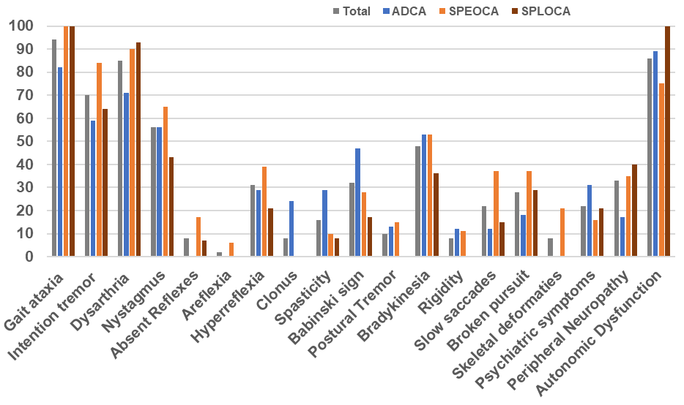
Fig.S1. Distribution of observed clinical features (in percentage) in different group

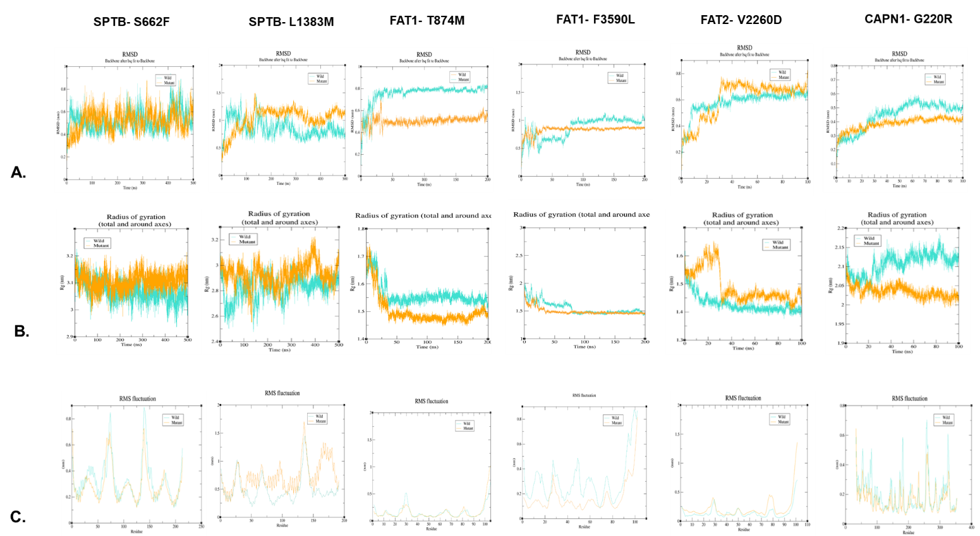

Fig.S2. Simulation graphs of homology modelled proteins A. Root-mean square deviation (RMSD) B. Radius of gyration C. Root Mean Square Fluctuation (RMSF). SPTB-S662F A) Root Mean Square Deviation of wild and variant was found to be same; B) there is no significant change on the radius of gyration upon variant; C) No significant changes were observed on the alpha carbon fluctuations of both the structure. SPTB-L1383M A) Backbone of variant was found to be more deviating than wild type; B) Radius of gyration is more for M1383 which means structure is opening up because of variant; C) variant structure was found to be more fluctuating specially at C-terminal than wild type. FAT1-T874M A) A large difference is observed between the backbone of wild and variant. Wild type is deviating till 0.8 nm and then got stabilized while the variant got stabilized at 0.5nm; B) Radius of gyration of variant is less than wild type which implies that the M874 is compacting the structure; C) Fluctuations in alpha carbons were almost same for both the structures. FAT1-F3590L A) Wild type backbone is showing more deviation than variant type; B) Radius of gyration is found to be same for wild and variant type; C) Wild type was fluctuating more than variant.
FAT2-V2260D A) Both the structures were highly unstable initially but got stabilized with time; B) There is a small difference between the radius of both the structures. Variant structure is opening a bit as compared to wild type; C) C-terminus of variant shows more RMSF than wild type. CAPN1-G220R A) a slight difference in the deviation was observed between the two structures; B) Large difference has been observed between the radii of two. Wild type structure is opening up with time while variant is getting compact with time; Wild type was fluctuating more than variant.
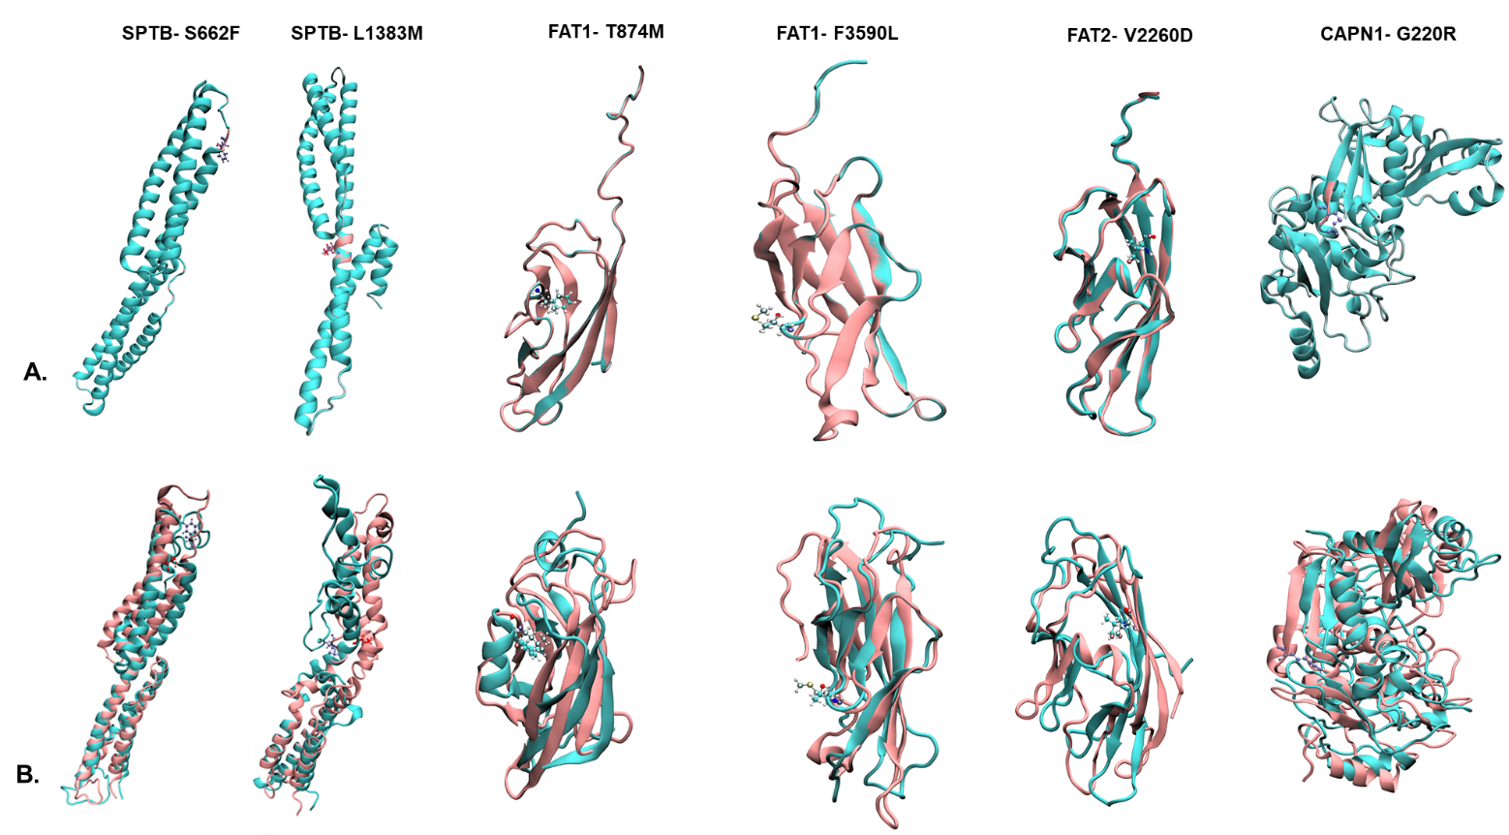
Fig S3. Structure of modelled domain of respective protein with wild (cyan) and mutant (pink) residue A. Before simulation, B. After simulation at protein specific time point (nanosecond; ns)

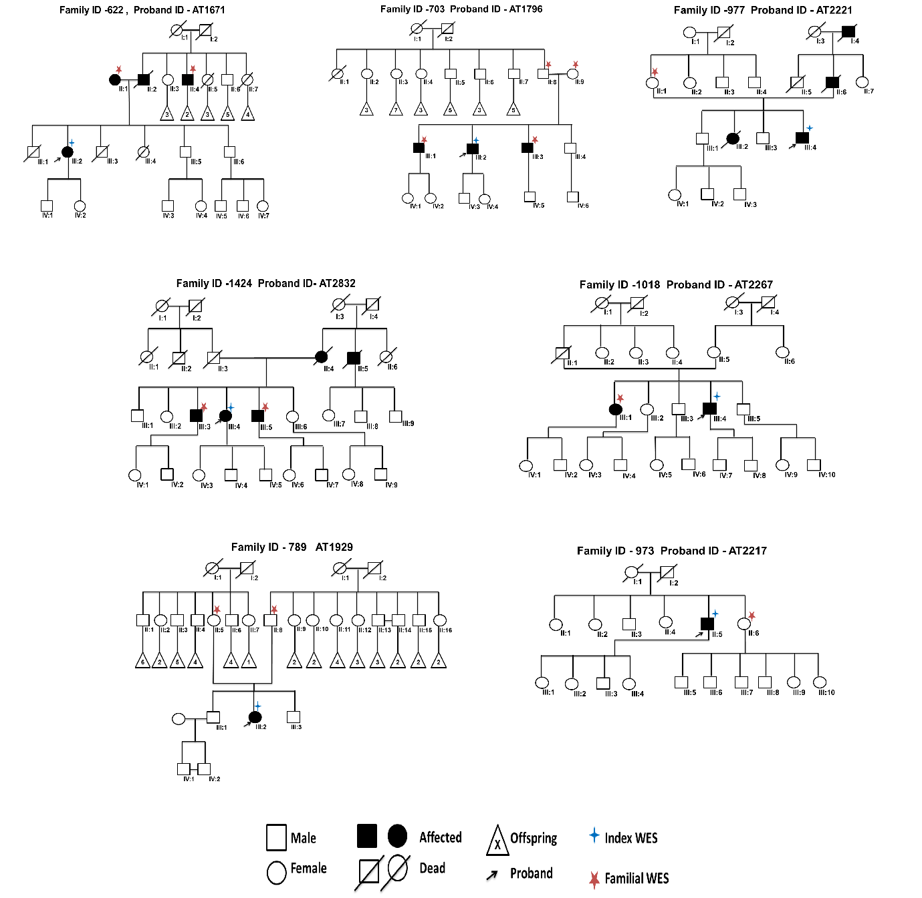
Fig. S4. Pedigree of seven families selected for family based WES with samples marked

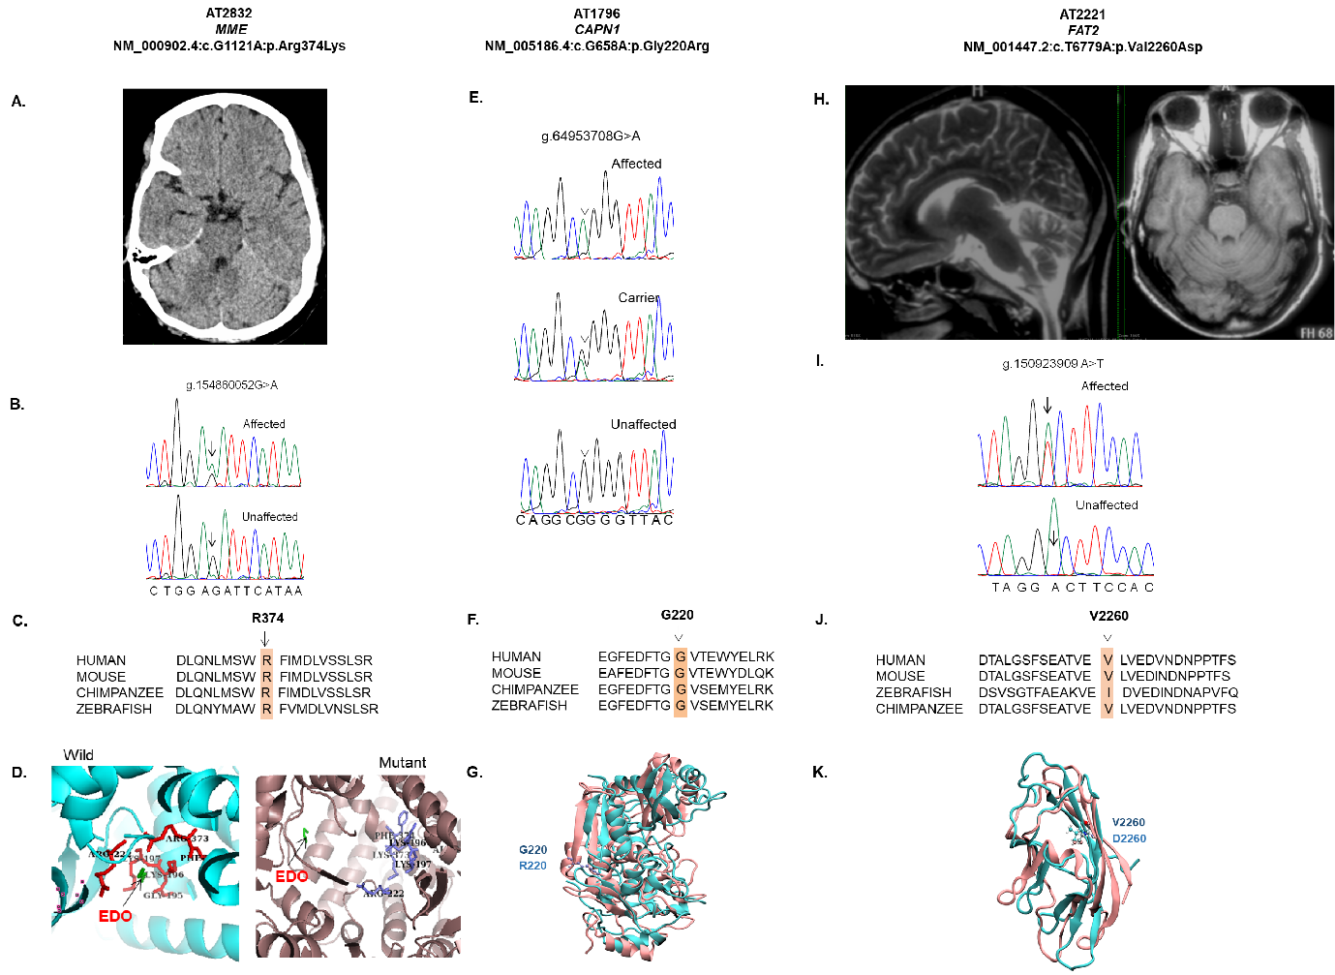
Fig. S5. Imaging and molecular finding of Three F-WES characterized families. A-D) Patient, AT2832 with MME (SCA43) variant in autosomal dominant model, A) CT head showing mild cerebellar atrophy, B) Chromatogram showing G>A change in affected individual, C) multiple species sequence alignment (MSA) showing conserved R374 residue, D) protein simulation showing altered binding of EDO due to R74K change. E-G) Patient, AT1796 with CAPN1 variant in autosomal recessive model, E) Chromatogram showing G>A homozygous change in affected and heterozygous change in carrier, F) MSA of G220 residue show conservation among species, G) Overall altered structure of variant containing region, could affect calcium ion binding due to R220 residue. H-K) patient with FAT2 (SCA45) variant in autosomal dominant model. H) T2 weighted sagittal image and T1 weighted axial image showing moderate vermian and cerebellar atrophy, I) sanger chromatogram of variant, J) MSA showing conserved residue and K) protein simulation of V2260D variant showing loss of coiled sheet coil structure of the protein.

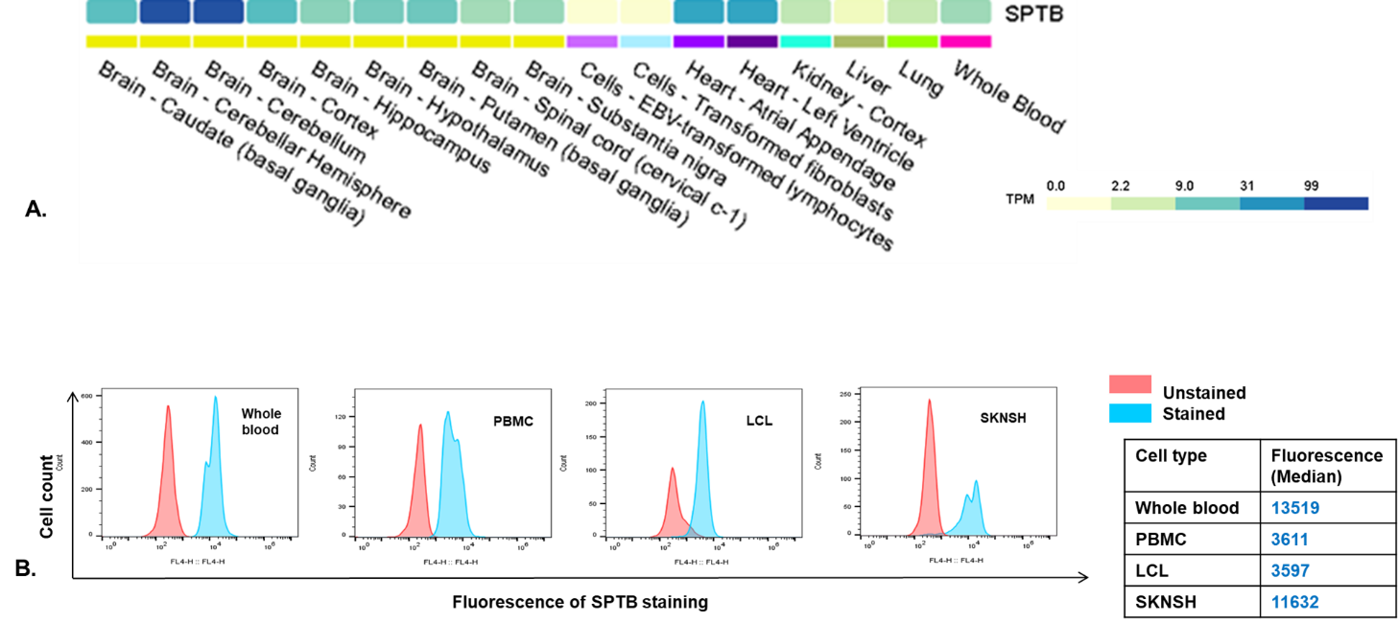
Fig.S6. Expression of SPTB in different cell type A. RNA expression of SPTB in different brain tissue, other organ and blood (Source GTEx portal) B. Protein expression analysis through FACS

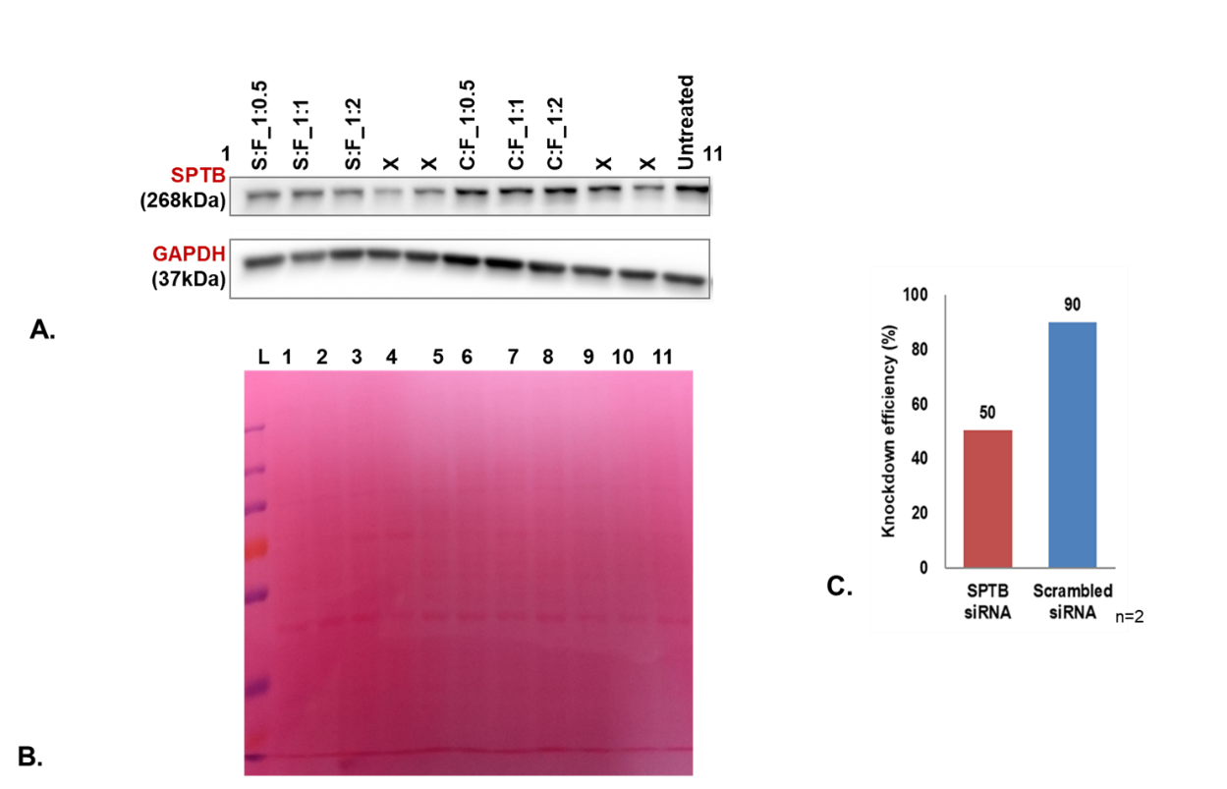
Fig. S7. Transfection of SPTB exon13 siRNA at 20nM concentration with different ratio of vehicle for 24hr (S- SPTB siRNA, C-Scrambled siRNA, F-vehicle)

