Supplemental figure.
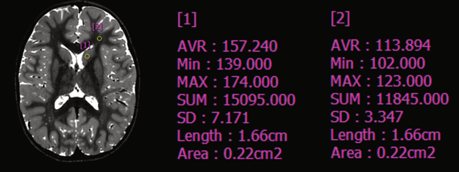
Supplemental figure 1. A representative image with regions of interests. Regions of interests were manually drawn at the frontal white matter and deep grey matter. The mean signal intensities and the standard deviation values of the regions were used for the signal-to-noise ratio and the contrast-to-noise ratio calculation.

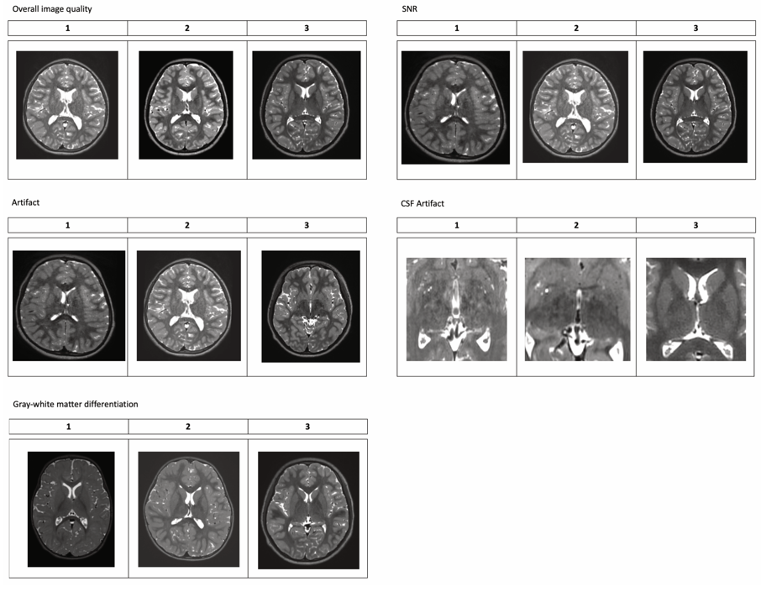
Supplemental figure 2. Representative images showing the qualitative image evaluation grades.

