Supplemental Figure 1. Monitoring of blast cells in peripheral blood in engrafted transgenic mice. A) K562-Luc (AML cell line) in control versus fb-PMT treated mice at different doses over 21 days during treatment and over 14 days post-treatment. fb-PMT at 1, 3, and 10 mg/kg, subcutaneous daily for 21 days, prevented blast cell expression/reproduction by 35%, 65%, and >95%, respectively, compared to controls. OFF treatment, fb-PMT (10 mg/kg) shows maintained remission. B) Primary AML cells (6373-FlT3-ITD) cells in peripheral blood in control versus fb-PMT treated mice through 28 days and 14 days post-treatment. fb-PMT at 1, 3, and 10 mg/kg, subcutaneous daily for 28 days, prevented abnormal blast cell expression/reproduction by 54%, 75%, and 90.5%, respectively, compared to controls. fb-PMT treated mice (10 mg/kg) were in full remission after discontinuation of treatment for 2 weeks, (***P<0.0001, **P<0.001, *P<0.01).

Supplemental figure 2
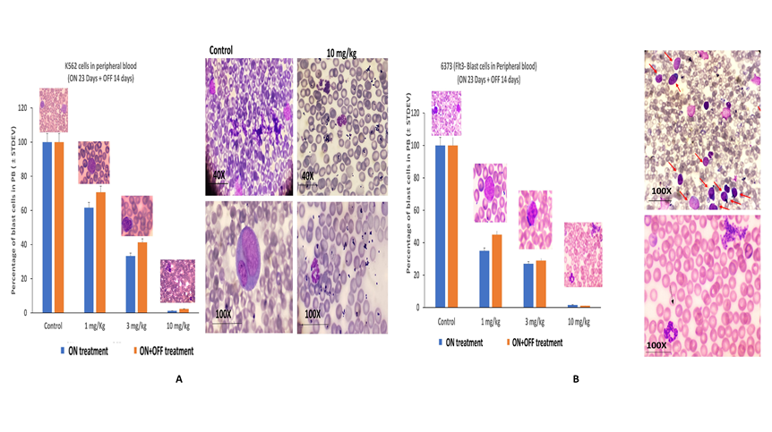
Supplemental 2. Blood smear from transgenic mice engrafted with leukemic cells. A) K562 cells in peripheral blood (PB) cells, control blood smears versus fb-PMT treated mice at different doses. Blast cells appeared in the blood smears of NSG-S mice after 10 days. After 21 days of fb-PMT daily subcutaneous injection, the control group showed many blast cells in the peripheral blood, while fb-PMT (1, 3, and 10 mg/kg) treated mice showed a significant decrease in the blast cells by 35%, 65%, and >95%, respectively. The decrease of blast cell percentage in the peripheral blood was dose-dependent. Left side shows blast cells in peripheral blood in fb-PMT treated animals at different doses ON 21 Days and ON+OFF treatment for 14 days and right side shows representative K562-Luc AML control blood smears versus fb-PMT (10 mg/kg) treated animal cells. Control group showed immature cells with prominent nucleoli (blast cells) in the peripheral blood. fb-PMT (10 mg/kg) treated animal showed segmented neutrophils with absent blast cells, after 21 days of daily subcutaneous injection. fb-PMT (10 mg/kg) maintained remission after 2 weeks discontinuation. B) Primary AML cells (6373-FlT3-ITD), fb-PMT treated at 1, 3, and 10 mg/kg subcutaneous daily for 28 days and 14 days OFF treatment prevented blast cell expression/reproduction by 54%, 75%, and 90.5%, respectively, compared to controls. Right side shows representative image from control group with immature cells and prominent nucleoli (blast cells) in the peripheral blood where fb-PMT (10 mg/kg) treated animal shows segmented neutrophils with absent blast cells. OFF study, 14 days post-treatment, fb-PMT (10 mg/kg) showed successful maintained remission.

Supplemental Figure 3. IVIS scans of different organs in transgenic mice engrafted with AML K562-Luc and sacrificed after 23 days of fb-PMT (ON treatment). fb-PMT at 1, 3 and 10 mg fb-PMT treatment, markedly reduced brain, lung, liver, and spleen infiltration with leukemic cells in dose dependent manner (***P<0.0001).

Supplemental figure 4
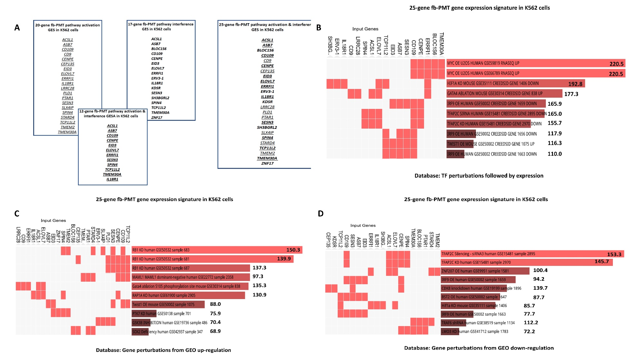
Supplemental Figure 4. Identification and characterization of the 25-gene fb-PMT-induced expression signature in K562 cells. A) Integration into different functional categories of fb-PMT treatment-induced gene expression signatures (GES) as reported in Table 1. B) GSEA of 25-gene GES using the TF perturbations followed by expression database. C) GSEA of 25-gene GES using the Gene perturbations from gene expression omnibus (GEO) database focused on up-regulated genes. D) GSEA of 25-gene GES using the GEO database focused on down-regulated genes. Numbers shown next to the bar graphs report the values of Cumulative scores (Methods).
Supplemental figure 5
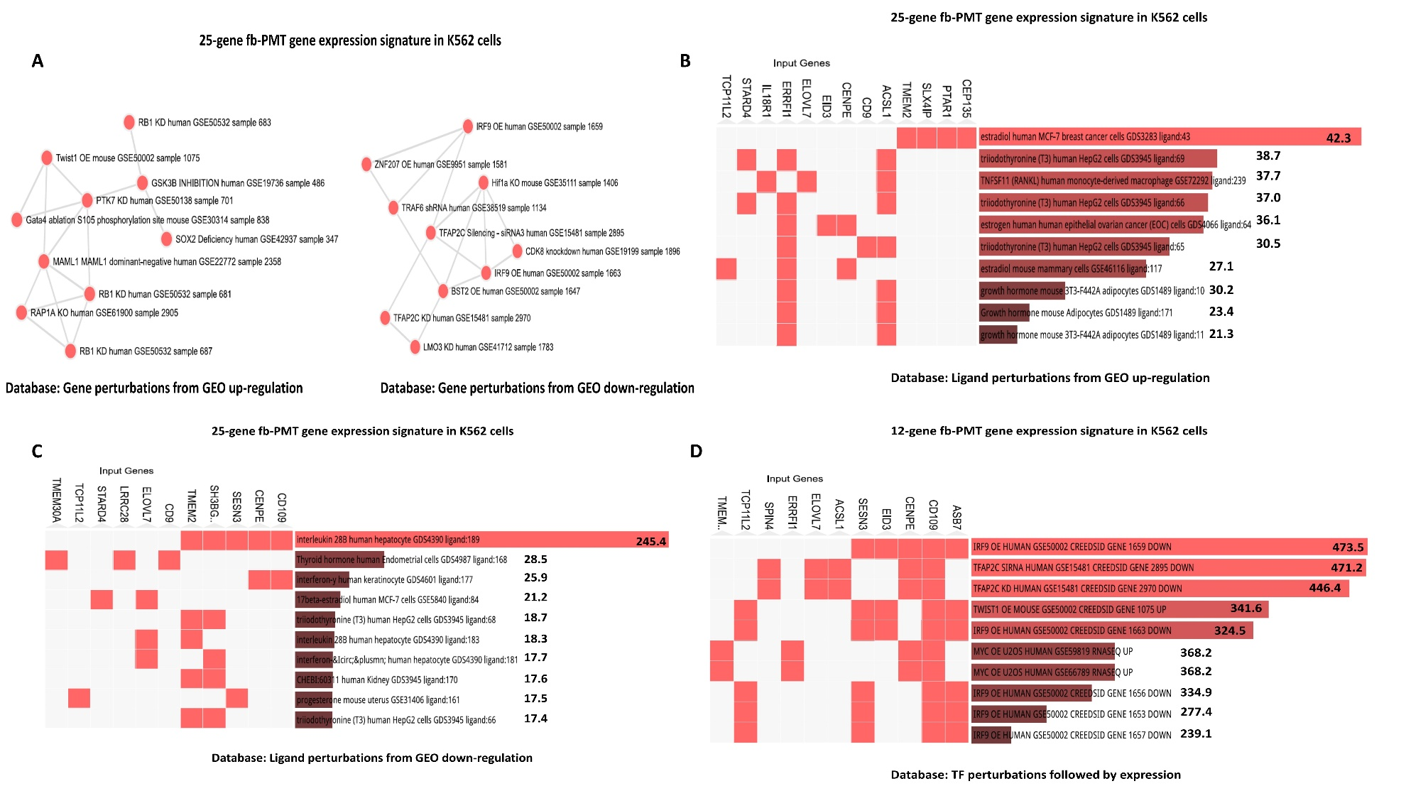
Supplemental Figure 5. Networks and Ligands associated with the 25-gene fb-PMT-induced expression signature in K562 cells. A) Affected genomic regulatory networks revealed by the GSEA of the Gene perturbations from gene expression omnibus (GEO) database focused on up-regulated (left) and down-regulated (right) genes. B) GSEA of the Ligand perturbations from GEO database focused on up-regulated genes. C) GSEA of the Ligand perturbations from GEO database focused on down-regulated genes. Numbers shown next to the bar graphs report the values of Cumulative scores (Methods). D) fb-PMT gene expression signature in K562 cells
Supplemental figure 6
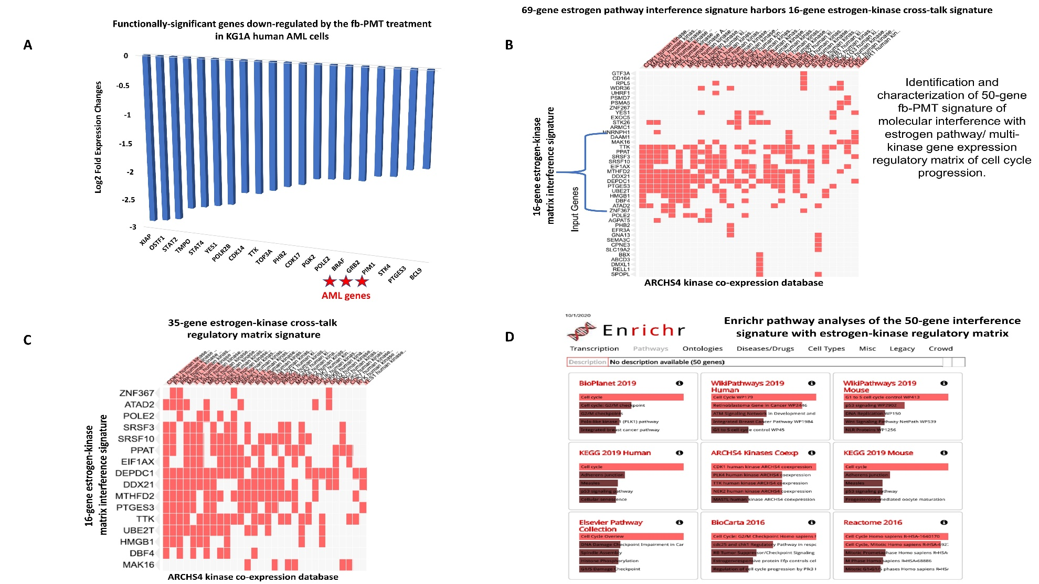
Supplemental Figure 6. Examples of the specific genes and pathways of potential functional significance revealed by the GSEA of 233 genes down-regulated in KG1a cells after fb-PMT treatment. A) Functionally significant genes down-regulated by fb-PMT treatment in KG1a human AML cells. B) GSEA of the TF Perturbations Followed by Expression database (top 30 of 84 significant records). C) GSEA of the LINCS L1000 Ligand Perturbations database of up-regulated genes revealed evidence of molecular interference with functions of multiple growth factors in human cancer cell lines. D) GSEA of the KEGG 2019 Human database revealed evidence of targeting multiple cancer pathways (including AML).
Supplemental figure 7
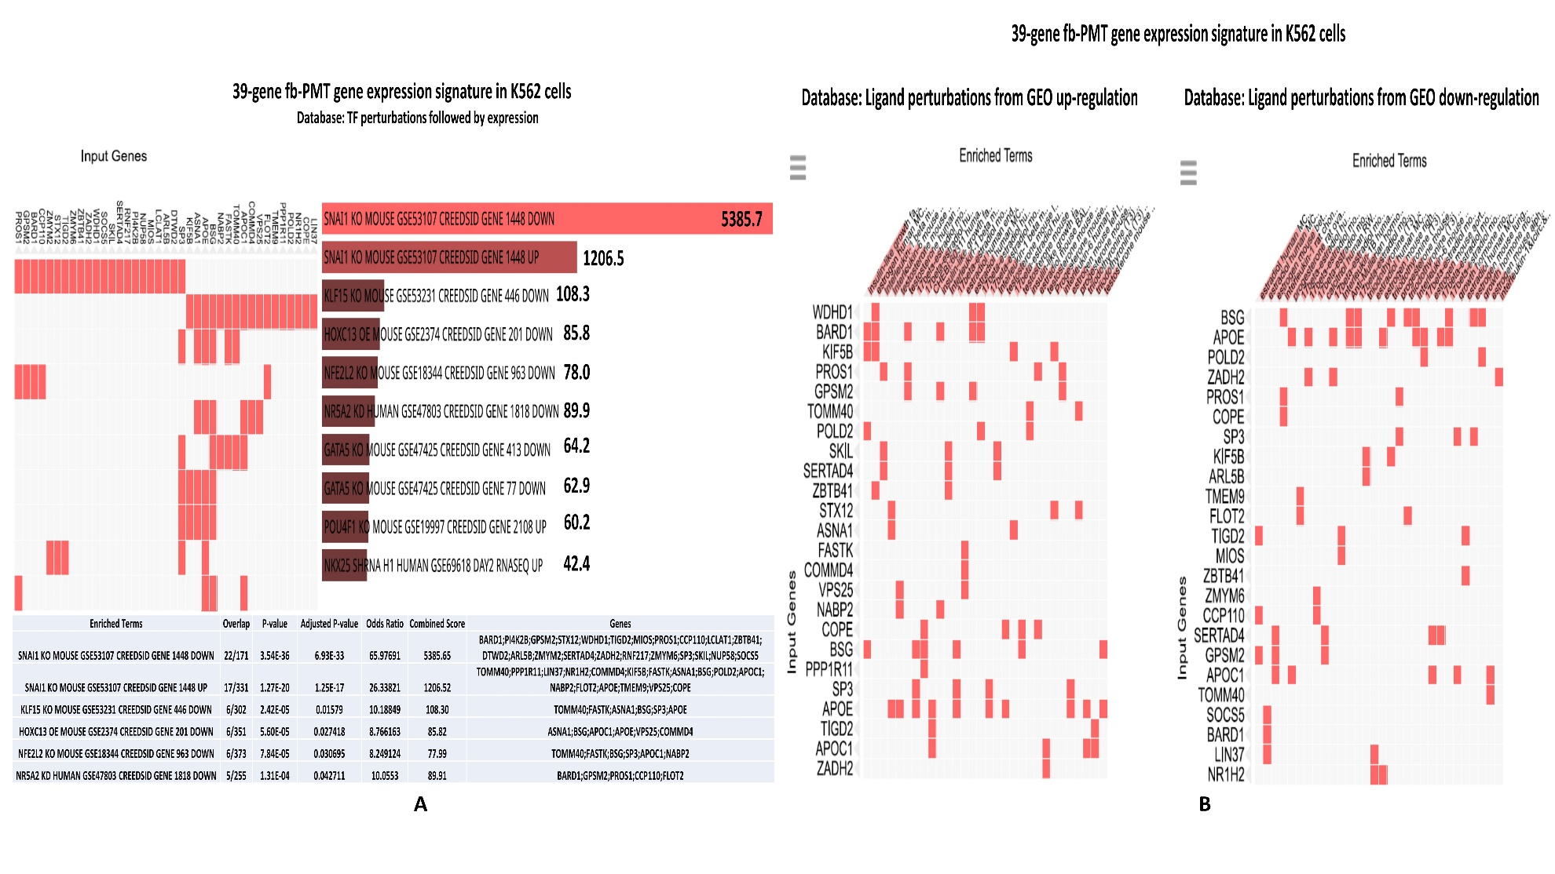
Supplemental Figure 7. Identification and characterization of the 39-gene SNAI pathway interference expression signature induced by fb-PMT treatment of K562 cells. A) GSEA of the TF perturbations followed by expression database. B) GSEA of Ligand perturbations from GEO up-regulation (left) and Ligand perturbations from GEO down-regulation (right) databases. Numbers shown next to the bar graphs report the values of Cumulative scores (Methods).
Supplemental figure 8
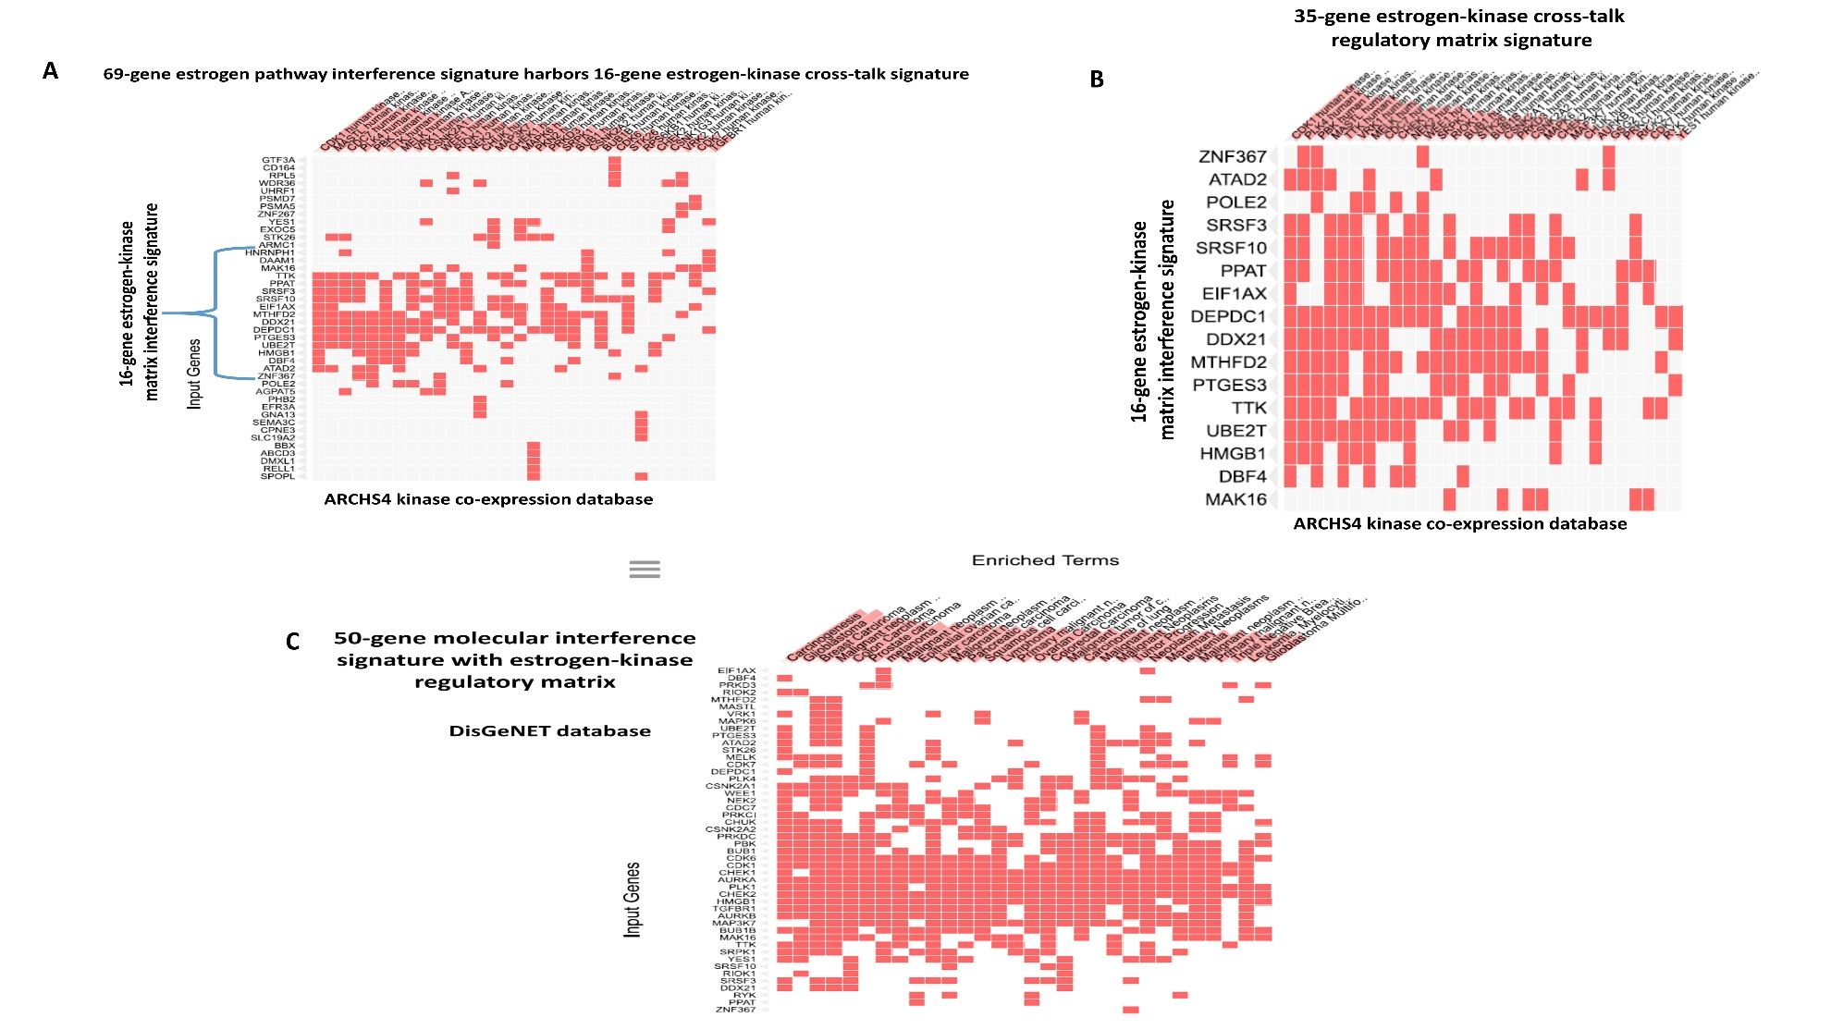Supplemental Figure 8. Identification and characterization of the 50-gene fb-PMT signature of molecular interference with estrogen pathway/multi-kinase gene expression regulatory matrix of cell cycle progression. A) 69-gene estrogen pathway interference signature harbors 16-gene estrogen-kinase crosstalk signature. B) 50-gene fb-PMT signature of molecular interference with estrogen pathway/multi-kinase gene expression regulatory matrix. C) Enrichr pathway analyses of the 50-gene interference signature with estrogen-kinase regulatory matrix identify the cell cycle progression pathway as the principal target. D) GSEA of the 50-gene interference signature with estrogen-kinase regulatory matrix using the DisGeNET database of human disorders.

